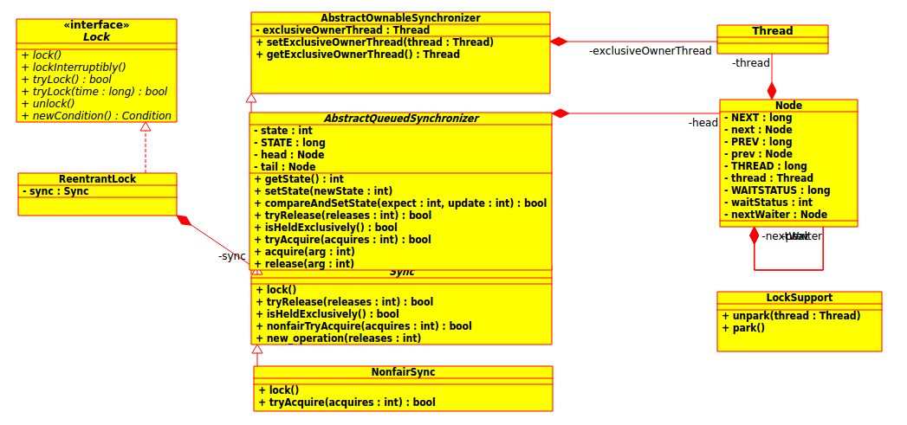
ReentrantLock源码分析
1.lock()方法分析
//ReentrantLock.java
public void lock() {
//调用NonfairSync类lock()方法
sync.lock();
}
NonfairSync.java
final void lock() {
//通过CAS操作比较state的值是否为0，如果为0则更新值为1
if (compareAndSetState(0, 1))
//设置独占的线程为当前线程
setExclusiveOwnerThread(Thread.currentThread());
else
//更新state失败，表示已经有线程更新过值了
//1.同一线程 2.不同线程
//调用AbstractQueuedSynchronizer的acquire()方法
acquire(1);
}
//AbstractQueuedSynchronizer.java
public final void acquire(int arg) {
//1.NonfairSync的tryAcquire方法
//2.AbstractQueuedSynchronizer的addWaiter方法
//3.AbstractQueuedSynchronizer的acquireQueued方法
if (!tryAcquire(arg) &&
acquireQueued(addWaiter(Node.EXCLUSIVE), arg))
selfInterrupt();
}
//NonfairSync.java
protected final boolean tryAcquire(int acquires) {
//Sync的nonfairTryAcquire方法
return nonfairTryAcquire(acquires);
}
//Sync.java
final boolean nonfairTryAcquire(int acquires) {
//当前的线程对象
final Thread current = Thread.currentThread();
//当前的state的值
int c = getState();
//当前资源没有被线程占据
if (c == 0) {
//通过CAS操作比较state的值是否为0，如果为0则更新值为1
if (compareAndSetState(0, acquires)) {
//设置独占的线程为当前线程
setExclusiveOwnerThread(current);
return true;
}
}
else if (current == getExclusiveOwnerThread()) {
//如果当前线程已经获取到了资源的锁
//直接更新资源对象
int nextc = c + acquires;
if (nextc < 0) // overflow
throw new Error("Maximum lock count exceeded");
setState(nextc);
return true;
}
//1.资源为0，但是CAS操作失败
//2.当前线程不是已经获取到资源的线程
return false;
}

//AbstractQueuedSynchronizer.java
private Node addWaiter(Node mode) {
//这里参数node的值为Node类的静态字段EXCLUSIVE;
//调用Node的构造函数
Node node = new Node(mode);

for (;;) {
//尾部节点对象
Node oldTail = tail;
//如果尾部节点不为空
if (oldTail != null) {
//更新当前节点的prev值为tail节点
U.putObject(node, Node.PREV, oldTail);
//AbstractQueuedSynchronizer的compareAndSetTail方法
//更新tail的值为node
if (compareAndSetTail(oldTail, node)) {
//前一个节点的next指向尾部节点
oldTail.next = node;
//返回尾部节点
return node;
}
} else {
//如果尾部节点为空，说明不存在这样的队列
//1.设置新建一个头部节点，然后把tail指向这个的头部节点
//即head与tail同时指向了一个没有数据的节点
initializeSyncQueue();
}
}
}
//AbstractQueuedSynchronizer.java
//设置资源的tail节点的值
private final boolean compareAndSetTail(Node expect, Node update) {
return U.compareAndSwapObject(this, TAIL, expect, update);
}
//AbstractQueuedSynchronizer.java
private final void initializeSyncQueue() {
Node h;
if (U.compareAndSwapObject(this, HEAD, null, (h = new Node())))
tail = h;
}
//Node.java
Node nextWaiter;
static final long PREV;
private static final long THREAD;
Node(Node nextWaiter) {
this.nextWaiter = nextWaiter;
//设置节点的THREAD字段为当前线程
U.putObject(this, THREAD, Thread.currentThread());
}

//AbstractQueuedSynchronizer.java
final boolean acquireQueued(final Node node, int arg) {
try {
boolean interrupted = false;
//参数node指向队列的tail节点
for (;;) {
//当前节点的前节点
final Node p = node.predecessor();
//前节点是头部节点,并且能够获取到资源
//这里说明第2个线程调用lock成功，并且会把第2个线程的Node设置为head
if (p == head && tryAcquire(arg)) {
//设置当前节点为head节点
setHead(node);
p.next = null; // help GC
//说明线程没有被终段，可以获取到锁
return interrupted;
}
//1.shouldParkAfterFailedAcquire返回true才会调用到步骤2的方法
//2.这里线程将会发生等待，直到调用unpart会唤醒线程继续执行，一般来说parkAndCheckInterrupt 返回false
//3.第一个线程调用unlock完毕，会调用第2个线程执行unpark操作
if (shouldParkAfterFailedAcquire(p, node) &&
parkAndCheckInterrupt())
interrupted = true;
}
} catch (Throwable t) {
cancelAcquire(node);
throw t;
}
}
//AbstractQueuedSynchronizer.java
private static boolean shouldParkAfterFailedAcquire(Node pred, Node node) {
int ws = pred.waitStatus;
if (ws == Node.SIGNAL)
/*
* This node has already set status asking a release
* to signal it, so it can safely park.
*/
//说明前一个节点设置了信号，后面的节点可以决定自己是否可以part操作
return true;
if (ws > 0) {
/*
* Predecessor was cancelled. Skip over predecessors and
* indicate retry.
*/
do {
node.prev = pred = pred.prev;
} while (pred.waitStatus > 0);
pred.next = node;
} else {
/*
* waitStatus must be 0 or PROPAGATE. Indicate that we
* need a signal, but don't park yet. Caller will need to
* retry to make sure it cannot acquire before parking.
*/
//说明前面一个节点还没被设置过值，需要设置它的前面节点为SIGNAL
pred.compareAndSetWaitStatus(ws, Node.SIGNAL);
}
return false;
}
//AbstractQueuedSynchronizer.java
//阻塞当前线程,返回当前线程是否被中断，一般来说这里返回false
private final boolean parkAndCheckInterrupt() {
LockSupport.park(this);
return Thread.interrupted();
}
//Node.java
final Node predecessor() throws NullPointerException {
Node p = prev;
if (p == null)
throw new NullPointerException();
else
return p;
}

2.unlock()方法分析
//ReentrantLock.java
public void unlock() {
//调用AbstractQueuedSynchronizer的release()方法
sync.release(1);
}
//AbstractQueuedSynchronizer.java
public final boolean release(int arg) {
//调用Sync类的tryRelease()方法
if (tryRelease(arg)) {
Node h = head;
if (h != null && h.waitStatus != 0)
unparkSuccessor(h);
return true;
}
return false;
}
//Sync.java
protected final boolean tryRelease(int releases) {
//state的值减去releases
int c = getState() - releases;
//如果当前线程不是独占的线程(也就是对资源已经加锁的线程)，抛出异常
if (Thread.currentThread() != getExclusiveOwnerThread())
throw new IllegalMonitorStateException();
boolean free = false;
//如果c的值为0，说明当前线程已经使用完了资源
if (c == 0) {
//表示unlock完毕
free = true;
//设置当前资源没有被线程占据
setExclusiveOwnerThread(null);
}
//设置资源的状态
setState(c);
return free;
}
//AbstractQueuedSynchronizer.java
private void unparkSuccessor(Node node) {
/*
* If status is negative (i.e., possibly needing signal) try
* to clear in anticipation of signalling. It is OK if this
* fails or if status is changed by waiting thread.
*/
int ws = node.waitStatus;
if (ws < 0)
node.compareAndSetWaitStatus(ws, 0);

/*
* Thread to unpark is held in successor, which is normally
* just the next node. But if cancelled or apparently null,
* traverse backwards from tail to find the actual
* non-cancelled successor.
*/
//下一个节点
Node s = node.next;
if (s == null || s.waitStatus > 0) {
s = null;
for (Node p = tail; p != node && p != null; p = p.prev)
if (p.waitStatus <= 0)
s = p;
}
//不要阻塞下一个节点，即被阻塞的线程开始执行
if (s != null)
LockSupport.unpark(s.thread);
}

2.LockSupport源码分析

//Unsafe类对象实例
private static final sun.misc.Unsafe U = sun.misc.Unsafe.getUnsafe();
//Thread类的parkBlocker字段的偏移量 Thread.java/volatile Object parkBlocker;
private static final long PARKBLOCKER;
//Thread类的threadLocalRandomSecondarySeed字段的偏移量 Thread.java/int threadLocalRandomSecondarySeed;
private static final long SECONDARY;
static {
try {
PARKBLOCKER = U.objectFieldOffset
(Thread.class.getDeclaredField("parkBlocker"));
SECONDARY = U.objectFieldOffset
(Thread.class.getDeclaredField("threadLocalRandomSecondarySeed"));
} catch (ReflectiveOperationException e) {
throw new Error(e);
}
}
//阻塞线程
public static void park(Object blocker) {
Thread t = Thread.currentThread();
//设置线程的组塞者
setBlocker(t, blocker);
U.park(false, 0L);
setBlocker(t, null);
}
private static void setBlocker(Thread t, Object arg) {
// Even though volatile, hotspot doesn't need a write barrier here.
U.putObject(t, PARKBLOCKER, arg);
}
//唤醒线程
public static void unpark(Thread thread) {
if (thread != null)
U.unpark(thread);
}

