ITS362

Lab #1

Geyang Xie

01/15/2017

Professor Ricardo A. Calix

Lab #1

1. Create a title for the website using <h1> tag





1. Create a table using <td> and <tr> tag and implement input form using <input > tag

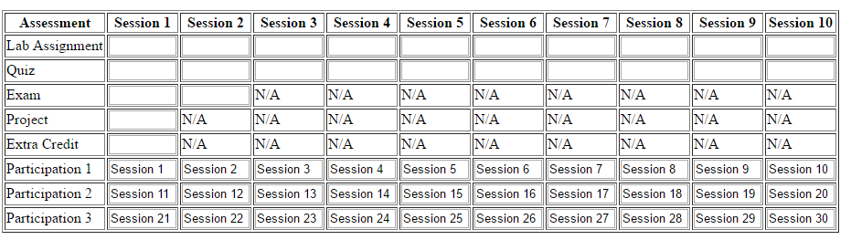

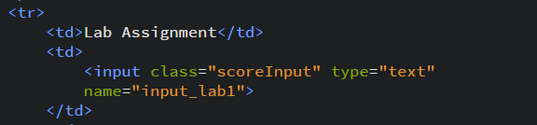

1. Create a button using <button> tag and customize the style of the button





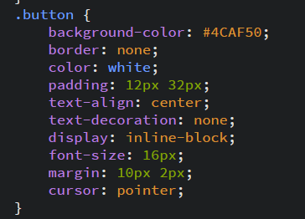

1. Generate the HTML page

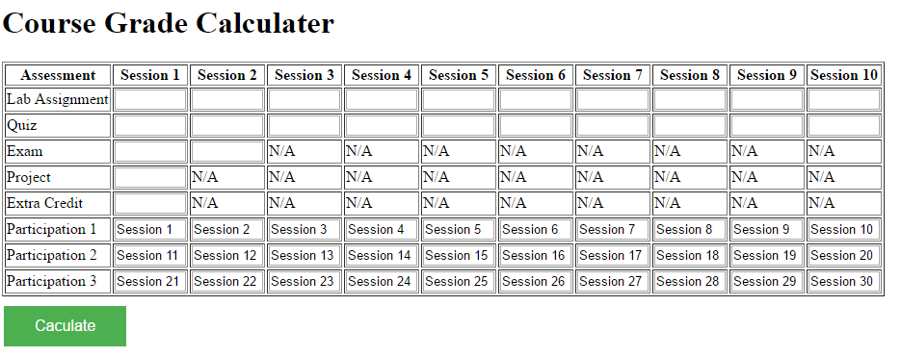

1. Add “id” and “name” on each input elements

