ITS362

Lab #2

Geyang Xie

01/15/2017

Professor Ricardo A. Calix

Lab #2

1. Create a function and Get all the data from Input tag.

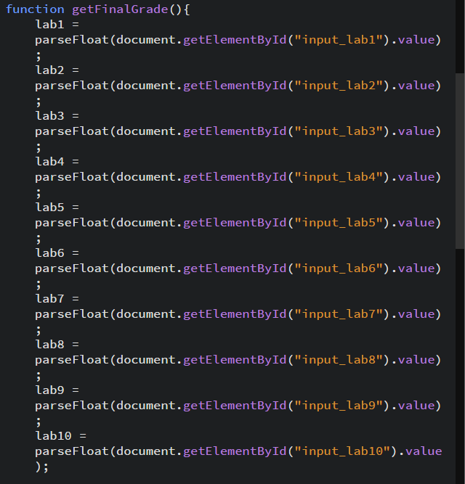

1. Calculate the final grade value

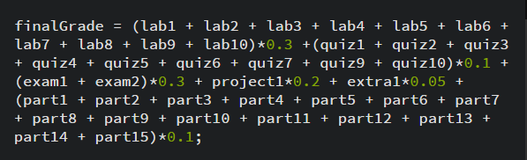

1. Check if the final grade is valid. If not, show the error massage.

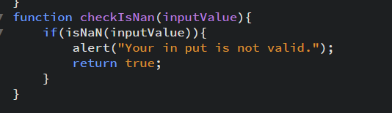

1. Show to final grade in the page.

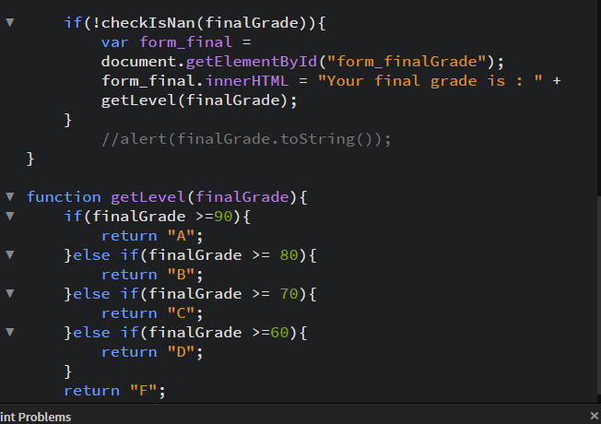

1. Test it.

