
Course Project Report for Undergraduate Students
Course Type： Subject Elective
Course Name： Internet Application Development
互联网应用开发(全英)
Course Code： 60080049
Instructor： 何明昕，HE Mingxin

《Assignment of Project 1 for IAD: Personal Home Page》

Name 王兴宇
Student ID 2020100697
College International School
Major Computer Science and Technology
Email 3431273558@qq.com

Submit Date： 9 /24/ 2022

Personal Home Page Description
Links
My Homepage is https://xieguibanyao.github.io/
The IAD assignments are in the homapage like
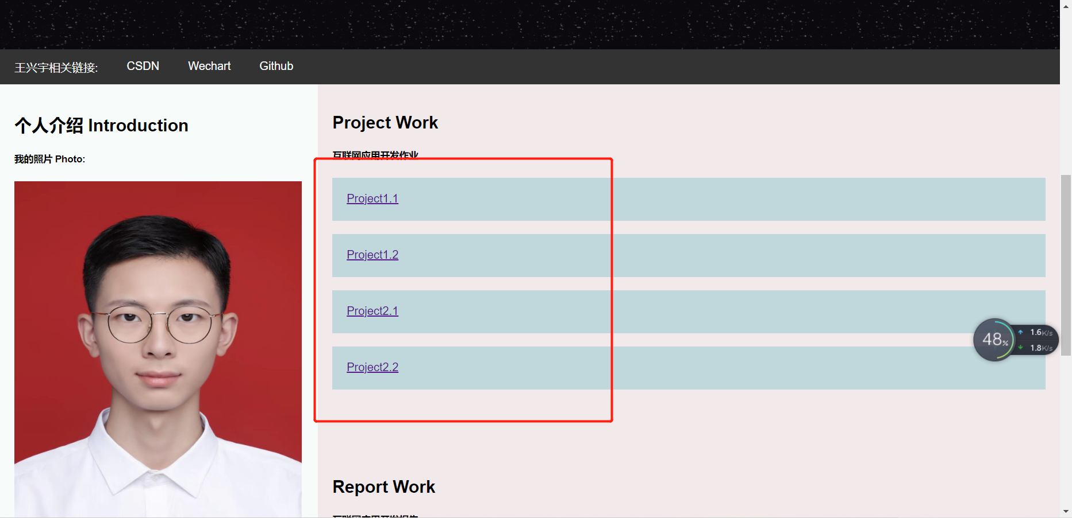
Interpretation
The project uses the Github to show my web.I put all the files into the Github repository to complete the final web page.This project uses html5 and css3 with 15 design patterns.
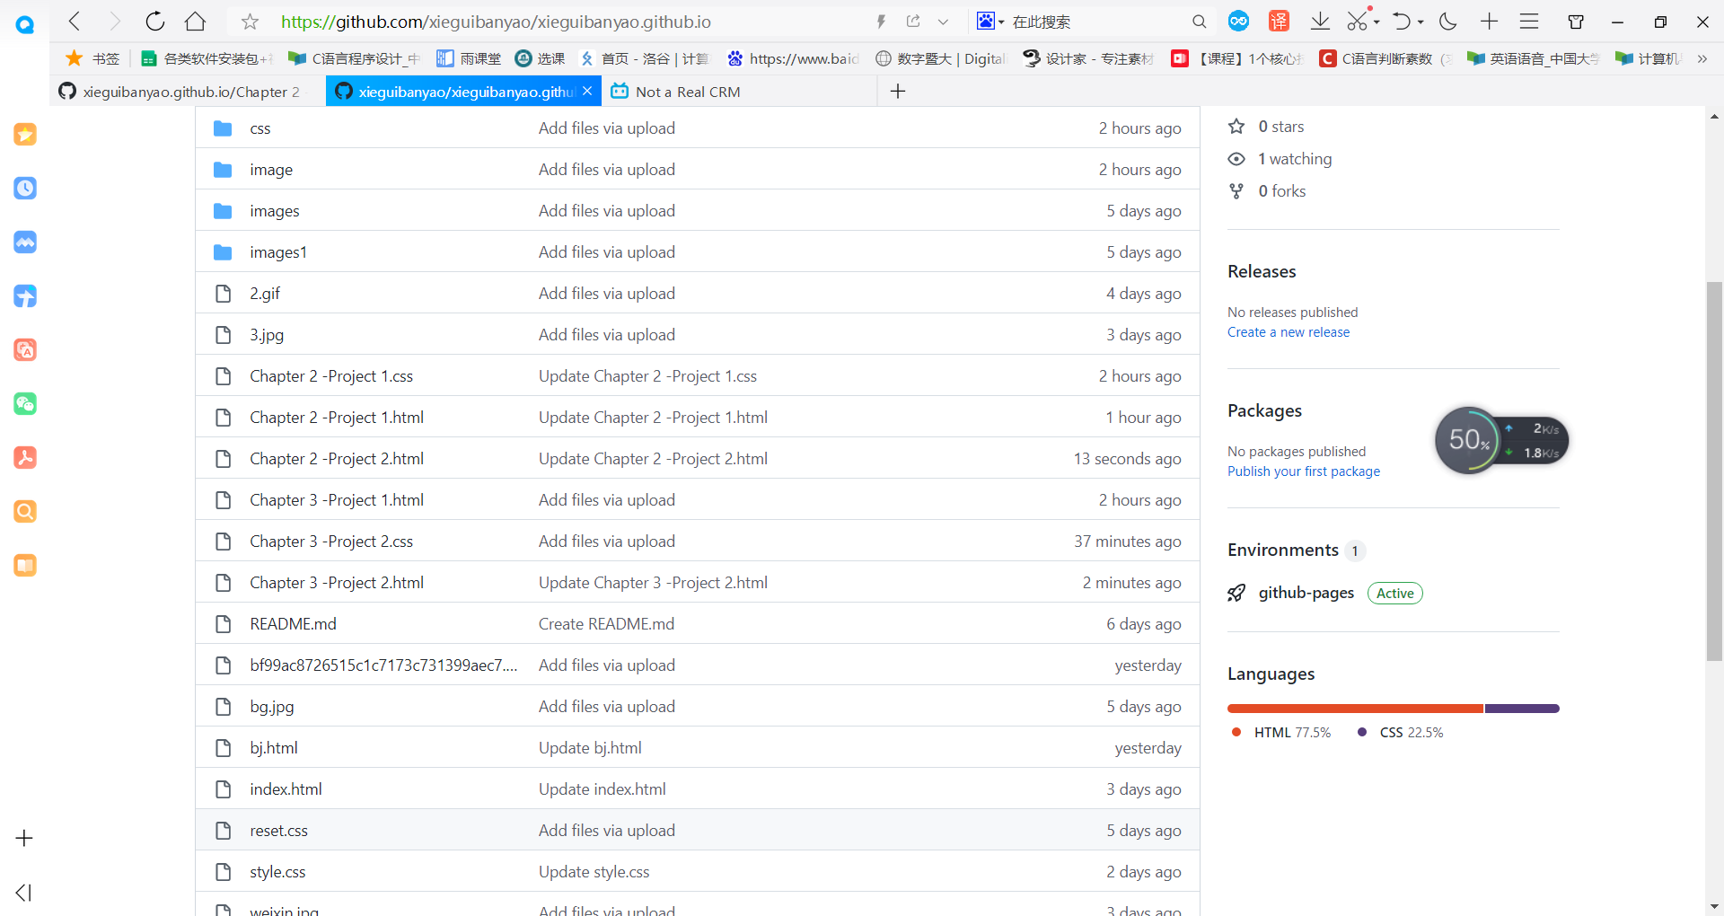
This page is mainly used as my home page and put in the Internet application homework. Clicking on my Web page first brings up a starry GIF background and the name of the home page.
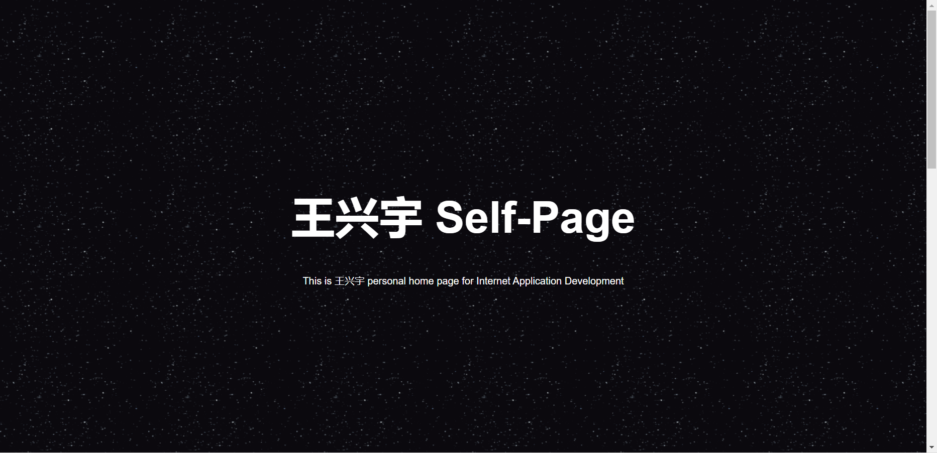
After the drop-down, the red box in the upper left corner of the page is my related links, including CSDN account, wechat QR code and Gethub account links.
The content in the yellow box on the left is personal introduction, including my picture and relevant personal information.
The blue box on the right is my Internet application development assignments and related reports. Click to enter the related assignments link.
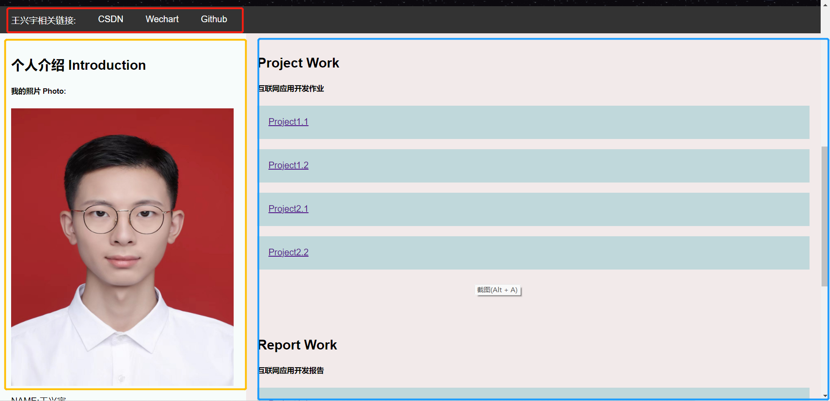
In the lower right corner of the black box is my detailed introduction, including my background information, professional skills, interests and hobbies, click to enter the relevant links.
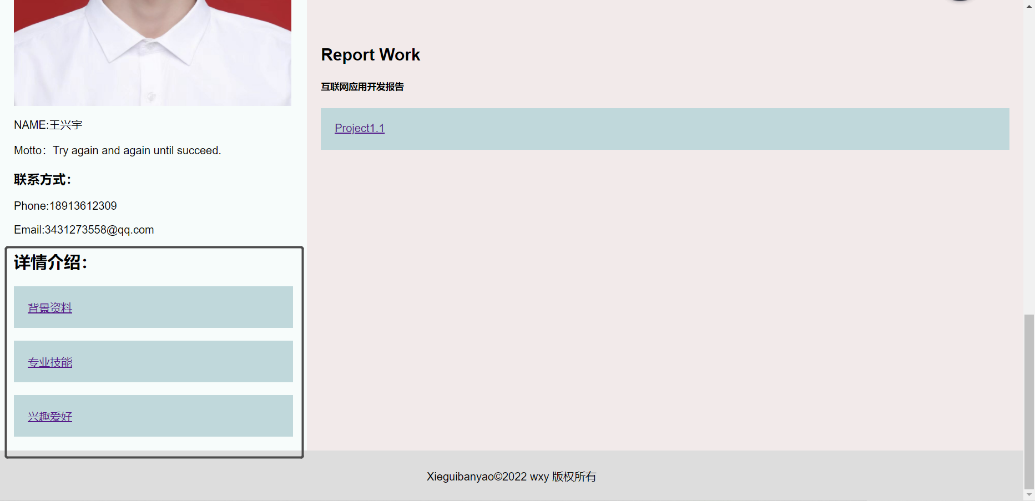
Design pattern
I used many design patterns in my website, including the following patterns.
- Factory Pattern
Define an interface for creating objects and let subclasses decide which class to instantiate.Create all the classes first, and then instantiate according to the requirements of the web page.

- Highlight the theme.
Through the black starry sky background picture and the white theme to form a sharp contrast, make the theme part more prominent, and the font has been enlarged accordingly, making it present a clean, clean, and majestic beauty.

- Color complement.
In the main page, the left side is white and the right side is light pink. The colors complement each other to make the whole more warm.

- Place discoloration.
When I mouse over a link to CSDN or GitHub, it turns the background of the link to white, making it stand out on the gray guide and welcoming the user's eye.

- Present the two-dimensional code.
When you place your mouse over wechat, a wechat QR code will appear for visitors to scan.

- Information intensive.
Put information that can be grouped together, such as personal information in a cluster on the left and job information in a unified place on the right.

- Plate.
The whole by the black, white, pink three blocks as the main body, in the three blocks present all kinds of information, so that the overall web planning sense.

- Save the information.
The background information, professional skills, hobbies and other text information is placed as a separate link in the detailed introduction, to avoid the complex information on the home page, so that the home page is beautiful and clean.

- The font emphasizes.
Use boldface for headlines to make the emphasis more effective and capture the viewer's view.

- Box Model
Sometimes we not only want to style the element but also its box. In that case, we use the box model. Box model defines the relationship between the following properties: display, width, height, padding, border, margin, background, overflow, and visibility.

- Border
If we want to put a border on one or more of the sides of an element, we use a border. We can independently set border-left, border-right, border-top, and border-bottom. border affects an element differently depending on the type of element and its alignment. You can set the style and color of the border. border: none is the default.

- Copyright.
Placing a copyright logo at the bottom of the page not only enhances the overall beauty of the page, but also gives the page a logo.

- Elements and empty Spaces.
Place appropriate Spaces between elements to make the whole cleaner and neater.

- Page contact.
When I click on a link, such as background, to go to another page, I just click on the home page in the related links of the background page to go back to the original page.

- Font size.
Contrast the font size to highlight the theme, while the font color contrasts with the background.

