sciBASIC#: Microsoft VisualBasic for Scientific Computing
GitHub release AppVeyor build License GPLv3 Gitter
A VisualBasic(.NET) language kernel and runtime for scientific data computing, deep learning, LLM inference, GPU acceleration, visualization and command-line data-science applications — running on .NET (net10.0) across Windows, Linux and macOS. Write your analysis as a plain .vb script and run it directly with the built-in vbs script engine.


Table of Contents
• Introduction
• What's New
• Features
• Installation & Build
• Quick Start
• NumericTable — One Data Model for the Whole Data-Science Pipeline
• Deep Learning Suite
• LLM Engine (Decoder-Only Transformer)
• GPU Acceleration — ILCuda & ILCudaTensor
• SIMD Math Acceleration
• The VBS Script Engine
• Module & Namespace Overview
• Extended VisualBasic Language
• Examples by Domain
• FAQ
• Documentation & Contacts

Introduction
sciBASIC# is a cross-platform framework, written entirely in Microsoft VisualBasic.NET, that brings the productivity of the BASIC language to scientific computing. It bundles a large, cohesive set of reusable libraries (100+ projects in nuget.slnx) that together form the foundation for building data-science command-line tools on Windows, Linux and macOS — on modern .NET (net10.0).
The runtime is organized into cooperating layers:
Layer | Source root | Purpose
Core runtime | Microsoft.VisualBasic.Core/ | Extended VB language syntax, LINQ-style collections, a CLI application framework, the NumericTable unified data model, serialization, networking and SIMD-accelerated math.
Data framework | Data/, mime/ | Tabular data (DataFrame), scientific file I/O (NetCDF, HDF5, Feather, SQLite3, HDSPack), MIME / text & XML parsing (JSON, xlsx, docx, pdf, markdown, yaml), and NLP (word2vec, KnowledgeGraph).
Math & data science | Data_science/ | Numerical math, statistics, ODE solvers, deep learning (CNN / RNN / Transformer / GNN / LNN / SNN), classic ML, dimension reduction (UMAP / PaCMAP / t-SNE), evolutionary algorithms (Darwinism) and machine vision.
LLM engine | llm/ | A pure-managed decoder-only LLM implementation: MoE, KV cache, RoPE, function calling with constrained decoding.
GPU acceleration | cuda/ | NVIDIA CUDA computing framework (ILCuda) and a GPU tensor runtime (ILCudaTensor) — native heterogeneous computing without any third-party NuGet dependency.
Graphics & visualization | gr/, Data_science/Visualization | The "sciBASIC# Artists" imaging engine that produces publication-quality 2D/3D plots, SVG / d3js export, network layouts and color palettes.
Script engine | vs_solutions/VBS/ | The vbs scripting host: run VB.NET scripts directly without creating a project — with vectorized syntax, dynamic types and more.
The design philosophy is CLI-first / script-first: instead of drag-and-drop controls, sciBASIC# emphasizes headless, scriptable, reproducible data-science programs that read files, compute, and emit figures or tables — the kind of artifacts that end up in a scientific manuscript.
3D Graphics Example From sciBASIC
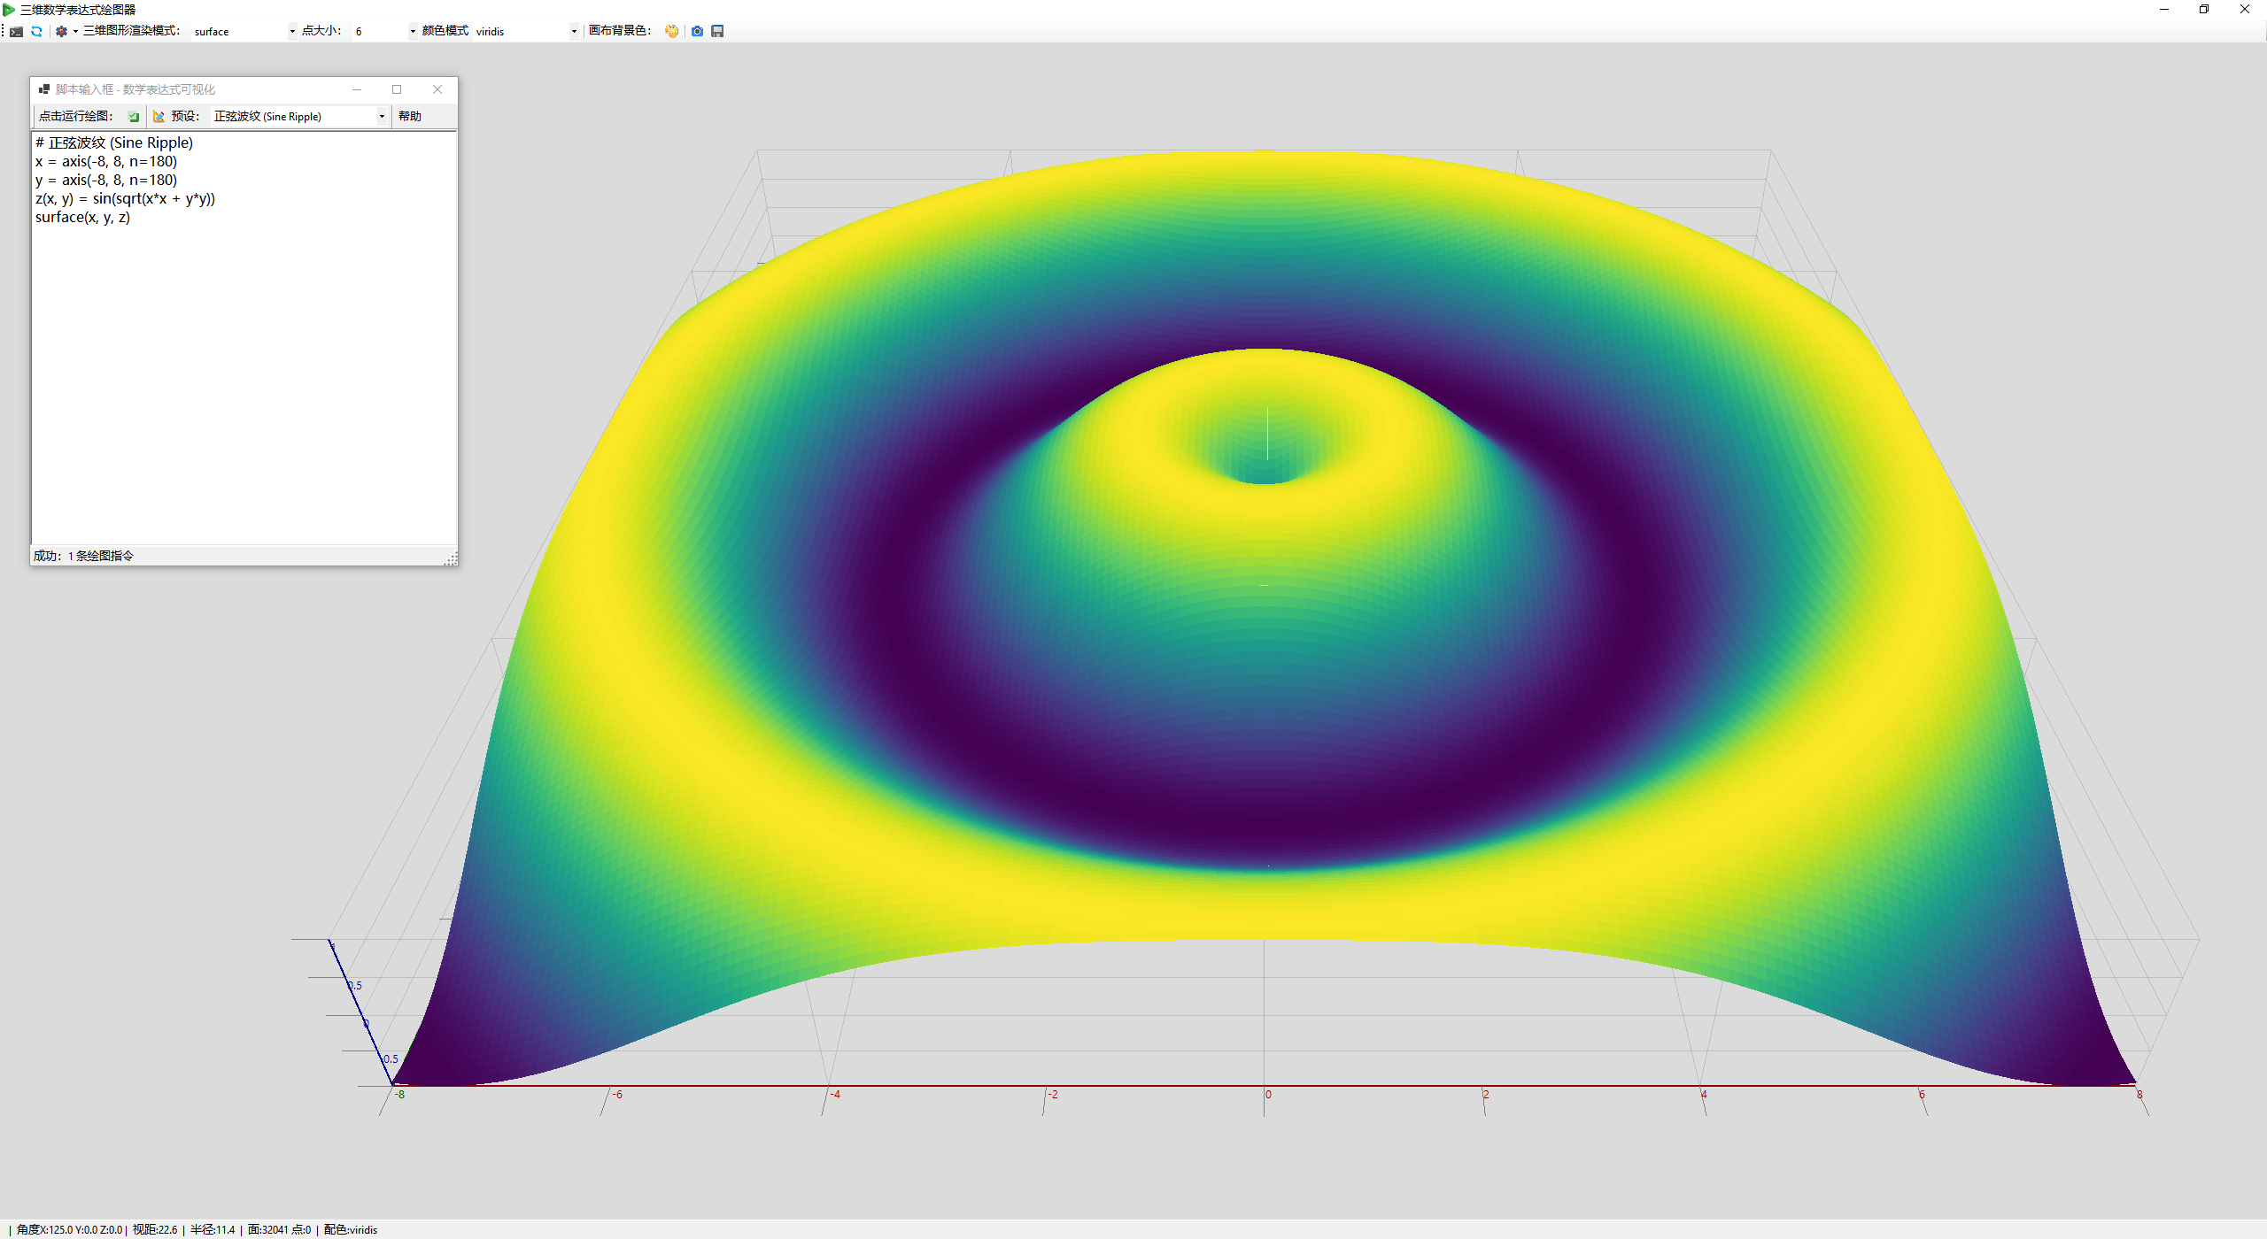
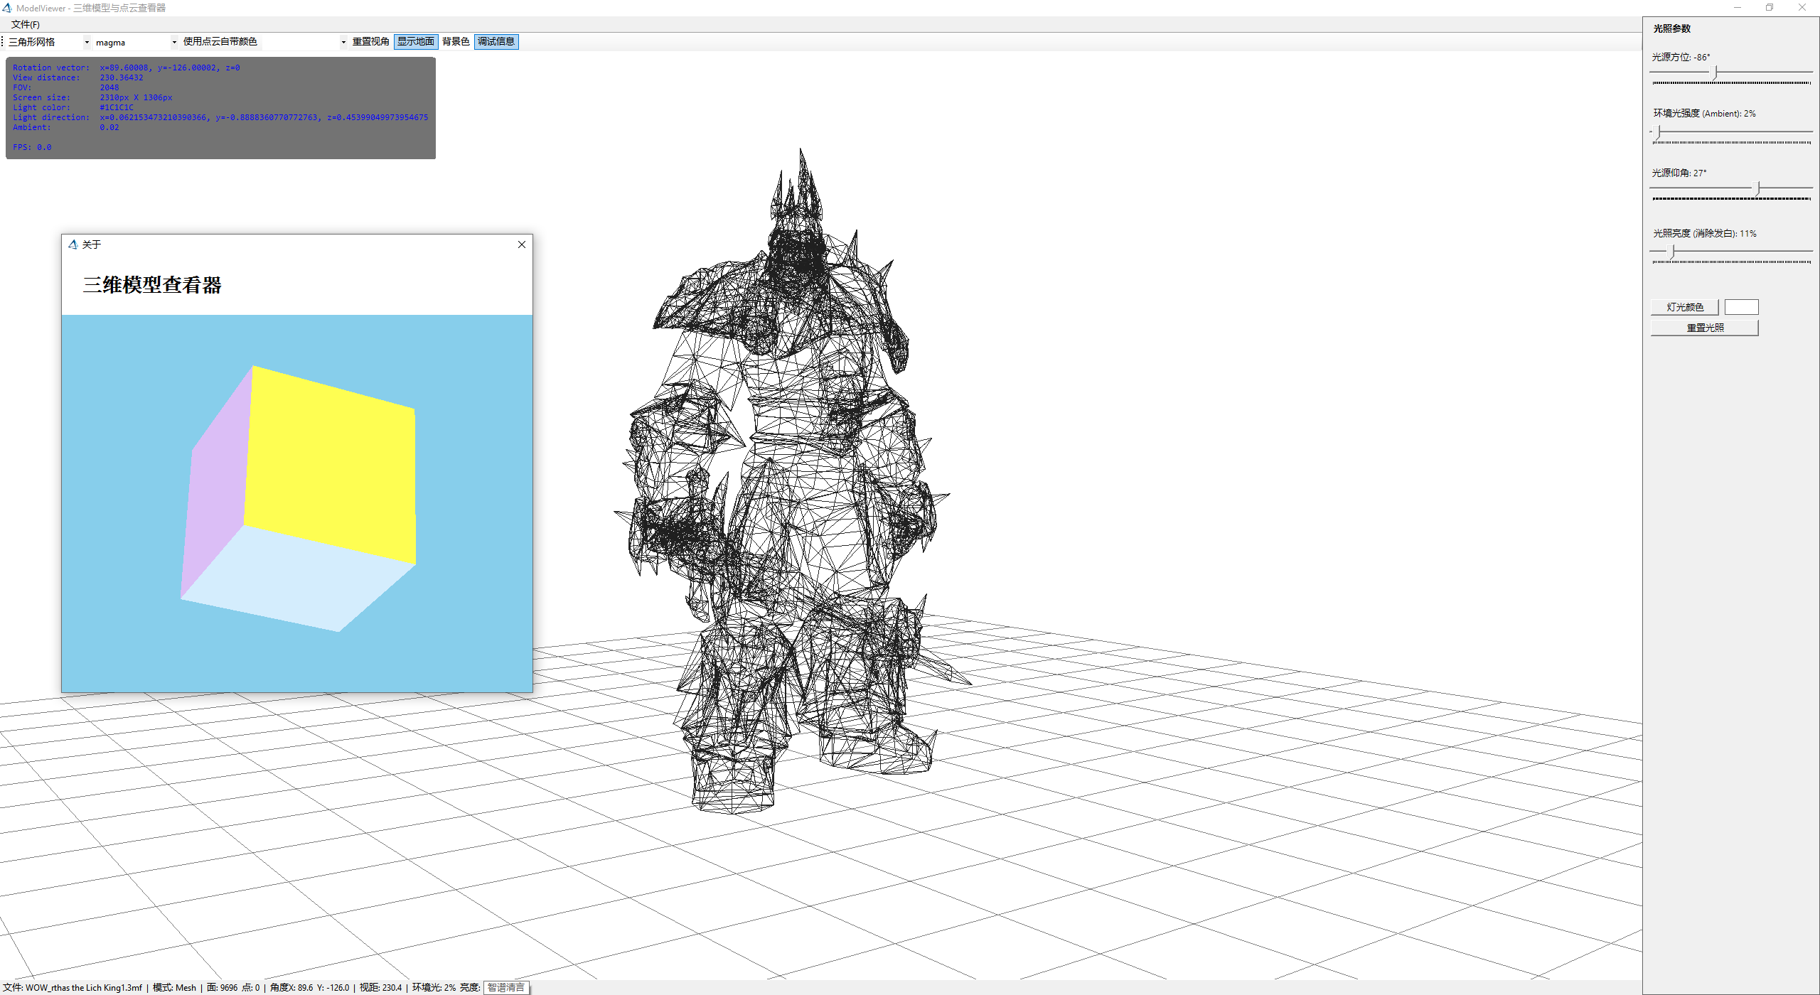
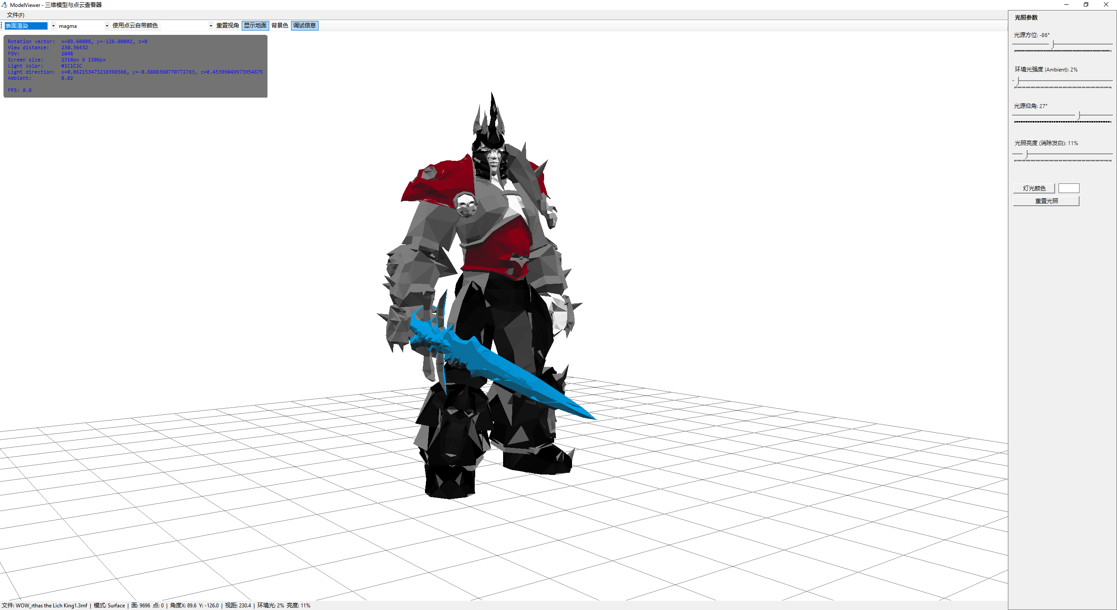

What's New
The framework has been extended substantially in the recent releases:
1. Deep learning model zoo (Data_science/MachineLearning/) — modern neural architectures
implemented in pure managed code: CNN, RNN, Transformer, ANN (in the DeepLearning package),
plus dedicated packages for GNN (graph neural networks: GCN / GAT / temporal graphs),
LNN (liquid neural networks with ODE-solver cells), SNN (spiking neural networks: LIF
neurons, surrogate gradients, STDP), VAE, RBM, DBN and Deep-Q-Network.
2. LLM engine (llm/) — a decoder-only language model built on the Transformer architecture:
DeepSeek-style MoE routing, KV cache incremental decoding, RoPE, RMSNorm, SwiGLU,
GQA/MQA, function calling with schema-constrained decoding and a full agent loop.
3. NumericTable unified data model (Microsoft.VisualBasic.Core/src/Data/NumericTable.vb) —
one table model (row names + feature columns + label columns) shared by every machine-learning
algorithm in the framework, enabling chain-style data-science pipelines:
NumericTableIO.ReadCsv(...).kmeans(3).pca(2).ScoreTable() …
4. SIMD math acceleration (Microsoft.VisualBasic.Core/src/Math/SIMD/) — hardware-vectorized
arithmetic (SSE2/AVX/ARM Advanced SIMD) for element-wise math, matrix kernels and reductions,
plus a Vec* operator vocabulary used by the script engine's auto-vectorization.
5. CUDA GPU framework (cuda/) — ILCuda (P/Invoke of the CUDA Driver API + NVRTC runtime
compilation, zero third-party dependencies, and an IL → CUDA translator that compiles your
.NET methods to GPU kernels) and ILCudaTensor (a double-precision GPU tensor runtime whose
CudaTensor transparently switches the whole Tensor/nn operator family to the GPU).
6. The VBS script engine (vs_solutions/VBS/) — run VB.NET scripts directly:
no project, no compilation step, no deployment. The engine parses, restructures, compiles
in memory via Roslyn and executes the assembly — and adds scripting-only syntax extensions
(vectorized array math, let dynamic typing, tuple destructuring, @ array projection,
#include of dlls/scripts/NuGet packages).

Features
• Extended VisualBasic syntax — Value(Of T) inline assignment, List(Of T) with a + append
operator and rich indexers, LINQ helpers (Sequence, Iterates, which, sentinel) and Unix-shell
style helpers (UnixBash.ls, cat).
• Command-line application framework — attribute-driven (<ExportAPI>, <Usage>) CLIs, automatic
help generation, and InteropService to host external command-line tools.
• VB.NET script engine (vbs) — top-level statements, ?"--arg" parameters, #include
(assembly / script / NuGet), magic methods (Here(), ScriptDir()), auto-vectorized numeric
array math, print data inspection in GNU R style, and make-project to promote a debugged
script into a real .vbproj project.
• Unified tabular model — NumericTable — row names + feature columns + label columns, with
chainable extension methods shared across K-Means, PCA, hierarchical clustering, linear/polynomial
fitting, UMAP/PaCMAP, SHAP and more.
• Deep learning — CNN (Conv2D/Pooling/Dropout/… + Softmax/SVM/Regression losses), char-level RNN,
encoder–decoder Transformer with multi-head attention, feed-forward ANN, GCN/GAT graph networks,
liquid time-constant networks, spiking neural networks, VAE/RBM/DBN, DQN reinforcement learning.
• LLM inference & training — decoder-only Transformer with MoE experts, KV cache prefill +
incremental decoding, RoPE positional embedding, AdamW trainer, sampling strategies and
schema-constrained function calling (agent loop).
• Classic machine learning — K-Means, hierarchical clustering, SVM, decision trees / random forest
(Bonsai), Naïve Bayes, HMM, XGBoost-style gradient boosting, association rules, sequence alignment,
SHAP value explanation.
• Dimension reduction & manifold learning — PCA, UMAP, PaCMAP, t-SNE.
• GPU heterogeneous computing — CUDA Driver API interop, NVRTC kernel compilation, device memory
& streams, BLAS/reduction/element-wise kernels, IL→CUDA source translation, and a
GPU tensor runtime with automatic backend switching.
• SIMD vectorized math — System.Numerics.Vector-based element-wise arithmetic, matrix kernels
(SimdMatrix), reductions (SimdReduce) and math functions (SimdMath) for float/double data.
• Scientific file I/O — NetCDF, HDF5, Feather, SQLite3, HDSPack, msgpack and other binary formats,
plus MIME text/XML and Excel (OpenXML) parsing.
• Mathematics — linear algebra, statistics & hypothesis testing (ANOVA), data fitting /
bootstrapping, Gibbs sampling, signal processing, symbolic math and ODE solvers (Runge–Kutta,
SUNDIALS CVODE bindings).
• Evolutionary algorithms — genetic algorithms and differential evolution under
Microsoft.VisualBasic.MachineLearning.Darwinism.
• Natural-language processing — word2vec, TextRank keyword extraction, KnowledgeGraph and the
GraphQuery object query DSL.
• Visualization / "Graphics Artist" — scatter, line, bar, histogram, heatmap, volcano and 3-D
plots; network/force-directed layouts; SVG / d3js / PDF export; colorbrewer palettes; isometric 3-D
engine; AVI video writing; Gaussian splatting 3D. Figures are tuned for printable,
publication-quality output.
• LLM proxy — bridge a local model (e.g. Ollama) or any Func(Of String, String) endpoint into the
runtime via Microsoft.VisualBasic.LLMs.

Installation & Build
Prerequisites
• .NET 10 SDK (the libraries target net10.0; graphics/imaging projects additionally
target net10.0-windows).
• Visual Studio 2022 (Windows) or any editor with the VB.NET / .NET workload (Visual Studio Code +
the C#/VB dev kit, or JetBrains Rider) on Linux / macOS.
• Optional: an NVIDIA GPU + driver for the cuda/ acceleration layer (everything else runs CPU-only).
Consume the packages
The individual libraries are published as NuGet packages under the Microsoft.VisualBasic.* family (e.g. the core runtime assembly Microsoft.VisualBasic.Runtime). Add them to your project with:
dotnet add package Microsoft.VisualBasic.Runtime
Build from source
Clone the repository and build the NuGet solution, which references every library project:
git clone https://github.com/xieguigang/sciBASIC.git
cd sciBASIC
dotnet build nuget.slnx -c Release
To build a single library, open its .vbproj (for example Microsoft.VisualBasic.Core/src/Core.vbproj, llm/llm.vbproj or vs_solutions/VBS/VBS.vbproj) or the relevant solution under vs_solutions/.

Quick Start
A. Classic sciBASIC# console application
Imports Microsoft.VisualBasic.ApplicationServices
Imports Microsoft.VisualBasic.CommandLine
Imports Microsoft.VisualBasic.CommandLine.Reflection
Module Program
Public Function Main() As Integer
' Standard sciBASIC# CLI entry point: dispatches /switch based on
' <ExportAPI> methods and auto-generates the help screen.
Return GetType(Program).RunCLI(App.CommandLine)
End Function
<ExportAPI("/hello")>
<Usage("/hello /name <string>")>
Public Function Hello(args As CommandLine) As Integer
Call Console.WriteLine($"Hello, {args("/name")}!")
Return 0
End Function
End Module
yourapp.exe /hello /name "sciBASIC#"
# -> Hello, sciBASIC#!
B. Or just write a script — no project needed
Save hello.vb:
' No Module, no Sub Main — top-level statements just work.
Dim name As String = ?"--name" ' read a command-line argument
Call Console.WriteLine($"Hello, {name}!")
Dim x = {1, 2, 3, 4, 5}
Call print(x * 2 + 1) ' vectorized array math, R-style output
' [1] 3 5 7 9 11
Run it with the vbs host (see The VBS Script Engine):
dotnet build vs_solutions/VBS/VBS.vbproj -c Release
.nuget/net10.0/vbs.exe hello.vb --name "sciBASIC#"

NumericTable — One Data Model for the Whole Data-Science Pipeline
Microsoft.VisualBasic.Core/src/Data/NumericTable.vb defines the framework's unified 2-D data model: row names + feature columns + label columns (labels are the label:-prefixed columns). Every machine-learning algorithm in sciBASIC# understands this model, so data flows between algorithms without conversion glue code — you simply chain the steps.
Imports Microsoft.VisualBasic.Data
' 1. Load a csv (row names + D1..D4 feature columns; text class column ignored)
Dim table = NumericTableIO.ReadCsv("bezdekIris.csv", columns := {"D1","D2","D3","D4"})
' 2. K-Means clustering writes its result back into the table's label matrix
Dim result = table.kmeans(k := 3)
' 3. PCA on the clustered table -> project to the first two components
Dim score = result.pca(maxPC := 2).ScoreTable()
' 4. Pull columns for plotting
Dim pc1 = score.Feature("PC1")
Dim pc2 = score.Feature("PC2")
(excerpt from tutorials/VBS/scripts/kmeans/kmeans.vb — a complete Iris clustering + PCA + scatter-plot demo)
Regression works the same way:
Dim model = table.LinearFit(y := "y") ' linear regression on the label column
Dim quad = table.PolyFit(poly_n := 2) ' polynomial comparison model
Dim out = table.SetPrediction(model, withResidual := True) ' new table + prediction/residual labels
Call out.WriteCsv("fit.csv")
(excerpt from tutorials/VBS/scripts/linear_regression/linear_regression.vb)
Key API surface: nsamples / nfeatures / nlabels, Feature(name), GetLabel(name), SetLabel(name, values), Slice(rows), Select(cols), Clone(), plus IO helpers (NumericTableIO.ReadCsv, WriteCsv) and R-style print(tbl) table rendering.

Deep Learning Suite
All models are implemented in pure managed VB.NET on a shared tensor runtime — no PyTorch/TensorFlow native runtime required, while the GPU can be layered on through ILCudaTensor.
Package (Data_science/MachineLearning/…) | Models | Highlights
DeepLearning (DeepLearning.NET6.vbproj) | CNN (CNN: Conv2D, Conv2DTranspose, Pooling, Dropout, Maxout, LRN, Fourier-feature, Gaussian layers; Softmax/SVM/Regression loss layers; model save/load), RNN (char-level), Transformer (encoder/decoder stacks, multi-head attention), ANN (NeuralNetwork) | SGD / AdaGrad / Adam optimizers, trainer loops, CeNiN model import
GNN (GNN.vbproj) | GCN layer, Graph attention (GAT), GRU/RNN recurrent graph layers, temporal graph models, graph classification | message-passing on graphs, dynamic-graph snapshots
LNN (LNN.vbproj) | Liquid neural networks — LiquidCell/LiquidLayer, ODE-solver based continuous-time units | time-series utilities, liquid trainer
SNN (SNN.vbproj) | Spiking neural networks — LIF / recurrent-LIF / sparse-LIF layers, rate & temporal encoders/decoders, surrogate gradients, STDP learning | third-generation neural networks with spike trains
VAE / RestrictedBoltzmannMachine / DBNCode | Variational autoencoder, RBM, deep belief networks | unsupervised representation learning
DeepQNetwork (DeepQNetwork.vbproj) | DQN reinforcement learning | Q-learning on neural function approximators
xgboost / XGBoostDataSet | gradient-boosted trees | tabular learning with the NumericTable dataset format
ML_SHAP | SHAP value explanation | model-agnostic feature attribution
MLDataStorage / MachineLearning.Data.Extensions | ML data packing & NumericTable bridges | interop glue between packages
Minimal CNN example:
Imports Microsoft.VisualBasic.MachineLearning
Imports Microsoft.VisualBasic.MachineLearning.CNN
Imports Microsoft.VisualBasic.MachineLearning.CNN.trainers
Dim net As New ConvolutionalNetwork()
Call net.AddLayer(New ConvolutionLayer(filters:=32, kernelSize:=3))
Call net.AddLayer(New PoolingLayer(size:=2))
Call net.AddLayer(New DenseLayer(units:=10))
Call net.Compile(loss:=New SoftmaxCrossEntropy())
Dim trainer As New SGDTrainer(optimizer:=Optimizer.Adam, learningRate:=0.001)
For epoch As Integer = 1 To 20
Call trainer.TrainEpoch(net, trainData)
Next

LLM Engine (Decoder-Only Transformer)
llm/llm.vbproj provides a pure-managed decoder-only language model covering three main lines beside the classic encoder–decoder Transformer in DeepLearning:
Line | Types | What it does
Mixture of Experts | MoELayer | DeepSeekMoE: fine-grained expert splitting + shared expert isolation + Sigmoid Top-K routing + auxiliary-loss-free load balancing + node-limited routing
KV Cache | KVCache, CausalSelfAttention | prefill + incremental decoding — per-step attention cost drops from O(t²) to O(t); nKvHeads < nHeads gives GQA/MQA
Function calling | ToolCallProtocol, JsonSchema, ConstrainedDecoder, ToolRegistry, AgentLoop | tool schema injection → constrained decoding (schema compiled to a finite-state machine, illegal tokens masked to -inf) → parse → execute → feed back → multi-turn loop
Supporting modules: RmsNorm, RotaryEmbedding (RoPE), SwiGLUFeedForward, LLMBlock, LLMModel, Sampler, LMTrainer (AdamW, warmup + cosine schedule, gradient clipping), ParameterSet, TokenStream, TokenizerVocabulary. No automatic differentiation framework — backprop is hand-written per component against cached forward snapshots, keeping the whole engine readable and debuggable.
' Build & train (see TalkBuddy/test/Program.vb for the full walkthrough:
' pretraining -> instruction SFT -> tool-call SFT -> MoE routing stats
' -> sampling comparison -> KV-cache consistency -> multi-turn tool calling)
Dim model As New LLMModel(New LLMModelConfig With {.dModel = 512, .nLayers = 8, ...})
Dim trainer As New LMTrainer(model, New AdamW(model.Parameters, lr:=0.0003))
Call trainer.TrainStep(batch)

GPU Acceleration — ILCuda & ILCudaTensor
The cuda/ root brings native NVIDIA GPU heterogeneous computing to sciBASIC# — with zero third-party NuGet dependencies (it P/Invokes nvcuda.dll and nvrtc64_*.dll directly).
Project | Role
cuda/ILCuda/ILCuda.vbproj | CUDA compute framework: device/context/stream management, device memory & pinned host buffers, NVRTC multi-pass kernel compilation, kernel registry & launch planning, built-in reduction / element-wise / BLAS (GEMM, GEMV) kernels, structured diagnostics. Includes IL2Cuda: an IL → AST → CUDA-C translator with <CudaKernel>/<CudaInput>/<CudaOutput> attributes that turns ordinary .NET methods into GPU kernels.
cuda/ILCudaTensor/ILCudaTensor.vbproj | GPU tensor runtime: device-resident CudaTensor (dense + CSR sparse storage) and a set of double-precision kernels (GEMM, softmax, reductions, conv/pool, sparse×dense). One Register() call switches the whole TensorFlow-style Tensor/Math/nn operator family to the GPU backend — operators without a GPU kernel silently fall back to the CPU implementation, so nothing ever breaks.
' After one registration, tensor math runs on the GPU automatically:
Call CudaTensor.Register()
Dim a = Tensor.Random(2048, 2048)
Dim b = Tensor.Random(2048, 2048)
Dim c = a * b ' GEMM on the GPU, double precision
The ILCuda test project doubles as a demo CLI:
dotnet ILCuda.Demo.dll info # device & NVRTC environment probe (with memory info)
dotnet ILCuda.Demo.dll demo # pearson-correlation + euclidean-distance matrices on GPU
dotnet ILCuda.Demo.dll selftest # kernel-logic self-check (no GPU required)

SIMD Math Acceleration
Microsoft.VisualBasic.Core/src/Math/SIMD/ is the CPU-side high-performance math core, used by the machine-learning packages and by the script engine's auto-vectorizer:
SIMD/
├── SimdEngine.vb # capability detection & dispatch (SSE2 / AVX / ARM Advanced SIMD)
├── SimdMath.vb # vectorized math functions (sqrt, exp, log, abs, ...)
├── SimdMatrix.vb # matrix kernels
├── SimdReduce.vb # sum / min / max / mean reductions (sequential, reproducible floats)
├── SimdCompare.vb / SimdCapabilities.vb
├── SimdExtensions.vb # Simd* extension vocabulary
├── Vectorized.vb # the Vec* operator vocabulary (VecAdd / VecMultiply / VecSum / ...)
├── Arithmetic/ # Add / Subtract / Multiply / Divide / Modulo / Exponent facades
└── Parallel/ # block-parallel variants
Script authors rarely call these directly — when a script performs arithmetic on numeric arrays, the VBS engine rewrites the expression tree into Vec* calls (see below), which resolve to these SIMD kernels at runtime.

The VBS Script Engine
vs_solutions/VBS/VBS.vbproj builds the vbs scripting host: run a .vb file directly, without creating a VS project or compiling an exe. The engine textually parses and restructures the script, compiles it in memory through Roslyn, executes it via reflection inside a collectible AssemblyLoadContext (fully unloaded afterwards), and never touches disk.
vbs ./run.vb --a=123 --flag # run a script with arguments
vbs ./run.vb --verbose # print the generated compilable code + debug build
vbs ./run.vb --no-vectorize # disable auto-vectorization
vbs make-project ./run.vb # promote the script into a real vbproj project
Scripting syntax extensions
Feature | Example
Top-level statements & functions | no Module/Sub Main boilerplate; top-level functions become local lambdas automatically
Command-line arguments | Dim a As Integer = ?"--a" → rewritten to args("--a") with automatic type conversion
#include | reference a dll (#include "Microsoft.VisualBasic.Drawing.dll"), another script (#include "./lib/Helper.vb"), or a NuGet package (#include "Newtonsoft.Json@13.0.3", with transitive dependency resolution and the local ~/.nuget/packages cache)
Magic methods | ScriptDir(), ScriptFile(), Here(relpath), Includes(), Locate(name), Package()/Author()/Version() …
Dynamic typing | let b = 456 → Object variable, re-bindable at runtime (b = New With {.a = 123} … b.a)
Tuple destructuring | Dim (a, b) = (1, 2), For Each (str, int) In tuples, nested & named forms
Vectorized array math | Dim z = (x * y + 6) / (x + y) on numeric arrays → auto-expanded to SIMD Vec* calls
@ array projection | list@x → list.Select(Function(o) o.x).ToArray() (Perl style, chainable, vectorizable)
Default parameter expressions | Optional c = If(b, New testdata(a), New testdata("default")) — arbitrary expressions as defaults
print | GNU R-style vector/table/NumericTable printing with wrapping, NA/NULL handling and width/digits options
A complete data-science script
tutorials/VBS/scripts/kmeans/kmeans.vb — Iris clustering + PCA + chart export, runnable as-is:
#include "Microsoft.VisualBasic.DataMining.Framework.dll"
#include "Microsoft.VisualBasic.Data.Framework.dll"
#include "Microsoft.VisualBasic.Data.DataPlot.dll"
#include "Microsoft.VisualBasic.Math.Statistics.ANOVA.dll"
#include "Microsoft.VisualBasic.Drawing.dll"
imports microsoft.visualbasic.data
imports microsoft.visualbasic.datamining.kmeans
imports microsoft.visualbasic.data.plots
imports microsoft.visualbasic.drawing
dim file = here("../../data/bezdekIris.csv") ' magic method: relative to the script
dim k = 3
dim table = NumericTableIO.ReadCsv(file, columns := {"D1","D2","D3","D4"})
dim result = table.kmeans(k := k) ' clustering via the unified table model
dim score = result.pca(maxPC := 2).ScoreTable() ' PCA projection
dim pc1 = score.Feature("PC1")
dim pc2 = score.Feature("PC2")
' ... build a ScatterPlot and save a PNG next to the script ...
Run it:
cd .nuget/net10.0
vbs.exe G:\GCModeller\src\runtime\sciBASIC#\tutorials\VBS\scripts\kmeans\kmeans.vb
The tutorials/VBS/scripts/ folder contains many more runnable demos, most with expected output (stdout.txt) and generated figures: linear_regression, word2vec (word vectors + UMAP + K-Means), hola_layout (orthogonal network layout), mnist_cnn, spiking_nn, tf-idf, hierarchical_clustering, mnist_umap, dynamic_type, tuple.
VBS.vbproj can also be embedded as a class library:
Imports VBScriptHost.Script
Dim vbs As ScriptParseResult = VBScript.ParseScript("./run.vb")
Using runtime As ScriptRuntime = vbs.CompileScript()
Dim exitCode As Integer = runtime.Run({"--a", "123"})
End Using ' the dynamic assembly is unloaded here

Module & Namespace Overview
The framework exposes a large, consistent set of namespaces. The tables below group them by layer (each row corresponds to a library project in nuget.slnx). Names marked with \ ship from the data-science runtime* (the Data/, Data_science/, gr/, cuda/, llm/, nlp/ and mime/ roots) rather than the general core.
Core runtime — Microsoft.VisualBasic.Core (Core.vbproj)
Namespace | Description
Microsoft.VisualBasic.Language | Extended VB syntax: Value(Of T), List(Of T), Vector, UnixBash shell helpers.
Microsoft.VisualBasic.Language.Linq | LINQ-style collection helpers (Sequence, Iterates, which, sentinel).
Microsoft.VisualBasic.CommandLine | CLI application framework, InteropService, POSIX helpers.
Microsoft.VisualBasic.ApplicationServices | App host, logging, println, debug port (8081).
Microsoft.VisualBasic.Data | NumericTable — the unified data model for machine learning + NumericTableIO.
Microsoft.VisualBasic.Math.SIMD | SIMD math acceleration: SimdEngine/SimdMath/SimdMatrix/SimdReduce + the Vec* operator vocabulary.
Microsoft.VisualBasic.ComponentModel | Component model: Collection, DataSourceModel, Range, settings.
Microsoft.VisualBasic.Scripting | Symbol tables and dynamic math-expression evaluation.
Microsoft.VisualBasic.Serialization | JSON / XML (de)serialization.
Microsoft.VisualBasic.Net | HTTP / networking utilities.
Microsoft.VisualBasic.Text | StringBuilder helpers and CSV/text utilities.
Microsoft.VisualBasic.Drawing | Color and 2-D drawing primitives.
Microsoft.VisualBasic.LLMs | LLM proxy: HookOllama, LLMsTalk.
Microsoft.VisualBasic.Printing | GNU R-style data printing (print, ToText).
Data framework — Data/ & mime/ **
Namespace | Description
Microsoft.VisualBasic.Data.Framework * (dataframework) | In-memory DataFrame, CSV / TSV I/O and reflection-based EntityObject storage.
Microsoft.VisualBasic.Data.Framework.Extensions * | DataFrame extension utilities.
Microsoft.VisualBasic.Data.BinaryData * (binarydata) | Binary scientific formats, including NetCDF.
Microsoft.VisualBasic.Data.HDF5 / Feather / SQLite3 / HDSPack / msgpack / DataStorage * | Scientific storage: HDF5, Feather, embedded SQLite3, packed binary datasets, msgpack.
Microsoft.VisualBasic.Data.Trinity * | In-memory triple-store / key-value storage.
Microsoft.VisualBasic.Data.MyersDiff * | Myers diff algorithm.
Microsoft.VisualBasic.Data.GraphQuery * | GraphQuery object query DSL and engine.
Microsoft.VisualBasic.MIME.Markup * | JSON / HTML / XML / Markdown text parsing.
Microsoft.VisualBasic.MIME.Office.Excel * (xlsx) | Excel (OpenXML / .xlsx) reading & writing.
mime/text%yaml, text%html, application%pdf, application%rdf+xml, application%rtf, ...wordprocessingml.document * | YAML, HTML, PDF, RDF/XML, RTF and DOCX parsers/writers.
Math & data science — Data_science/ **
Namespace | Description
Microsoft.VisualBasic.Math * (Math) | Core numerical math (root namespace of the Mathematica library).
Microsoft.VisualBasic.Math.LinearAlgebra * | Vectors, matrices, matrix decomposition.
Microsoft.VisualBasic.Math.Statistics * (ANOVA, stats) | Descriptive statistics, distributions, hypothesis tests (ANOVA).
Microsoft.VisualBasic.Math.Calculus.Dynamics * (ODE) | ODE system solver (ODEs, Runge–Kutta).
Microsoft.VisualBasic.Math.Sundials.CVODE * | SUNDIALS CVODE stiff/non-stiff ODE bindings.
Microsoft.VisualBasic.Math.DataFrame * | Math-side dataframe utilities.
Microsoft.VisualBasic.Math.SignalProcessing * | Signal processing (+ Signal.IO, wav).
Microsoft.VisualBasic.Math.GibbsSampling * | Gibbs sampling.
Microsoft.VisualBasic.Math.Symbolic.GeneticProgramming / MathLambda | Symbolic / genetic programming math, lambda symbolic engine.
Microsoft.VisualBasic.Math.Randomizer * | Random number helpers.
Microsoft.VisualBasic.Math.mHG / KaplanMeierEstimator * | mHG statistics, Kaplan–Meier estimator.
Microsoft.VisualBasic.DataMining * | Data mining: clustering, Association Rules, sequence alignment, NumericTable integration.
Microsoft.VisualBasic.DataMining.BinaryTree / Bonsai / HMM / DynamicProgramming / DensityQuery / FeatureFrame * | Decision trees, random forest, HMM, DP algorithms, density queries, feature frames.
Microsoft.VisualBasic.DataMining.UMAP / PaCMAP / t-SNE / hierarchical-clustering * | Dimension reduction & manifold learning (all consume NumericTable).
Microsoft.VisualBasic.MachineLearning * (machine_learning) | Machine learning: SVM, decision tree, Naïve Bayes, PCA, NumericTable extensions (kmeans, LinearFit, PolyFit, SetPrediction...).
Microsoft.VisualBasic.MachineLearning.Darwinism * | Evolutionary algorithms (genetic algorithm, differential evolution).
Microsoft.VisualBasic.MachineLearning.Convolutional / RNN / Transformer / NeuralNetwork * (DeepLearning) | Deep learning: CNN, char-level RNN, encoder–decoder Transformer, feed-forward ANN.
Microsoft.VisualBasic.DeepLearning.GNN * | Graph neural networks: GCN, GAT, temporal graphs, graph classification.
Microsoft.VisualBasic.DeepLearning.LNN * | Liquid neural networks (ODE-solver cells, time-series).
Microsoft.VisualBasic.DeepLearning.SNN * | Spiking neural networks (LIF, STDP, surrogate gradients).
Microsoft.VisualBasic.MachineLearning.VAE / RestrictedBoltzmannMachine / DBNCode * | VAE / RBM / deep belief networks.
Microsoft.VisualBasic.MachineLearning.DeepQNetwork * | DQN reinforcement learning.
Microsoft.VisualBasic.MachineLearning.xgboost * / XGBoostDataSet | Gradient-boosted trees + dataset format.
Microsoft.VisualBasic.MachineLearning.ML_SHAP * | SHAP feature attribution.
Microsoft.VisualBasic.MachineLearning.CellularAutomaton * | Cellular automata (Game of Life).
Microsoft.VisualBasic.Math.MachineVision * / GaussianSplatting3D | Machine vision; 3D Gaussian splatting.
Data_science/Graph * | Graph algorithms (PageRank etc.).
LLM & GPU **
Namespace | Description
llm/llm.vbproj * | Decoder-only LLM engine: LLMModel, MoELayer, KVCache, CausalSelfAttention, RotaryEmbedding, RmsNorm, SwiGLUFeedForward, ConstrainedDecoder, AgentLoop, LMTrainer, AdamW, Sampler.
Microsoft.VisualBasic.Computing.ILCuda.* * (ILCuda) | CUDA framework: driver interop, NVRTC compilation, device memory/streams, BLAS & reduction kernels, IL2Cuda IL→CUDA translator.
Microsoft.VisualBasic.Computing.ILCuda.GPUTensor * (ILCudaTensor) | GPU tensor runtime: CudaTensor, dense/CSR storage, GEMM/softmax/conv/pool kernels, transparent CPU fallback.
Visualization & graphics — Data_science/Visualization & gr/ **
Namespace | Description
Microsoft.VisualBasic.Data.ChartPlots * (plots) | Plotting: scatter, line, bar, histogram, heatmap, volcano, 3-D.
Microsoft.VisualBasic.Data.Plots * (DataPlot) | Plot abstraction + NumericTable-driven plotting.
Microsoft.VisualBasic.Imaging * | "Graphics Artist" device: GraphicsData, drawing primitives.
Microsoft.VisualBasic.Imaging.Drawing2D * | 2-D vector graphics, colors, styles.
Microsoft.VisualBasic.Data.visualize.Network * | Force-directed network layout & rendering.
Microsoft.VisualBasic.Data.visualize.Network.Layouts * (network_layout) | Layout algorithms incl. HOLA orthogonal layout.
Microsoft.VisualBasic.Data.visualize.Network.IO * / NetworkCanvas / Visualizer | Network I/O extensions, interactive canvas, visualizer.
Microsoft.VisualBasic.Imaging.colorbrewer * | Publication color palettes.
gr/physics * | Physics simulation helpers.
gr/Landscape * | Procedural landscape rendering.
gr/avi * | AVI video writing.
Microsoft.VisualBasic.Drawing (DXApi, DxCanvas, TrueType) | GDI+/Skia drawing devices, TrueType fonts.
gr/Drawing-net4.8 | Classic .NET Framework drawing backend.
NLP — nlp/ **
Namespace | Description
Microsoft.VisualBasic.Data.NLP.Word2Vec * | word2vec training (CBOW / Skip-gram).
Microsoft.VisualBasic.Data.NLP * | NLP model types, segmentation.
Microsoft.VisualBasic.Data.NLP.TextRank * | TextRank keyword extraction.
nlp/KnowledgeGraph * | Knowledge graph construction.
Tooling & services
Project | Description
vs_solutions/VBS/VBS.vbproj | The vbs script engine (see above).
vs_solutions/dev/VisualStudio | VB project tooling + the VBProj.NuGet client used by #include NuGet resolution.
vs_solutions/dev/vs_PDB | PDB utilities.
vs_solutions/PkgVersionUpgrade | Package version migration tool.
www/axel, www/Microsoft.VisualBasic.Webservices.Bing | HTTP client utilities, web services.
docs/guides, tutorials/ | Language guides (LanguageSyntax, VectorDemo, parameter_expression) and demos (MESH, ModelViewer, logo).

Extended VisualBasic Language
sciBASIC# extends the VB.NET surface so that small data-science scripts read almost like a domain-specific language. All of the helpers below live in Microsoft.VisualBasic.Language (core runtime) unless noted.
Inline value assignment — Value(Of T)
Imports Microsoft.VisualBasic.Language
Dim line As Value(Of String) = ""
' inline assignment
Do While (line = stream.ReadLine) IsNot Nothing
' ...
Loop
List(Of T) append operator and rich indexers
The core List(Of T) overloads +, so l += item appends, and it exposes Python-like slice/negative indexers:
Imports Microsoft.VisualBasic.Language
Dim l As New List(Of String)
l += "a"
l += "b"
l += "c"
Dim last = l(-1) ' "c"
Dim slice = l(0, 2) ' { "a", "b" }
LINQ-style sequence helpers
Imports Microsoft.VisualBasic.Language
Imports Microsoft.VisualBasic.Linq
' 100.Sequence -> 0 .. 99
Dim squares = 100.Sequence _
.Select(Function(i) i * i) _
.ToArray
For Each x In New List(Of Integer)({1, 2, 3}).IteratesALL
Call Console.WriteLine(x)
Next
Unix-shell style helpers — UnixBash
Imports Microsoft.VisualBasic.Language
' list files, recursively, long format — mirroring the `ls -l -r` shell command
Dim files = (ls - l - r) _
.Select(Function(path) path.FullName) _
.ToArray
Dim text = cat("data/notes.txt") ' read a whole file as one string
println and the application host
Imports Microsoft.VisualBasic.App
Call println("hello from sciBASIC#")
Vectorized array math (scripts & runtime)
Numeric vectors participate in arithmetic directly; the runtime dispatches to the SIMD kernels:
Dim x = {1, 2, 3, 4, 5}
Dim y = {2, 3, 4, 5, 1}
Dim sum = x + 5 ' => VecAddScalar(Of Integer)(x, 5)
Dim z = (x * y + 6) / (x + y) ' whole expression tree expanded element-wise
Call print(x.Average()) ' [1] 3
Inside a vbs script this rewriting is automatic; in a compiled project the same operators are available through the Microsoft.VisualBasic.Math.SIMD.Vectorization vocabulary.

Examples by Domain
Tabular data & file I/O (Data/)
Imports Microsoft.VisualBasic.Data.Framework.IO
Imports Microsoft.VisualBasic.Data.Framework.StorageProvider
' Load a CSV into an in-memory dataframe resolver:
Dim df = DataFrameResolver.Load("data.csv")
' Strongly-typed loading into entity objects (confirmed API):
Dim people = EntityObject.LoadDataSet(Of Person)("people.csv")
Reading a NetCDF scientific file:
Imports Microsoft.VisualBasic.Data.BinaryData
Dim nc = netCDFReader.Open("model.nc")
Dim v = nc.getDataVariable("temperature") ' ICDFDataVector
Dim data = v.genericValue ' System.Array of the variable
The chain-style data-science pipeline (NumericTable)
See NumericTable above — load → cluster → reduce → plot → export in a single fluent chain, shared by every ML package.
Deep learning training (Data_science/MachineLearning/)
See Deep Learning Suite for the CNN snippet; GNN, LNN and SNN follow the same add-layer → compile → train pattern (SGD/Adam), each with its own focused package.
LLM inference (llm/)
See LLM Engine — MoE routing, KV-cache decoding and schema-constrained function calling with a complete agent loop.
GPU kernels (cuda/)
See GPU Acceleration — either hand-written .cu kernels registered via KernelSources, or plain .NET methods translated to CUDA through IL2Cuda.
Natural-language processing
TextRank keyword extraction (Microsoft.VisualBasic.Data.NLP.TextRank + NLPExtensions):
Imports Microsoft.VisualBasic.Data.NLP.TextRank
Imports Microsoft.VisualBasic.Data.NLP.NLPExtensions
' Build the TextRank word graph, then rank it with PageRank:
Dim doc As String = IO.File.ReadAllText("paper.txt")
Dim graph = doc.TextGraph() ' WeightedPRGraph (a GraphMatrix)
Dim keywords = graph.KeyWords() ' Dictionary(Of String, Double): word -> score
GraphQuery — a GraphQL-like DSL over your .NET objects (Microsoft.VisualBasic.Data.GraphQuery):
Imports Microsoft.VisualBasic.Data.GraphQuery
<GraphQuery("gene")>
Public Class Gene
<GraphQuery("symbol")> Public symbol As String
<GraphQuery("length")> Public length As Integer
End Class
' Project only the requested fields from any object graph:
Dim q = GraphQuery.DoQuery("gene { symbol length }")
Dim out = q.From(myGene)
See Data/GraphQuery/README.md and Data/TextRank/README.md for the full reference.
Mathematics & ODEs (Data_science/Mathematica)
Solve a system of ordinary differential equations by subclassing ODEs (namespace Microsoft.VisualBasic.Math.Calculus.Dynamics):
Imports Microsoft.VisualBasic.Math.Calculus.Dynamics
Imports Microsoft.VisualBasic.Math.LinearAlgebra
Public Class Lorenz : Inherits ODEs
Public x, y, z As var
Public a As Double = 10
Public b As Double = 8 / 3
Public c As Double = 28
' Initial values of the state variables.
Protected Overrides Function y0() As var()
Return {New var("x", 0), New var("y", 1), New var("z", 0)}
End Function
' The differential equations: dy/dt = f(t, y).
Protected Overrides Sub func(dx#, ByRef dy As Vector)
dy(0) = a * (y - x)
dy(1) = x * (c - z) - y
dy(2) = x * y - b * z
End Sub
End Class
' Integrate for 10000 steps over t in [0, 30]:
Dim result = New Lorenz().Solve(10000, 0, 30)
' result.x -> time grid; result.y -> Dictionary(name -> trajectory)
Machine learning & data mining (Data_science/)
Imports Microsoft.VisualBasic.DataMining.KMeans
' source: IEnumerable(Of T) where T carries a numeric feature vector
' (T : EntityBase(Of Double)).
Dim clusters = New KMeans().ClusterDataSet(source, k:=3)
For i As Integer = 0 To clusters.NumOfCluster - 1
Dim centroid = clusters(i).ClusterMean() ' centroid of cluster i
Console.WriteLine($"cluster {i}: {String.Join(",", centroid)}")
Next
Evolutionary search with Darwinism (genetic algorithm):
Imports Microsoft.VisualBasic.MachineLearning.Darwinism.GAF
' 1. Implement the fitness function (smaller value == better):
Public Class MyFitness : Implements Fitness(Of MyChromosome)
Public ReadOnly Property Cacheable As Boolean = False
Public Function Calculate(c As MyChromosome, parallel As Boolean) As Double _
Implements Fitness(Of MyChromosome).Calculate
Return -EvaluateModel(c)
End Function
End Class
' 2. Build a Population(Of MyChromosome) and evolve it generation by generation:
Dim ga As New GeneticAlgorithm(Of MyChromosome)(population, New MyFitness())
For i As Integer = 1 To 500
ga.Evolve() ' advance one generation
Next
Dim best = ga.Best ' the fittest chromosome
Visualization & "Graphics Artist" (Data_science/Visualization, gr/)
Imports Microsoft.VisualBasic.Data.ChartPlots
Imports Microsoft.VisualBasic.Imaging
' 3-D scatter heatmap -> saved as a high-resolution raster image.
Call Plot3D.ScatterHeatmap _
.Plot(data, size:=New Size(1200, 800)) _
.Save("scatter3d.png")
' 2-D scatter heatmap.
Call ScatterHeatmap.Plot(points, gridSize:=20).Save("heatmap.png")
' Bar plot directly from a CSV.
Dim bars = csv.LoadBarData("counts.csv")
Call BarPlot.Plot(bars).Save("bars.png")
Network / force-directed layouts and SVG/d3js export are provided by the Microsoft.VisualBasic.Data.visualize.Network and colorbrewer modules — see gr/network-visualization/README.md.
Example for Draw sciBasic Logo
Dim logo As Image, fontName$ = FontFace.Verdana
Dim color1 As New SolidBrush(Color.FromArgb(0, 65, 102))
Dim color2 As New SolidBrush(Color.FromArgb(0, 172, 221))
Using g As IGraphics = DriverLoad.CreateDefaultRasterGraphics(New Size(900, 800), fill_color:=Color.Transparent)
Dim isometricView As New IsometricEngine(ambientStrength:=0.05, lightIntensity:=0.1)
isometricView.Add(New Knot(New Point3D(1, 1, 1), scale:=1), GREEN)
isometricView.Draw(g)
logo = DirectCast(g, GdiRasterGraphics).ImageResource.CorpBlank(blankColor:=Color.Transparent)
End Using
Using g As IGraphics = DriverLoad.CreateDefaultRasterGraphics(New Size(2400, 500), fill_color:=Color.Transparent)
Call g.DrawImageUnscaled(logo, New Point(50, 50))
Call g.DrawString("sci", New Font(fontName, 140), color1, New PointF(430, 90))
Call g.DrawString("BASIC#", New Font(fontName, 200), color2, New PointF(670, 60))
Call g.DrawString("http://sciBASIC.NET", New Font(FontFace.SegoeUI, 48), color1, New PointF(720, 350))
Call g.Flush()
Call DirectCast(g, GdiRasterGraphics).ImageResource _
.CorpBlank(blankColor:=Color.Transparent, margin:=30) _
.SaveAs("logo.png")
End Using
LLM proxy (Microsoft.VisualBasic.LLMs, core)
Imports Microsoft.VisualBasic.LLMs
' Bridge a local Ollama (or any Func(Of String, String)) endpoint in:
HookOllama(Function(prompt) MyLocalModel.Ask(prompt))
' Prompt the hooked model from anywhere in your code:
Dim answer As String = Await LLMsTalk("Explain principal component analysis")

FAQ
Why VisualBasic for scientific computing? Because the language is concise and readable, and sciBASIC# turns it into a productive environment for writing headless, reproducible data-science programs — without giving up the .NET ecosystem.
Are the figures usable in a paper? Yes. The Imaging / ChartPlots engines are tuned for printable, publication-quality output and can export SVG, PDF and high-DPI raster images, which is why sciBASIC# is often described as the "Graphics Artist" for scientific plotting.
Is it cross-platform? Yes. The core and math libraries target net10.0 and run on .NET under Windows, Linux and macOS. The graphics/imaging projects additionally target net10.0-windows. The cuda/ layer requires an NVIDIA GPU and is compiled for x64; everything else runs CPU-only.
Do the deep-learning models need PyTorch/TensorFlow installed? No. All neural networks (CNN/RNN/Transformer/GNN/LNN/SNN) and the LLM engine are pure managed implementations. If an NVIDIA GPU is present, ILCudaTensor can transparently move tensor math to the GPU; otherwise everything runs on the SIMD-accelerated CPU path.
CLI or GUI? CLI-first and script-first. sciBASIC# is designed for command-line data-science applications — and with the vbs script engine you can even skip the project entirely and just run a .vb file.

Documentation & Contacts
• Source & issues: https://github.com/xieguigang/sciBASIC
• Module guides: docs/guides, project documentation: docs
• Tutorials: tutorials/ — script-engine demos live in tutorials/VBS/
• Author / contact: xieguigang — xie.guigang@live.com
sciBASIC# is licensed under the GNU GPLv3. See the headers in each source file for authorship and copyright details.

