Linear regression report
1. Synthetic dataset
The dataset contains 100 samples of one feature column x and the label y = 2x + 3 + noise.
2. Fitted models
model | R2 | RMSE
linear | 0.998790 | 0.201119
poly(2) | 0.998794 | 0.200790
3. Observation and fitted line
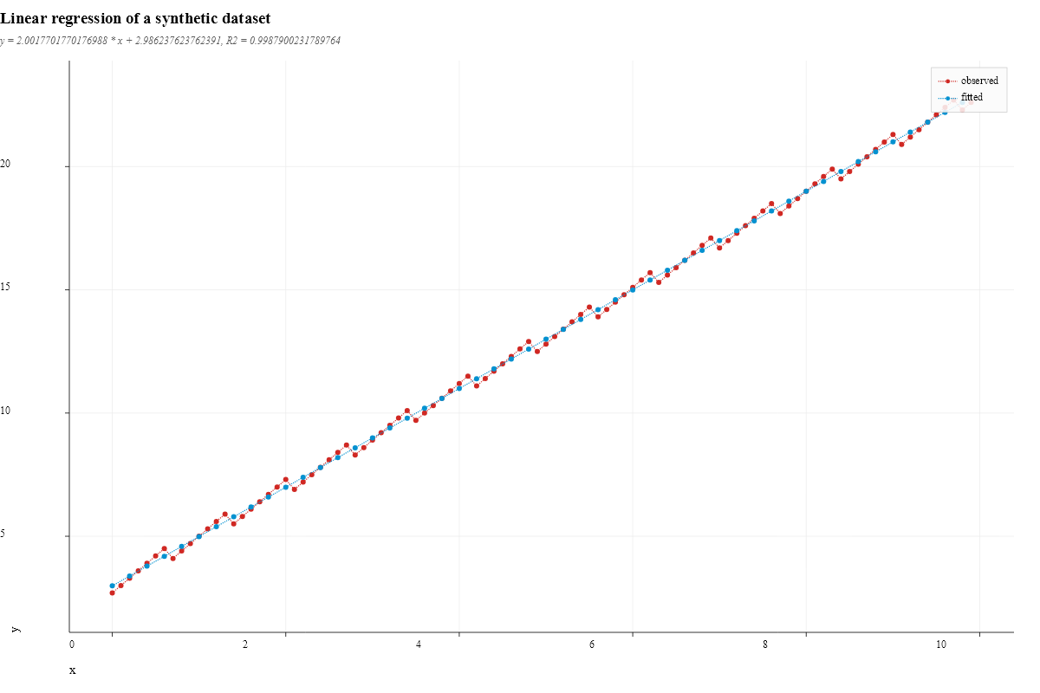
linear regression
4. First 5 prediction rows
 | x | label:y | label:prediction | label:residual
sample_1 | 0 | 2.7 | 2.98624 | 0.286238
sample_2 | 0.1 | 3 | 3.18641 | 0.186415
sample_3 | 0.2 | 3.3 | 3.38659 | 0.0865917
sample_4 | 0.3 | 3.6 | 3.58677 | -0.0132313
sample_5 | 0.4 | 3.9 | 3.78695 | -0.113054

