# 3. 部分RESTFUL API

## **3.1 Restful API 获取所有用户列表**

Method: GET

Request URL: <http://localhost:8080/v1/get_users>

Demo:

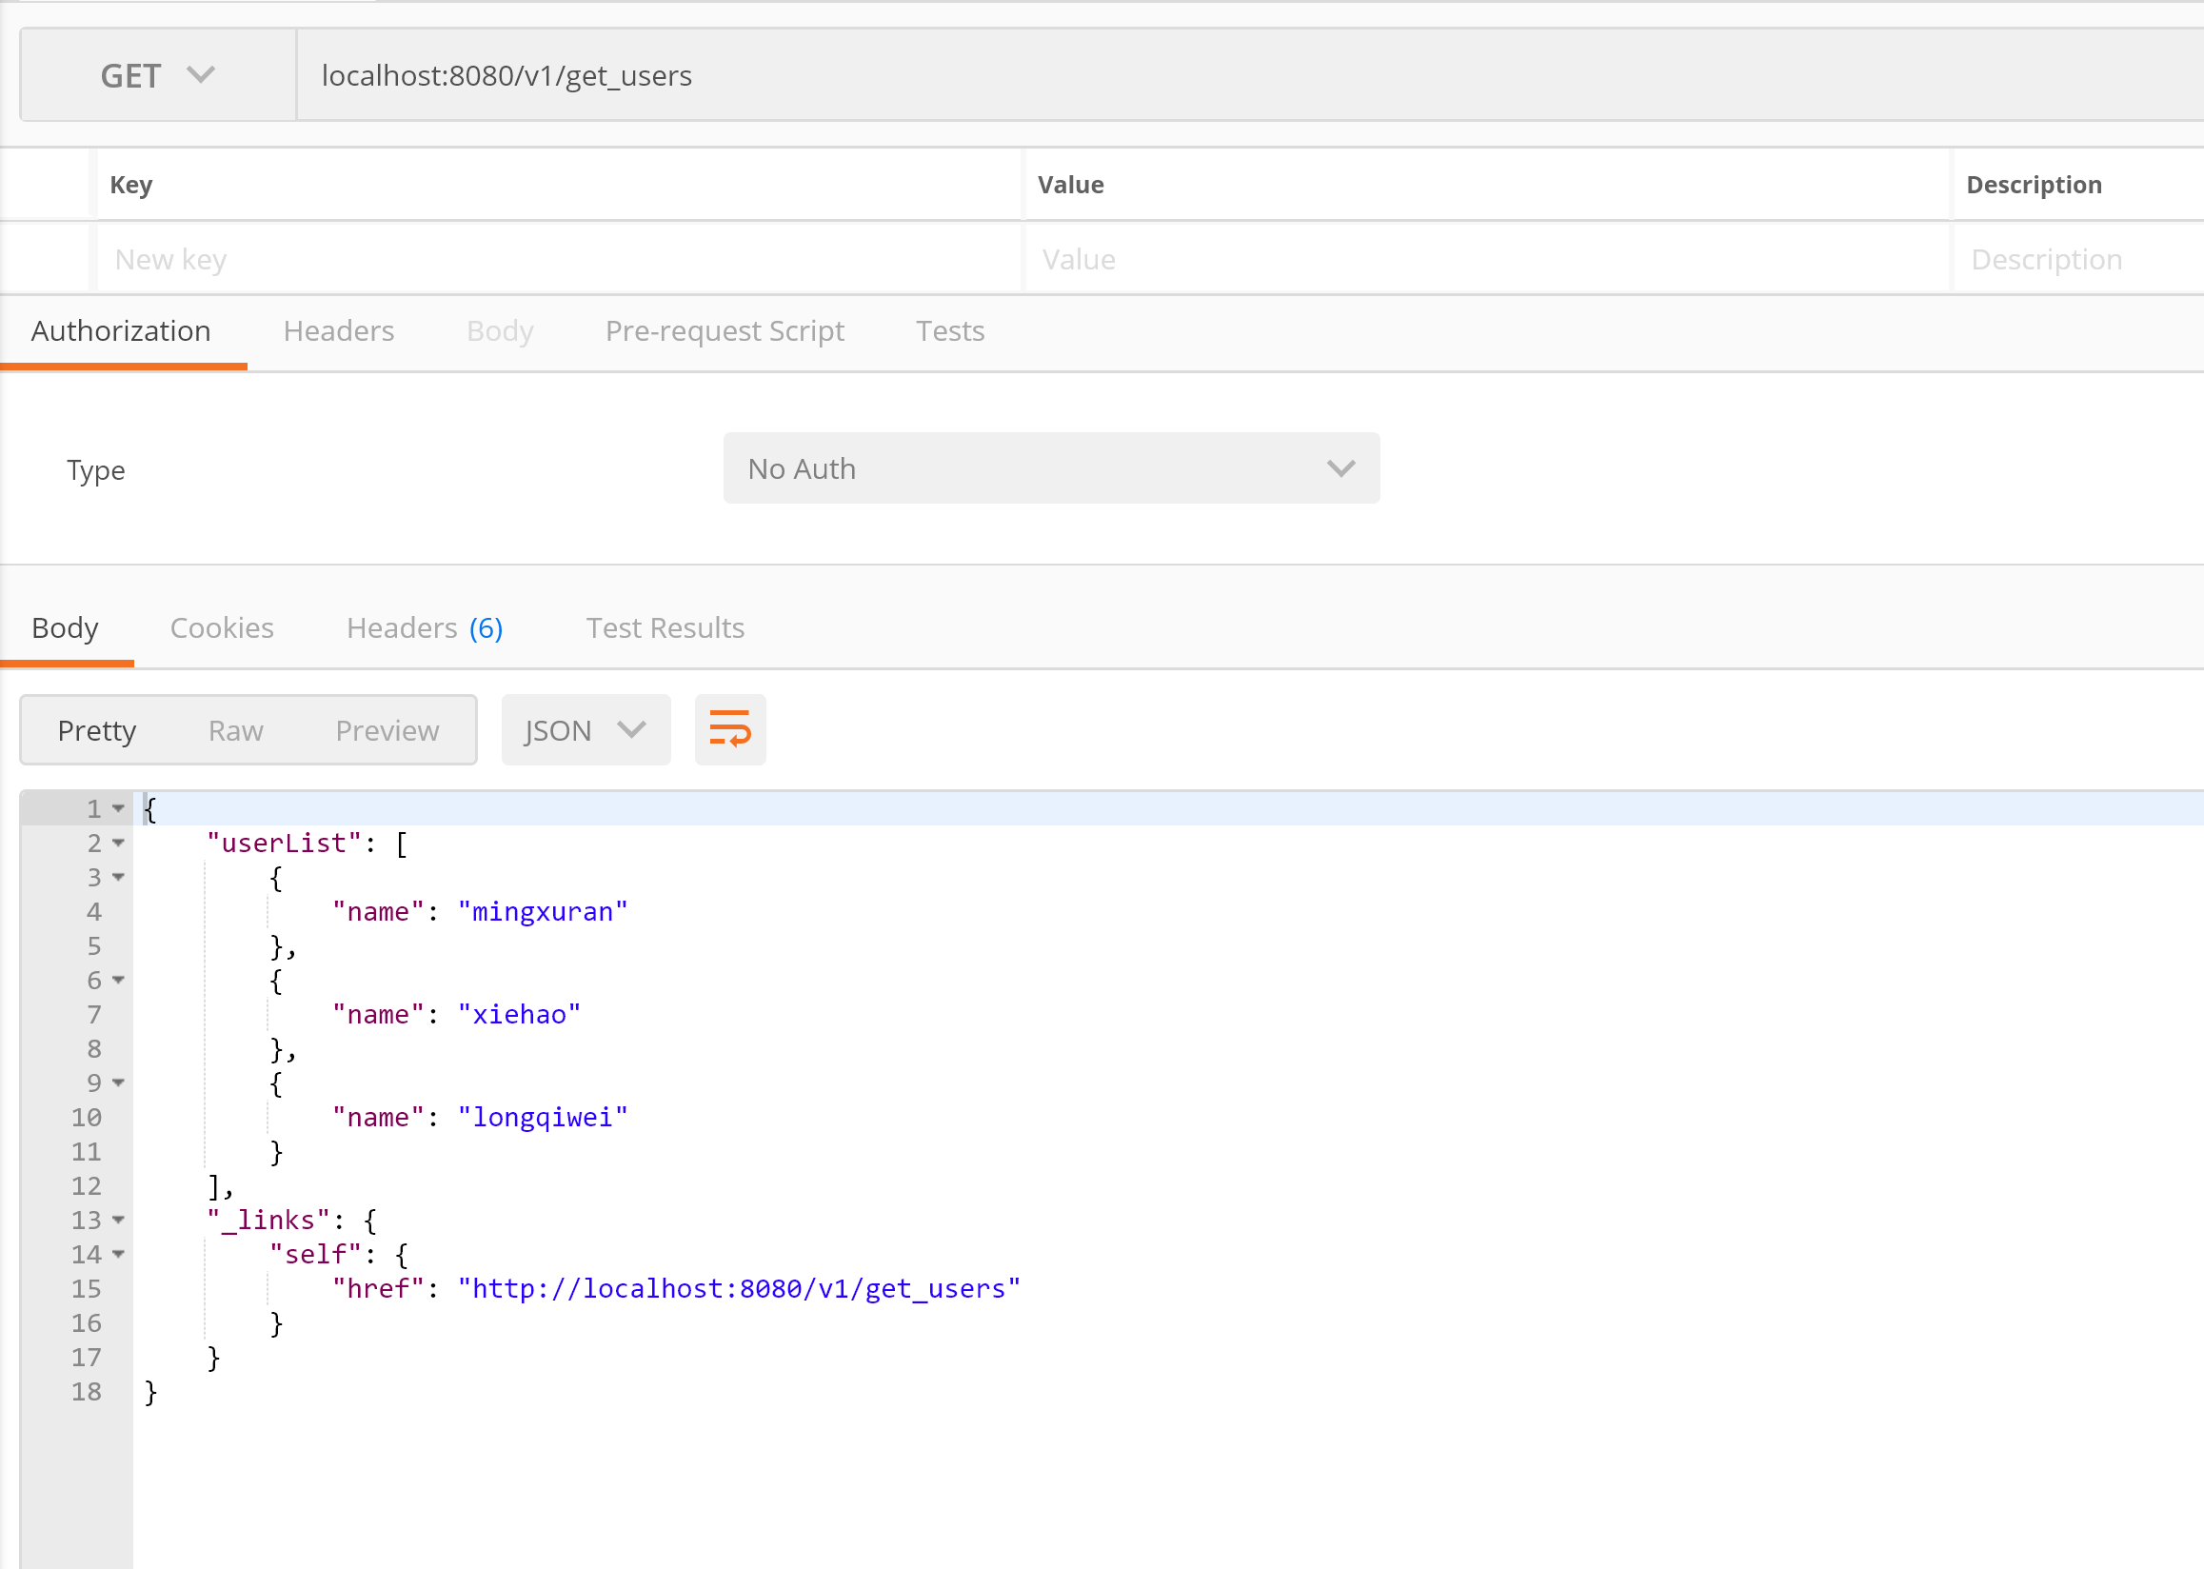

## **3.2 Restful API 添加一个用户**

Method: POST

Request URL: <http://localhost:8080/v1/add_user>

Params:

name

password

Demo:

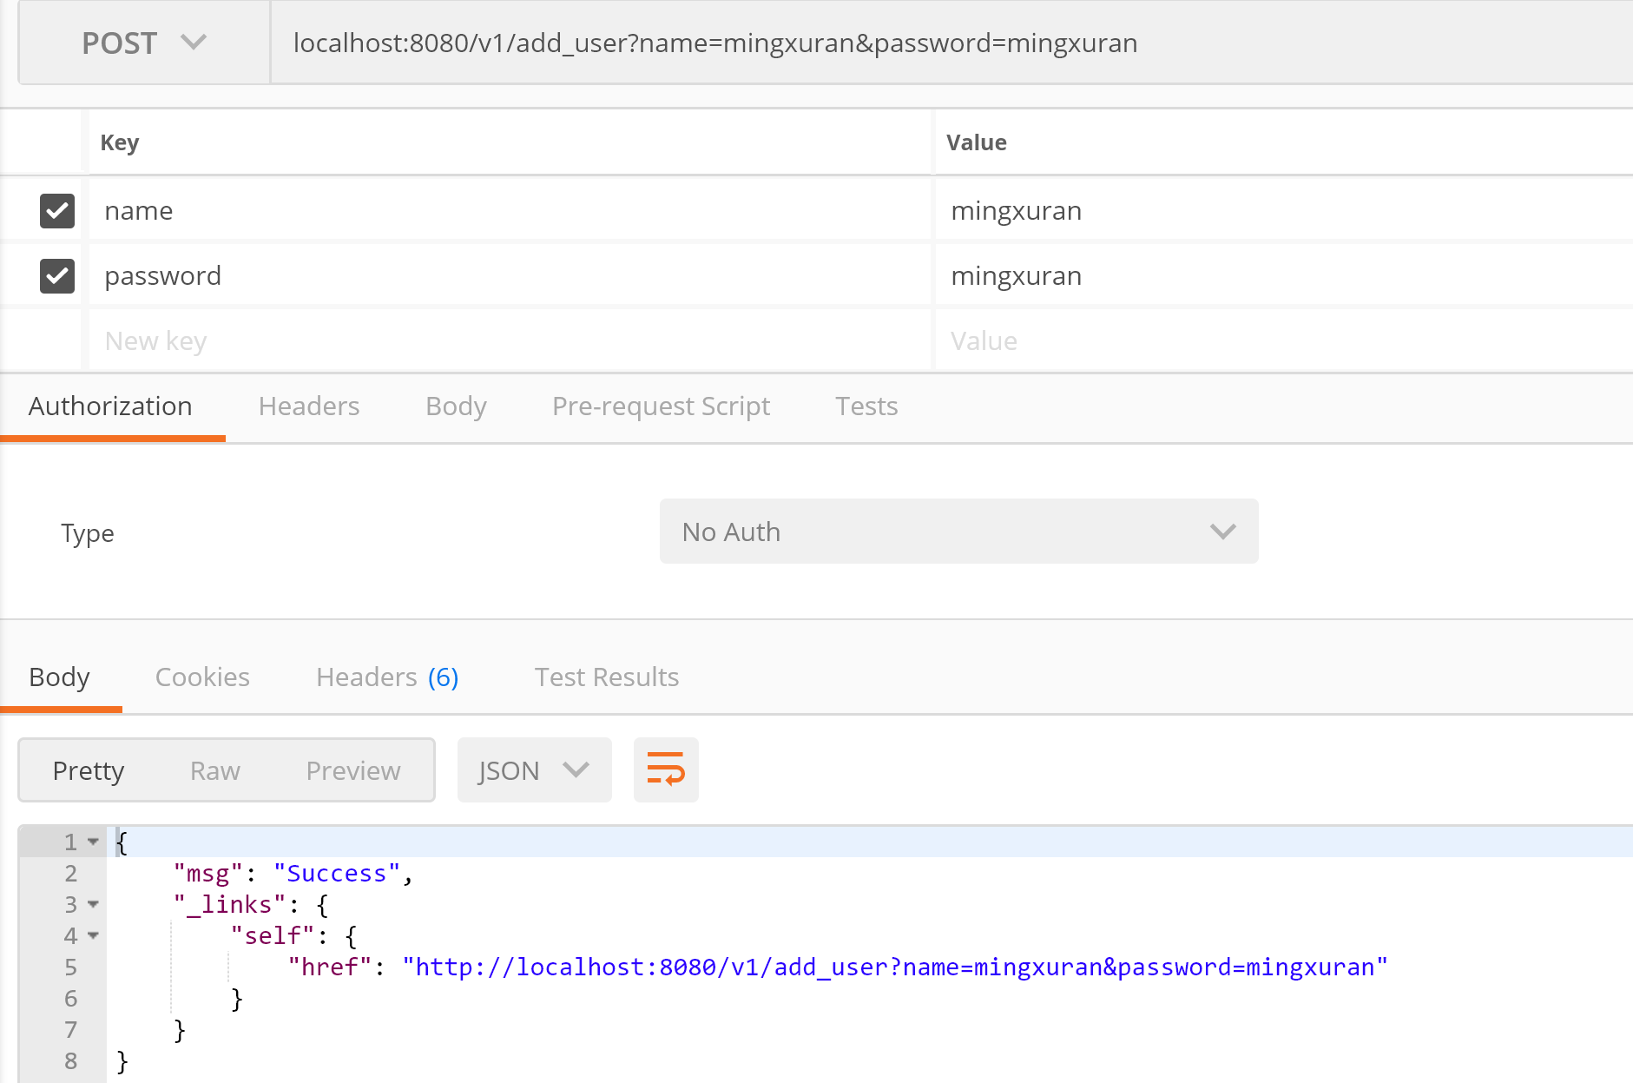

## **3.3 Restful API 通过用户名删除一个用户**

Method: POST

Request URL: [http://localhost:8080/v1/del_user_by_name](http://localhost:8080/v1/del_user_by_namer)

Params:

name

Demo:

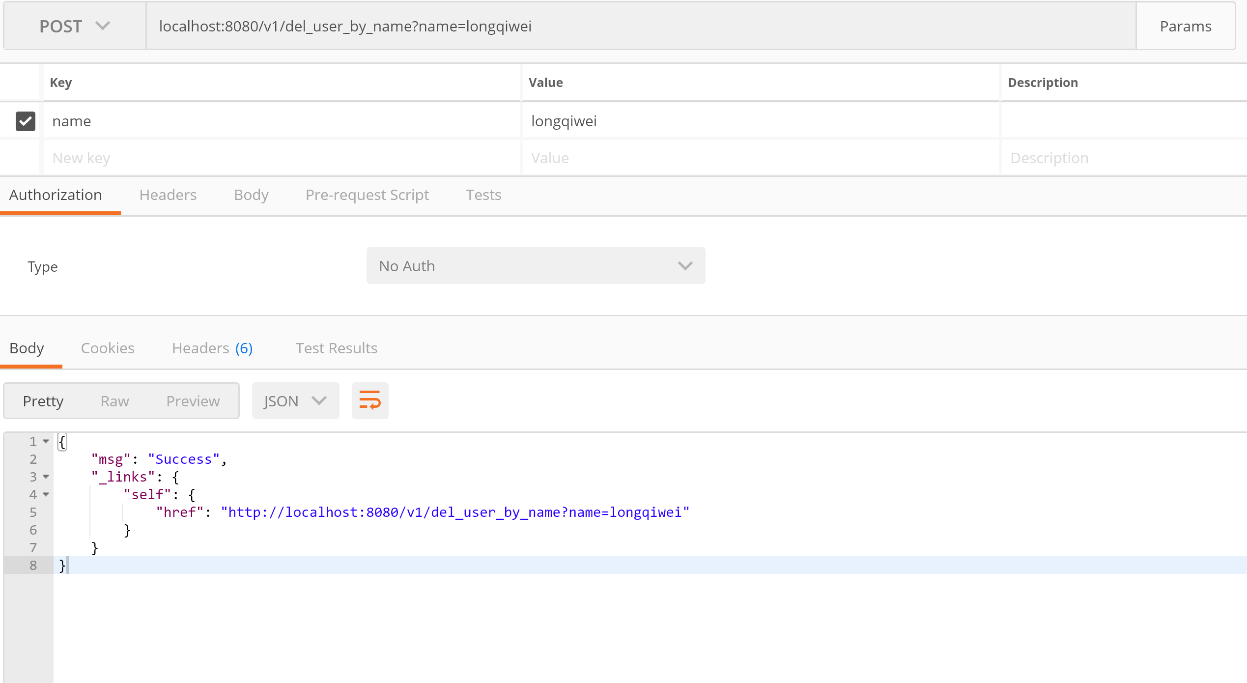

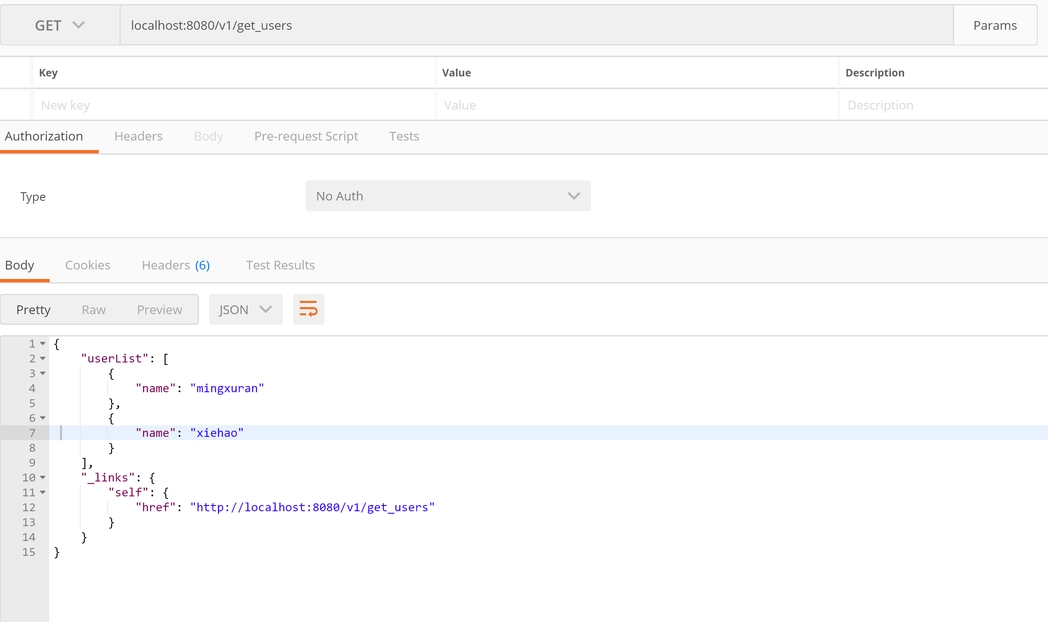

## **3.4 Restful API 添加一个教练**

Method: POST

Request URL: <http://localhost:8080/v1/add_trainer>

Params:

name

phone

Demo:

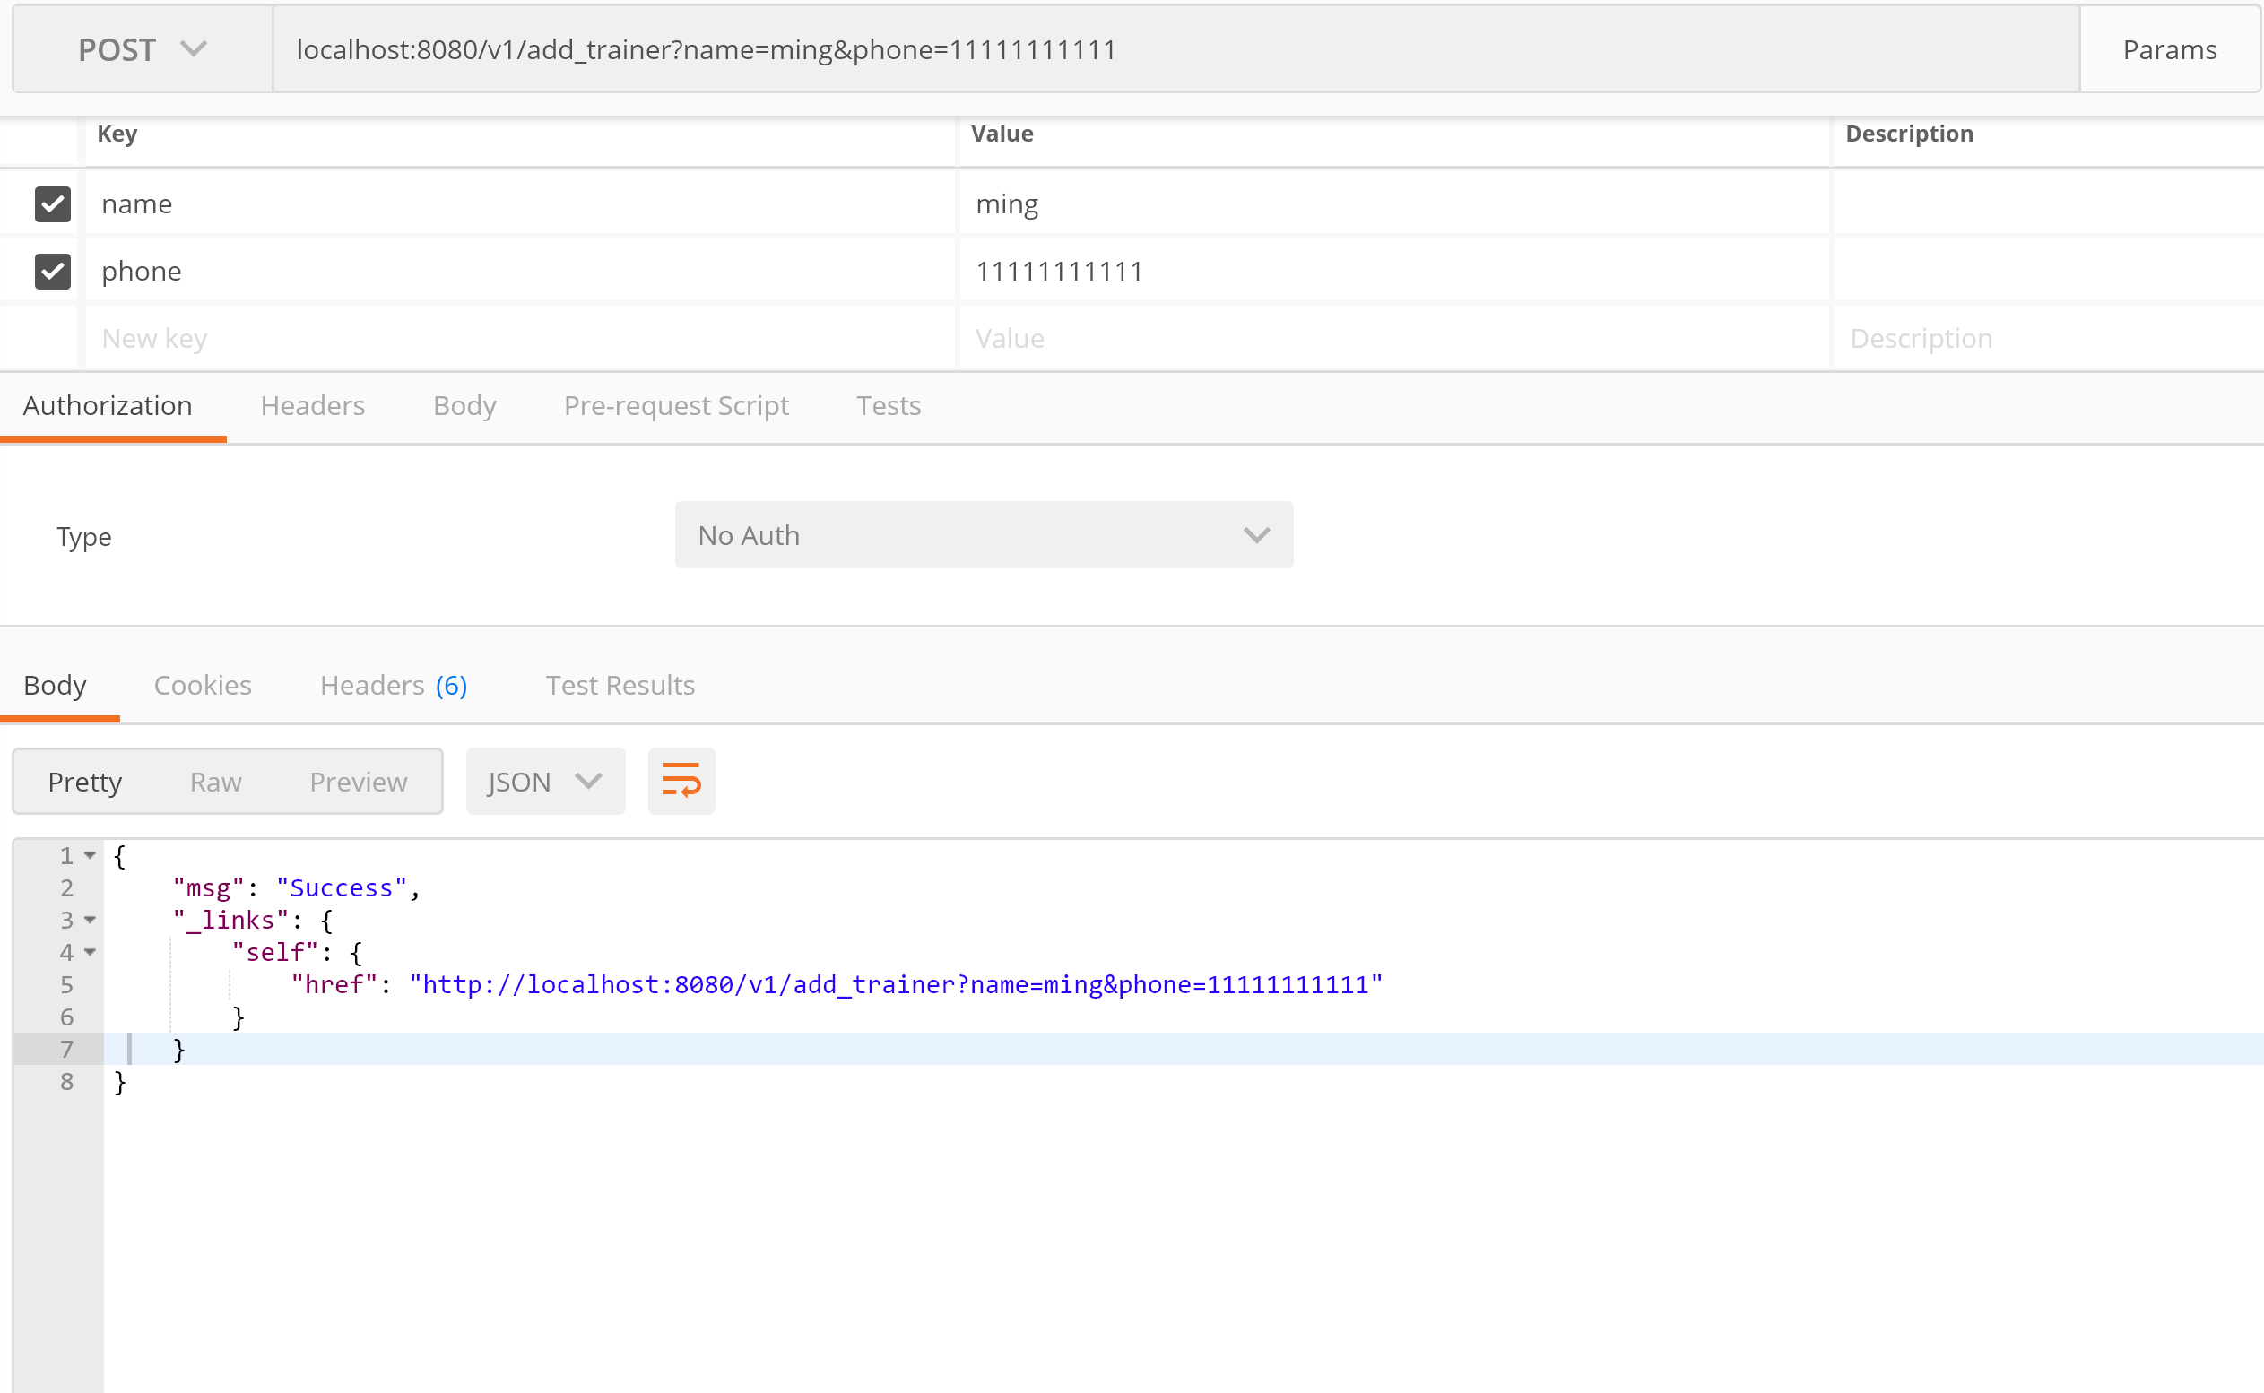

## **3.5 Restful API 获取所有教练列表**

Method: GET

Request URL: <http://localhost:8080/v1/get_trainers>

Params:

name

phone

Demo:

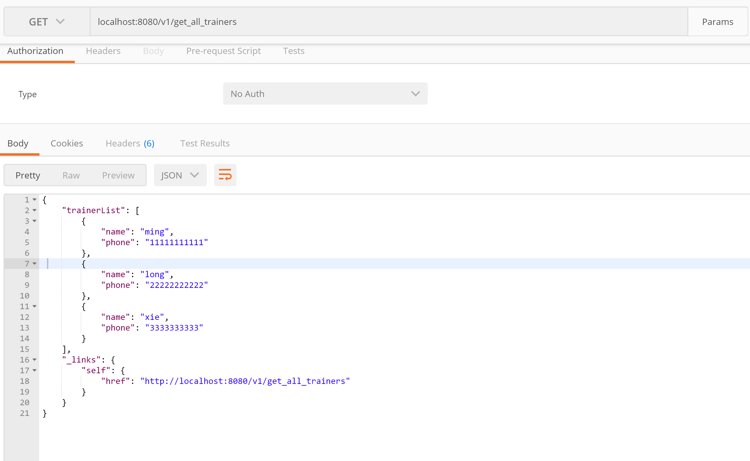

## **3.6 Restful API 通过电话删除一个教练**

Method: POST

Request URL: <http://localhost:8080/v1/del_trainer_by_phone>

Params:

phone

Demo:

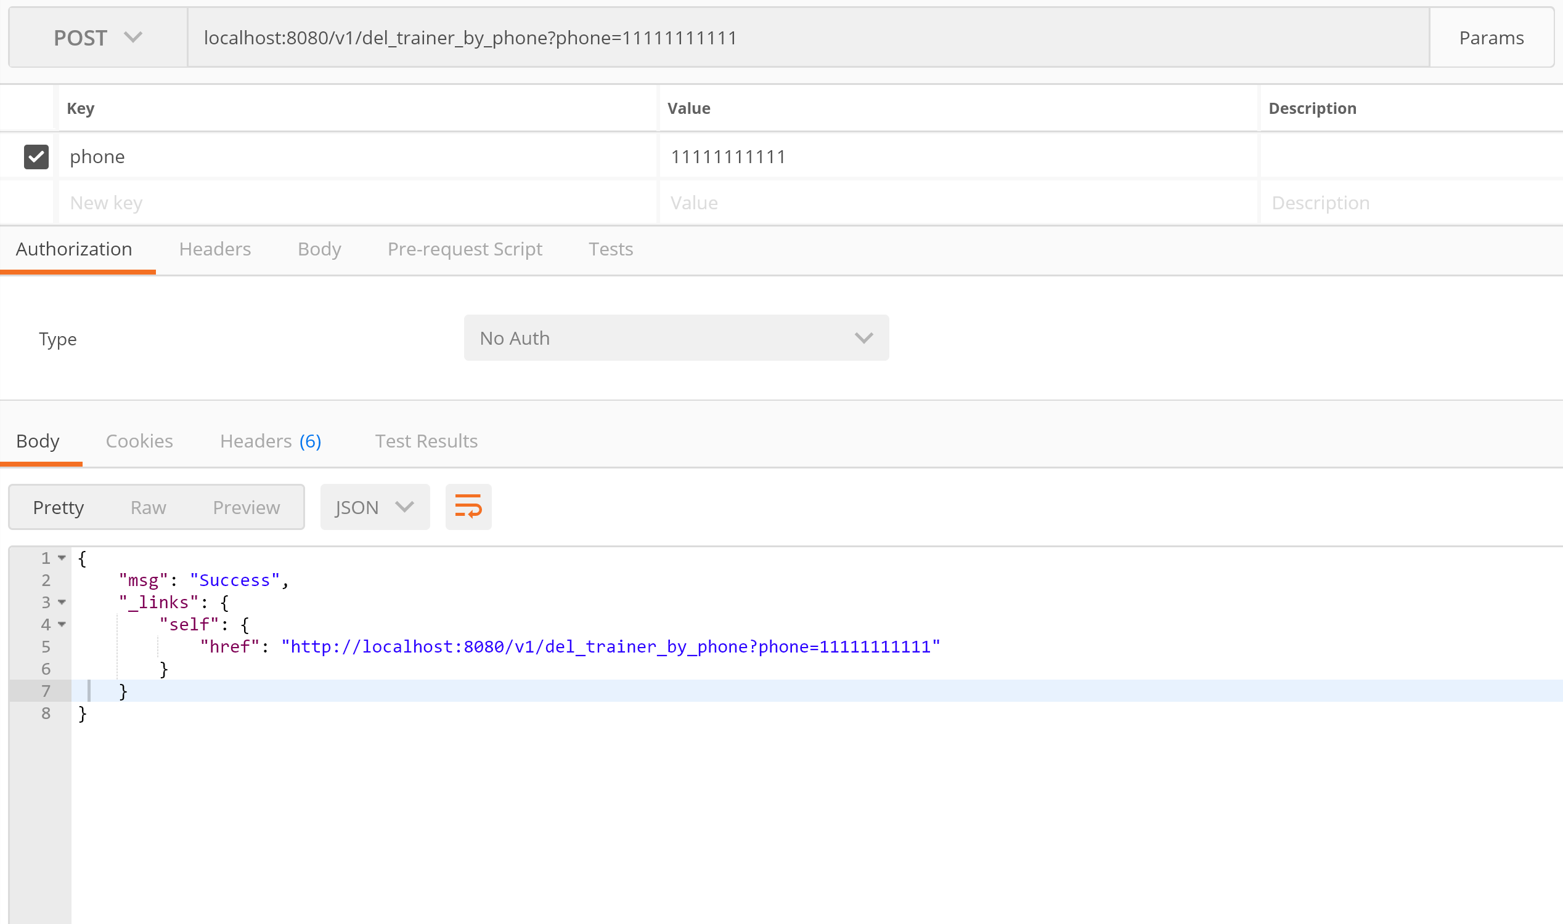

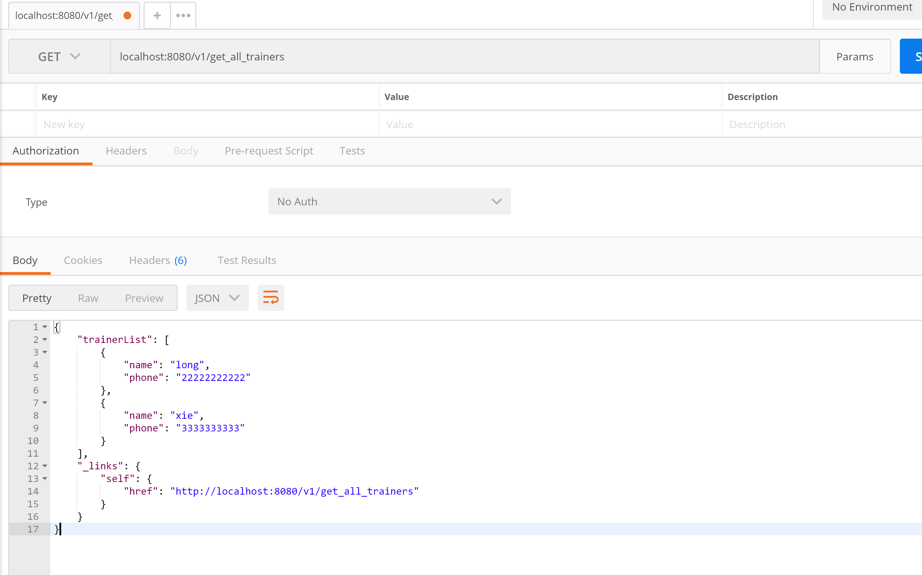

# 4. Oauth2

# 5. RateLimit

Framework:

spring-cloud-zuul-ratelimit

Enable Zuul Proxy

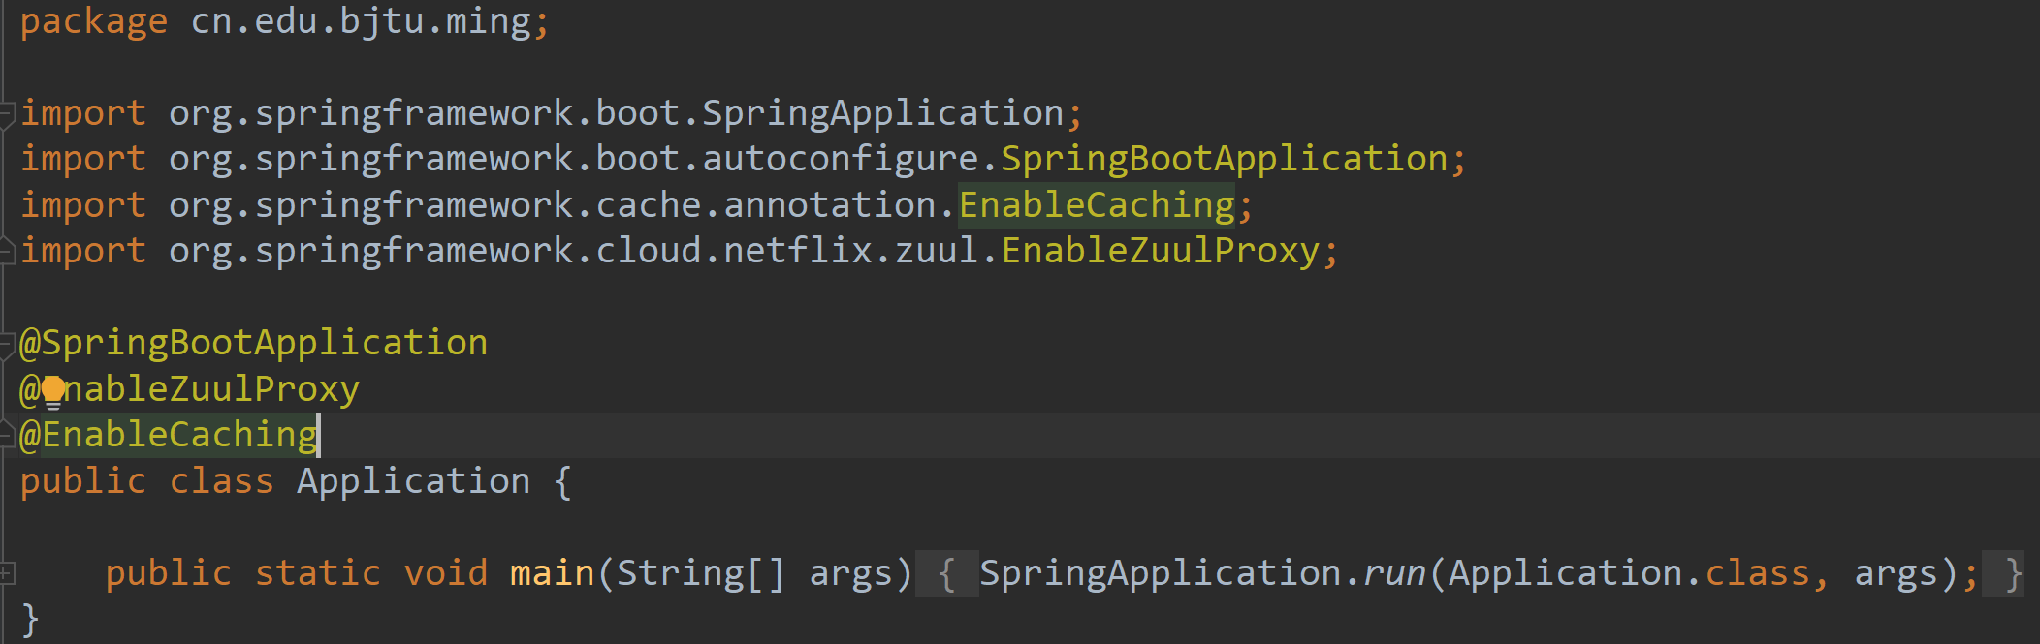

Config Zuul in application.yml

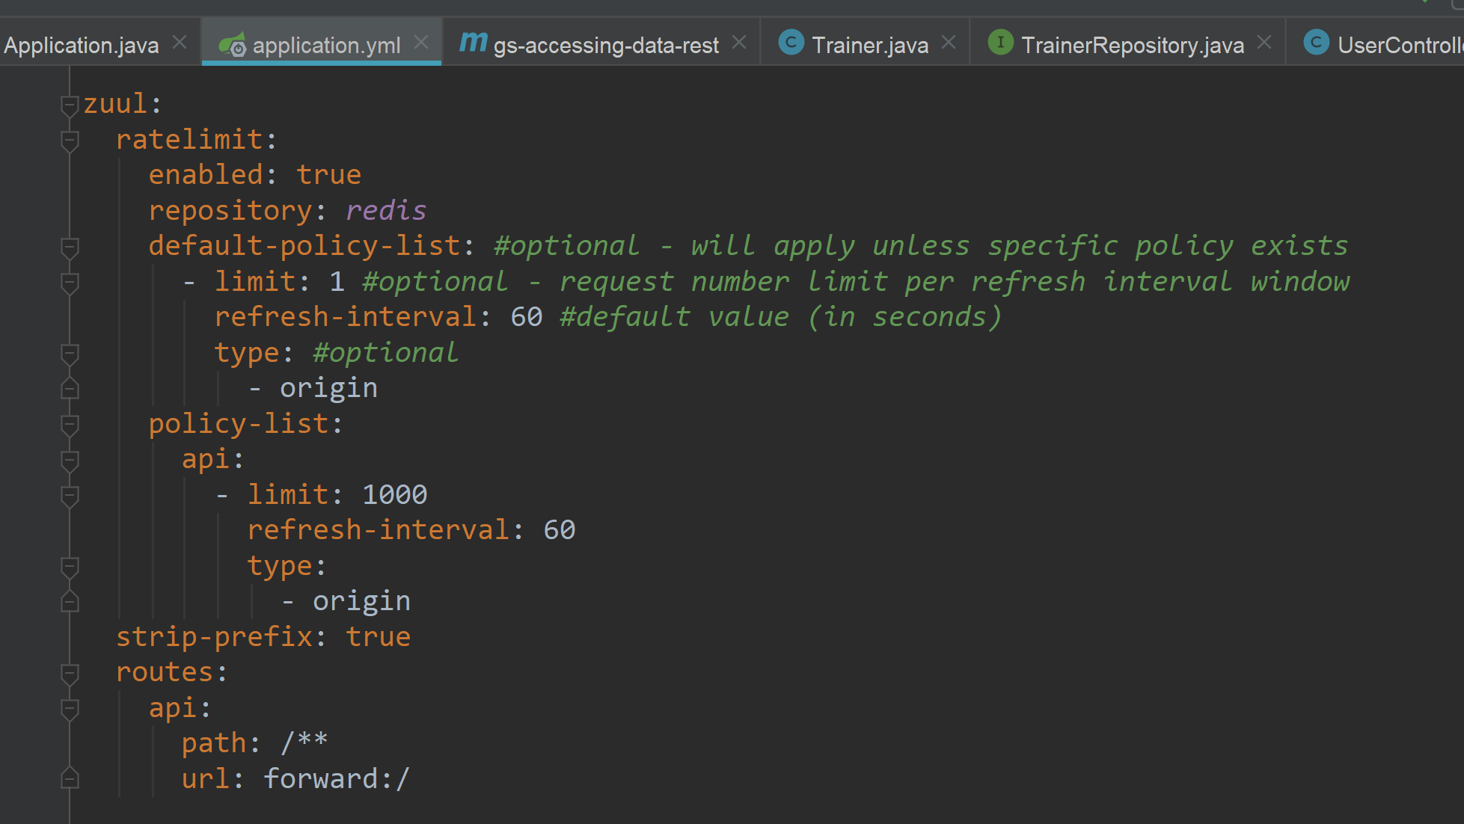

From the headers we can say rate was limited

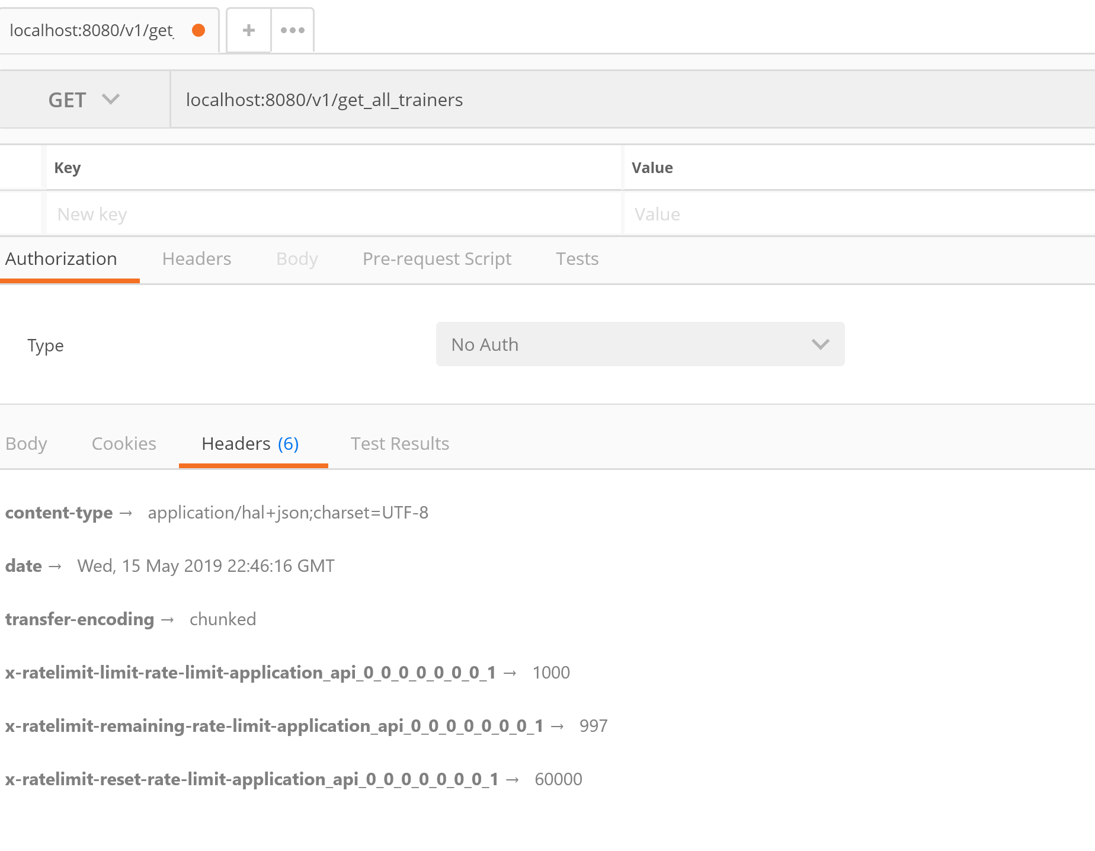

# 6. Others

## 6.1 Swagger

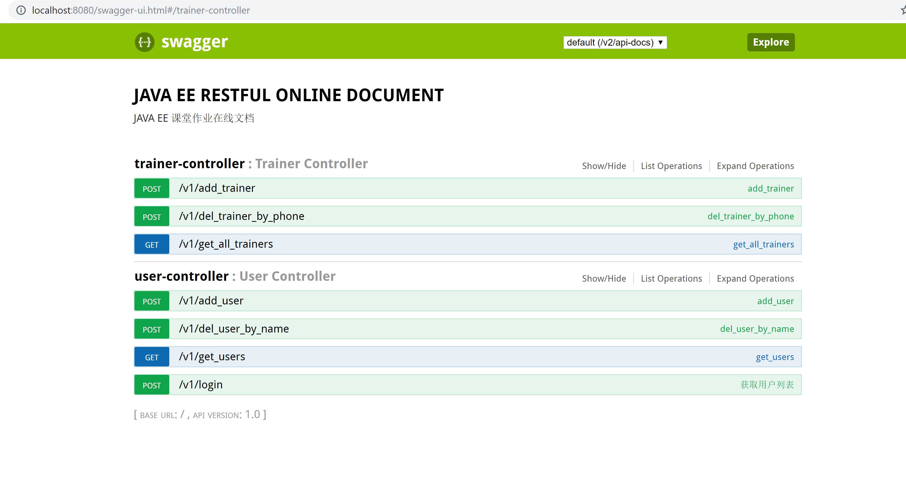

## 6.2 API pagination

Framework:

PageHelper

Demo:

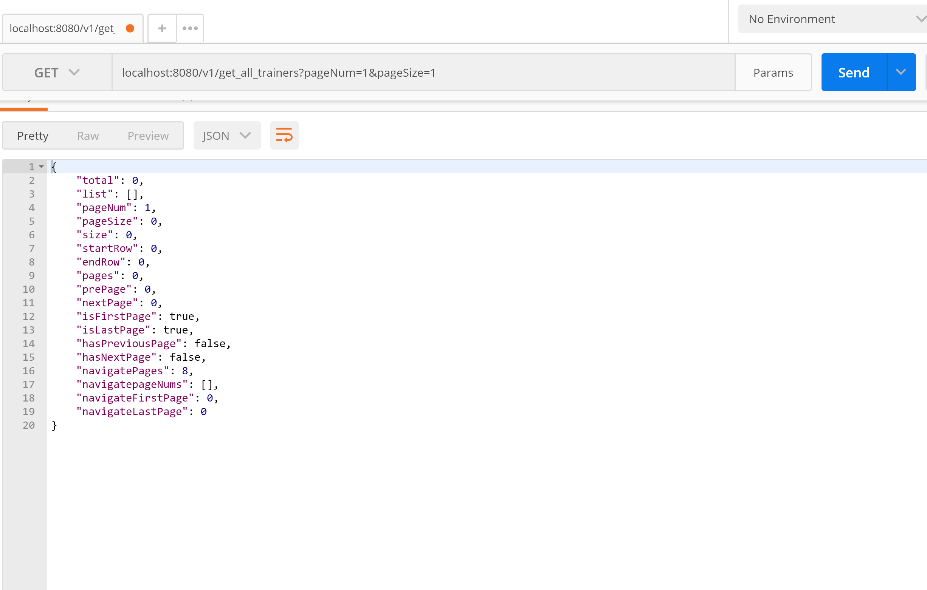

## 6.3 Cache

We enabled Cache and cache GET methods in Dao

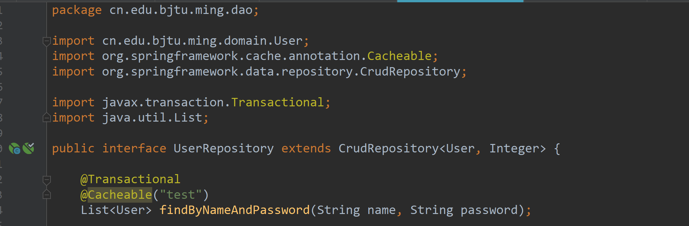

## 6.4 Hateoas

