3.1
#include<bits/stdc++.h>
using namespace std;
typedef long long ll;
int n;
int a[110];
int s[110];
bool vis[110];
int main()
{
while(cin>>n&&n!=0)
{
memset(a,0,sizeof(a));
memset(s,0,sizeof(s));
int num=n*(n-1)/2;
for(int i=1;i<=num;i++) cin>>s[i];
int cc=s[2]-s[1];//cc=a[3]-a[2]
for(int i=3;i<=num;i++)
{
//遍历可能的a[2]+a[3]
if((cc+s[i])%2) continue;
memset(vis,false,sizeof(vis));
bool flag=true;
vis[1]=vis[2]=vis[i]=true;
a[3]=(cc+s[i])/2;
a[1]=s[2]-a[3];
a[2]=s[1]-a[1];
for(int j=4;j<=n;j++)
{
int pos=0;
//找到现有的s中最小的 确定a[j]
for(int k=1;k<=num;k++)
{
if(vis[k]==false)
{
pos=k;
break;
}
}
if(pos)
{
vis[pos]=true;
a[j]=s[pos]-a[1];
//排除掉a[1]+a[j],a[2]+a[j],a[3]+a[j]~~
for(int k=1;k<j;k++)
{
int temp=a[j]+a[k];
bool ff=false;
for(int m=1;m<=num;m++)
{
if(s[m]==temp)
{
ff=true;
if(!vis[m])
{
vis[m]=true;
break;
}
}
}
if(!ff)
{
//如果s里面没有a[k]+a[j]这一元素
//就说明假设的这个a[2]+a[3]是错的
flag=false;
break;
}
}
//假设错误 立即跳出
if(!flag) break;
}
}
//假设正确 答案唯一 立即跳出
if(flag) break;
}
for(int i=1;i<=n;i++) cout<<a[i]<<" ";
cout<<endl;
}
return 0;
}
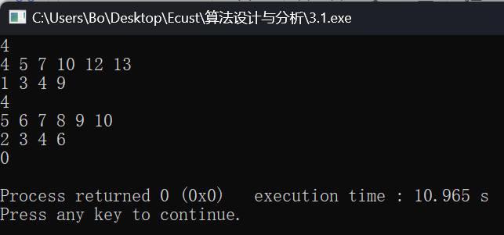
3.2
#include<stdio.h>
#include<string.h>
bool ans=false;
char c[1000][1000];
bool flag[1000];
int cnt=0;
void dfs(char cl) {
if(cl=='m')
ans=true;
else {
for(int l=0; l<cnt; l++) {
if(c[l][0]==cl&&flag[l]==0) {
flag[l]=1;
int t=strlen(c[l]);
dfs(c[l][t-1]);
}
}
}
}
int main() {
while(scanf("%s",c[cnt++])!=EOF) {
memset(flag,0,sizeof(flag));
if(c[cnt-1][0]=='0') {
dfs('b');
printf("%s\n",ans?"Yes.":"No.");
cnt=0;
ans=false;
}
}
return 0;
}
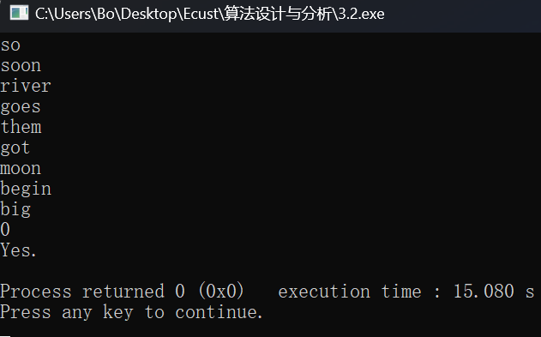
3.7
#include<iostream>
#include<cstring>
using namespace std;
int n;
int d[10010];
char result[10010][10010];
int num = 0;
bool isLeagal(int row, int col) { //是否符合条件
bool judge = true;
for (int i = 1; i < row; i++) {
if (col == d[i]) {
judge = false;
break;
}
if (i - d[i] == row - col) {
judge = false;
break;
}
if (i + d[i] == row + col) {
judge = false;
break;
}
}
return judge;
}
void dfs(int row) {
if (row == n + 1) {
num++;
return ;
}
//核心代码
for (int col = 1; col <= n; col++) { //在row这一行每一列怎么放
if (isLeagal(row, col)) {
d[row] = col;
result[row][col- 1] = 'Q';
dfs(row + 1);
result[row][col-1] = '.';
d[row] = 0;
}
}

}
int main() {
while(1)
{
num=0;
cin >> n;
if(n==0) break;
for (int i = 1; i <= n; i++) {
for (int j = 0; j < n; j++) {
result[i][j] = '.';
}
}
dfs(1);
cout << num << endl;
}
return 0;
}
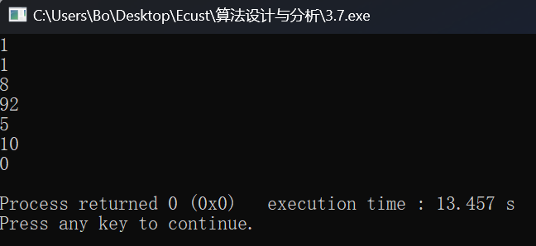
3.8
#include<iostream>
#include<string>
using namespace std;
int main()
{
int n, i,red=0,yellow=0;
char a[20];
while (1)
{
cin >> n;
if (n == 0) break;
else
{
red = 0, yellow = 0;
for (i = 1; i <= n; i++)
{
cin >> a[i];
if (a[i] == 'R') red++;
if (a[i] == 'Y') yellow++;
}
if (a[n] == 'B')
{
if (red == 7)
{
cout << "Red" << endl;
}
if (red != 7)
{
cout << "Yellow" << endl;
}
}
if (a[n] == 'L')
{
if (yellow == 7)
{
cout << "Yellow" << endl;
break;
}
if (yellow != 7)
{
cout << "Red" << endl;
break;
}
}
}
}
return 0;
}
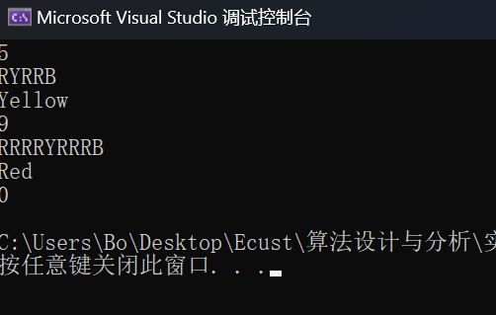
3.9
#include<bits/stdc++.h>
using namespace std;
int main()
{
int n,ans=0,temp=0,i;
int fac[10]={1,1,2,6,24,120,720,5040,40320,362880};
for(i=1;i<=3628800;i++)
{
ans=0;
temp=i;
while(temp!=0)
{
ans+=fac[temp%10];
temp/=10;
}
if(ans==i) cout<<i<<endl;
}
return 0;
}
