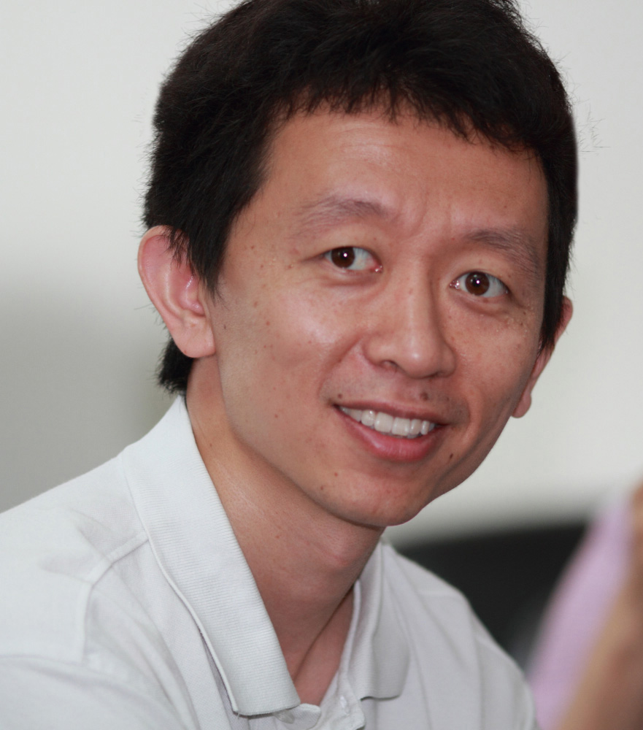

Wei Xie, Ph.D

Principal Investigator

HHMI International Research Scholar

**Education:**

1999-2003 B.S. Biological Sciences, Peking University, China

2003-2008 Ph.D Molecular, UCLA, USA.

2006-2008 M.S. Department of Statistics (double degree), UCLA, USA.

**Work experience (including postdoctoral training)**

2008-2009 Postdoc Researcher, Molecular Biology Institute, Department of Biological Chemistry, UCLA, USA.

2009-2013 Postdoc Researcher, Ludwig Institute for Cancer Research, UCSD, USA.

2013- 2017 Assistant Professor, School of Life Sciences, Tsinghua University, China

2017-2018 Associate Professor, School of Life Sciences, Tsinghua University, China

2019-present Professor, School of Life Sciences, Tsinghua University, China

**Major Research Interests:**

Our lab is interested in understanding the epigenetic regulation of transcription in the mammalian genome that governs development and related human diseases. For this purpose, we use a variety of methods in molecular biology, developmental biology, genomics and bioinformatics. By combining “wet” lab and “dry” lab, we aim to decipher the mechanisms underlying a number of key biological processes including: (1) epigenetic regulation of early animal development mediated by DNA methylation and chromatin modifications; (2) epigenetic regulation of pluripotency and stem cell differentiation; (3) the role of *cis*-regulatory elements such as enhancers, promoters, insulators and 3D chromatin structure in development and cell fate determination; (4) molecular mechanisms underlying human diseases linked to aberrant epigenetic regulation.

**Representative Papers:**

# Correspondence author

* First author

1. Weikun Xia,* Jiawei Xu,*,# Guang Yu,* Guidong Yao,* Kai Xu, Xueshan Ma, Nan Zhang, Bofeng Liu, Tong Li, Zili Lin, Xia Chen, Lijia Li, Qiujun Wang, Dayuan Shi, Senlin Shi, Yile Zhang, Wenyan Song, Haixia Jin Linli Hu, Zhiqin Bu, Yang Wang, Jie Na, **Wei Xie**,**#** Ying-Pu Sun# (2019) Resetting histone modifications during human parental-to-zygotic transition. ***Science*** 365 (353-360).
2. Hui Zheng*, **Wei Xie#** (2019). The role of 3D genome organization in development and cell differentiation. ***Nature Reviews Molecular Cell Biology*** 20 (535-550).
3. Qianhua Xu, * Yunlong Xiang, * Qiujun Wang, * Leyun Wang, * Julie Brind’Amour, Aaron Blair Bogutz, Yu Zhang, Bingjie Zhang, Guang Yu, Weikun Xia, Zhenhai Du, Chunyi Huang, Jing Ma, Hui Zheng, Yuanyuan Li, Chao Liu, Cheryl Lyn Walker, Eric Jonasch, Louis Lefebvre, Min Wu, Matthew Lorincz, Wei Li, # Li Li, #**Wei Xie#**(2019) SETD2 regulates the maternal epigenome and embryonic development. ***Nature Genetics*** 51 (844–856).
4. Yao Wang,* Hanben Wang,* Yu Zhang,* Zhenhai Du,* Wei Si,* Suixing Fan, Dongdong Qin, Mei Wang, Yanchao Duan, Lufan Li, Yuying Jiao, Yuanyuan Li, Qiujun Wang, Qinghua Shi, Xin Wu# & **Wei Xie#**(2019) Reprogramming of meiotic chromatin architecture during spermatogenesis. ***Molecular Cell*** 73(547-561).
5. Bingjie Zhang* Xiaotong Wu,* Wenhao Zhang,* Weimin Shen, Qingrui Sun, Kaili Liu, Yu Zhang, Qiujun Wang, Yuanyuan Li, Anming Meng,# **Wei Xie#** (2018) Widespread enhancer dememorization and promoter priming during parental-to-zygotic transition. ***Molecular Cell*** 72 (673-686).
6. Jingyi Wu,* Jiawei Xu,* Bofeng Liu,* Guidong Yao,* Peizhe Wang,* Zili Lin,* Bo Huang, Xuepeng Wang, Tong Li, Senlin Shi, Nan Zhang, Fuyu Duan, Jia Ming, Xiangyang Zhang, Wenbin Niu, Wenyan Song, Haixia Jin, Yihong Guo, Shanjun Dai, Linli Hu, Lanlan Fang, Qiujun Wang, Yuanyuan Li, Wei Li, Jie Na,**#** **Wei Xie#** & Yingpu Sun**#** (2018) Chromatin analysis in human early development reveals epigenetic transition during ZGA. ***Nature*** 557 (256–260).
7. Qianhua Xu, **Wei Xie#** (2018) Epigenome in Early Mammalian Development: Inheritance, Reprogramming and Establishment. ***Trends in Cell Biology*** 28 (3).
8. Yuanyuan Li,* Hui Zheng,* Qiujun Wang, Chen Zhou, Lei Wei, Xuehui Liu, Wenhao Zhang, Yu Zhang, Zhenhai Du, Xiaowo Wang, **Wei Xie#** (2018) Genomewide analyses reveal a role of Polycomb in promoting hypomethylation of DNA methylation valley. ***Genome Biology*** 19 (18).
9. Yu Zhang,* Yunlong Xiang,* Qiangzong Yin,* Zhenhai Du,* Xu Peng, Qiujun Wang, Miguel Fidalgo, Weikun Xia, Yuanyuan Li, Zhenao Zhao, Wenhao Zhang, Jing Ma, Feng Xu, Jianlong Wang, Lei Li, **Wei Xie#** (2018) Dynamic epigenomic landscapes during early lineage specification. ***Nature Genetics*** 50 (96-105).
10. Zhenhai Du, Hui Zheng, Bo Huang, Rui Ma, Jingyi Wu, Xianglin Zhang, Jing He, Yunlong Xiang, Qiujun Wang, Yuanyuan Li, Jing Ma, Xu Zhang, Ke Zhang, Michael Q. Zhang, Juntao Gao, Jesse R. Dixon, Xiaowo Wang, Jianyang Zeng, **Wei Xie#** (2017) Allelic reprogramming of 3D chromatin architecture during early mammalian development. ***Nature*** 547 (232-235).
11. Reinhard Brunmeir*, Jingyi Wu*, Xu Peng, Sun-Yee Kim, Sofi G. Julien, Qiongyi Zhang, **Wei Xie#**and Feng Xu# (2016) Comparative Transcriptomic and Epigenomic Analyses Reveal New Regulators of Murine Brown Adipogenesis. ***PLoS Genetics*** 12(12): e1006474.
12. Wenhao Zhang,* Weikun Xia,* Qiujun Wang, Aaron Towers, Jiayu Chen, Rui Gao, Yu Zhang, Chia-an Yen, Ah Young Lee, Yuanyuan Li, Chen Zhou, Kaili Liu, Jing Zhang, Xiuqi Chen, Zai Chang, Danny Leung, Shaorong Gao, Yong-hui Jiang, **Wei Xie#** (2016) Isoform switch of TET1 regulates demethylation and mouse development. ***Molecular Cell***64 (1-12).
13. Bingjie Zhang,* Hui Zheng,* Bo Huang,* Wenzhi Li,* Yunlong Xiang, Xu Peng, Jia Ming, Xiaotong Wu, Yu Zhang, Qianhua Xu, Wenqiang Liu, Xiaochen Kou, Yanhong Zhao, Wenteng He, Chong Li, Bo Chen, Yuanyuan Li, Qiujun Wang, Jing Ma, Qiangzong Yin, Zai Chang, Kehkooi Kee, Anming Meng, Shaorong Gao, Feng Xu, Jie Na,# **Wei Xie#** (2016). Allelic reprogramming of the histone modification H3K4me3 in early mammalian development. ***Nature*** 537 (553-557).
14. Hui Zheng,* Bo Huang,* Bingjie Zhang,* Yunlong Xiang, Zhenhai Du, Qiujun Wang, Yuanyuan Li, Jing Ma, Xu Peng, Zai Chang, Feng Xu, Wei Xie# (2016). Resetting epigenetic memory by reprogramming of histone modifications in mammals. ***Molecular Cell*** 63 (1066-1079).
15. Jingyi Wu,* Bo Huang,* He Chen, Qiangzong Yin, Yang Liu, Yunlong Xiang, Bingjie Zhang, Bofeng Liu, Qiujun Wang, Weikun Xia, Wenzhi Li, Yuanyuan Li, Jing Ma, Xu Peng, Hui Zheng, Jia Ming, Wenhao Zhang, Jing Zhang, Geng Tian, Feng Xu, Zai Chang, Jie Na, Xuerui Yang, **Wei Xie**# (2016). The landscape of accessible chromatin in mammalian preimplantation embryos. ***Nature*** 534 (652-657).
16. Bo Xia, Dali Han, Xingyu Lu, Zhaozhu Sun, Ankun Zhou, Qiangzong Yin, Hu Zeng, Menghao Liu, Xiang Jiang, **Wei Xie,** Chuan He & Chengqi Yi (2015). Bisulfite-free, base-resolution analysis of 5-formylcytosine at the genome scale. ***Nature Methods*** 12,1047–1050.
17. Danny Leung*, Inkyung Jung*, Nisha Rajagopal*, Anthony Schmitt, Siddarth Selvaraj, Ah Young Lee, Chia-An Yen, Shin Lin, Yiing Lin, Yunjiang Qiu, **Wei Xie**, Feng Yue, Manoj Hariharan, Pradipta Ray, Samantha Kuan, Lee Edsall, Hongbo Yang, Neil C. Chi, Michael Q. Zhang, Joseph R. Ecker & Bing Ren (2015). Integrative analysis of haplotype-resolved epigenomes across human tissues. ***Nature****518*, 350-354.
18. Jesse R. Dixon*, Inkyung Jung*, Siddarth Selvaraj*, Yin Shen, Jessica E. Antosiewicz-Bourget, Ah Young Lee, Zhen Ye, Audrey Kim, Nisha Rajagopal, **Wei Xie**, Yarui Diao, Jing Liang, Huimin Zhao, Victor V. Lobanenkov, Joseph R. Ecker, James A. Thomson & Bing Ren (2015). Chromatin architecture reorganization during stem cell differentiation. ***Nature****518*, 331-336.
19. **Wei Xie#**, Bing Ren#(2013) Enhancing Pluripotency and Lineage Specification, ***Science*** 341:247-7
20. **Wei Xie**, Matthew D. Schultz, Ryan Lister, Zhonggang Hou, Nisha Rajagopal, Pradipta Ray, John W. Whitaker, Shulan Tian, R. David Hawkins, Danny Leung, Hongbo Yang, Tao Wang, Ah Young Lee, Scott A. Swanson, Jiuchun Zhang, Yun Zhu, Audrey Kim, Joseph R. Nery, Mark A. Urich, Samantha Kuan, Chia-an Yen, Sarit Klugman, Pengzhi Yu, Kran Suknuntha, Nicholas E. Propson, Huaming Chen, Lee E. Edsall, Ulrich Wagner, Yan Li, Zhen Ye, Ashwinikumar Kulkarni, Zhenyu Xuan, Wen-Yu Chung, Neil C. Chi, Jessica E. Antosiewicz-Bourget, Igor Slukvin, Ron Stewart, Michael Q. Zhang, Wei Wang, James A. Thomson,  Joseph R. Ecker, and Bing Ren (2013) Epigenomic Analysis of Multi-lineage Differentiation of Human Embryonic Stem Cells, ***Cell***153: *1134-1148*.
21. **Wei Xie**, Cathy L Barr, Audrey Kim, Feng Yue, Ah Young Lee, James Eubanks, Emma L Dempster and Bing Ren (2012) Base-resolution analyses of sequence and parent-of-origin dependent DNA methylation in the mouse genome, ***Cell*** 148: 816-831.
22. Hao Wu, Volkan Coskun, Jifang Tao, **Wei Xie**, Weihong Ge, Kazuaki Yoshikawa, En Li, Yi Zhang and Yi Eve Sun (2010) Dnmt3a-Dependent Nonpromoter DNA Methylation Facilitates Transcription of Neurogenic Genes, ***Science*** 329 (5990): 444-448.
23. Mark H. Chin, Mike J. Mason, ***Wei Xie***, Stefano Volinia, Mike Singer, Cory Peterson, Gayane Ambartsumyan, Otaren Aimiuwu, Laura Richter, Jin Zhang, Ivan Khvorostov, Vanessa Ott, Michael Grunstein, Neta Lavon, Nissim Benvenisty, Carlo M. Croce, Amander T. Clark, Tim Baxter, April D. Pyle, Mike A. Teitell, Matteo Pelegrini, Kathrin Plath and William E. Lowry (2009) Induced Pluripotent Stem Cells and Embryonic Stem Cells Are Distinguished by Gene Expression Signatures, ***Cell Stem Cell*** 5(1): 111-123.
24. **Wei Xie**, Chunying Song, Nicolas L. Young, Adam Sperling, Feng Xu, Rupa Sridharan, Anne Conway, Benjamin A. Garcia, Kathrin Plath, Amander Clark and Michael Grunstein (2009) Histone H3 lysine 56 acetylation is linked to the core transcriptional network in human embryonic stem cells, ***Molecular Cell***, 33(4):417-427.
25. Roberto Ferrari, Matteo Pellegrini, Gregory A. Horwitz, **Wei Xie**, Arnold J. Berk and Siavash K. Kurdistani (2008) Epigenetic reprogramming by adenovirus e1a, ***Science***321, 1086-1088.
26. Nimet Maherali*, Rupa Sridharan*, **Wei Xie**, Jochen Utikal, Sarah Eminli, Katrin Arnold, Matthias Stadtfeld, Robin Yachechko, Jason Tchieu, Rudolf Jaenisch, Kathrin Plath and Konrad Hochedlinger (2007) Directly reprogrammed fibroblasts show global epigenetic remodeling and widespread tissue contribution, ***Cell Stem Cell***, 1(1): 55-70.
27. Feng Xu, Qiongyi Zhang, Kangling Zhang,**Wei Xie** and Michael Grunstein (2007) Sir2 deacetylates histone H3 lysine 56 to regulate telomeric heterochromatin structure in yeast, ***Molecular Cell***, 27(6): 890-900.

**Contact**：

Tel: +86-10-62771496 (Lab)

E-mail: xiewei121 @ tsinghua.edu.cn