**SAMPLE**

**GAME DESIGN DOCUMENT**

Contents

Game Overview 4

High Concept 4

Unique Selling Points 4

Platform Minimum Requirements 5

Competence Titles 5

Synopsis 6

Game Objectives 6

Game Rules 6

Game Structure 6

Gameplay 7

Game Controls 7

Game Camera 8

HUD 8

Player 9

Player Characters 9

Player Metrics 9

Player States 9

Player Weapons 9

Character Line-up 10

NPC Enemies 10

Enemy: Clown 10

Enemy: ZomBear 10

Enemy: ZomBunny 10

Enemy: ZomDuck 10

Enemy: Hellephant 10

Enemy States 11

Enemy Spawning 11

NPC Allies 11

Sheep 11

Ally Spawning 11

Art 12

Setting 12

Level Design 12

Audio 13

MVP (Minimum Viable Product) 14

Wishlist 14

# Game Overview

Title: Pac-Man

Platform: PC Standalone

Genre: 2D survival

Rating: (10+) ESRB

Target: Casual gamer (aging from 12 - 30)

Release date: April, 2021

Publisher: …

Pac-Man is a maze chase video game; the player controls the eponymous character through an enclosed maze. The objective of the game is to eat all of the dots placed in the maze while avoiding four colored ghosts — Blinky (red), Pinky (pink), Inky (cyan), and Clyde (orange) — that pursue him.

# High Concept

Pac-Man sets the …..

# Unique Selling Points

1. Stunning particle effects
2. Unique story

# Platform Minimum Requirements

PC STANDALONE

OS: Windows XP SP2+

Graphics card: DX9 (shader model 2 .0) capabilities; generally everything made since 2004 should work

# Competing Titles

Mac-Man by …

# Synopsis

You play the role of Pac-Man who is trying to avoid the 4 ghosts chasing him, and try to last as long as you can.

# Game Objectives

The objective of the game is to survive for as long as possible, while eating cherries so that you can attack the ghosts and scoring points .

# Game Rules

The game level is a closed environment with many walls in it. The pathways are filled with dots, and you get points for collecting each dot. 4 ghosts will chase you, and if you eat 1 of the 4 cherries in the game level, they will get stunned for about 30 seconds. You can eat them to get extra points while the ghost will respawn and restart the chase for you. You win when you have collected all the dots. You lose a life when you get caught by the ghost and when you lose all 3 lives, then you will lose the game.

# Game Structure

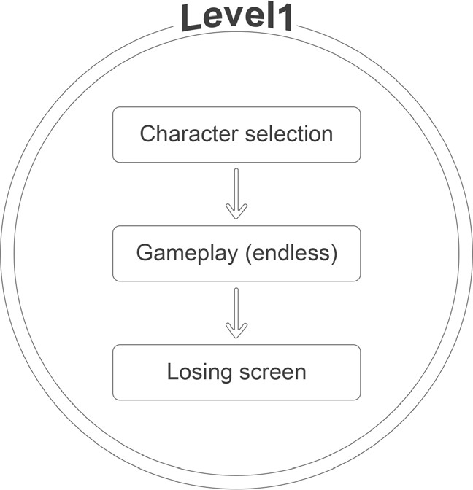

# Gameplay

Game Controls (PC)

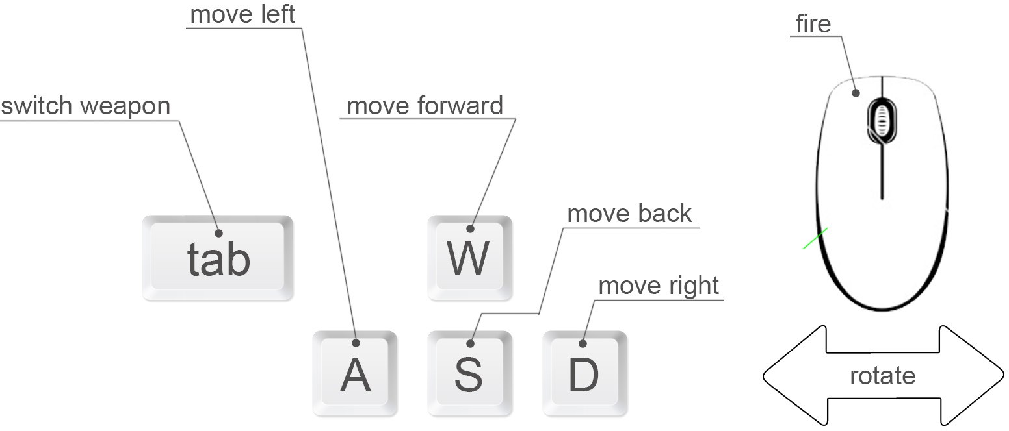

# Player

## Player Character

…

## Player Metrics

Speed: 6

Number of lives: 3

Attack Damage: N/A

Time to attack: Depending on weapon

## Player States

Idle: The idle state is …

Move: The movement state ….

Death: The death animation will make the character fall backwards when their life reaches zero .

## Player Weapons

Nil.

# Character Line-up

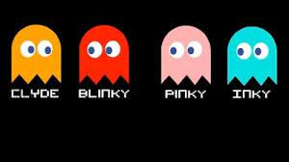

# NPC Enemies

The Ghosts spawn from the room in the middle of the game level.

Red

|  |  |  |  |  |
| --- | --- | --- | --- | --- |
| SPEED | MAX HEALTH | SCORE VALUE | ATTACK DAMAGE | TIME TO ATTACK |
| 3 .5 | 150 | 25 | 30 | 1 .5 |

Orange

|  |  |  |  |  |
| --- | --- | --- | --- | --- |
| SPEED | MAX HEALTH | SCORE VALUE | ATTACK DAMAGE | TIME TO ATTACK |
| 3 .5 | 100 | 10 | 10 | 0 .5 |

Pink

|  |  |  |  |  |
| --- | --- | --- | --- | --- |
| SPEED | MAX HEALTH | SCORE VALUE | ATTACK DAMAGE | TIME TO ATTACK |
| 3 .5 | 100 | 10 | 10 | 0 .5 |

Cyan

|  |  |  |  |  |
| --- | --- | --- | --- | --- |
| SPEED | MAX HEALTH | SCORE VALUE | ATTACK DAMAGE | TIME TO ATTACK |
| 3 .5 | 120 | 20 | 20 | 1 |

## Enemy States

All Ghosts possess the same behavior and states, as described below:

Idle: …

Move: …

Death: …

## Enemy Spawning

Each Ghost will spawn in the middle of the game level

# Art

## Setting

The game takes place in a room with walls.

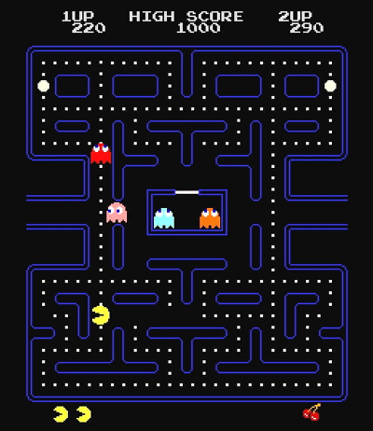

# Level Design

The level consists of walls with dots and cherries…

# Audio

|  |  |  |
| --- | --- | --- |
| NAME | CATEGORY | DESCRIPTION |
| music_rev1_loop_01 | Background music | Plays during the game |
| Collect dots | FX | Collect dots |
| Collect cherries | FX | Collect cherries |
| Death | FX | Death |

# MVP (Minimum Viable Product)

* One Player character only
* Built for the PC platform

# Wishlist

ADD MORE SKINS

In a future DLC, add more skins for the Player to apply on the game background.