**Homework 2 Instruction**

This assignment needs to be done in Palmetto. Details on how to log in to Palmetto and install PyTorch in Palmetto are available here <https://github.com/yongkaiwu/palemtto> .

Please make sure that PyTorch is installed correctly in Palmetto. The correct sign is when you log back into Palmetto and get the following screen:

The assignment is divided into the following sections.

1. Download the CIFAR-10 dataset and preprocess the CIFAR-10 dataset using the tools in PyTorch (optional).

2. Define the network structure.

3. Define the loss function.

4. Define the optimization function.

5. Train the neural network model and obtain the accuracy of training and testing.

**Section 1 Prepare Data and Perform Pre-processing**

CIFAR-10 (Canadian Institute for Advanced Research) is a dataset collected by Alex Krizhevsky, Vinod Nair and Geoffrey Hinton for image recognition, 60,000 32*32 color images, 50,000 training data, 10000 test data There are 10 categories, airplane, car, bird, cat, deer, dog, frog, horse, boat, truck, 6000 images in each category. Compared with MNIST, there are more color and color noise, different size, angle and color of objects in the same category, as shown in the following figure.

PyTorch has perfect handling of CIFAR-10 datasets, and we can use torchvision in torch, that has data loaders for common datasets such as ImageNet, CIFAR10, MNIST, etc. and data transformers for images, to load and preprocess CIFAR-10 datasets. The details can be found here <http://pytorch.org/vision/main/generated/torchvision.datasets.CIFAR10.html> .

In Palmetto, after we log into Jupyter Lab, we download and load data using the methods with torchvision and utils, and the result is shown in the figure below:

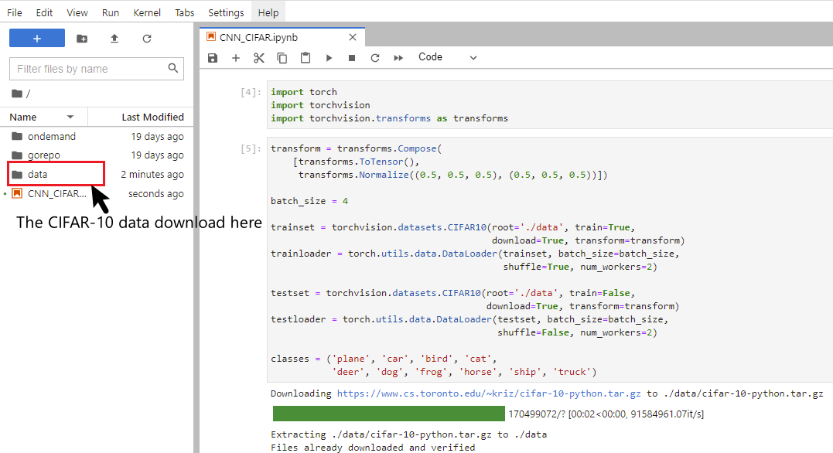

As shown below, we can print some of the images and the corresponding labels. I would like to emphasize that the batch size here is 4 (you can define the size of the batch size), the size of each Image is (32*32), and the input channel of each Image is 3 (R, G, B). These details will be used later in the definition of the network model.

**Section 2 Defining the Network Structure**

In general, after we load data with Dataloader() function, we use PyTorch to learn the CIFAR-10 dataset with the following steps:

In defining the network structure, we will likely use the following methods:

(1). Containers (such as nn.Module(), nn.Sequential()…)

(2). Convolution Layers (such as nn.Conv1d, nn.Conv2d …)

(3). Pooling layers (such as nn.MaxPool2d, nn.AvgPool2d…)

(4). Padding Layers

(5). Non-linear Activations (such as nn.ReLu(), nn.Tanh…)

(6). Normalization Layers (such as nn.BatchNorm1d, nn.BatchNorm2d…)

The details are here <https://pytorch.org/docs/stable/nn.html> .

These methods will be learned by yourselves and used in this assignment. Here I will build a simple network model of MINIST image classification to help you understand how these methods are used to implement a model.

**class** NeuralNetwork(nn.Module):

*# Create a network container using nn.Module()*

**def** __init__(self):

super(NeuralNetwork, self).__init__()

*# note: for each neural network, the size of the output of this layer*

*# should be exactly the same as the size of the input of next layer*

self.model = nn.Sequential(

*# use nn.Conv2d to insert the first convolutional layer*

*# the input channel =1, output channel = 6, kernel size =3, stride =1*

*# Note: input x = [28,28], after the first convolutional layer*

*# the output will be [6, 26,26] from the formula*

*# rounding down((x.size - kernel_size + 2* padding)/2)+1*

*# here we don't have the padding, so padding =0*

*# rounding down((28 - 3 + 2* 0)/2)+1 = 26*

nn.Conv2d(1, 6, kernel_size=3, stride = 1),

*# the number in the BatchNorm should be the same as*

*# the number of the output channel of the last convolutional layer*

nn.BatchNorm2d(6),

*# here we have (6, 26, 26)*

*# pooling with the height and width reduced by half each*

nn.MaxPool2d(kernel_size=2, stride =2),

*# after maxpooling, we have (6, 13, 13)*

*# the activation function doesn't change the size of channel*

nn.ReLU(),

*# here, the input is (6, 13, 13)*

*# the second convolutional layer requires the input channel = 6,*

*# output channel = 16, and kernel_size=3, stride =1*

*# insert this input (6, 13, 13) and get output (16, 11, 11) from the formula*

*# rounding down((13-3 + 2*0)/1)+1 = 11*

nn.Conv2d(6, 16, kernel_size=3, stride =1),

nn.BatchNorm2d(16),

*# here we have (16, 11, 11)*

*# pooling with the height and width reduced by half each*

nn.MaxPool2d(kernel_size=2, stride=2),

*# after maxpooling, we have (16, 5, 5)*

*# the activation function ReLu*

nn.ReLU(),

*# flattening layers to facilitate fully connected layer input*

nn.Flatten(),

*# here we have the input (16, 5, 5), after flattening,*

*# we have 16*5*5 = 400 for the input of the linear layer,*

*# 120 is your decision (you can choose any number you like)*

nn.Linear(400,120)

nn.ReLU(),

*# both 120 and 84 are your decision*

nn.Linear(120, 84),

nn.ReLU(),

*# The MNIST data is 10- categories, the final output should be 10*

nn.Linear(84,10)

)

**def** forward(self, x):

x = self.model(x)

**return** x

Note that the selection of parameters can be rather challenge. In PyTorch, the nn.Conv2d function mainly uses the following formula to accept parameters <https://pytorch.org/docs/stable/generated/torch.nn.Conv2d.html> .

**Section 3 Defining the loss function**

Since this is an image classification problem, it is important to choose a suitable loss function. PyTorch provides a number of tools for calculating the loss function: <https://pytorch.org/docs/stable/nn.html#loss-functions> .

Here I briefly describe the use of nn.CrossEntropyLoss().

<https://pytorch.org/docs/stable/generated/torch.nn.CrossEntropyLoss.html>

*# Example of target with class probabilities*

loss = nn.CrossEntropyLoss()

input = torch.randn(3, 5, requires_grad=True)

target = torch.randn(3, 5).softmax(dim=1)

output = loss(input, target)

output.backward()

**Section 4 Define optimization functions**

The torch.optim is a package that implements various optimization algorithms. Most of the common methods are already supported and the interface is generic enough so that more complex methods can be easily integrated in the future as well <https://pytorch.org/docs/stable/optim.html> . As an example,

optimizer = optim.SGD(model.parameters(), lr=0.01)

Here the optimizer uses the SGD algorithm, and the learning rate is set to 0.01 after the model parameters are put in.

When combining with the loss function of the model, the initial gradient of each epoch is guaranteed to be 0. After the loss function backward, the step() method should be used for the gradient of the optimizer.

**for** input, target **in** dataset:

optimizer.zero_grad()

output = model(input)

loss = loss_fn(output, target)

loss.backward()

optimizer.step()

**Section 5 Train the neural network model and obtain the accuracy of training and testing**

Follow the python file hints.

**Friendly reminder**

Since this assignment is done on a GPU-capable Palmetto, we need to make the best use of computational resources to achieve the results we need.

Thus we explicitly specify device = 'cuda' at the beginning of the python file.

For example, when calling the model, we need to load the model onto the GPU.

model = NeuralNetwork().to(device)

When training the model, you need to load x and y onto the GPU as shown below.

**for** i, (X, y) **in** enumerate(trainloaer):

timer.start()

optimizer.zero_grad()

X, y = X.to(device), y.to(device)

y_hat = net(X)

l = loss(y_hat, y)

l.backward()

optimizer.step()

When you train the model, using model.train(), the parameters of the model will to be updated. But when you test the model, you do not need to update the parameters, use “ with torch.no_grad() “ to avoid updating the parameters.