- 获取token
url：http://crmtest.truking.cn:9001/token
参数：grant_type：password
username：crmadmin
password：cw1Wo]gKd+

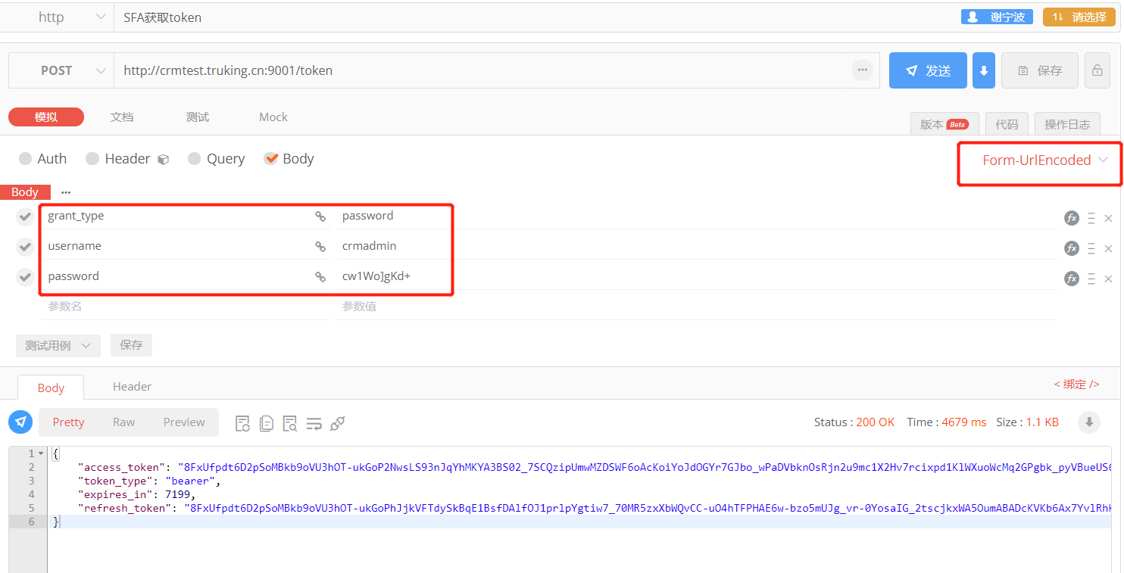

- 发货单接口
url：http://crmtest.truking.cn:9001/api/interface/shipment/saveshipment
参数
{"new_erp_number":"SHP21100001","new_type":1,"new_organization_id":"韩国区域","new_contract_id":"TK/TG211002","createdby":"","ownerid":"CT0001","createdon":"","new_account_id":"newgrand","new_shiptoaccount_id":"newgrand","new_amount":5025.65,"transactioncurrencyid":"人民币","new_shipping_date":"2021/10/08","data": [{"new_seq":"1","new_productno":"CP021542","new_saleorder_id":"XSDD202110180001","new_orderseq":"1","new_ord_shipmentline_id":"SN202100001","new_qty":1,"new_uom_id":"","new_warrantydate":"2022/10/08"}]}
