Table of Contents

1. Project introduction 1
1.1 Project name 1
1.2 Project personnel 1
1.3 Project description 2
2. Login platform 2
3. Admin platform 2
4. User platform 2
5. Login platform form 3
6. Admin platform form 3
7. User platform form 3
8. Database schema 3

Project Proposal

Project introduction

Project name

Project name：Bug Management System

Project personnel

This project completed jointly by xieqing Hai, zhanli Hou.

Project description

This project is Bug Management System. it can be used in software company or any software
testing work.User group is all Software Quality Assurance Engineers.Once the QA engineers found the defects, they could submit the defects and manage them on the basis of this system.In the meantime, administrator has access to manage users, Set user permissions，set user group and so on. However, due to the project time is very short,at present, we just will complete the functions as follows:
- Create defects
- Edit defects
- Delete defects
- Query defects
- Defects states management
- Add users
- Delete users
In this project, we will design three separate interfaces. The first is login interface, roles include admin and common user. The second is admin interface, the functions include add users, delete users and query users. The third is common users interface, the mainly functions include manage defects, specifically, create a defect, edit a defect, delete a defect and so on.

Login platform

Admin platform

User platform

Login platform form
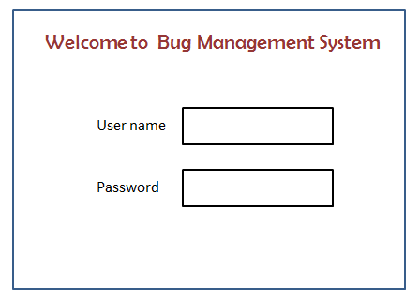
Figure 5.1 Login Form

Admin platform form
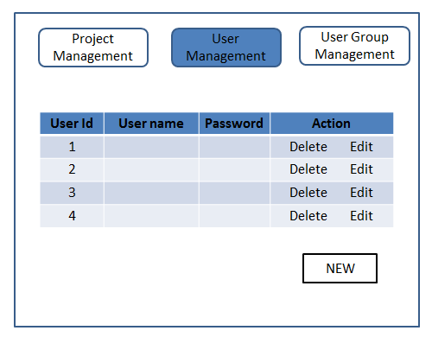
Figure 6.1 Administrator Main Form

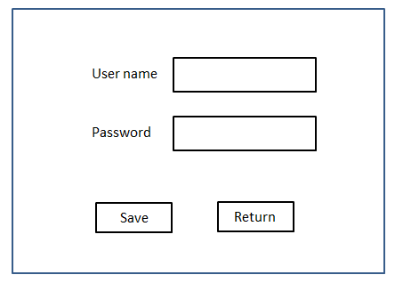
Figure 6.2 New User Form

Note: In Administrator Main Page,we just will complete User Management Function.

User platform form
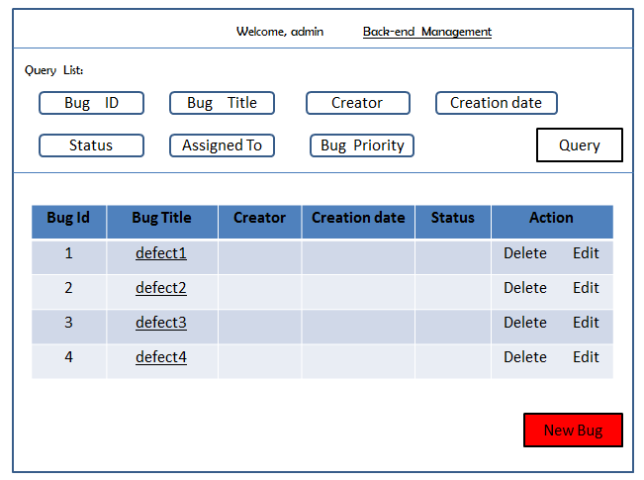
Figure 7.1 Main Form
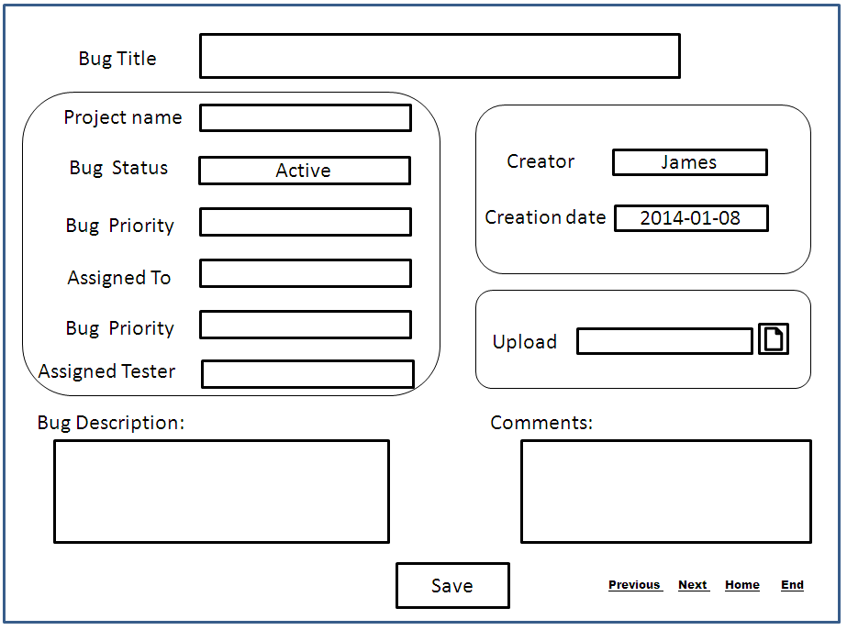
Figure 7.2 New Bug Form

Database schema
Database name:Web_ProjectProject

Users

FieldName | FieldType | Description
id | int | pk
UserName | varchar(10)
Password | varchar(25)
fname | varchar(15)
lname | varchar(15)
Email | varchar(25)
user_type | varchar(10)

BugInfo

FieldName | FieldType | Description
id | int | pk
UserName | varchar(10)
Password | varchar(25)
fname | varchar(15)
lname | varchar(15)
Email | varchar(25)
user_type | varchar(10)

