Table of Contents

1. Project introduction 2
1.1 Project name 2
1.2 Project personnel 2
1.3 Project description 2
2. Login platform 3
3. Admin platform 3
4. User platform 3
5. Login platform form 3
6. Admin platform form 4
7. User platform form 5
8. Database schema 7
8.1 Users 7
8.2 Project 8
8.3 Bug_Info 8
8.4 Bug_Action 9
8.5 Bug_History 9
8.6 Bug_File 9

Project Proposal

Project introduction

Project name

Project name：Bug Management System

Project personnel

This project completed jointly by xieqing Hai, zhanli Hou.

Project description

This project is Bug Management System. it can be used in software company or any software
testing work.User group is all Software Quality Assurance Engineers.Once the QA engineers found the defects, they could submit the defects and manage them on the basis of this system.In the meantime, administrator has access to manage users, Set user permissions，set user group and so on. However, due to the project time is very short,at present, we just will complete the functions as follows:
- Create defects
- Edit defects
- Delete defects
- Query defects
- Defects states management
- Add users
- Delete users
- History record
In this project, we will design three separate interfaces. The first is login interface, roles include admin and common user. The second is admin interface, the functions include add users, delete users and query users. The third is common users interface, the mainly functions include manage defects, specifically, create a defect, edit a defect, delete a defect and so on.

Login platform

Login platform is the main interface when users log in this system. So far, the system includes two kinds of user, common users and administrator.Login page includes the user name and password, it will be managed in Admin platform.

Admin platform

Admin platform belongs System backend, realizes the basic function mainly has users management, for examply, add users, edit users, delete users.Users informations include user name, user email, user password, user type. Only have permission the users who have permission can log in this system and have different Privilege.

User platform

User platform belongs System frontend, realizes the basic function mainly has Bug management, for examply, create a new bug, query bugs, edit bug, delete bug; before the edit and delete, the system will judge the status of the bug, if bug status is Active, it can be edited or deleted, otherwise, it could not be edited or deleted.
In the meantime, user platform record the history that each operation.

Login platform form
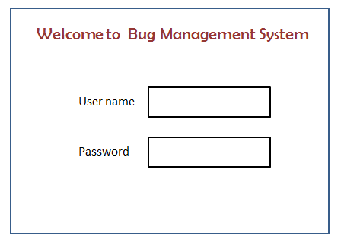
Figure 5.1 Login Form

Admin platform form
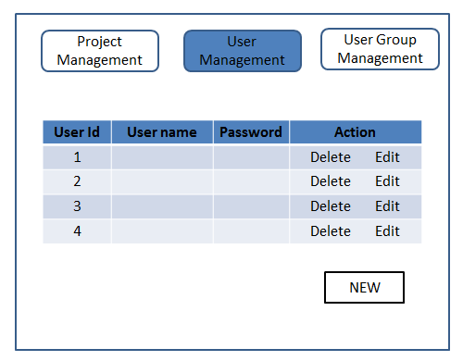
Figure 6.1 Administrator Main Form

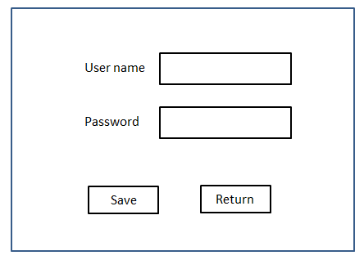
Figure 6.2 New User Form

Note: In Administrator Main Page,we just will complete User Management Function.

User platform form
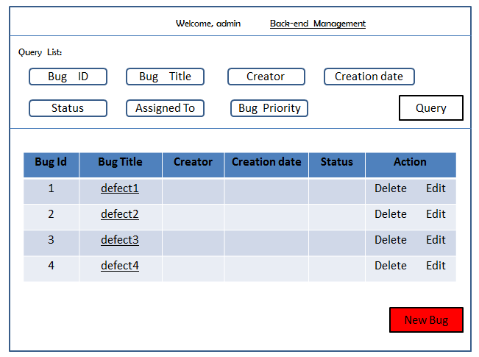
Figure 7.1 Main Form
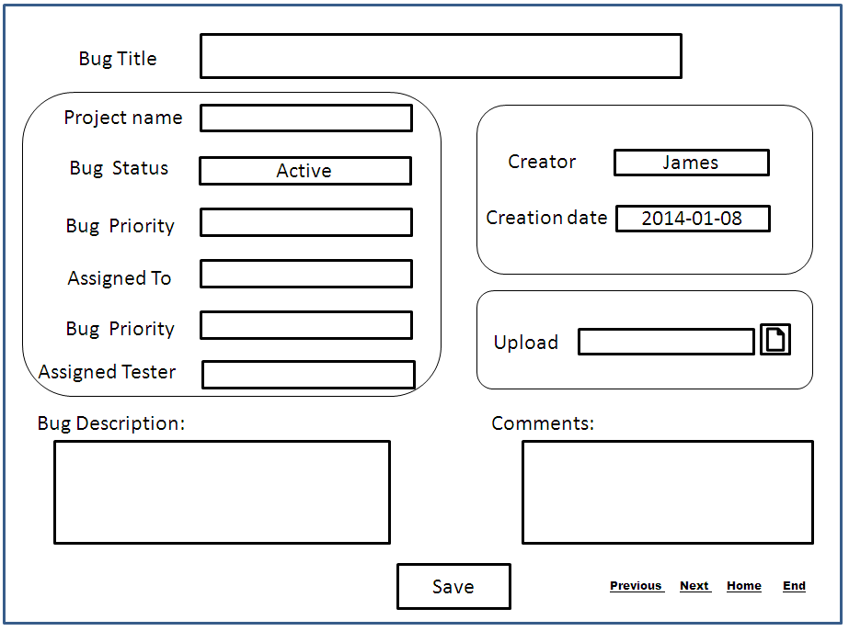
Figure 7.2 New Bug Form

Database schema

Users
Database Name:Users
FieldName | FieldType | Description
Id | int | pk
Username | varchar(10) | Not null
Fname | varchar(15) | Not null
Lname | varchar(15) | Not null
Password | varchar(25) | Not null
Email | varchar(25)
user_type | varchar(10) | Developer, Tester

Project
Database Name:Project
FieldName | FieldType | Description
Project_Id | int | pk
Project_name | varchar(255)
created_at | datetime
created_by | int | fk (Users table)
updated_at | datetime
updated_by | int | fk (Users table)
is_dropped | enum('0', '1')
display_order | smallint
bug_priority | varchar(10)

Bug_Info

Database Name:Bug_Info
FieldName | FieldType | Description
Bug_Info_Id | int | pk
Bug_Title | varchar(30)
Status | varchar(10)
Assign_to_developer | int | fk (Users table-User Id)
Assign_to_Tester | int | fk (Users table-User Id)
priority | varchar(10) | High, mediate, low
Description | varchar(500)
Comments | Varchar(500)
Created_by | int | fk (Users table-User Id)
Created_at | datetime
closed_by | int | fk (Users table-User Id)
closed_at | datetime
fixed_by | int | fk (Users table-User Id)
fixed_at | datetime
Project_Id | int | Fk(project table)

Bug_Action
Database Name:Bug_Action
FieldName | FieldType | Description
Bug_Action_Id | int | pk
Bug_Info_Id | int | fk(Bug_Info table)
action_note | text
created_at | datetime
created_by | int | fk (Users table-User Id)
action_type | varchar(255) | Action, Close, Fixed, Edit, Delete

Bug_History

Database Name:Bug_History
FieldName | FieldType | Description
Bug_History_Id | int | pk
action_field | varchar(45)
old_value | text
new_value | text
Bug_Action_Id | Int | fk(Bug_Action table)

Bug_File
Database Name:Bug_File
FieldName | FieldType | Description
Bug_File_Id | int | pk
File_title | varchar(255)
File_location | text
File_type | varchar(45)
File_size | varchar(45)
Is_dropped | enum('0', '1')
Bug_Info_Id | int
Add_action_id | Int | fk(Bug_Action table)
Delete_action_id | Int | fk(Bug_Action table)

