Web and Database Project proposal

# Project Name: ChineseFoodInMontreal

# Project Description:

This project is planning to create and setup a website including both front-end and back-end. The website is used to provide information of varieties Chinese food related services within Montreal to users, as well as interact with users on rating to the specific food service center and also collect comments. The food services centers are classified to four difference categories: ‘Restaurant’, ‘Cafe’, ‘Delicatessen’, and ‘Supermarket’.

There are six main pages in this project and used four database tables. The six pages are in three classes:

1. User login management

In terms of this website, only a user wants to add comment/rating for a food service center, then needs to login.

1. Main page

Website viewer can either choose to request displaying all the food service centers underneath a particular category (1 in 4), or choose to search a specific food center within a correct category.

1. Detail page on food center

Each food center displayed in main page has a link to its detail page. The detain page contains:

* Food center name
* Street view google map, as well as detail address and contact info
* Rating from users
* Comments list from users

The database tables are:

1. Category

It is food service center category. It is currently fixed in 4: ‘Restaurant’, ‘Cafe’, ‘Delicatessen’, and ‘Supermarket’.

1. Food_center

This is the main table. It stores the detailed information of a food service center. For detail, please refer to Project Database topic below.

1. Comment_rating

This table is used to store the comments and rating information from a user to the specific food center. For detail, please refer to Project Database topic below.

1. User

This table is used to store the user account information and corresponding privilege of a particular user.

# Project function

In terms of this website, we have three different client roles: the administrator, website user, and website passer-by. For different client role, the project can provide different function according to their privilege.

With regard to website passer-by, who has the lowest privilege, the website can provide these functions:

* Displaying all food service centers followed a particular category
* Search a specific food service center within a category
* View the detail information of the selected food service center, include the name, address, comments, rating

For website user, who has the privilege of adding comments and rating for a specific food service center, the website can provide these functions:

* All the function can be used by website passer-by, which are list above
* Login to the website, and logout
* For each food service center, the website user can add/modify comments and rating on the condition of login

For administrator, who has the full privilege, the website provides these functions:

* All functions used by website passer-by and website users
* Create, update, delete a particular food service center, as well as the category
* Update, delete the items of food service center information
* Delete comment in case illegal
* Create and delete user

# Project Database

There are four tables to be used in this project. They are: Category, Food_Center, Comment_Rating, and User.

Database Name: ChineseFoodCenter

Table Name: Category

|  |  |  |  |  |
| --- | --- | --- | --- | --- |
| Column Name | Column Type | Column Length | PK/FK/None | Description |
| C_ID | NUMBER | 1 | PK | The category of food center |
| NAME | VARCHAR | 30 | None | RESTAURANT,  CAFÉ, SUPERMARKET, DELICATESSEN |

Table Name: Food_Center

|  |  |  |  |  |
| --- | --- | --- | --- | --- |
| Column Name | Column Type | Column Length | PK/FK/None | Description |
| FC_ID | NUMBER | 2 | PK | Food Center ID |
| NAME | VARCHAR | 30 | None | Food Center name |
| Address | VARCHAR | 50 | None | Food Center Address |
| Contact | VARCHAR | 30 | None | Contact info |
| Desc | VARCHAR | 100 | None | Brief description of the food center |
| Rating | NUMBER | 2 | None | Rating of this specific food center |
| C_ID | NUMBER | 1 | FK | The category of food center |

Table Name: Comment_Rating

|  |  |  |  |  |
| --- | --- | --- | --- | --- |
| Column Name | Column Type | Column Length | PK/FK/None | Description |
| CR_ID | NUMBER | 3 | PK | The comment item ID from user |
| Content | VARCHAR | 300 | None | The comment content |
| RatDetail | NUMBER | 2 | None | Rating of this comment id |
| CommDate | DATE |  | None | The date of the comment generated |
| FC_ID | NUMBER | 2 | FK | Food Center ID |
| U_ID | NUMBER | 2 | FK | User ID |

Table Name: User

|  |  |  |  |  |
| --- | --- | --- | --- | --- |
| Column Name | Column Type | Column Length | PK/FK/None | Description |
| U_ID | NUMBER | 2 | PK | User ID |
| Account | VARCHAR | 20 | None | Account name |
| Password | VARCHAR | 128 | None | Password |
| Role | VARCHAR | 30 | None | ADMIN/USER |

# Project Pages

## Main page

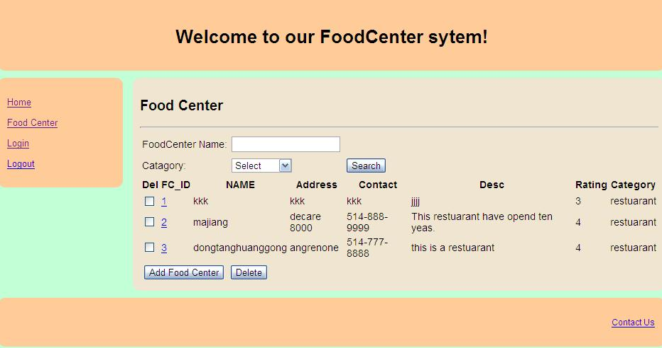

1. Search
2. Click search button user can get all of the sotre info list;
3. IF user enter a foodcenter full name or part of the name, after clicking search button user will get the specitfy sotre info list.
4. User also can select a category to find the related to store info list.
5. Add

Click this button the system will show the adding food center page to user,user can use this page add a new sotre in this system.

1. Delete

User can select all of the sotre in info list that user want to be deletle form this system,and then click “delete” button ,the selected store will be deleted.

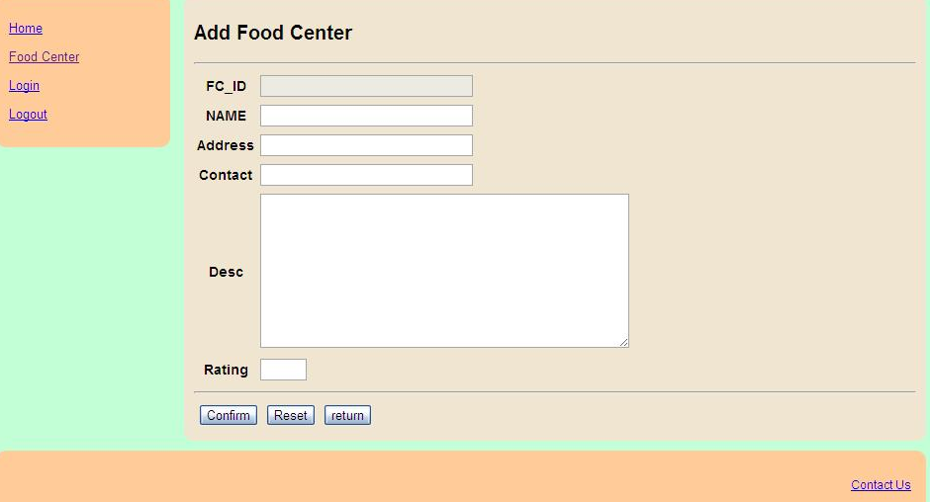

In the page user can add a new store in this system.

1. After entering the related to info user can click “confirm” button to save the info to database.
2. If it is necessary user can user “reset” button to reset every information that is entered by user before.
3. Click the “return” button ,user can return to the previous page.

## Food center detail page