# High performance oxide lithium ion battery anode for in-situ induced orientation growth

*Shu-Ang He, Zhe Cui, Jianhua Zhang, Guoqiang Guan, Chaoting Xu, Wenlong Zhang, Qing Cao, Rujia Zou*, and Junqing Hu\**

## Abstract

The high potential (from 2.0 V to 1.0 V vs. Li+/Li) lithium intercalation behavior of orthorhombic Nb2O5 (T-Nb2O5) has attracted widespread attention due to it could avoid the formation of SEI (solid-electrolyte-interface) and improve the coulombic efficiency and stability of the electrodes. However, there is a large capacity that has not been released below this electrochemical window. It is a pity to abandon this part of the capacity in order to avoid the generation of SEI. In this work, we obtained an electrode (S doping Nb2O5@rGO, marked as S-Nb2O5@rGO) with excellent cycle stability and rate performance by in-situ electrochemical orientation growth. Among them, rGO is used as a growth substrate to induce oxide growth on its surface. The growth crystal face of Nb2O5 has quick ion transport properties, providing high Li-ionic conductance, and sulfur doping increases oxygen vacancies and thereby improves electron conductance. It delivers a reversible capacity 312 mAh·g-1 at 2 A·g-1 over 800 cycles. The result demonstrates this design has certain feasibility. And this work offers a new perspective in designing high-performance electrodes for long-lifespan lithium-ion batteries.

## Introduction

Lithium-ion batteries are efficient and convenient energy storage systems and have been widely used in various portable electronic devices and electric vehicles in recent decades[1]. Anodes as an important part of the LIBs system is critical to the performance of the battery[2]. Many high-energy density anode materials such as Si, Sn, transition metal oxides (TMO), transition metal sulfides (TMD)[3-6], etc., will form loose solid-electrolyte-interface (SEI) on the surface during discharge and cover the surface of the electrode, consuming part of the active material and electrolyte[7]. The anode electrode material undergoes volume expansion/contraction during charging and discharging, which causes the SEI to be continuously destroyed and generated. It causes irreversible loss of active material, resulting in low coulombic efficiency (CE). Current processing strategies include the following: SEI modification[8], fabrication of hollow structures to reserve expansion space[9][10], and the like. Although it has improved to some extent, there are still drawbacks, such as these: the introduction of extra inactive components would make the internal reaction of the battery more complicated, the reserved space would reduce the electrode capacity density and so on. Therefore, it has been thought to use T-Nb2O5 that could insert Li-ion in the potential window from 2.0 to 1.0 V (vs. Li+/Li) as an anode to avoid the formation of SEI[11][12]. Due to as far as the current consensus is concerned, SEI is rarely formed, when the voltage is higher than 1.0 V[13][14][15]. In this case, each Nb2O5 unit is combined with 2 Li ions. Thus, each Nb5+ ion accepts one electron to form a Nb4+, the corresponding specific capacity is 201 mAh·g-1[12][16][17]. It suggests that this material might provide a large capacity below 1.0 V. To charge and discharge under this electrochemical window will inevitably form SEI, can we have it both ways?

It is known that T-Nb2O5 have two-dimensional Li ion transport properties, and graphene could only conduct electrons in the plane[18][19]. The formation of SEI should consume electrolytes and Li ions on the active surfaces of electrodes[20]. From this point of view, the electrode with two-dimensional ion-electron transport characteristics should only form a less SEI in the vertical direction.

In this work, we combined S doping rGO and T-Nb2O5 and obtained an oxide composite electrode with a two-dimensional structure by electrochemical in-situ orientation growth method between the cut-off voltage of 0.01-3.0 V (vs. Li+/Li), and the growth direction was coplanar with the fast ion channel. Since the integrated structure maintained a lamellar morphology during charge and discharge, it makes SEI a high stability. Simultaneously, oriented T-Nb2O5 provides high ionic conductance and rGO provides efficient electron channel. The combination of the above advantages makes electrode represent excellent electrochemical performance. The electrode exhibits a superior specific capacity (480 mAh·g-1 at 0.1 A·g-1) and high cycle stability (After 800 cycles under a current density of 2 A·g-1, the capacity is 312 mAh·g-1, which is equivalent to 0.052 % of capacity change per cycle.)

## Experimental Section

*Chemicals*: Graphite powder, NaNO3, KMnO4, sulfuric acid, H2O2, hexane, absolute ethanol, oleylamine, ethylene glycol, NbCl5, CS2, super P, PVDF, NMP.

*Preparation of GO*: Graphene oxide (GO) was prepared by a modified Hummers’ method[21]. Generally, 2 g of powdered flake graphite and 1 g of NaNO3 were slowly added into 46 mL concentrated H2SO4 with mechanical agitation. The mixture was placed in an ice-bath and stirred for 30 minutes. While maintaining vigorous agitation, 6 g of KMnO4 was added to the suspension. After another 1 hour reaction, 95 mL of deionized water was slowly poured into the mixture, and the temperature of suspension rose to 98 °C. The diluted suspension was maintained at this temperature for 15 minutes and added 15 mL of H2O2 (30 %) to remove excess ions. Then the mixture was washed with deionized water followed by the vacuum freeze-dying process.

*Synthesis of* ***S-Nb2O5@rGO***: 90 mg of GO powder was added into 15 mL of oleylamine with sonicated dispersion for several hours to form a homogeneous mixture. Then a three-neck flask containing suspension was heated to 140 °C for 30 minutes under nitrogen atmosphere to remove dissolved water and oxygen. Afterward, 280 mg of NbCl5 was added into suspension and dissolved under vigorous agitation. Then the mixture was quickly heated to 300 °C, and 4 mL of CS2 was slowly injected into the flask at 300 °C. The reaction system was kept at 300 °C for 3 h and then naturally cooled to room temperature, the deep brown precipitate was centrifuged, washed successively with hexane and ethanol, and dried in a vacuum oven at 60 °C (noted as NbS2@GO). Finally, the obtained powder was placed into a quartz tube filled with argon and heated at 800 °C for 3 h and 6 h with a heating rate of 2 °C·min-1 followed with a natural cooling process (noted as NbS2@GO-3 and S-Nb2O5@rGO, respectively)

*Synthesis of Nb2O5 nanosheets*: certain mass of S-Nb2O5@rGO was annealed at 700 ℃ for 1h in air with a heating rate of 5 ℃·min-1 to remove the rGO and S element from S-Nb2O5@rGO, and the obtained samples were noted as Nb2O5.

*Synthesis of* ***Nb2O5@rGO***: In a typical procedure[22], 90 mg of GO powder was added into 20 mL of EG (ethylene glycol) and dispersed with ultrasonic treatment. 280 mg of NbCl5 was dissolved in 15 mL EG with magnetic stirring. Above two solutions were mixed by magnetic stirring for 30 min, obtaining a homogeneous solution. Then the solution was transformed into a 50 mL Teflon-lined stainless steel autoclave and heated at 180 ℃ for 24 h. The resulting species was collected by centrifugation followed by washing with deionized water and absolute ethanol for three times, respectively. Finally, the products were dried under vacuum at 60 ℃ overnight, and marked as Nb2O5@rGO.

## Characterization

The morphologies and microstructure were characterized by field emission scanning electron microscope (Hitachi S-4800 equipped with an energy-dispersive X-ray spectrometer) and field emission transition electron microscope (JEM-2100F). Powder XRD patterns were collected using an X-ray diffractometer D/MAX-2550VB+ to confirm the ingredients and the phases of the composites. XPS data was used to identify the surface chemical situation, which were obtained in an EALALab MIKII spectrometer with an excitation source of Mg-Kα radiation.

## Electrochemical Tests

The working electrodes were prepared by mixing 70 wt% of active materials (S-Nb2O5@rGO, Nb2O5 and Nb2O5@rGO), 20 wt% of acetylene black as conducting agent, and 10 wt% of polyvinylidene fluoride (PVDF) as binder in N-methypyrrolidinone to form a homogeneous slurry. Then coated the slurry uniformly on a copper foil before dried in a vacuum oven of 60 ℃ for 12 h. Active materials loading was 0.6~1.0 mg·cm-2. CR2032-type coin cells were fabricated in an argon-filled glovebox (with both the moisture and the oxygen concentration below 0.1 ppm) with metal lithium foil as a counter electrode, Celgard 2400 (Charlotte, NC, USA) as the separator and LiPF6 (1 M) in ethylene carbonate (EC)-dimethyl carbonate (DMC) (1:1 vol%) as electrolyte. The galavanostatic measurements were conducted on a Land-CT2001A battery test system at different current densities in potential windows from 0.01 to 3.0 V (vs. Li+/Li). The CV tests were carried out to examine the electrode reaction under the scan rate of 0.1 mV·s-1 over the cut-off voltages of 0.01 and 3.0 V (vs. Li+/Li). And the electrochemical impedance spectroscopy in frequency range of 100 kHz to 0.01 Hz were operated on an Autolab (PGSTA302N) electrochemical workstation.

## Results and Discussion

The morphology and microstructure of S-Nb2O5@rGO were characterized by scanning electron microscopy (SEM) and transmission electron microscopy (TEM). The whole morphology is showed in the SEM image (**Figure 1a**), the Nb2O5 nanosheets are uniformly spread on the surface of rGO of several micrometers instead of being wrapped in rGO. This could also be well confirmed by the TEM images (**Figure 1b, c**,). **Figure 1c** reveals that the size of the Nb2O5 nanoparticles is around 20 nm. **Figure 1d** is the HRTEM image of a nanosheet and the corresponding Fast Fourier Transform (FFT) image, the lattice fringes of 3.93 Å and 3.09 Å can be assigned to the (001) and (200) planes of the orthorhombic Nb2O5 phase, respectively. The EDS elements mapping reveal that the compositional distributions of the Nb, O and S in the S-Nb2O5@rGO. The result indicates that S atoms are mainly distributed in the Nb2O5 nanosheets and rarely in rGO (**Figure 1e**). It imply that the Nb2O5 nanosheets are doped by S element.

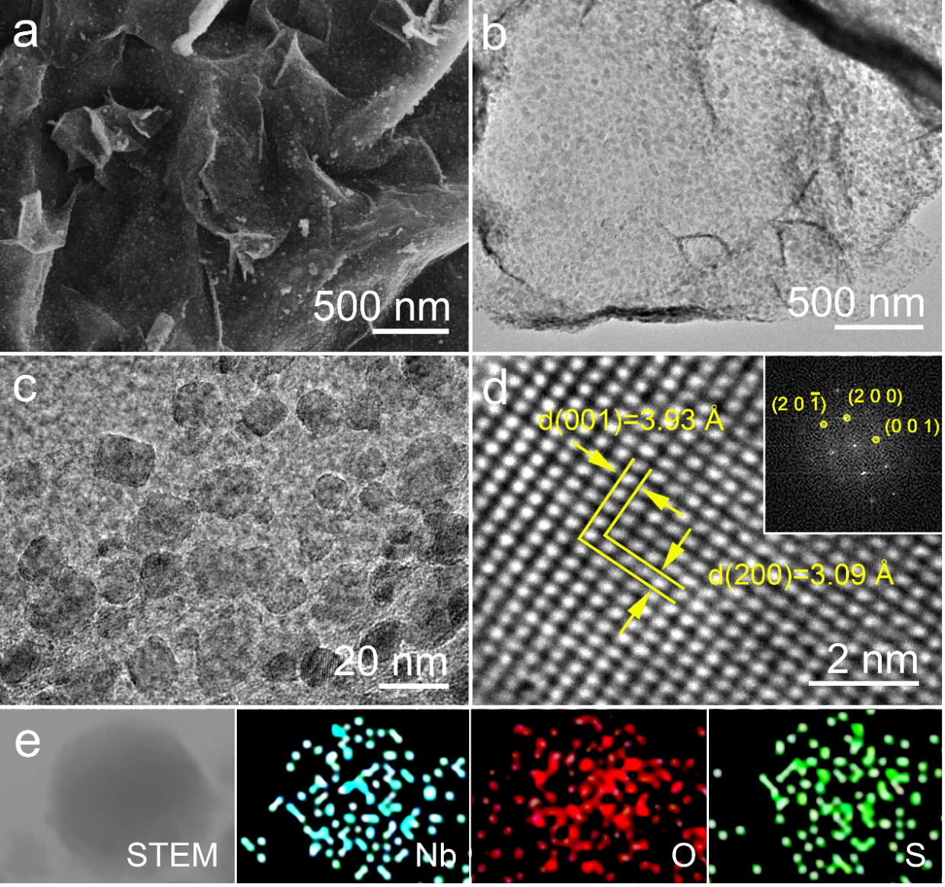

**Figure 1.** a) SEM images of S-Nb2O5@rGO. b) and c) TEM image of S-Nb2O5@rGO. d) HRTEM image of S-Nb2O5@rGO; the insets show the corresponding FFT image. e) the EDS elemental mapping of S-Nb2O5@rGO, showing Nb, O and S.

To investigate the crystalline structure of S-Nb2O5@rGO, X-ray diffraction (XRD) pattern was shown in **Figure 2a**. It includes the XRD pattern of NbS2@GO, NbS2@GO-3 and S-Nb2O5@rGO, respectively. Obviously, the curve of NbS2@GO match the peak of NbS2 (PDF#41-0980). The diffraction peak of NbS2@GO-3 and NbS2@GO are substantially the same expect the peaks that corresponds to the orthorhombic Nb2O5 located in 22 and 28 degrees. It means that the product heated at 800 ℃ for 3 h is not calcined enough to transform NbS2 to Nb2O5[23]. With referent to an XRD pattern for the orthorhombic Nb2O5 (PDF#27-1003) and compared it with the curve of S-Nb2O5@rGO, it could be confirmed that the NbS2 have totally transformed to Nb2O5. It is worth noting that the atmosphere of calcination is argon, the sulfide yet converted to oxide. In that way, it could only be considered that the oxygen-containing functional groups on GO participated in the reaction. X-ray photoelectron spectroscopy (XPS) was utilized to further analyze the surface chemical state. As can be seen from the **Figure 2b**, there are four pairs of split peaks, which are at ~207.0 and 209.9 eV, 207.3 and 210.2 eV, 207.7 and 210.6 eV, 208.1 and 210.9 eV, representing Nb 3d5/2 and Nb 3d3/2, respectively. They suggest the Nb2O5 are mainly species in the S-Nb2O5@rGO. The peak at 207.0 eV could attribute to the incompletely oxidized Nb4+ that connected with S atoms partially[24]. Namely, sulfur is doped into the Nb2O5 nanoparticles. This is consistent with the results we derived from the previous images of S-element mapping. As for the other three peaks at 207.3 eV, 207.7 eV and 208.1 eV, respectively, the difference in values among them is due to different oxygen-containing functional groups on the GO participate in the reaction, which makes the bonding energy of Nb-O different[25]. **Figure S3** display the XPS spectra of O 1s region, the peaks at 530.1 eV, 530.5 eV is assigned to the bonds of O-Nb4+ and O-Nb5+, the rest peaks at 531.0 eV and 532.2 eV correspond to the bonds of O-C and O-S, respectively[26]. In **Figure 2c**, the XPS spectra of S 2p, a couple of peaks at 164.2 and 165.4 eV that are associated with S 2p3/2 and S 2p1/2 are ascribed to the bonds of S-O. The peaks at 163.8 and 164.9 eV are related to the formation of S-C. Exist of S-C bonds imply that sulfur simultaneously doped into the graphene lattice. Combining with the previous analysis, it could be aware of that the S element is doped in the S-Nb2O5@rGO. In carbon spectra (**Figure 2d**), five peaks appeared at 284.3, 284.8, 285.2, 286.1 and 289.5 eV, respectively, which were derived from C-S, C-C, C=C, C-O and C=O[27].

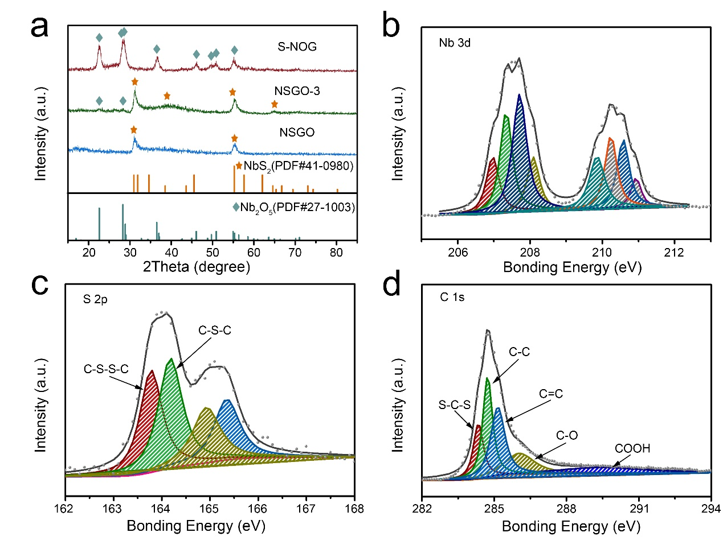

**Figure 2.** a) XRD patterns of S-Nb2O5@rGO, NbS2@GO-3, and NbS2@GO. In addition to the PDF cards (T-Nb2O5, PDF#27-1003, marked with cyan rhombus; NbS2, PDF#41-0980, marked with orange pentagram). b-d) High-resolution XPS spectra of Nb 3d, S 2p and C 1s of S-Nb2O5@rGO.

The electrochemical test of the electrode was performed in a coin-type cell and the

lithium foil was used as the counter electrode. The cell was tested between the cut-off voltage of 0.01-3.0 V (vs Li+/Li). The cyclic voltammetry (CV) curves of S-Nb2O5@rGO for the first to fifth cycles at a scan rate of 0.1 mV·s-1. As shown in **Figure 2a**, it exhibits irreversible reduction peak at around 0.8 V in the first cycle, which could be attributed to the form of SEI[28]. The reversible reduction peaks centered at 1.6 and 0.01 V display a significant amount of charge storage, and the former could be explained with Li-ions intercalation and subsequently generate Li2Nb2O5, the latter that could be interpreted as Li2Nb2O5 is reduced to elemental niobium, which makes a major contribution to capacity. In the anode scanning process, the curves illustrate that the strong peak at 2.45 V that decreases with the number of cycles until the fourth circle disappears completely and a peak around 2.1 V only appeared at first cycle. Though analyzing the XPS spectra of S 2p of the electrode surface after 800 charge-discharge cycles (**Figure S8**), it could be considered that this is the result of oxidation of sulfur-containing species, and S element partially enters the SEI lead to the peaks shrink and disappear in the fourth cycle[29][30]. **Figure 3b** shows the galvanostatic charge-discharge (GCD) profiles of the first five cycles of the S-Nb2O5@rGO**.** The platform at 0.8 V disappears in the second cycle, which could be the reaction of SEI formation. It is consistent with the conclusions obtained from **Figure 3a**. To test the rating capability, the S-Nb2O5@rGO, Nb2O5 and Nb2O5@rGO electrode was measured between 0.01 and 3.0 V at a series of current densities, the result is shown in **Figure 3c**, and the latter two electrodes as control samples. At 0.1 A·g-1, repetitive lithiation/delithiation cycling results in the capacity rapidly decreasing from 890 mAh·g-1 to 500 mAh·g-1 over the first 3 cycles. This capacity drop is due to the formation of SEI. Around 2.5 Li+/Nb can be reversibly intercalated for a gravimetric capacity of around 490 mAh·g-1. As the current densities increases from 0.2 A·g-1 to 0.5 A·g-1, 1 A·g-1, 2 A·g-1 and 5 A·g-1, the corresponding average discharge capacity of the S-Nb2O5@rGO decrease from 420 to 372, 340, 304 and 238 mAh·g-1. Then as the current density was decreased back to 0.1 A·g-1, the discharge capacity of S-Nb2O5@rGO exhibited around 480 mAh·g-1. It indicating an excellent rate capability and reversibility of the electrode. It shows a larger discharge capacity than the two control samples. **Figure 3d** illustrates the galvanostatic charge-discharge (GCD) profiles of the S-Nb2O5@rGO at the current density of 0.1 A·g-1, 0.2 A·g-1, 0.5 A·g-1, 1 A·g-1, 2 A·g-1, 5 A·g-1，respectively. The distinct plateaus around 1.6 V and 1.8 V in the discharge and charge profile correspond to the insertion and extraction of Li-ions to form Li2Nb2O5 and Nb2O5, respectively. It matches well with the CV curves. Besides, the voltage plateaus positions are approximately the same at the current density of 0.1 A·g-1, 0.2 A·g-1, 0.5 A·g-1, 1 A·g-1, 2 A·g-1, only the voltage plateaus at 5 A·g-1 has slight deviations. It indicates that the battery expresses a low polarization at high current density and a well reversible performance. It could be benefited from the high conductivity of S-doping rGO. **Figure 3e** displayed the cycling performances of S-Nb2O5@rGO, Nb2O5 and Nb2O5@rGO at 2 A·g-1, the discharge capacity of S-Nb2O5@rGO slowly increases from 235 mAh·g-1 after three cycles at 0.1 A·g-1 to 312 mAh·g-1 at the 300th cycles, then maintaining to the 800th cycle. In contrast, the represented specific capacity of two control groups are only around 200 mAh·g-1. Moreover, the Nb2O5 and Nb2O5@rGO started to show capacity decay after cycled 300 and 400 times, respectively. Then, we analyzed the redox capacitance-like contribution in the S-Nb2O5@rGO electrodes to investigate origin of the superior electrochemical performance of S-Nb2O5@rGO electrodes.

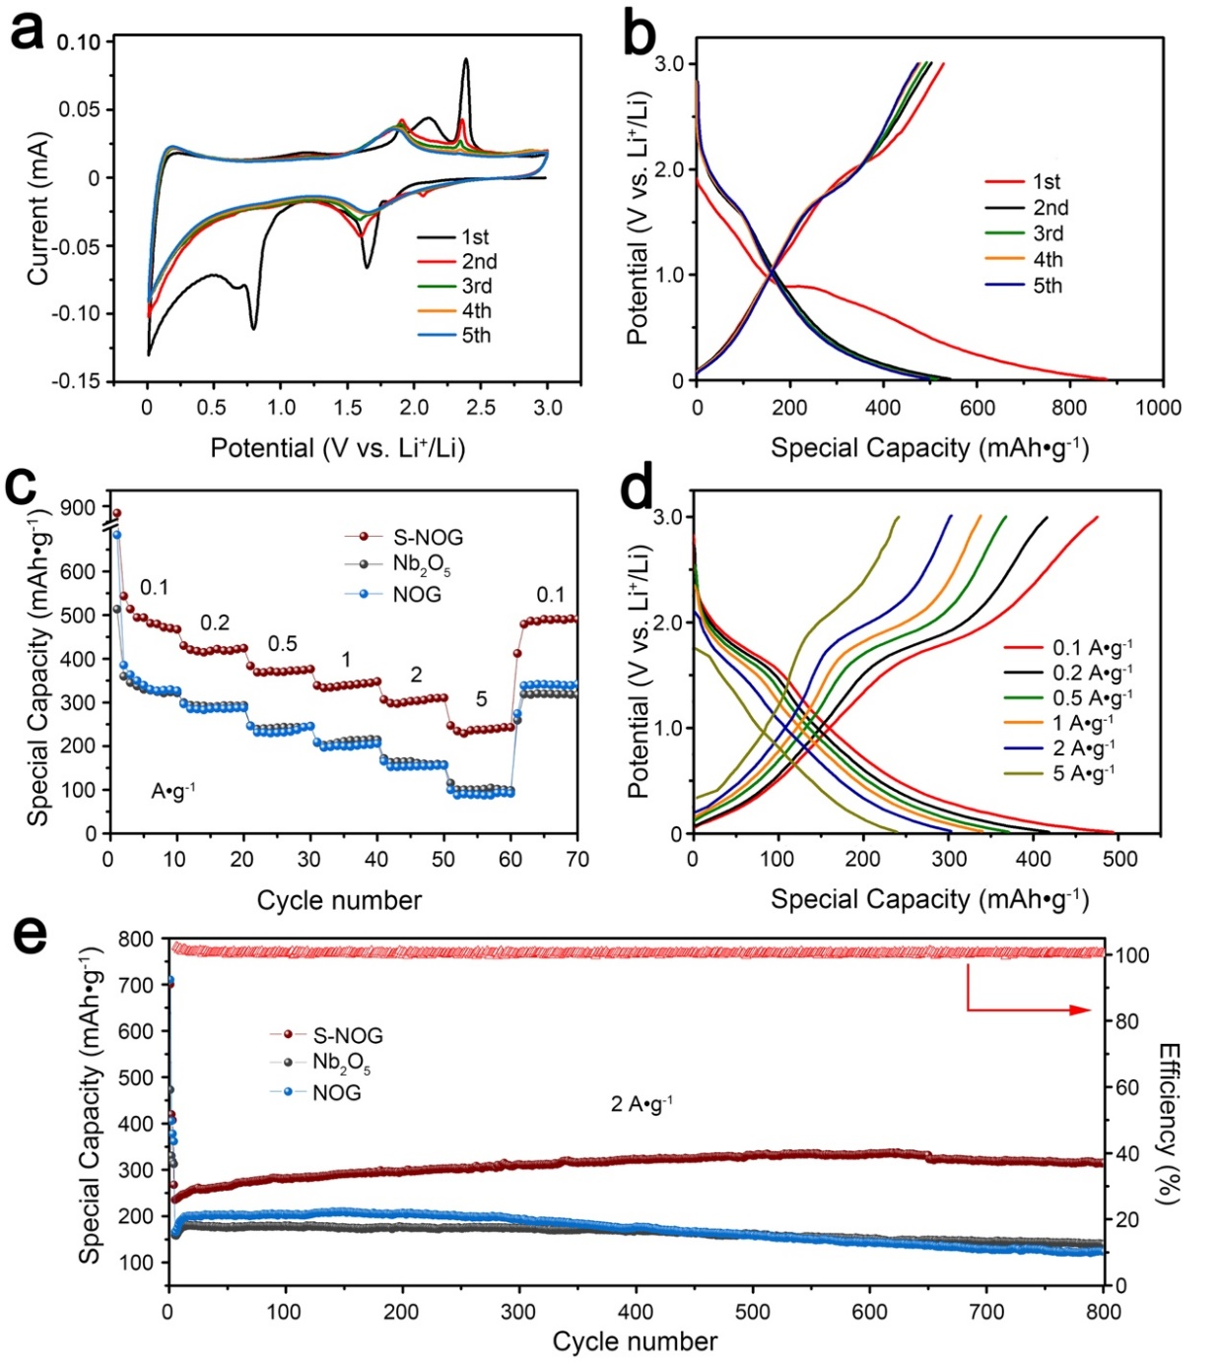

**Figure 3.** a) Cyclic voltammetry curves of S-Nb2O5@rGO electrode in the first five charge-discharge cycles with a scan rate of 0.1 mV s-1. b) galvanostatic charge-discharge (GCD) profiles of the first five cycles of S-Nb2O5@rGO electrode. c) Rating performance of S-Nb2O5@rGO, Nb2O5 and Nb2O5@rGO electrode under different current rates, respectively. d) GCD profiles of S-Nb2O5@rGO electrode under different current densities. e) Cycling performance of S-Nb2O5@rGO, Nb2O5 and Nb2O5@rGO electrode under a current density of 2 A·g-1, respectively.

**Figure 4a** shown the CV results at various scan rates from 0.2 to 10 mV·s−1. The peak current (i) fits a power-law relationship with the scan rate (ν):

or

Where a and b both are alterable constants. While the b-value is 0.5, it indicates the electrode undergo a total diffusion-controlled behavior (semi-infinite linear diffusion)[31][32]. Then the b-value of 1 indicates the electrode go through a surface-controlled behavior or capacitive process. As shown in **Figure 4b**, the anodic and cathodic b values are 0.77 and 0.83, respectively, demonstrating the capacitance takes up the main status in the capacity of S-Nb2O5@rGO electrode. The kinetics characterizations of electrodes under different rates could be analyzed by the follow equation:

or

Where *k*1*v* represents the contribution of capacitance, *k*2*v*1/2 represents the contribution of the Li-ion intercalation process[33][34]. **Figure 4c** exhibits the capacitive curve (blue region) and the original CV curve (gray region) at scan rate of 5 mV·s−1 after fitting. As illustrated in **Figure 4d**, the ratio of capacitance to the total charge storage gradually increases with increasing sweep rates, increases from 41% corresponding to the scan rate of 0.2 mV·s−1, to 85% at the scan rate of 10 mV·s−1. It demonstrates the capacity of S-Nb2O5@rGO electrodes at low rate is mainly attributed to Li-ion insertion and at high rate is mainly ascribed to pseudo-capacitance.

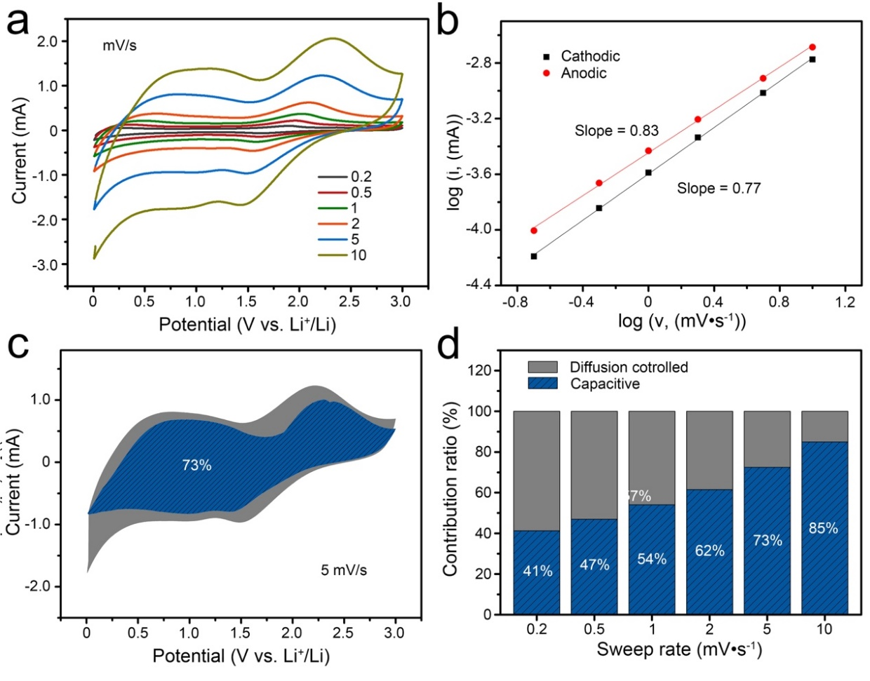

**Figure 4.** a) CV curves of S-Nb2O5@rGO electrode at different scan rates from 0.2–10 mV·s−1. b) The linear relation of peak currents and scan rates. c) Capacitive contribution curve of S-Nb2O5@rGO electrode at a scan rate of 5 mV·s−1. d) Contribution ratio of the capacitive and diffusion-controlled capacity at different scan rates.

To further explore the electrochemical mechanism of electrode during charge and discharge, the electrodes undergo 800 cycles of charge and discharge were observed in the transmission electrode microscope. As shown in **Figure 5a,** half-cell was full charge, a large amount of flakes appear in the electrode, those selected area electron diffraction pattern is shown in **Figure 5b**, which is Nb2O5 sheets grown along the 001 plane. According to previous research results, the general atomic arrangement consists of two sets of alternating atomic layers: a rather loosely packed 4g layer that is occupied by ~40% of oxygen ions; the other part is the denser 4h layer that contains all Nb cations and the other ~60% of oxygen ions. The Li ions could move between the loosely 4g layer with very low steric hindrance[17][18][35]. It leads to the exceptionally fast kinetics of electrode, scilicet the electrode could endure large current density and maintain high rating performance, simultaneously. To investigate what the discharge product is, and to speculate on the number of possible exchange electrons, we observed the electrode with complete discharge state, as **Figure 5c, 5d** depicted. There are also numerous sheets characterized to be metal Nb pieces by means of selected area electron diffraction. This suggests that each Nb5+ ion accepts 5 electrons to form a Nb atom, in which case the theoretical capacity should be 1000 mAh·g-1 instead of 200 mAh·g-1. The electrochemical reaction equation could be:

The rating performance illustrated in **Figure 3c** is lower than this value, which might be result of not completely reaction. In fact, we also found a series of intermediate products: LiNbO2, LiNb3O8, etc. (as shown in **Figure S5** and **Figure S6**). As display of the above figures, the electrode material maintains a sheet-like structure rather than undergoing a large volume change during the charge-discharge cycle, which contributes to the stability of the SEI and thus enhance the reversibility of electrode under long cycle.

To understand the details of the redox behavior of the S-Nb2O5@rGO and the origin of its impress electrochemical performance, the S-Nb2O5@rGO was placed in a STM-TEM sample holder to track evolution of its morphology and phase changes during lithiation and delithaition (**Figure 5e, f, g and h**). **Figure S9** displayed the as-prepared S-Nb2O5@rGO before lithiation. The schematic diagram of in situ TEM setup is shown in **Figure S7**. A bias of 3.0 V was applied to initiate the lithiation processes. As can be seen from the **Figure 6b-d-e**, the morphology of S-Nb2O5@rGO changes gradually with the lithiation time, the microstructure of each Nb2O5 nanoparticle developed from nanocrystals into smaller nanoparticles, which are uniformly dispersed on the graphene planes. Combined with the selected area electron diffraction (SAED) pattern, the phase transition during lithiation could be analyzed to infer possible chemical reactions in the S-Nb2O5@rGO. As noted in **Figure 6c**, the S-Nb2O5@rGO lithiation for 10 minutes mainly contained Nb2O5 and Li2O. After about 40 minutes, no obvious morphology changes can be detected. **Figure 6f** shows a SAED image of area in **Figure 6e**, it can be found that in addition to Nb2O5 and metal Nb, there are also LiNbO2 which is considered as the intermediates in the lithiation, and we have observed them in ex situ TEM images. **Figure 7** illustrated the morphology evolution of the electrode during lithiation/delithiation.

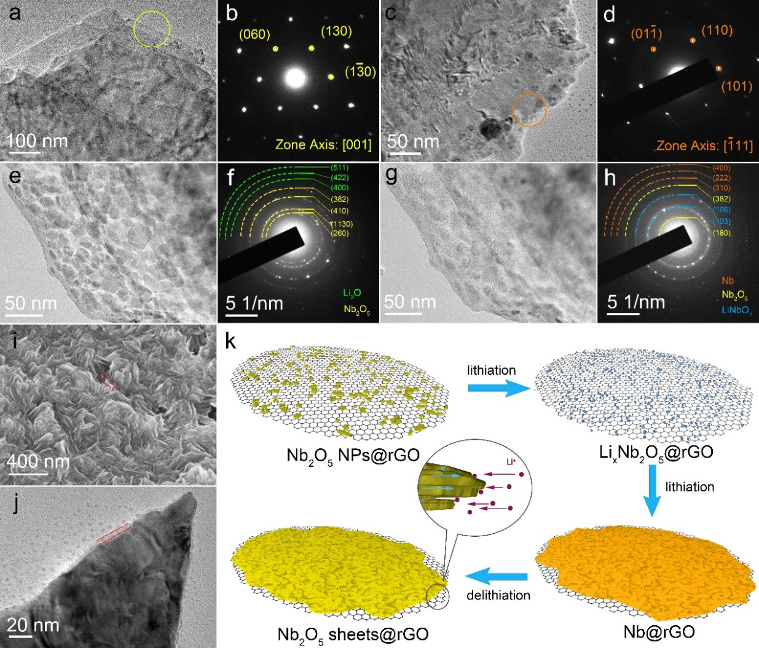

**Figure 5.** a-d) the morphology of S-Nb2O5@rGO electrodes under half-cell measure, a) the morphology of electrodes with full charged state after test for 800 cycles at 2 A·g-1. b) the corresponding SAED pattern of the area in the yellow circle of a). c) morphology of electrodes with full discharged state after test for 800 cycles at 2 A·g-1. d) the corresponding SAED pattern of the area in the orange circle of c). e-h) the morphology and phase evolution of S-Nb2O5@rGO electrodes during in situ electrochemical lithiation with a bias voltage of 3.0 V. e) and f) the profile of the S-Nb2O5@rGO applied a bias for 10 minutes and SAED pattern corresponding area, respectively. g) and h) the profile of the S-Nb2O5@rGO applied a bias for 40 minutes and SAED pattern corresponding area, respectively. i) SEM image of surface of S-Nb2O5@rGO electrodes after 800 cycles at 2 A·g-1. j) TEM image of electrodes after cycled 800th at 2 A·g-1, the closely covered SEI layer is indicated by two red dash lines. k) schematic diagram of the morphology evolution of the electrode during lithiation/delithiation.

## Conclusions

In summary, we design the S-Nb2O5@rGO anode materials, and obtained the anode with unprecedented cycle stability and rate capability by in-situ electrochemical orientation growth. The electrode represented a reversible capacity 312 mAh·g-1 at 2 A·g-1 over 800 cycles. We combined with in-situ and ex-situ characterization, then demonstrated the orientation growth behavior of Nb2O5 during charge and discharge, the stacked layered structure has a stable morphology, which is favorable for stabilizing the SEI, thereby reducing the capacity fading; the stacked structure is consist of rGO and T-Nb2O5, the rGO compensates for the disadvantage of the low electron conductivity of the T- Nb2O5, besides, T-Nb2O5 plane provides a high-speed transmission channel for Li-ions, so the electrode could simultaneously exhibit satisfactory performance and sustain high current density. Under the synergy of these factors, the electrodes exhibited good rate performance and cycle stability. This work provides a novel approach to building high performance electrodes.

## Acknowledgements

This work is supported by International Joint Laboratory for Advanced fiber and Low-dimension Materials, State Key Laboratory for Modification of Chemical Fibers and Polymer Materials, College of Materials Science and Engineering, Donghua University, Shanghai 201620, P.R. China.

## Keywords

In-situ, orientation growth, fast ion transport, anode, SEI

## References

1. M. Armand, J. M. Tarascon, Building better batteries. *Nature* 2008, 451, 652.
2. A. S. Arico, P. Bruce, B. Scrosati, J. M. Tarascon, W. V. Schalkwijk, Nanostructured materials for advanced energy conversion and storage devices. *Nat. Mater.* 2005, 4, 366.
3. N. Liu, Z. D. Lu, J. Zhao, M. T. McDowell, H. W. Lee, W. T. Zhao, Y. Cui, A pomegranate-inspired nanoscale design for large-volume-change lithium battery anodes. *Nat. Nanotechnol.* 2014, 9, 187.
4. D. Deng, J. Y. Lee, Reversible storage of lithium in a rambutan-like tin-carbon electrode. *Angew. Chem. Int. Ed.* 2009, 48, 1660.
5. Y. G. Li, B. Tan, Y. Y. Wu, Mesoporous Co3O4 nanowire arrays for lithium ion batteries with high capacity and rate capability. *Nano Lett.* 2008, 8, 265.
6. Y. Zhao, L. P. Wang, M. T. Sougrati, Z. X. Feng, Y. Leconte, A. Fisher, M. Srinivasan, Z. C. Xu, A review on design strategies for carbon based metal oxides and sulfides nanocomposites for high performance Li and Na ion battery anodes. *Adv. Energy Mater.* 2017, 7, 1601424.
7. M. Winter, The solid electrolyte interphase - the most important and the least understood solid electrolyte in rechargeable Li batteries. *Z. Phys. Chem.* 2009, 223, 1395.
8. Q. Pang, X. Liang, A. Shyamsunder, L. F. Nazar, An in vivo formed solid electrolyte surface layer enables stable plating of Li metal. *Joule* 2017, 1, 871.
9. H. Wu, G. Y. Zheng, N. Liu, T. J. Carney, Y. Yang, Y. Cui, Engineering empty space between Si nanoparticles for lithium-ion battery anodes. *Nano Lett*. 2012, 12, 904.
10. H. Wu, G. Chan, J. W. Choi, I. Ryu, Y. Yao, M. T. McDowell, S. W. Lee, A. Jackson, Y. Yang, L. B. Hu, Y. Cui, Stable cycling of double-walled silicon nanotube battery anodes through solid-electrolyte interphase control. *Nat. Nanotechnol*. 2012, 7, 309.
11. B. Reichman, A. J. Bard, Electrochromism at niobium pentoxide electrodes in aqueous and acetonitrile solutions. *J. Electrochem. Soc.* 1980, 127, 241.
12. J. Come, V. Augustyn, J. W. Kim, P. Rozier, P. L. Taberna, P. Gogotsi, J. W. Long, B. Dunn, P. Simon, Electrochemical kinetics of nanostructured Nb2O5 electrodes. *J. Electrochem. Soc*. 2014, 5, A718.
13. J. T. Han, D. Q. Liu, S. H. Song, Y. Kim, J. B. Goodenough, Lithium ion intercalation performance of niobium oxides: KNb5O13 and K6Nb10.8O30. *Chem. Mater*. 2009, 21, 4753.
14. J. T. Han, J. B. Goodenough, 3-V full cell performance of anode framework TiNb2O7/spinel LiNi0.5Mn1.5O4. *Chem. Mater*. 2011, 23, 3404.
15. N. Kumagai, Y. Koishikawa, S. Komaba, N. Koshiba, Thermodynamics and kinetics of lithium intercalation into Nb2O5 electrodes for a 2 V rechargeable lithium battery. *J. Electrochem. Soc.* 1999, 9, 3203.
16. H. T. Sun, L. Mei, J. F. Liang, Z. P. Zhao, C. Lee, H. L. Fei, M. N. Ding, J. Lau, M. Li, C. Wang, X. Xu, G. L. Hao, B. Papandrea, I. Shakir, B. Dunn, Y. Huang, X. F. Duan, Three-dimensional holey-graphene/niobia composite architectures for ultrahigh-rate energy storage. *Science* 2017, 356, 599.
17. K. J. Griffith, A. C. Forse, J. M. Griffin, C. P. Grey, High-rate intercalation without nanostructuring in metastable Nb2O5 bronze phases. *J. Am. Chem. Soc.* 2016, 138, 8888.
18. D. C. Chen, J. H. Wang, T. F. Chou, B. Zhao, M. A. EI-Sayed, M. L. Liu, Unraveling the nature of anomalously fast energy storage in T‑Nb2O5. *J. Am. Chem. Soc*. 2017, 20, 7071.
19. M. Kuhne, F. Paolucci, J. Popovic, P. M. Ostrovsky, J. Maier, J. H. Smet, Ultrafast lithium diffusion in bilayer graphene. *Nat. Nanotechnol*. 2017, 12, 895.
20. D. Aurbach, Electrode-solution interactions in Li-ion batteries: a short summary and new insights. *J. Power Sources* 2003, 119, 497.
21. W. S. Hummers, R. E. Offeman, Preparation of graphitic oxide. *J. Am. Chem. Soc*. 1958, 80, 1339.
22. L. P. Kong, C. F. Zhang, J. T. Wang, W. M. Qiao, L. C. Ling, D. H. Long, Free-standing T‑Nb2O5/graphene composite papers with ultrahigh gravimetric/volumetric capacitance for Li-ion intercalation pseudocapacitor. *ACS Nano* 2015, 9, 11200.
23. R. Kodama, Y. Terada, I. Nakai, S. Komaba, N. Kumagai, Electrochemical and in situ XAFS-XRD investigation of Nb2O5 for rechargeable lithium batteries. *J. Electrochem. Soc*. 2006, 3, A583.
24. S. J. Kim, H. S. Bae, K. A. Yee, J. H. Choy, D. K. Kim, N. H. Hur, Structure and physical properties of the barium niobium sulfides BaNbS3 and BaNb0.8S3-δ. *J. Solid State Chem*. 1995, 115, 427.
25. W. B. Zhang, W. D. Wu, X. M Wang, X. L. Cheng, D. W. Yan, C. L. Shen, L. P. Peng, Y. Y. Wang, B. Li, The investigation of NbO2 and Nb2O5 electronic structure by XPS, UPS and first principles methods. *Surf. Interface Anal*. 2013, 45, 1206.
26. V. V. Atuchin, I. E. Kalabin, V. G. Kesler, N. V. Pervukhina, Nb 3d and O 1s core levels and chemical bonding in niobates. *J. Electron. Spectrosc. Relat. Phenom*. 2005, 142, 129.
27. M. M. Islam, C. M. Subramaniyam, T. Akhter, S. N. Faisal, A. I. Minett, H. K. Liu, K. Konstantinov, S. X. Dou, Three-dimensional cellular architecture of sulfur doped graphene: self-standing electrode for flexible supercapacitors lithium ion and sodium ion batteries. *J. Mater. Chem. A* 2017, 5, 5290.
28. G. X. Gao, H. B. Wu, X. W. Lou, Citrate-assisted growth of NiCo2O4 nanosheets on reduced graphene oxide for highly reversible lithium storage. *Adv. Energy Mater.* 2014, 4, 1400422.
29. D. Littlejohn, S. G. Chang, An XPS study of nitrogen-sulfur compounds. *J. Electron. Spectrosc. Relat. Phenom*. 1995, 71, 47.
30. H. Peisert, T. ChassB, P. Streubel, A. Meisel, R. Szargan, Relaxation energies in XPS and XAES of solid sulfur compounds. *J. Electron. Spectrosc. Relat. Phenom.* 1994, 68, 321.
31. J. W. Kim, V. Augustyn, B. Dunn, The effect of crystallinity on the rapid pseudocapacitive response of Nb2O5. *Adv. Energy Mater.* 2012, 2, 141.
32. K. Zhao, F. N. Liu, C. J. Niu, W. W. Xu, Y. F. Dong, L. Zhang, S. M. Xie, M. Y. Yan, Q. L. Wei, D. Y. Zhao, L. Q. Mai, Graphene oxide wrapped amorphous copper vanadium oxide with enhanced capacitive behavior for high‐rate and long‐life lithium‐ion battery anodes. *Adv. Sci.* 2015, 2, 1500154.
33. Y. Zhu, L. Peng, D. H. Chen, G. H. Yu, Intercalation pseudocapacitance in ultrathin VOPO4 nanosheets: toward high-rate alkali-ion-based electrochemical energy storage. *Nano Lett*. 2016, 1, 742.
34. V. Augustyn, J. Come, M. A. Lowe, J. W. Kim, P. L. Taberna, S. H. Tolbert, H. D. Abruna, P. Simon, B. Dunn, High-rate electrochemical energy storage through Li+ intercalation pseudocapacitance. *Nat. Mater*. 2013, 12, 518.
35. Q. L. Deng, M. J. Li, J. Y. Wang, K. Jiang, Z. G. Hu, J. H. Chu, Free-anchored Nb2O5@graphene networks for ultrafast-stable lithium storage. *Nanotechnology* 2018, 29, 18.