## Results and Discussion

S-doped Nb2O5@rGO (S-Nb2O5@rGO) composite is synthesized by manipulating the oxidizing ability of ~~r~~GO surface to control the nucleation and growth of the Nb2O5 form conversion NbSx. The crystalline structure of as-synthesized composite is carried out by X-ray diffraction (XRD) measurement, as shown in **Figure 1**. Figure 1a shows XRD pattern of NbSx@GO, NbSx@GO-3 and S-Nb2O5@rGO, and the standard diffractions of NbS2 (Joint Committee on Powder Diffraction Standards card (JCPDS) No. 41-0980) and Nb2O5 (JCPDS No. 27-1003), respectively. Figure 1a (i) shows the curve of the as-synthesized composite, which was found to be mainly the peak of NbSx@GO(PDF#41-0980). ). The diffraction peaks of 22 and 28 degrees can be indexed to orthorhombic phase (PDF#27-1003) after calcined at 800 oC for 3 h, which indicates that the orthorhombic Nb2O5 is just appearing. When the NbSx@rGO was calcined at 800 oC for 6 h, all diffraction peaks are consistent with the orthorhombic Nb2O5. Almost no extra diffraction peaks of NbSx are observed, indicating their almost pure phases. -. Interestingly, whole calcination process was achieved in argon atmosphere, which indicates obtained Nb2O5 not through oxidation reaction occurs of NbSx with oxygen in the air. Thus the orthorhombic Nb2O5 is obtained by oxidation from NbSx with manipulating the oxidizing ability of the oxygen-containing functional groups on GO surface. To further analyze the chemical composition of the as-obtained sample after calcined at 800 oC for 6 h, X-ray photoelectron spectroscopy (XPS) was utilized. As can be seen from the **Figure1b**, there are four pairs of split peaks, which are at ~207.0 and 209.9 eV, 207.3 and 210.2 eV, 207.7 and 210.6 eV, 208.1 and 210.9 eV, for representing Nb 3d5/2 and Nb 3d3/2, respectively. They suggest that the as-obtained sample is Nb2O5 -obtained sample. We have found the peak of Nb4+ state is seen at ~207.0 eV, which could be indicative of the incompletely oxidized Nb4+ to from the bonds of S-Nb[24]. Previous experiments have shown participating in the reaction with different oxygen-containing functional groups on the GO to have the three peaks at 207.3 eV, 207.7 eV and 208.1 eV, respectively, , which causes the different bonding energy of Nb-O [25]. **Figure S3** display the XPS spectra of O 1s region, the peaks at ~530.1 eV, 530.5 eV are assigned to the bonds of O-Nb4+ and O-Nb5+, the rest peaks at ~531.0 eV and 532.2 eV correspond to the bonds of O-C and O-S, respectively[26]. In Figure  **1c**, the peaks at binding energies of ~164.2 and 165.4 eV are associated with the bonds of S-O, whereas other peaks at ~163.8 and 164.9 eV are assigned to the bonds of S-C. . In carbon spectra (**Figure 1d**) can be deconvolute into five peaks at ~284.3, 284.8, 285.2, 286.1 and 289.5 eV, respectively, which corresponds to the C-S, C-C, C=C, C-O and C=O[27]. Based on the above analysis, the peak shows the S-Nb and S-C bonds, demonstrating the successfully S-doped Nb2O5 and rGO to form S-Nb2O5@rGO composite. In addition, when the NbSx@rGO was calcined at 800 oC to extend time, no other S element were observed (Fig. S?), demonstrating phase pure Nb2O5@rGO composite. Likewise, we have only access to the pure Nb2O5@rGO composite rather than the S-doped Nb2O5 and rGO when the sample was calcined at 1000 oC for 6 h (Fig. S?). So, one simple method for oxidation itself to control the nucleation and growth of the Nb2O5 by conversion NbSx with manipulating the oxidizing ability of ~~r~~GO surface is successfully synthesized S-Nb2O5@rGO composite. 1. 延长时间，没有硫掺杂，2. 升高烧结温度，没有硫掺杂。添加相关证明1.800度长时间，可以是mapping，2，更高温， xps?mapping?其中一个。有1000度xrd?，可以加入图a, 同时xrd中可以去掉无用信息，选20-70/80度，足够了。

**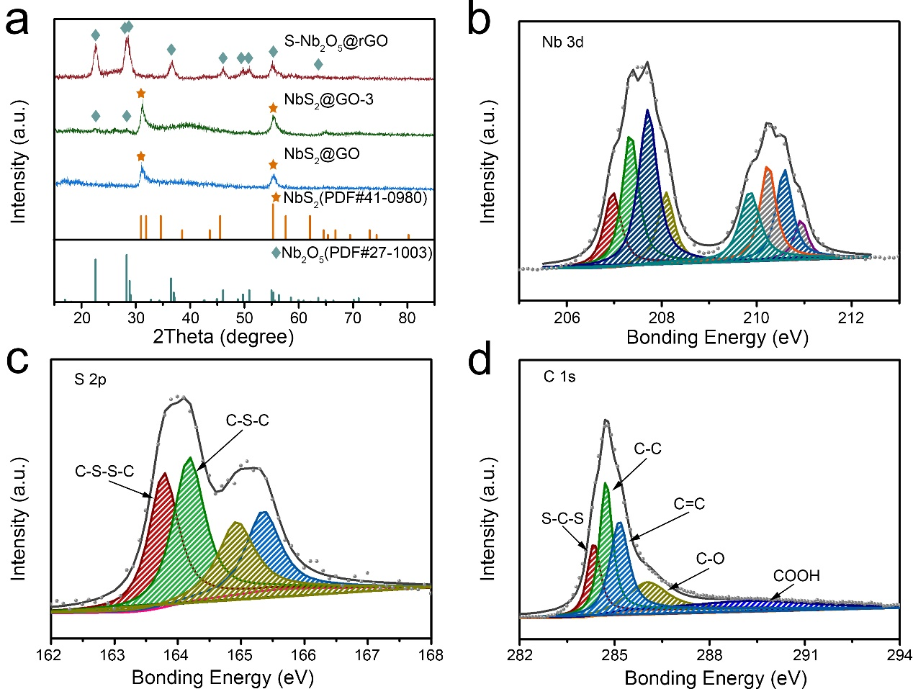Figure 1.** (a) XRD patterns of S-Nb2O5@rGO, NbS2@GO-3, and NbS2@GO. In addition to the PDF cards (T-Nb2O5, PDF#27-1003, marked with cyan rhombus; NbS2, PDF#41-0980, marked with orange pentagram). (b-d) XPS spectra of of Nb 3d, S 2p and C 1s for S-Nb2O5@rGO composite .

To further investigate the morphology and microstructure of S-Nb2O5@rGO composite were characterized by scanning electron microscopy (SEM) and transmission electron microscopy (TEM). The minuscule Nb2O5 nanosheets are uniformly spread on the surface of rGO with small thickness, as shown in Figure 2a. The TEM image in Figure 2b further shows that a large scale nanosheets were uniformly grown on the rGO. Enlarged TEM image in Figures 2c reveal that the circular Nb2O5 nanosheets have a uniform diameter of ~20 nm and the thickness of Nb2O5 nanosheets extends for [several](http://cn.bing.com/dict/clientsearch?mkt=zh-CN&setLang=zh&form=BDVEHC&ClientVer=BDDTV3.5.0.4311&q=several" \t "_blank) nm. **Figure 2**d is the HRTEM image and the corresponding Fast Fourier Transform (FFT) image of a nanosheet. The interplanar distances were measured to be 0.39 nm and 0.31 nm, which correspond to the d-spacing of (001) and (200) planes, respectively, in the orthorhombic Nb2O5 phase. Figure 2e presents an energy-dispersive X-ray spectroscopy (EDX) pattern of S-Nb2O5@rGO, which clearly illuminates the presence of Nb, O and S elements.. As denoted in the figure, the S element is well-dispersed on the surface of the Nb2O5 nanosheet and rGO, which suggests the successful S doping on the Nb2O5 nanosheet and rGO to form S-Nb2O5@rGO composite.

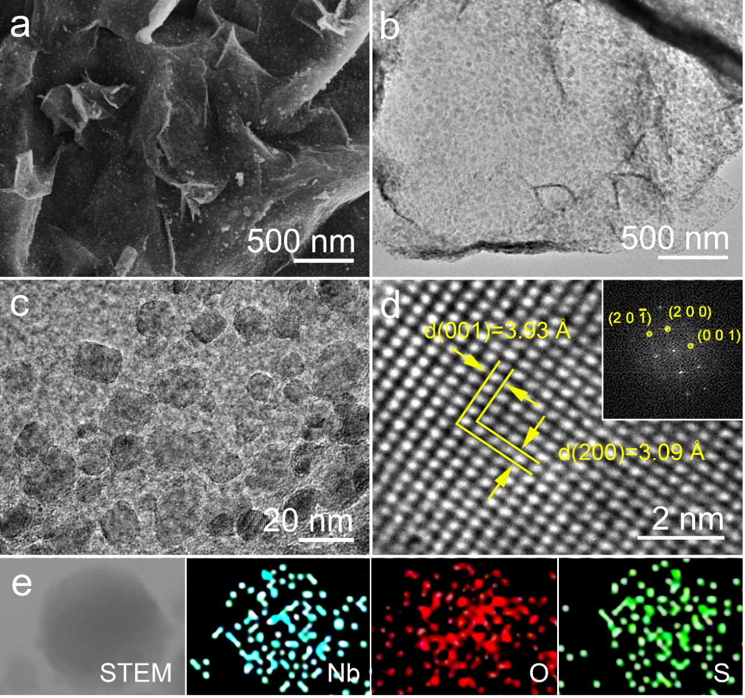

**Figure 2.** (a) SEM images of S-Nb2O5@rGO composite. (b) and (c) TEM image of S-Nb2O5@rGO composite. (d) HRTEM image of S-Nb2O5@rGO composite; the insets show the corresponding FFT image. (e) The EDX elemental mapping of S-Nb2O5@rGO composite, showing elements of Nb, O and S, respectively.