

PRML（Midterm）



学 院（系）： 电子信息与电气工程学部

专 业： 计算机科学与技术

班 级： 电计1704

学 生 姓 名： 谢玉宁

学 号： 201792260

完 成 日 期： 2020年5月30日

**Problem 1: Maximizing-A-Posterior (MAP) Decision Rule and Maximum likelihood Estimation (MLE) (35 points)**

1. Samples:

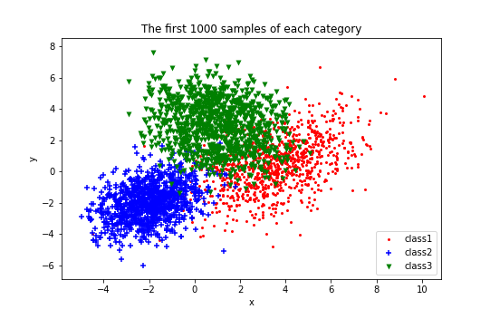

(b)

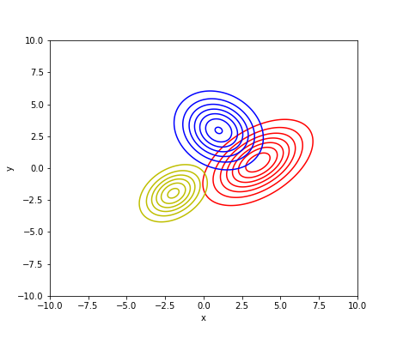

Fig class-conditional densities for each class with 1000 samples

(c)

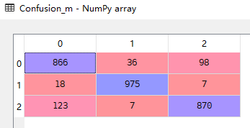



The misclassification rates are 12.4%, 2.5% and 13% for each class under the MAP decision rule.

(d)

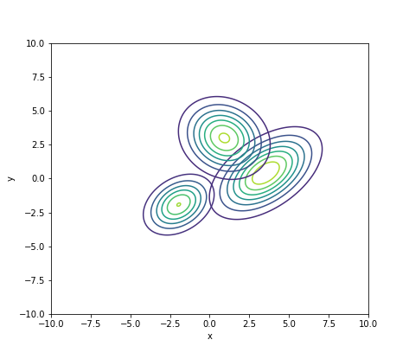

Fig 2 class-conditional densities for each class with 500 samples

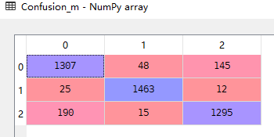 

The misclassification rates are 12.87%, 2.46% and 13.67% for each class under the MAP decision rule.

(e)

The misclassification rates of different numbers of training samples are close, so we can extrapolate that even a small amount of training data can build a good classifier when the distribution of data is known. In other words, if the distribution of data we assume are close to real distribution of data, the training samples we need to build a good classifier will be small.

**Problem 2: Parzen Window Estimation and k-Nearest Neighbor (k-NN) Estimation (40 points)**

(a)

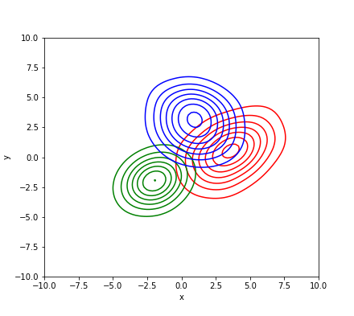

Fig 3 the parzen window estimate of density function of each category

(b)

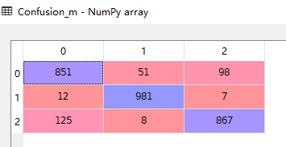



The misclassification rates are 14.9%, 1.9% and 13.3% for each class under the MAP decision rule.

(c)

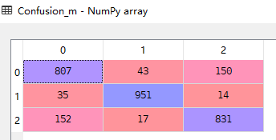



The misclassification rates are 19.3%, 4.9% and 16.9% for each class by the NN classifier.

(d)

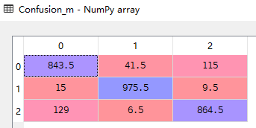



The misclassification rates are 15.65%, 2.45% and 13.55% for each class under the MAP decision rule.

(e)

By comparing the misclassification rates of NN classifier and kNN classifier, the misclassification rate gets smaller as the k gets larger within limits.