/lib/lsb/init-functions is needed

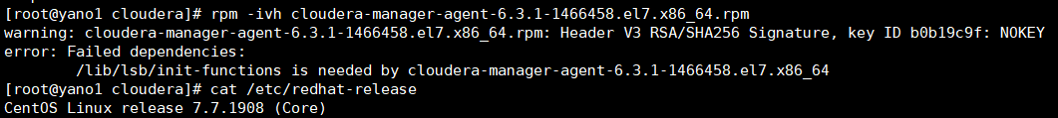

解决办法：yum install redhat-lsb