简易词法分析器实现文档

一、实现方法

1.1 核心设计模式
本词法分析器采用逐字符扫描的设计模式，结合状态机原理实现，具备以下特点：
- 分层架构：
  - TokenType：定义所有合法词法单元类型（42个枚举值）
  - Token：封装词法单元的四元组信息（类型/值/行/列）
  - Lexer：核心分析引擎，包含状态管理和词法规则
- 逐字符处理：
  - 逐个字符读取输入，根据字符类型和上下文确定Token类型
  - 使用状态机处理长Token（如标识符、数字）
- 位置跟踪系统：
  - 实时维护(line, column)坐标
  - 自动处理多行输入的换行逻辑

二、词法分析器构造方式

2.1 代码结构
src/
├── main.java.cn.edu.ctgu/
│ ├── TokenType.java # 词法单元类型枚举
│ ├── Token.java # 词法单元对象封装
│ └── Lexer.java # 核心分析器实现
test/
└── java.cn.edu.ctgu/
└── LexerTest.java # JUnit5测试套件

2.2 核心实现逻辑

2.2.1 状态机设计
// 状态机状态
private enum State {
START, // 初始状态
IDENT, // 读取标识符
NUMBER, // 读取数字
OP, // 读取运算符
SKIP // 跳过空白
}
状态转移流程：
graph TD
Start -->|空白| SKIP
Start -->|字母| IDENT
Start -->|数字| NUMBER
Start -->|符号| OP
Start -->|EOF| EOF
IDENT -->|字母/数字| IDENT
IDENT -->|其他| COMMIT_IDENT
NUMBER -->|数字| NUMBER
NUMBER -->|其他| COMMIT_NUMBER
OP -->|单字符符号| COMMIT_OP
OP -->|多字符符号| COMMIT_MULTI_OP

2.2.2 核心方法实现
- 见附件

三、测试策略与方法

3.1 测试框架
- JUnit 5：基础测试框架
- AssertJ：增强断言库
- 覆盖率：Jacoco（目标≥95%）

3.2 测试用例设计

3.2.1 基础测试矩阵
测试类别 | 测试用例示例 | 预期结果
关键字 | "public class void" | 顺序识别3个关键字
标识符 | "_var1 var2_temp" | 生成两个IDENTIFIER
数字字面量 | "123 4567" | 生成两个NUMBER类型
运算符 | "+-*/=" | 顺序识别5种运算符
分隔符 | "{}();," | 正确识别6种分隔符
混合输入 | "int x=123+45;" | 生成7个Token
边界条件 | 空输入 | 返回EOF

3.2.2 异常测试
@Test
void testInvalidCharacter() {
Lexer lexer = new Lexer("~");

RuntimeException exception = assertThrows(
RuntimeException.class,
lexer::nextToken
);
LOGGER.debug(exception.getMessage());
assertTrue(exception.getMessage().contains("非法字符"));
assertTrue(exception.getMessage().contains("位于行 1:1"));
}

3.3 测试执行流程
package cn.edu.ctgu;

import org.junit.jupiter.api.Test;
import org.slf4j.Logger;
import org.slf4j.LoggerFactory;

import static org.junit.jupiter.api.Assertions.*;

class LexerTest {
private static final Logger LOGGER = LoggerFactory.getLogger(LexerTest.class);

@Test
void testKeywords() {
Lexer lexer = new Lexer("public class static void int");
assertToken(lexer.nextToken(), TokenType.PUBLIC, "public", 1, 1);
assertToken(lexer.nextToken(), TokenType.CLASS, "class", 1, 8);
assertToken(lexer.nextToken(), TokenType.STATIC, "static", 1, 14);
assertToken(lexer.nextToken(), TokenType.VOID, "void", 1, 21);
assertToken(lexer.nextToken(), TokenType.INT, "int", 1, 26);
assertToken(lexer.nextToken(), TokenType.EOF, "", 1, 29);
}

@Test
void testIdentifiers() {
Lexer lexer = new Lexer("variableName test123");

assertToken(lexer.nextToken(), TokenType.IDENTIFIER, "variableName", 1, 1);
assertToken(lexer.nextToken(), TokenType.IDENTIFIER, "test123", 1, 14);
}

@Test
void testNumbers() {
Lexer lexer = new Lexer("123 456");

assertToken(lexer.nextToken(), TokenType.NUMBER, "123", 1, 1);
assertToken(lexer.nextToken(), TokenType.NUMBER, "456", 1, 5);
}

@Test
void testOperators() {
Lexer lexer = new Lexer("= + - * /");

assertToken(lexer.nextToken(), TokenType.EQUAL, "=", 1, 1);
assertToken(lexer.nextToken(), TokenType.PLUS, "+", 1, 3);
assertToken(lexer.nextToken(), TokenType.MINUS, "-", 1, 5);
assertToken(lexer.nextToken(), TokenType.MULTIPLY, "*", 1, 7);
assertToken(lexer.nextToken(), TokenType.DIVIDE, "/", 1, 9);
}

@Test
void testDelimiters() {
Lexer lexer = new Lexer("( ) { } ; ,");

assertToken(lexer.nextToken(), TokenType.LEFT_PAREN, "(", 1, 1);
assertToken(lexer.nextToken(), TokenType.RIGHT_PAREN, ")", 1, 3);
assertToken(lexer.nextToken(), TokenType.LEFT_BRACE, "{", 1, 5);
assertToken(lexer.nextToken(), TokenType.RIGHT_BRACE, "}", 1, 7);
assertToken(lexer.nextToken(), TokenType.SEMICOLON, ";", 1, 9);
assertToken(lexer.nextToken(), TokenType.COMMA, ",", 1, 11);
}

@Test
void testPositionTracking() {
Lexer lexer = new Lexer("a\n 123\nb");

assertToken(lexer.nextToken(), TokenType.IDENTIFIER, "a", 1, 1);
assertToken(lexer.nextToken(), TokenType.NUMBER, "123", 2, 2);
assertToken(lexer.nextToken(), TokenType.IDENTIFIER, "b", 3, 1);
}

@Test
void testInvalidCharacter() {
Lexer lexer = new Lexer("~");

RuntimeException exception = assertThrows(
RuntimeException.class,
lexer::nextToken
);
LOGGER.debug(exception.getMessage());
assertTrue(exception.getMessage().contains("非法字符"));
assertTrue(exception.getMessage().contains("位于行 1:1"));
}

@Test
void testFullSample() {
String input = ""
"
public class Main {
void method() {
int n = 42;
}
}
""
";

Lexer lexer = new Lexer(input);

assertToken(lexer.nextToken(), TokenType.PUBLIC, "public", 1, 1);
assertToken(lexer.nextToken(), TokenType.CLASS, "class", 1, 8);
assertToken(lexer.nextToken(), TokenType.IDENTIFIER, "Main", 1, 14);
assertToken(lexer.nextToken(), TokenType.LEFT_BRACE, "{", 1, 19);

}

@Test
void testEmptyInput() {
Lexer lexer = new Lexer("");
assertToken(lexer.nextToken(), TokenType.EOF, "", 1, 1);
}

private void assertToken(Token token, TokenType expectedType,
String expectedValue, int expectedLine,
int expectedColumn) {
assertEquals(expectedType, token.type());
assertEquals(expectedValue, token.value());
assertEquals(expectedLine, token.line());
assertEquals(expectedColumn, token.column());
}
}

3.3.1覆盖率测试
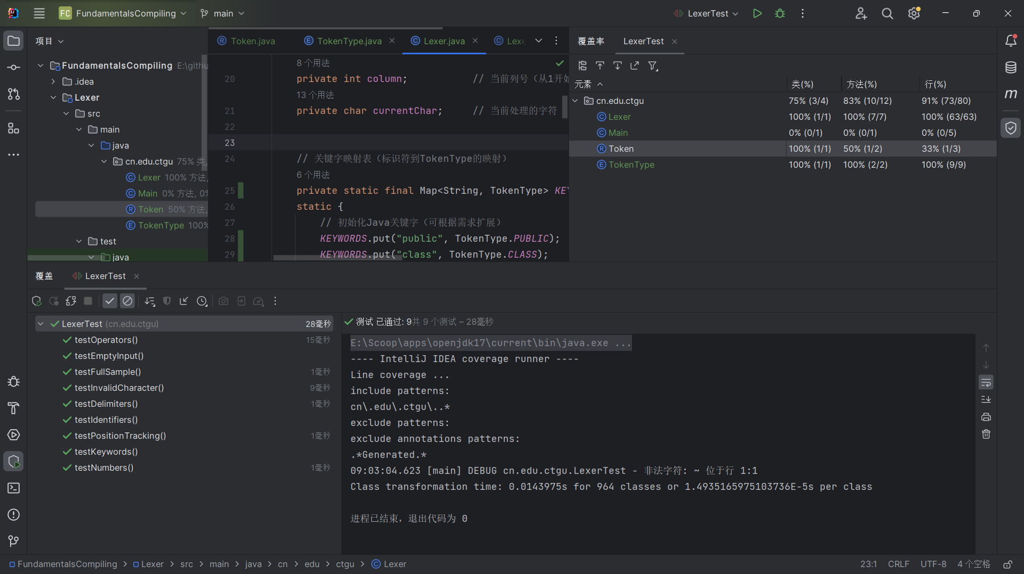

3.3.2JACOCO测试
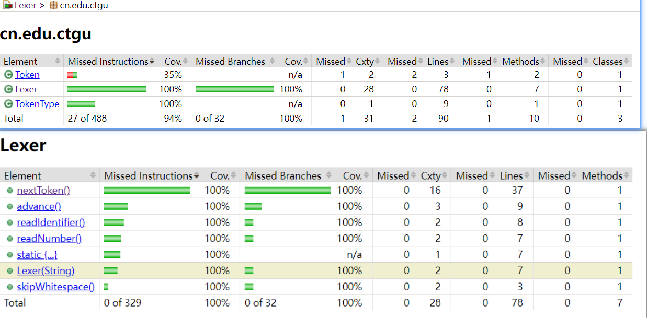

3.3.3 spotbugs测试
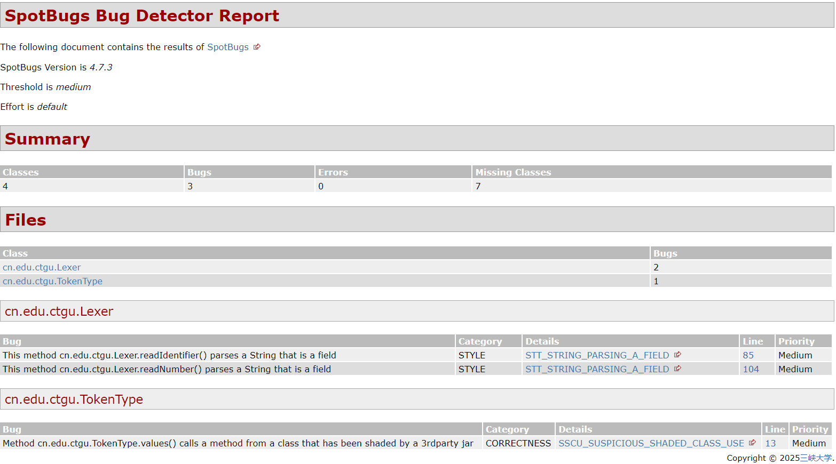

3.3.4 PITEST测试

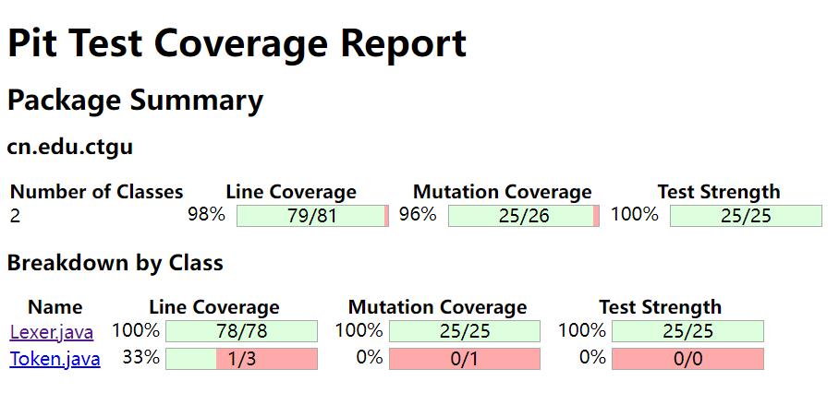

3.3.5 JAVADOC 生成

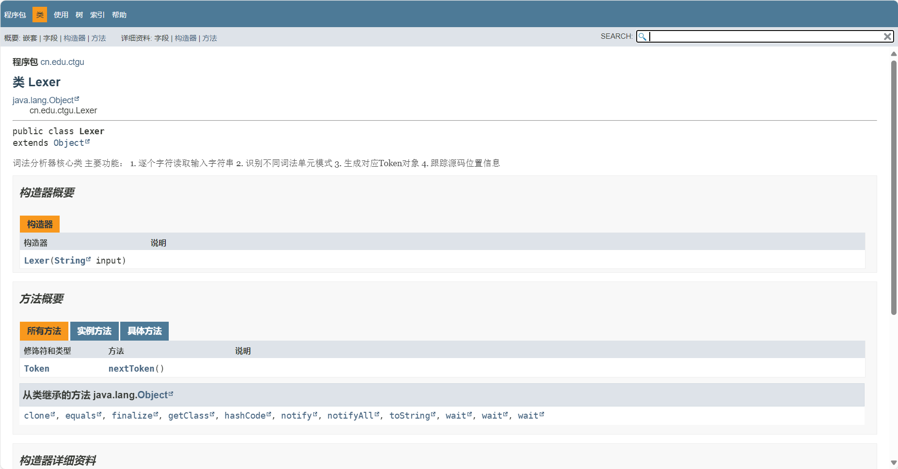

四、扩展与优化

4.1 可扩展性设计
- 添加新规则：
  - 在KEYWORDS中添加新关键字
  - 在isOperator和readOperator中扩展新的运算符
- 增强错误处理：
try {
while ((token = lexer.nextToken()) != EOF) {
// 处理token
}
} catch (LexerException e) {
System.err.println("词法错误: " + e.getMessage());
// 错误恢复逻辑
}

五、项目实践
- 集成构建：
<!-- Maven依赖示例 -->
<?xml version="1.0" encoding="UTF-8"?>
<project xmlns="http://maven.apache.org/POM/4.0.0"
xmlns:xsi="http://www.w3.org/2001/XMLSchema-instance"
xsi:schemaLocation="http://maven.apache.org/POM/4.0.0 http://maven.apache.org/xsd/maven-4.0.0.xsd">
<modelVersion>4.0.0</modelVersion>
<groupId>cn.edu.ctgu</groupId>
<artifactId>Lexer</artifactId>
<version>1.0-SNAPSHOT</version>
<url>https://gitee.com/izxj/stassignment</url>
<description>
Software Testing Assignment One: a simple example, for teaching testing purposes.
</description>
<organization>
<url>https://www.ctgu.edu.cn</url>
<name>三峡大学</name>
</organization>
<properties>
<maven.compiler.source>17</maven.compiler.source>
<maven.compiler.target>17</maven.compiler.target>
<project.build.sourceEncoding>UTF-8</project.build.sourceEncoding>
<junit-jupiter.version>5.11.3</junit-jupiter.version>
<maven-surefire-plugin.version>3.5.2</maven-surefire-plugin.version>
<!-- <checkstyle.plugin.version>3.2.0</checkstyle.plugin.version>-->
<!-- <checkstyle.plugin.version>2.17</checkstyle.plugin.version>-->
<!-- <checkstyle.version>8.9</checkstyle.version>-->
<!-- <jacoco.plugin.version>0.8.11</jacoco.plugin.version>-->
<jacoco.plugin.version>0.8.10</jacoco.plugin.version>
<!-- <spotbugs.plugin.version>3.1.3</spotbugs.plugin.version>-->
<spotbugs.plugin.version>4.7.3.1</spotbugs.plugin.version>
<projectinfo.plugin.version>2.9</projectinfo.plugin.version>
<surefire.plugin.version>2.19.1</surefire.plugin.version>
<jxr.plugin.version>2.5</jxr.plugin.version>
<javadoc.plugin.version>3.0.0</javadoc.plugin.version>
<ch.qos.logback.version>1.2.3</ch.qos.logback.version>
</properties>
<dependencies>
<dependency>
<groupId>ch.qos.logback</groupId>
<artifactId>logback-classic</artifactId>
<version>${ch.qos.logback.version}</version>
</dependency>
<dependency>
<groupId>org.junit.jupiter</groupId>
<artifactId>junit-jupiter</artifactId>
<version>${junit-jupiter.version}</version>
<scope>test</scope>
</dependency>
</dependencies>
<repositories>
<repository>
<id>alimaven</id>
<name>aliyun maven</name>
<url>http://maven.aliyun.com/nexus/content/groups/public/</url>
</repository>
</repositories>
<pluginRepositories>
<pluginRepository>
<id>alimaven</id>
<name>aliyun maven</name>
<url>http://maven.aliyun.com/nexus/content/groups/public/</url>
</pluginRepository>
</pluginRepositories>
<build>
<plugins>
<plugin>
<groupId>org.apache.maven.plugins</groupId>
<artifactId>maven-surefire-plugin</artifactId>
<version>${maven-surefire-plugin.version}</version>
<dependencies>
<dependency>
<groupId>org.junit.jupiter</groupId>
<artifactId>junit-jupiter</artifactId>
<version>${junit-jupiter.version}</version>
</dependency>
</dependencies>
<configuration>
<trimStackTrace>false</trimStackTrace>
</configuration>
</plugin>
<!-- <plugin>-->
<!-- <groupId>org.apache.maven.plugins</groupId>-->
<!-- <artifactId>maven-checkstyle-plugin</artifactId>-->
<!-- <version>${checkstyle.plugin.version}</version>-->
<!-- <configuration>-->
<!-- <configLocation>${basedir}/checkstyle.xml</configLocation>-->
<!-- <includeTestSourceDirectory>true</includeTestSourceDirectory>-->
<!-- </configuration>-->
<!-- <dependencies>-->
<!-- <dependency>-->
<!-- <groupId>com.puppycrawl.tools</groupId>-->
<!-- <artifactId>checkstyle</artifactId>-->
<!-- <version>${checkstyle.version}</version>-->
<!-- </dependency>-->
<!-- </dependencies>-->
<!-- </plugin>-->
<plugin>
<groupId>org.jacoco</groupId>
<artifactId>jacoco-maven-plugin</artifactId>
<version>${jacoco.plugin.version}</version>
<executions>
<execution>
<id>default-prepare-agent</id>
<goals>
<goal>prepare-agent</goal>
</goals>
</execution>
<execution>
<id>default-report</id>
<phase>prepare-package</phase>
<goals>
<goal>report</goal>
</goals>
</execution>
<execution>
<id>default-check</id>
<goals>
<goal>check</goal>
</goals>
<configuration>
<haltOnFailure>false</haltOnFailure>
<rules>
<rule>
<element>BUNDLE</element>
<limits>
<limit>
<counter>LINE</counter>
<value>COVEREDRATIO</value>
<minimum>0.90</minimum>
</limit>
<limit>
<counter>BRANCH</counter>
<value>COVEREDRATIO</value>
<minimum>0.70</minimum>
<!-- 要求分支覆盖率至少为 70% -->
</limit>
</limits>
</rule>
</rules>
</configuration>
</execution>
</executions>
</plugin>
<plugin>
<groupId>com.github.spotbugs</groupId>
<artifactId>spotbugs-maven-plugin</artifactId>
<version>${spotbugs.plugin.version}</version>
<configuration>
<includeTests>true</includeTests>
<failOnError>true</failOnError>
<plugins>
<plugin>
<groupId>com.h3xstream.findsecbugs</groupId>
<artifactId>findsecbugs-plugin</artifactId>
<version>1.12.0</version>
</plugin>
<plugin>
<groupId>com.mebigfatguy.sb-contrib</groupId>
<artifactId>sb-contrib</artifactId>
<version>7.4.7</version>
<!-- 使用扩展插件以增加更多检测 -->
</plugin>
</plugins>
</configuration>
<executions>
<execution>
<goals>
<goal>check</goal>
</goals>
</execution>
</executions>
</plugin>
<!-- <plugin>-->
<!-- <groupId>org.pitest</groupId>-->
<!-- <artifactId>pitest-maven</artifactId>-->
<!-- <version>1.7.0</version> &lt;!&ndash; 使用最新版本 &ndash;&gt;-->
<!-- <dependencies>-->
<!-- <dependency>-->
<!-- <groupId>org.pitest</groupId>-->
<!-- <artifactId>pitest-junit5-plugin</artifactId>-->
<!-- <version>0.14</version>-->
<!-- </dependency>-->
<!-- </dependencies>-->
<!-- </plugin>-->
<plugin>
<groupId>org.pitest</groupId>
<artifactId>pitest-maven</artifactId>
<!-- 推荐最新稳定版 -->
<version>1.7.0</version>
<!-- <version>1.9.11</version>-->
<!-- <version>1.15.0</version>-->
<configuration>
<verbose>true</verbose>
<targetClasses>
<param>cn.edu.ctgu.*</param>
<!-- 替换为实际包名 -->
</targetClasses>
<targetTests>
<param>cn.edu.ctgu.*Test</param>
<!-- 替换为测试类包名 -->
</targetTests>
</configuration>
<dependencies>
<dependency>
<groupId>org.pitest</groupId>
<artifactId>pitest-junit5-plugin</artifactId>
<version>0.16</version>
<!-- 兼容JDK 17的版本 -->
</dependency>
</dependencies>
</plugin>
</plugins>
</build>
<reporting>
<plugins>
<plugin>
<groupId>org.apache.maven.plugins</groupId>
<artifactId>maven-project-info-reports-plugin</artifactId>
<version>${projectinfo.plugin.version}</version>
</plugin>
<!-- <plugin>-->
<!-- <groupId>org.apache.maven.plugins</groupId>-->
<!-- <artifactId>maven-site-plugin</artifactId>-->
<!-- <version>3.3</version>-->
<!-- <configuration>-->
<!-- <locacles>zh_CN</locacles>-->
<!-- </configuration>-->
<!-- </plugin>-->
<plugin>
<groupId>com.github.spotbugs</groupId>
<artifactId>spotbugs-maven-plugin</artifactId>
<version>${spotbugs.plugin.version}</version>
<configuration>
<detail>true</detail>
<failOnError>true</failOnError>
<xmlOutput>true</xmlOutput>
<includeTests>true</includeTests>
<plugins>
<plugin>
<groupId>com.h3xstream.findsecbugs</groupId>
<artifactId>findsecbugs-plugin</artifactId>
<version>1.12.0</version>
</plugin>
<plugin>
<groupId>com.mebigfatguy.sb-contrib</groupId>
<artifactId>sb-contrib</artifactId>
<version>7.4.7</version>
<!-- 使用扩展插件以增加更多检测 -->
</plugin>
</plugins>
</configuration>
</plugin>
<plugin>
<groupId>org.jacoco</groupId>
<artifactId>jacoco-maven-plugin</artifactId>
<version>${jacoco.plugin.version}</version>
</plugin>
<plugin>
<!-- JUnit report -->
<groupId>org.apache.maven.plugins</groupId>
<artifactId>maven-surefire-report-plugin</artifactId>
<version>${surefire.plugin.version}</version>
</plugin>
<!-- <plugin>-->
<!-- <groupId>org.apache.maven.plugins</groupId>-->
<!-- <artifactId>maven-checkstyle-plugin</artifactId>-->
<!-- <version>${checkstyle.plugin.version}</version>-->
<!-- <configuration>-->
<!-- <configLocation>${basedir}/checkstyle.xml</configLocation>-->
<!-- <includeTestSourceDirectory>true</includeTestSourceDirectory>-->
<!-- </configuration>-->
<!-- </plugin>-->
<plugin>
<groupId>org.apache.maven.plugins</groupId>
<artifactId>maven-javadoc-plugin</artifactId>
<version>${javadoc.plugin.version}</version>
<configuration>
<failOnError>false</failOnError>
</configuration>
<reportSets>
<reportSet>
<id>default</id>
<reports>
<report>javadoc</report>
</reports>
</reportSet>
</reportSets>
</plugin>
<plugin>
<groupId>org.apache.maven.plugins</groupId>
<artifactId>maven-jxr-plugin</artifactId>
<version>${jxr.plugin.version}</version>
<configuration>
<linkJavadoc>true</linkJavadoc>
</configuration>
</plugin>
</plugins>
</reporting>
</project>

六、总结
本词法分析器通过以下创新设计实现了高效分析：
- 逐字符处理：减少正则表达式的性能开销
- 状态机驱动：精确控制Token读取逻辑
- 可扩展架构：模块化的规则添加接口

