重庆理工大学毕业设计（论文）

文 献 翻 译

学 院 计算机科学与工程学院
班 级 115030702
学生姓名 苏业纯 学 号 11503070233

译 文 要 求
1、译文内容必须与课题（或专业）内容相关，并需注明详细出处。
2、外文翻译译文不少于2000字；外文参考资料阅读量至少3篇（相当于10万外文字符以上）。
3、译文原文（或复印件）应附在译文后备查。

译 文 评 阅
导师评语（应根据学校“译文要求”，对学生外文翻译的准确性、翻译数量以及译文的文字表述情况等作具体的评价）

（要求手写，封面为第一页，此页为第二页，不得改变格式。）

指导教师：
年 月 日

推荐系统的协同过滤算法
概要
大部分的推荐系统使用协同过滤或者基于内容的推荐算法来预测用户的兴趣。这两种方法都有优点，但在许多情况下它们各自都不能给出一个令人满意的结果。 通过结合这两种方法形成一种混合推荐系统，可以克服这个缺点。在这篇论文中，我们介绍一种优雅高效的框架来组合二者。我们使用基于内容的推荐算法加强用户数据，然后通过协同过滤给出个性化的建议。我们将通过实验数据来证明，这种基于内容的协同过滤算法比纯基于内容的推荐算法、纯协同过滤算法和简单的混合算法表现更为优异。
内容介绍
推荐系统通过提供基于用户历史数据的个性化建议，来解决信息过载的问题。 许多在线商城都提供了推荐服务。 例如Amazon, CDNOW, Barnes& Noble, IMDb, 等等。 有两种盛行的方法来构建推荐系统— 协同过滤 (CF) 和 基于内容 (CB)的推荐。 协同过滤 (CF) 系统通过收集给定范围内条目的概率反馈和利用用户间个人信息的相同点和不同点来决定如何推荐条目。另一方面，基于内容的方法，通过与用户感兴趣的内容相比较来给用户提供建议。
基于内容的方法可以唯一地描述每个用户，但CF与他们相比仍有一些关键优势。首先，CF可以处理没有太多内容相关的条目的情况，或者电脑很难分析的内容——思想、意见等。其次CF系统具有推荐新信息的能力，即它可以推荐与用户相关，但不包含来自用户个人信息的条目。由于这些因素，CF系统已经相当成功地被用来构建推荐系统。但是它仍然面临两个根本问题：
稀疏
简单来说，大多数用户不关心大部分条目,因此“用户-条目”概率矩阵非常稀疏。所以找到一组有着显著相似概率的用户集合的可能性是非常低的。这就是通常情况下“条目-用户”比率非常高的原因。在系统的开始阶段，这个问题也是非常显著的。
第一流问题
除非用户评估过，否则该条目就不能被推荐。这个问题适用于新条目也适用于模糊的条目，并且对那些有着广泛兴趣的用户更为不利。
我们通过利用已经被评估过的条目的内容信息来克服CF系统的这个缺点。我们的基本方法使用基于内容的预测来将一个稀疏的用户评估矩阵转化为一个完整的评估矩阵，然后使用CF来提供建议。 在这篇论文中，我们提供基于内容的协同过滤 (CBCF)，这种新的混合类型的推荐框架。 我们在电影推荐领域使用这种框架来做测试，结果显示我们的方法比纯粹的CF和纯粹的基于内容的方法表现的更为优异。
领域描述
我们展示我们的方法在电影推荐领域的成果。我们使用由康柏系统研究中心提供的，来自EachMovie 的用户评估数据集。数据集包含每一位用户对各种电影的评估数据。用户评估范围从0到5星。0星代表极端讨厌一部电影，5星代表对该电影有着一个很高的评价。为了是我们的实验有一个快速的反应时间，我们只截取了EachMovie数据集的子集。这个数据集包含随机选取的7893名用户和1461部可以从互联网电影数据库(IMDb)获取的电影。缩减后的数据集有对1408部电影的299,997条评估。 平均每位用户的票数约是38票，用户评估矩阵的稀疏度约是97.4%。
每部电影的内容通过爬虫收集自IMDb。爬虫通过IMDb为EachMovie数据集中每一部电影提供的链接爬取数据。我们用每部电影的内容信息作为一些特性的集合。我们对每部电影使用的特性是：电影标题、导演、演员、流派、情节摘要、关键词、用户评论、外界评论、新闻评论、和获奖情况。
系统描述
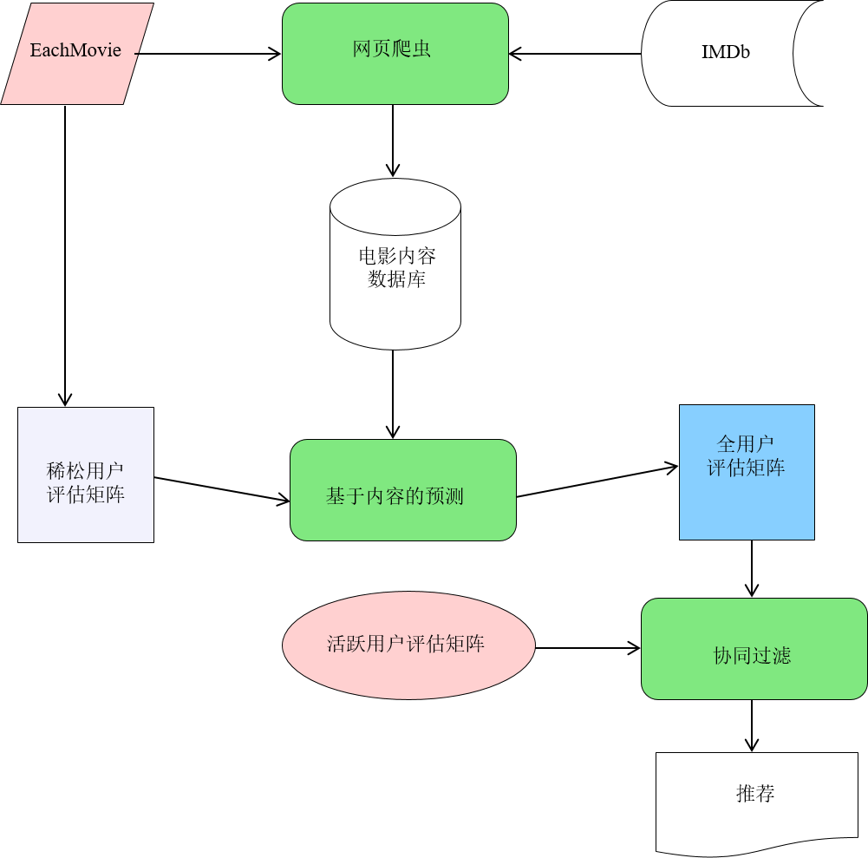
我们系统的概览如图1所示。 网络爬虫通过URL从IMDb下载电影信息。 之后，通过适当的预处理，电影信息被存入电影数据库。EachMovie 数据集也提供“用户-条目”评估矩阵， 每一个单体都是用户对电影的评估。我们将会引用矩阵的每一行作为用户向量。由于大部分电影没有被绝大多数用户评估，所以用户评估矩阵非常稀疏。基于每个用户评估向量训练内容预测并创建一个伪用户评估向量。伪用户评估向量包含用户真实的评估和对未评估条目的基于内容的预测。所有伪用户评估向量组合一起形成一个完整的评估矩阵。现在给出一个活跃用户的评估， CF将会利用完整的伪评估矩阵做出预测。
下面的区域描述了我们基于内容预测的实现和纯CF组件的实现，紧接着是我们的混合方法的细节。
纯基于内容的预测
为了提供基于内容的预测，我们把预测任务看成文本分类问题，讲电影内容信息视作文本文档，0-5的用户评估等级视作6个等级的标签。我们实现了一个文本朴素贝叶斯分类器扩展来处理单词的向量。其中每一个词袋对应一个电影特征（如标题、演员等）。我们使用分类器从一个评估电影的集合中得到用户的个人信息即标记文件。之后，标记文件被用来预测未评估电影的标签（评估）。一个相似的推荐方法已经被高效的用于书籍推荐系统Libra。
纯协同过滤
我们实现了一个使用基于邻域算法的纯粹的协同过滤算法组件。在基于领域的算法中，用户的子集通过他们与活跃用户的相似性选择出来，他们评估的加权平均数被用作为活跃用户产生预测。我们使用的这种算法可以被概括为以下几步：
1.将所有用户与活跃用户相比较。
用户间的相似性测量值作为他们评估矩阵的皮尔森数。
2.选择n个与活跃用户有着最高相似性的用户。
这些用户将形成领域。
3.从选择的领域的评估的加权平均数中计算出预测结果。
在第1步中, 用户的相似性计算结果被用作下面定义的皮尔森系数:
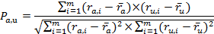

(1)
当 是用户a给定的条目， 代表用户a给定的评估， m则是条目总数。
在第3步中，预测被计算作为来自领域的平均偏差权重:
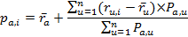

(2)
当 是用户a对条目i的预测时， Pa,u 使用户a和用户u之间的相似性。n是领域间用户的数量。在我们的实验中，我们使用的领域数量为30。
对于活跃用户来说，拥有高相关度基于少量重叠条目的领域是很常见的情况。这些基于很少重叠条目的领域倾向于做出不太理想的预测。为了降低基于很少条目的相关性，我们通过权重因子的概念来叠加相关性。当n 是重复条目数时，如果两个用户间有少于50个重复条目，我们通过权重因子sga,u = n/50叠加他们的相关性。如果重复条目超过50，我们将使相关性保持不变，即sga,u = 1。
基于内容的协同过滤
在基于内容的协同过滤中，我们首先为数据库中的每位用户创建一个伪用户评估向量。伪用户评估向量vu由用户u提供的评估条目组成，否则将由基于内容的预测器提供。

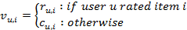

在上面的等式中 表示用户u对条目i的真实评估, 是纯内容推荐系统提供的评估预测。
所有用户的伪用户评估向量被组合在一起形成密集的伪评估向量V。我们现在使用这个稠密矩阵进行协同过滤。活跃用户a和其他用户u之间的相似度通过等式1中描述的皮尔森系数来计算。我们使用伪用户评估向量来代替最初的用户投票。
实验评估
在本节中,我们描述了实现方法和我们比较不同预测算法的指标。同时也展示了我们的实验结果。
讨论
在本节中,我们解释基于内容的协同过滤是如何克服的一些纯CF的缺点。同时，我们也讨论一些改善CBCF的方法。
克服第一流问题
在纯CF中预测不能单独为一个条目或者一个活跃用户产生，除非它提前被其他用户评估过。不过,我们可以为用户使用基于内容的预测做出这样的预测。使用CBCF利用其他用户的基于内容的预测我们可以进一步改善CB预测。如果活跃用户的领域是高度相关的,那么他们的CB预测也应该非常相关。如果领域比活跃用户做出了更多的评估的情况下，更是如此。因为他们的CB预测很可能比活跃用户的更准确。我们进行下面的实验来验证这一假设。我们从EachMovie数据集中随机选择500个 用户。我们随机选择一个项目从用户评分矩阵中删除。然后我们为已经评估了选中条目的用户生成纯基于内容和CBCF的预测。我们重复这个过程55次。我们发现纯CB预测和CBCF的MAEs值分别为1.060和1.023。差异显著(p < 0.001)。所以我们可以得出结论,使用协作信息是有益的,即使没有其他用户评分项的问题。这样，CBCF方法解决了头等货问题,并比基于内容的预测产生更好的预测。
处理稀疏
在CBCF中,因为我们使用一个完整的伪评级矩阵来消除稀疏的根源问题。伪用户评分向量包含所有项目评级;因此所有用户将被视为潜在的领域。这增加了寻找相似用户的可能性。因此用户评分矩阵的稀疏影响程度CBCF小于CF。我们进行下面的实验来验证这一假设。从EachMovie数据集随机选择一组1000个用户。我们选取500个用户作为测试用户，对他们评估过的25%的条目做出预测。
内容
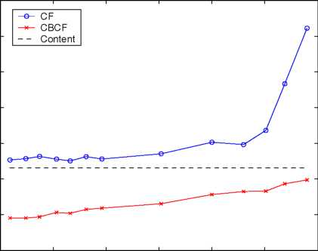
通过随机丢弃矩阵中的元素，我们人为增加了用户评分矩阵的稀疏程度。我们比较不同稀疏等级下的MAE值。图2证实我们的假设，CBCF比CF更稳定。事实上,当稀疏超过99%,CF的性能急剧下降,虽然CBCF 关联未受影响。单在极限情况下,CBCF将收敛于纯粹的基于内容的预测。
寻找更好的领域
CF关键一步是选择一个领域。活跃用户的领域完全决定他的预测结果。因此选择与活跃用户最相似的领域是最关键的。在纯粹的CF包括与活跃用户相关的n个最有关联的用户。用户间的相似性仅有给定的重复条目评估决定。所有没有得到任何一个用户评估的条目将会被忽略。但是在CBCF中,相似性是基于评级中包含伪用户评分向量决定的。因此用户不需要高度重叠。我们认为CBCF的这一特性,可以选择一个更好的,更有代表性的领域。例如,考虑两个用户提供相同的口味没有额定任何物品共同之处。纯粹的协同过滤不会考虑他们相似。然而,伪用户评级向量使用基于内容的创建两个用户的预测将是高度相关,因此他们会被认为是领域。
提升CBCF
由于我们的混合方法的本质,我们相信,提高各个组件的性能几乎肯定会提高整个系统的性能。换句话说,如果我们加强纯粹的基于内容的预测或CF算法,我们将能够提高系统的预测。更好的基于内容的预测意味着伪评级矩阵生成更精确的近似实际的完整用户评分矩阵。反过来,这将提高找到更多有代表性领域的机会。既然最终的预测在我们的系统是基于一个CF算法,更好的CF算法只能改进我们的系统的性能。
在我们当前的实现基于内容的预测中,我们使用一个朴素贝叶斯文本分类器学习六个方法分类的任务。这种方法可能不是理想的,因为它忽视了类表示评级在线性范围内这一事实。这个问题可以通过使用学习算法直接产生数值预测来克服。例如,逻辑回归和局部加权回归可以用来从项目内容直接预测评级。使用这些方法之一，我们应该能够提高基于内容的预测。此外，在我们的系统中使用一个集群皮尔森预测，CF组件可能会得到提高。协同预测只使用集群质心作为潜在的领域。费舍尔等人宣称,这种方法比纯粹的CF算法更准确,更具有可伸缩的优势。
相关工作
已经有了一些对组合内容信息和协同过滤算法的尝试。一种简单的途径是允许这两种方法分别提供独立的推荐内容，然后直接组合它们的推荐。而另一种方法，术语文档矩阵与用户评估矩阵叠加形成个性化内容矩阵。 利用潜在语义索引，计算出个性化内容矩阵的近似值排名k 。用户关联文档的术语矩阵被用来生成用户个性化文件。在 Pazzani的方法中，每位用户的个性化文件由单词的权重向量代替。通过CF产生的预测被直接应用于用户个性化文件（作为用户评估矩阵的对立面）。一种备用方案是Fab，使用相关的反馈来同时模拟公共主题过滤器中的个人过滤器。文档被主题过滤器初始化范围然后发送给用户过滤器。用户相关反馈，被用来修改个人过滤器和最初的主题过滤器。另一种方法，Basu讲推荐视作分类。他们使用一个介绍系统的规则来学习用户喜欢或者是不喜欢一部电影。他们通过创建例如喜欢喜剧的用户和喜欢genre X的用户 的特性组合协同过滤和内容信息。 Good在许多个性化信息过滤代理中使用协同过滤。预测内容通过基于其他用户和活跃用户个性化代理运用协同过滤而产生。我们的方法也是用基于其他用户的个性化代理的协同过滤，但仍有不同。在近期的成果中，Lee把推荐任务视作学习用户表现的功能，利用条目内容和相似用户的评估数据。他们研究几个这方面工作的混合模型。 Popescul扩展霍夫曼的模型将三方用户,项目,项目内容，共现数据合并。他们提出的处理稀疏方法与我们的很类似。他们即通过比较一个文档与该用户浏览过的所有文档的平均余弦，来预估一个用户获取之前没有见过的文档的可能性。我们的任务不同于他们的因为我们提供数值评级,而不是排名。并且他们的方法与EM框架有着很紧密的联系。而我们的方法更加模块化和通用,因此它独立于协同过滤和基于内容的组件的选择。
结论和预期
CBCF 优雅的利用的协同过滤框架中的内容。它克服了单纯的基于内容的算法和协同过滤算法的缺点。将来，由于我们对我们框架模块化的支持，任何协同过滤算法或者内容推荐算法，都将被非常简单地用来构建强大的系统。
尽管CBCF 总体表现优于CF，但是二者的差异并不是非常大没有超过4%。我们系统的表现可以通过早前描述的方法提高。
原文出处：http://www.aaai.org/Papers/AAAI/2002/AAAI02-029.pdf

Content-Boosted Collaborative Filtering for Improved Recommendations

Abstract
Most recommender systems use Collaborative Filtering or Content-based methods to predict new items of interest for auser. While both methods have their own advantages, individually they fail to provide good recommendations in many situations. Incorporating components from both methods, a hybrid recommender system can overcome these shortcomings. In this paper, we present an elegant and effective framework for combining content and collaboration. Our approach uses a content-based predictor to enhance existing user data, and then provides personalized suggestions through collaborative filtering. We present experimental results that show how this approach, Content-Boosted Collaborative Filtering, performs better than a pure content-based predictor, pure collaborative filter, and a naive hybrid approach.
Introduction
Recommender systems help overcome information overload by providing personalized suggestions based on a history of a user’s likes and dislikes. Many on-line stores provide recommending services e.g. Amazon, CDNOW, BarnesAnd- Noble, IMDb, etc. There are two prevalent approaches to building recommender systems — Collaborative Filtering (CF) and Content-based (CB) recommending. CF systems work by collecting user feedback in the form of ratings for items in a given domain and exploit similarities and differences among profiles of several users in determining how to recommend an item. On the other hand, content-based methods provide recommendations by comparing representations of content contained in an item to representations of content that interests the user.
Content-based methods can uniquely characterize each user, but CF still has some key advantages over them (Her- locker et al. 1999). Firstly, CF can perform in domains where there is not much content associated with items, or where the content is difficult for a computer to analyze — ideas, opinions etc. Secondly a CF system has the ability to provide serendipitous recommendations, i.e. it can recommend items that are relevant to the user, but do not contain content from the user’s profile. Because of these reasons, CF systems have been used fairly successfully to build recom- mender systems in various domains (Goldberg et al. 1992;
Copyright © 2002, American Association for Artificial Intelligence (www.aaai.org). All rights reserved.
Resnick et al. 1994). However they suffer from two fundamental problems:
Sparsity
Stated simply, most users do not rate most items and hence the user-item rating matrix is typically very sparse. Therefore the probability of finding a set of users with significantly similar ratings is usually low. This is often the case when systems have a very high item-to-user ratio. This problem is also very significant when the system is in the initial stage of use.
First-rater Problem
An item cannot be recommended unless a user has rated it before. This problem applies to new items and also obscure items and is particularly detrimental to users with eclectic tastes.
We overcome these drawbacks of CF systems by exploiting content information of the items already rated. Our basic approach uses content-based predictions to convert a sparse user ratings matrix into a full ratings matrix; and then uses CF to provide recommendations. In this paper, we present the framework for this new hybrid approach, Content-Boosted Collaborative Filtering (CBCF). We apply this framework in the domain of movie recommendation and show that our approach performs better than both pure CF and pure content-based systems.
Domain Description
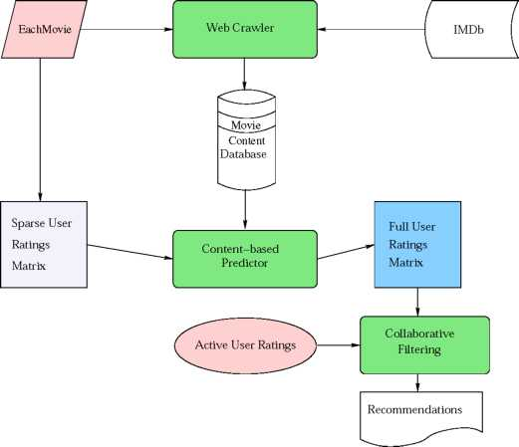
Figure 1: System Overview
We demonstrate the working of our hybrid approach in the domain of movie recommendation. We use the user-movie ratings from the EachMovie dataset, provided by the Compaq Systems Research Center. The dataset contains rating data provided by each user for various movies. User ratings range from zero to five stars. Zero stars indicate extreme dislike for a movie and five stars indicate high praise. To have a quicker turn-around time for our experiments, we only used a subset of the EachMovie dataset. This dataset contains 7,893 randomly selected users and 1,461 movies for which content was available from the Internet Movie Database (IMDb). The reduced dataset has 299,997 ratings for 1,408 movies. The average number of votes per user is approximately 38 and the sparsity of the user ratings matrix is 97.4%.
The content information for each movie was collected from IMDb using a simple crawler. The crawler follows the IMDB link provided for every movie in the EachMovie dataset and collects information from the various links off the main URL. We represent the content information of every movie as a set of slots (features). Each slot is represented simply as a bag of words. The slots we use for the Each- Movie dataset are: movie title, director, cast, genre, plot summary, plot keywords, user comments, external reviews, newsgroup reviews, and awards.
System Description
The general overview of our system is shown in Figure 1. The web crawler uses the URLs provided in the EachMovie dataset to download movie content from IMDb. After appropriate preprocessing, the downloaded content is stored in the Movie Content Database. The EachMovie dataset also provides the user-ratings matrix, which is a matrix of users versus items, where each cell is the rating given by a user to an item. We will refer to each row of this matrix as a user- ratings vector. The user-ratings matrix is very sparse, since most items have not been rated by most users. The content- based predictor is trained on each user-ratings vector and a pseudo user-ratings vector is created. A pseudo user-ratings vector contains the user’s actual ratings and content-based predictions for the unrated items. All pseudo user-ratings vectors put together form the pseudo ratings matrix, which is a full matrix. Now given an active user’s ratings, predictions are made for a new item using CF on the full pseudo ratings matrix.
The following sections describe our implementation of the content-based predictor and the pure CF component; followed by the details of our hybrid approach.
Pure Content-based Predictor
To provide content-based predictions we treat the prediction task as a text-categorization problem. We view movie content information as text documents, and user ratings 0-5 as one of six class labels. We implemented a bag-of-words naive Bayesian text classifier (Mitchell 1997) extended to handle a vector of bags of words; where each bag-of-words corresponds to a movie-feature (e.g. title, cast, etc.). We use the classifier to learn a user profile from a set of rated movies
e. labeled documents. The learned profile is then used to predict the label (rating) of unrated movies. A similar approach to recommending has been used effectively in the book-recommending system Libra (Mooney & Roy 2000).
Pure Collaborative Filtering
We implemented a pure collaborative filtering component that uses a neighborhood-based algorithm (Herlocker et al. 1999). in neighborhood-based algorithms, a subset of users are chosen based on their similarity to the active user, and a weighted combination of their ratings is used to produce
predictions for the active user. The algorithm we use can be summarized in the following steps:
Weight all users with respect to similarity with the active user.
Similarity between users is measured as the Pearson correlation between their ratings vectors.
Select n users that have the highest similarity with the active user.
These users form the neighborhood.
Compute a prediction from a weighted combination of the selected neighbors’ ratings.
In step 1, similarity between two users is computed using the Pearson correlation coefficient, defined below:
where ra,i is the rating given to item i by user a; Ta is the mean rating given by user a; and m is the total number of items.
In step 3, predictions are computed as the weighted average of deviations from the neighbor’s mean:
where pa,i is the prediction for the active user a for item i; Pa,u is the similarity between users a and u; and n is the number of users in the neighborhood. For our experiments we used a neighborhood size of 30, based on the recommendation of (Herlocker etal. 1999).
It is common for the active user to have highly correlated neighbors that are based on very few co-rated (overlapping)
items. These neighbors based on a small number of overlapping items tend to be bad predictors. To devalue the correlations based on few co-rated items, we multiply the correlation by a Significance Weighting factor (Herlocker et al. 1999). If two users have less than 50 co-rated items we multiply their correlation by a factor sga,u = n/50, where n is the number of co-rated items. If the number of overlapping items is greater than 50, then we leave the correlation unchanged i.e. sga,u = 1.
Content-Boosted Collaborative Filtering
In content-boosted collaborative filtering, we first create a pseudo user-ratings vector for every user u in the database. The pseudo user-ratings vector, vu, consists of the item ratings provided by the user u, where available, and those predicted by the content-based predictor otherwise.
ru,i ： if user u rated item i Cu,i ： otherwise
In the above equation ru,i denotes the actual rating provided by user u for item i, while cu,i is the rating predicted by the pure content-based system.
The pseudo user-ratings vectors of all users put together give the dense pseudo ratings matrix V. We now perform collaborative filtering using this dense matrix. The similarity between the active user a and another user u is computed using the Pearson correlation coefficient described in Equation 1. Instead of the original user votes, we substitute the votes provided by the pseudo user-ratings vectors Va and vu.
Harmonic Mean Weighting The accuracy of a pseudo user-ratings vector computed for a user depends on the number of movies he/she has rated. If the user rated many items, the content-based predictions are good and hence his pseudo user-ratings vector is fairly accurate. On the other hand, if the user rated only a few items, the pseudo user-ratings vector will not be as accurate. We found that inaccuracies in pseudo user-ratings vector often yielded misleadingly high correlations between the active user and other users. Hence to incorporate confidence (or the lack thereof) in our correlations, we weight them using the Harmonic Mean weighting factor (HM weighting).
using 10-fold cross-validation (Mitchell 1997). To test performance on varying amounts of training data, a learning curve was generated by testing the system after training on increasing subsets of the overall training data. We generated learning curves for 132 users who had rated more than 200 items. The points on the 132 curves were averaged to give the final learning curve. From the learning curve we noted that as the predictor is given more and more training examples the prediction performance improves, but at around 50 it begins to level off. Beyond this is the point of diminishing returns; as no matter how large the training set is, prediction accuracy improves only marginally.
To the HM weight, we add the significance weighting factor described earlier, and thus obtain the hybrid correlation
Self Weighting Recall that in CF, a prediction for the active user is computed as a weighted sum of the mean- centered votes of the best-n neighbors of that user. In our approach, we also add the pseudo active user to the neighborhood. However, we may want to give the pseudo active user more importance than the other neighbors. In other words, we would like to increase the confidence we place in the pure-content predictions for the active user. We do this by incorporating a Self Weighting factor in the final prediction:
where na is the number of items rated by the active user. Again, the choice of the threshold 50 is motivated by the learning curve mentioned earlier. The parameter max is an indication of the over-all confidence we have in the content- based predictor. In our experiments, we used a value of 2 for max.
Producing Predictions Combining the above two weighting schemes, the final CBCF prediction for the active user a and item is produced as follows:

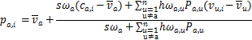

In the above equation Ca,i corresponds to the pure-content predictions for the active user and item i; vu,i is the pseudo user-rating for a user u and item i; Vu is the mean over all items for that user; swa, hwa,u and Pa,u are as shown in Equations 4, 3 and 1 respectively; and n is the size of neighborhood. The denominator is a normalization factor that ensures all weights sum to one
Experimental Evaluation
In this section we describe the experimental methodology and metrics we use to compare different prediction algorithms; and present the results of our experiments.

Methodology
We compare CBCF to a pure content-based predictor, a CF predictor, and a naive hybrid approach. The naive hybrid approach takes the average of the ratings generated by the pure content-based predictor and the pure CF predictor. For the purposes of comparison, we used a subset of the ratings data from the EachMovie data set (described earlier). Ten percent of the users were randomly selected to be the test users. From each user in the test set, ratings for 25% of items were withheld. Predictions were computed for the withheld items using each of the different predictors.
The quality of the various prediction algorithms were measured by comparing the predicted values for the withheld ratings to the actual ratings.
Metrics
The metrics for evaluating the accuracy of a prediction algorithm can be divided into two main categories: statistical accuracy metrics and decision-support metrics (Herlocker et al. 1999). Statistical accuracy metrics evaluate the accuracy of a predictor by comparing predicted values with user- provided values. To measure statistical accuracy we use the mean absolute error (MAE) metric — defined as the average absolute difference between predicted ratings and actual ratings. In our experiments we computed the MAE on the test set for each user, and then averaged over the set of test users.
Decision-support accuracy measures how well predictions help users select high-quality items. We use Receiver Operating Characteristic (ROC) sensitivity to measure decision-support accuracy. A predictor can be treated as a filter, where predicting a high rating for an item is equivalent to accepting the item, and predicting a low rating is equivalent to rejecting the item. The ROC sensitivity is given by the area under the ROC curve — a curve that plots sensitivity versus 1-specificity for a predictor. Sensitivity is defined as the probability that a good item is accepted by the filter; and specificity is defined as the probability that a bad item is rejected by the filter. We consider an item good if the user gave it a rating of 4 or above, otherwise we consider the item bad. We refer to this ROC sensitivity with threshold 4 as ROC-4. ROC sensitivity ranges from 0 to 1, where 1 is ideal and 0.5 is random.
The statistical significance of any differences in performance between two predictors was evaluated using twotailed paired t-tests (Mitchell 1997).
Results
Algorithm | MAE | ROC-4
Pure content-based (CB) predictor | 1.059 | 0.6376
Pure CF | 1.002 | 0.6423
Naive Hybrid | 1.011 | 0.6121
Content-boosted CF | 0.962 | 0.6717
Table 1: Summary of Results
The results of our experiments are summarized in Table 1. As can be seen, our CBCF approach performs better than the other algorithms on both metrics. On the MAE metric, CBCF performs 9.2% better than pure CB, 4% better than pure CF and 4.9% better than the naive hybrid. All the differences in MAE are statistically significant (p < 0.001).
On the ROC-4, metric CBCF performs 5.4% better than pure CB, 4.6% better than pure CF and 9.7% better than the naive hybrid. This implies that our system, compared to others, does a better of job of recommending high-quality items, while reducing the probability of recommending bad items to the user.
Interestingly, Self Weighting did not make significant improvements to our predictions. We believe that SelfWeighting would play a more important role if the pure CB predictor significantly outperformed CF.
Discussion
In this section we explain how content-boosted collaborative filtering overcomes some of the shortcomings of pure CF; and we also discuss some ways of improving CBCF.
Overcoming the First-Rater Problem
In pure CF a prediction cannot be made for an item, for the active user, unless it was previously rated by other users. However, we can make such a prediction using a content- based predictor for the user. Using CBCF we can further improve the CB predictions by utilizing the content-based predictions of other users as well. If the neighbors of the active user are highly correlated to it, then their CB predictions should also be very relevant to the user. This is particularly true if neighbors have rated many more items than the active user; because their CB predictions are likely to be more accurate than the active user’s. To verify this hypothesis we ran the following experiments. A set of 500 users were selected at random from the EachMovie data set. We randomly selected an item to be deleted from the user-ratings matrix. We then produced pure content-based and CBCF predictions for the users that had rated the selected item. We repeated this process for 55 items and averaged the MAE over all users and items. We found that the MAEs for the pure CB predictor and CBCF were 1.060 and 1.023 respectively; and that the difference is statistically significant (p < 0.001). So we can conclude that using collaborative information is beneficial even if no other user has rated the item in question. In this way, CBCF solves the first-rater problem, and produces even better predictions than the content-based predictor.
Tackling Sparsity
In CBCF, since we use a pseudo ratings matrix, which is a full matrix, we eliminate the root of the sparsity problem. Pseudo user-ratings vectors contain ratings for all items; and hence all users will be considered as potential neighbors. This increases the chances of finding similar users. Thus the sparsity of the user-ratings matrix affects CBCF to a smaller degree than CF. To verify this hypothesis we ran the following experiments. A set of 1000 users were selected at random from the EachMovie data set. We treated 500 of these users as test users, and produced predictions on 25% of the items they rated. We artificially increased the sparsity of the user-ratings matrix, by randomly dropping elements from the matrix. We compared the MAE of the different predictors at varying levels of sparsity. Figure 2 confirms our hypothesis that CBCF is more stable than CF with respect to sparsity. In fact, when sparsity exceeds 99%, the performance of CF drops precipitously, while CBCF is relatively unaffected. In the limit, CBCF will converge to pure content-based predictions.
Finding Better Neighbors
A crucial step in CF is the selection of a neighborhood. The neighbors of the active user entirely determine his predictions. It is therefore critical to select neighbors who are most similar to the active user. In pure CF, the neighborhood comprises of the users that have the best n correlations with the active user. The similarity between users is only determined by the ratings given to co-rated items; so items that have not been rated by both users are ignored. However, in CBCF, the similarity is based on the ratings contained in the pseudo user-ratings vectors; so users do not need to have a high overlap of co-rated items to be considered similar. Our claim is that this feature of CBCF, makes it possible to select a better, more representative neighborhood. For example, consider two users with identical tastes who have not rated any items in common. Pure collaborative filtering would not consider them similar. However, pseudo user- ratings vectors created using content-based predictions for the two users would be highly correlated, and therefore they would be considered neighbors. We believe that this superior selection of neighbors is one of the reasons that CBCF outperforms pure CF.
Improving CBCF
Due to the nature of our hybrid approach, we believe that improving the performance of the individual components would almost certainly improve the performance of the whole system. In other words, if we improved our pure content-based predictor or the CF algorithm, we would be able to improve our system’s predictions. A better content- based predictor would mean that the pseudo ratings matrix generated would more accurately approximate the actual full user-ratings matrix. This in turn, would improve the chances of finding more representative neighbors. And since the final predictions in our system are based on a CF algorithm, a better CF algorithm can only improve our system’s performance.
In our current implementation of the content-based predictor, we use a naive Bayesian text-classifier to learn a sixway classification task. This approach is probably not ideal, since it disregards the fact that classes represent ratings on a linear scale. This problem can be overcome by using a learning algorithm that can directly produce numerical predictions. For example, logistic regression and locally weighted regression (Duda, Hart, & Stork 2000) could be used to directly predict ratings from item content. We should be able to improve our content-based predictions using one of these approaches. In addition, the CF component in our system may be improved by using a Clustered Pearson Predictor (CPP) (Fisher et al. 2000). The CPP algorithm creates clusters of users based on 念-means clustering. Collaborative predictions are made by only using the cluster centroids as potential neighbors. Fisher et al. claim that this approach is more accurate than the pure CF algorithm, with the added advantage of being more scalable.
Related Work
There have been a few other attempts to combine content information with collaborative filtering. One simple approach is to allow both content-based and collaborative filtering methods to produce separate recommendations, and then to directly combine their predictions (Cotter & Smyth 2000; Claypool, Gokhale, & Miranda 1999). In another approach (Soboroff & Nicholas 1999), the term-document matrix is multiplied with the user-ratings matrix to produce a content- profile matrix. Using Latent Semantic Indexing, a rank- k approximation of the content-profile matrix is computed. Term vectors of the user’s relevant documents are averaged to produce a user’s profile. Now, new documents are ranked against each user’s profile in the LSI space. In Pazzani’s approach (1999), each user-profile is represented by a vector of weighted words derived from positive training examples using the Winnow algorithm. Predictions are made by applying CF directly to the matrix of user-profiles (as opposed to the user-ratings matrix). An alternate approach, Fab (Bal- abanovic & Shoham 1997), uses relevance feedback to simultaneously mold a personal filter along with a communal “topic” filter. Documents are initially ranked by the topic filter and then sent to a user’s personal filter. The user’s relevance feedback is used to modify both the personal filter and the originating topic filter. In another approach, Basu et al. (1998) treat recommending as a classification task. They use Ripper, a rule induction system, to learn a function that takes a user and movie and predicts whether the movie will be liked or disliked. They combine collaborative and content information, by creating features such as comedies liked by user and users who liked movies of genre X. Good et al. (1999) use collaborative filtering along with a number of personalized information filtering agents. Predictions for a user are made by applying CF on the set of other users and the active user’s personalized agents. Our method differs from this by also using CF on the personalized agents of the other users. In recent work, Lee (2001) treats the recommending task as the learning of a user’s preference function that exploits item content as well as the ratings of similar users. They perform a study of several mixture models for this task. Popescul et al. (2001) extended Hofmann’s aspect model to incorporate three-way co-occurrence data among users, items, and item content. They propose a method of dealing with sparsity that is similar to ours. They estimate the probability of a user accessing a document, that he has not seen before, by the average cosine similarity of the document to all the documents the user has seen. Our task differs from their’s since we provide numerical ratings instead of just rankings. Also their approach is tied to the EM framework; whereas our approach is more modular and general, and as such it is independent of the choice of collaborative and content-based components.
Conclusions and Future Work
Incorporating content information into collaborative filtering can significantly improve predictions of a recommender system. In this paper, we have provided an effective way of achieving this. We have shown how Content-boosted Collaborative Filtering performs better than a pure content- based predictor, collaborative filtering, and a naive hybrid of the two.
CBCF elegantly exploits content within a collaborative framework. It overcomes the disadvantages of both collaborative filtering and content-based methods, by bolstering CF with content and vice versa. Further, due to the modular nature of our framework, any improvements in collaborative filtering or content-based recommending can be easily exploited to build a more powerful system.
Although CBCF performs consistently better than pure CF, the difference in performance is not very large (4%). The performance of our system can be boosted by using the methods described earlier. Experiments comparing the different approaches of combining content and collaboration, outlined in the previous section, are also needed.

http://research.compaq.com/SRC/eachmovie
http://www.imdb.com
The active user is the user for whom predictions are being made.
Pseudo active user refers to the pseudo user-ratings vector based on the active user’s ratings.

