Deposit Flow
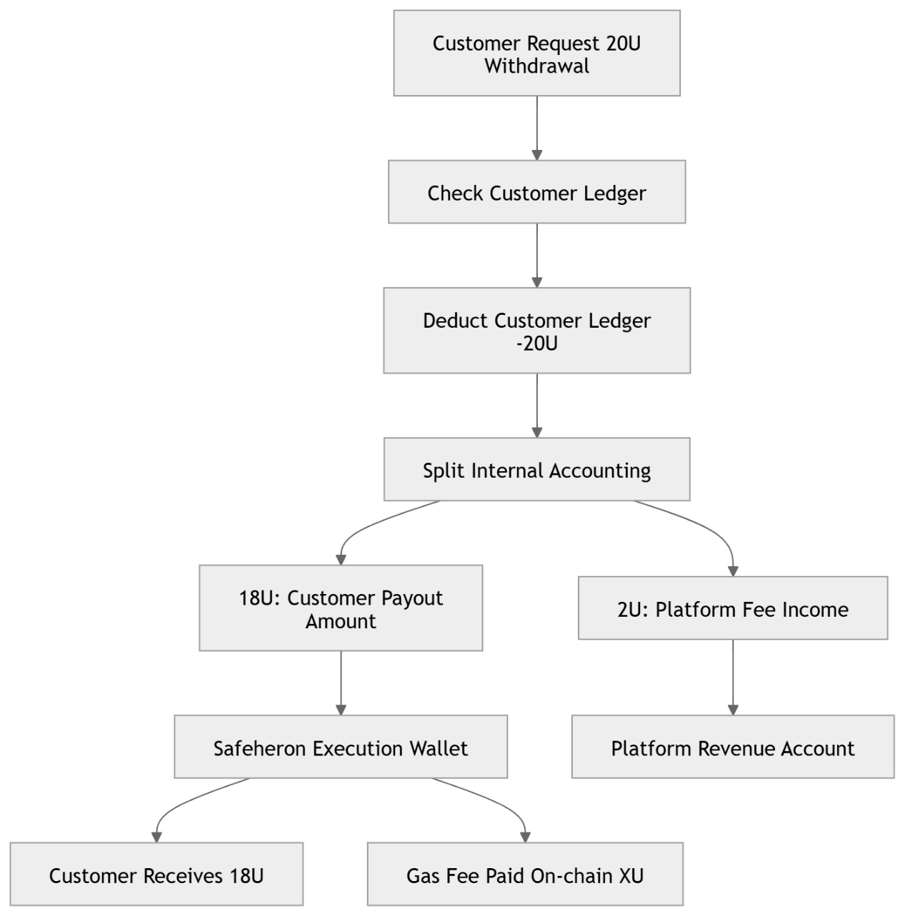
Flow
Customer Wallet
↓
Safeheron Deposit Address
↓ (Auto Sweep)
YASBe Client Asset Wallet

Balance Changes
Customer
100 → 0
YASBe Client Asset
0 → +100
Safeheron
(Not applicable as asset owner)

Withdrawal Flow
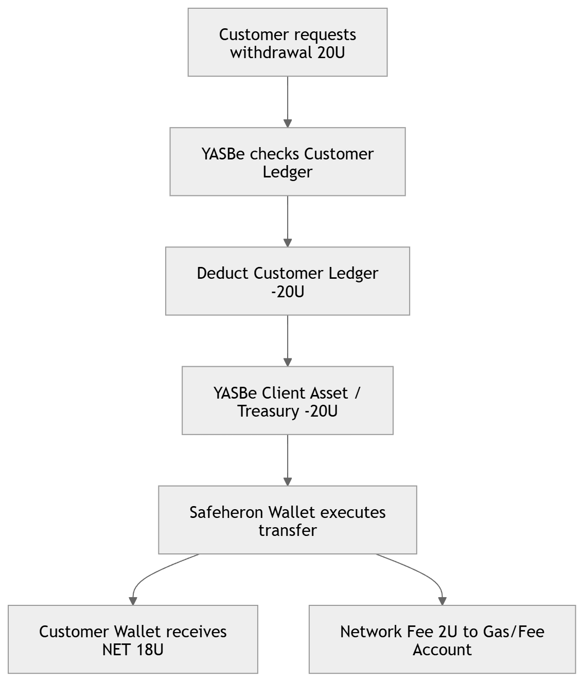
Flow
YASBe Client Asset Wallet
↓
Safeheron Wallet
↓
Customer Wallet

If withdrawal fee exists
明确：
Item | Amount
Requested Withdrawal | 20U
Network Fee | 2U
Net Received | 18U

