Homework 5 – Testing

Part 1

(Refer to Section 8 in the homework description)

Overall coverage of all code blocks after running EMMA: 47%

Screenshot of “EMMA Coverage Report”
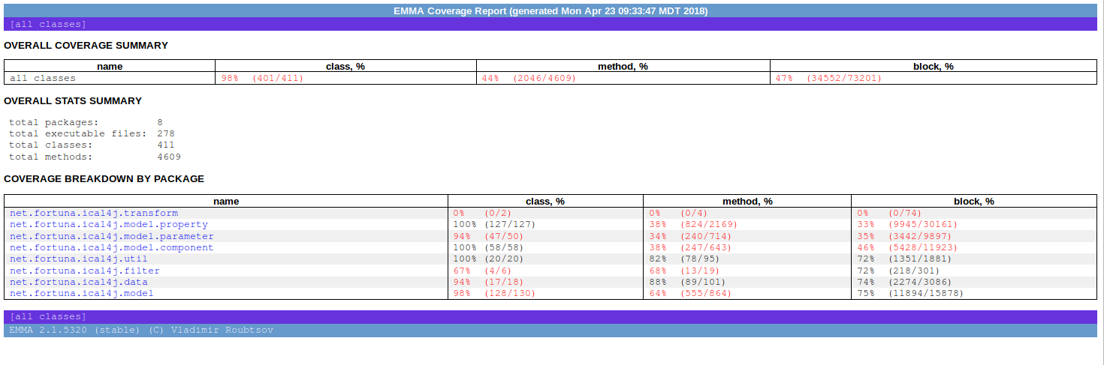

Number of product lines of code: 13747+2515=16262
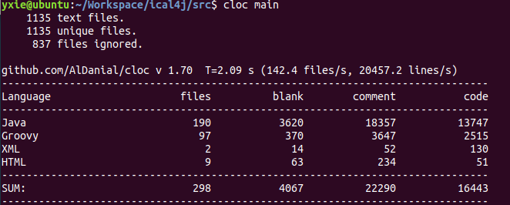

Number of test lines of code: 6913+682 = 7595
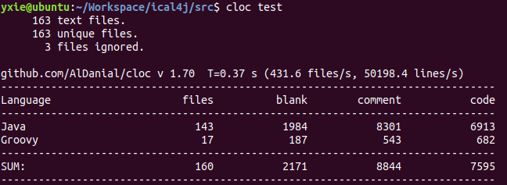

Ratio of (Number of test lines of code) / (Number of product lines of code):
7595/16262= 46.7%

(Refer to Section 10 in the homework description)

Overall “Mutation Coverage”: 29%

Screenshot of “Pit Test Coverage Report”
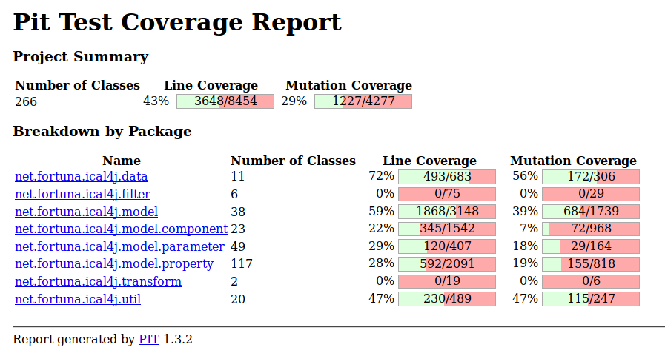

Comparison of three instruments of the effectiveness of the test suite
I think the PIT mutation coverage would be the most accurate in determining the quality of the test suite. The reasons are:
1. Most of the time, lowest test score would be the valuable reference results since it generally covered wider area even though sometimes it is overkill.
2. EMMA test is based on the test code you provides, which means if your test suites does design properly. So It does not check that your tests are actually able to detect faults in the executed code. Commonly, the code is partially tested by test suites.
3. Ratio of test also based on the result of your test code.
4. PIT is a tool for mutation coverage, which means it will not only measure line coverage of the code but will also perform mutations in application logic in order to check how well written your tests are.

Part2

Discuss the Defect Removal Model DRM1:
30%
code
Unit Test
35 defects/KLOC
24.5 defects/KLOC
10.5 defects/KLOC removed

Estimation of the delivered defect density using DRM1:
If the code has 35defects/KOL, after unit test activity is done, the delivered defect density would be 24.5 defects/KOL and 10.5 defects/KOL are expected to be removed.

Discuss the Defect Removal Model DRM2:
30%
code
Unit Test
35 defects/KLOC
24.5 defects/KLOC
10.5 defects/KLOC removed
60%
beta Test
14.7 defects/KLOC removed
9.8 defects/KLOC

Estimation of the delivered defect density using DRM2:
If the code has 35defects/KOL, after unit test activity (30% effective) is done, the defect density would be 24.5 defects/KOL and 10.5 defects/KOL are expected to be removed. Then with extra beta test done ( 60% effective), the delivered defect density would be 9.8 defects/KLOC, another 14.7 defects/KLOC would be removed.

How does DRM1 compare with DRM2?
The DRM1 expects the delivery defect density 24.5 and DRM2 has 9.8 defect density, which is 60% less defect density than DRM1. DRM2 dramatically improves code quality.
Part3

Discuss your plan for improving a given Defect Removal Model
TBD

