CS575 Software Security Assignment #2
Student Name: Yi Xie

1. What if a client connects to SimpleWebServer, but never sends any data and never disconnects? What type of attack would such a client be able to conduct? (15 points)
Answer: Since this simple web server only can take care one thread, which is not multi-thread server, If a client connects to SimpleWebServer, but never sends any data and never disconnects, the server will keep connecting to the attacker. Other clients could not connect to the SimpleWebServer. This attack is called Denial-of-Service(Dos) attack. The sever site might set up a connection time threshold to disconnect the client if the connection is longer than the threshold.

2. Modify SimpleWebServer.java to allow clients to upload file through a PUT command, and save all client requests into a log file. The sample methods for text file storage and logging are given below. You also need to modify SimpleWebClient.java to allow user to upload a given file. (25 points)
Answer: Please see attached source file.

3. Rewrite the serveFile method such that it imposes a maximum file size limit. If a user attempts to download a file that is larger than the maximum allowed size, write a log entry to a file called error_log.txt and return a “403 Forbidden” HTTP response code. (20 points).
Answer: In the source file, I added a bytesCounter variable. If the downloaded file larger than the preset MAX_DOWNLOAD_SIZE( To test the feature, user has to manually change this size to a small number to see the effect). Instead of sending the put of the file, the serveFile method will clean the StringBuffer then replace with a error message and send the error message back to the client. (Please see the source file)

4. Describe and implement: (a) an attack that defaces the index.html homepage, and (b) an attack that removes the log data. Attach screenshots of your attacks. (20 points)
Answer: (a) The attacker can use PUT feature of the SimpleWebServer.java simply replace his own index.html file with the original index.html file since there is no authorization check in this server program at all.
(b) The attacker can first GET logfile.txt and save the output data to a new logfile.txt in client site and modify the log data then PUT logfile.txt logfile.txt to load to the server site, which will replace the original log file with modified log file. But unfortunately, this behavior could be detected by the server admin since the last put operation will be write to the logfile.txt. Please see the screenshot below: the data has been moved and replaced with random text. But the PUT operation has been recorded in the new uploaded logfile.txt.

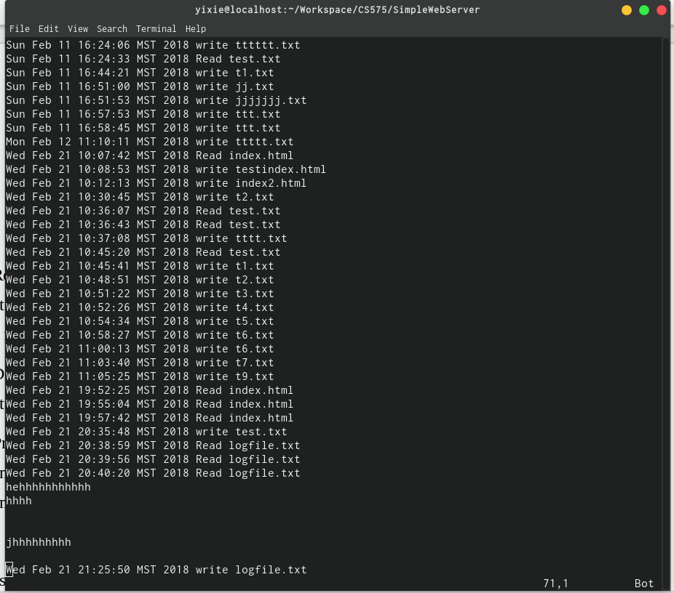

5. Pretend you are an attacker who got hold of the complied SimpleWebServer.class. Describe an attack such that, after SimpleWebServer is re-started (e.g., because of an exception by another attack), the functionality in (3) is disabled. (20 points)
Answer: the java bytecode is very easy to disassembly and reverse engineer. For example if I use vim to open SimpleWebServer.class. I could identify there is a keyword MAX_DOWNLOAD_LIMIT at line 44( pleas see screenshot below). From there, attack could disable this limit.
Also, there are lots of decompile software available:
- Jad (commercial, no fee for noncommercial use, no source code)
- MoCha
- JADO (Free, GPL, not actively maintained)
- DJ Java Decompiler ("freeware", no source code)
- HomeBrew Decompiler (Free, GPL)
- JODE decompiler and optimizer (Free, GPL)
- JReversePro (Free, GPL)
- SourceTec Java Decompiler (commercial, patch to Mocha)

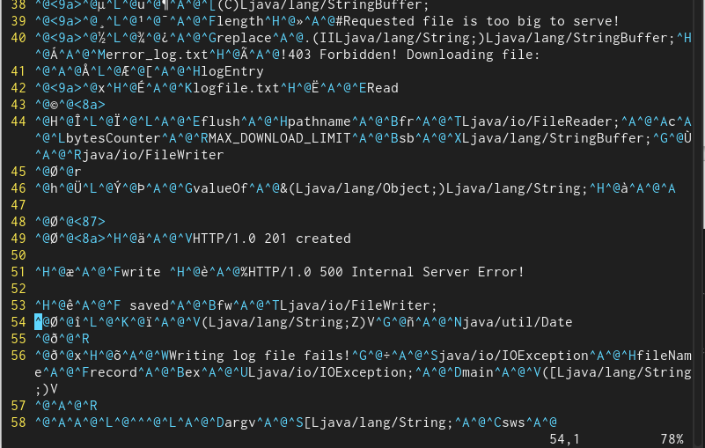
Attackers are really easy to decompile and modify the code by using these decompiler.

