武汉大学计算机学院

嵌入式系统设计

题目： 触摸屏计数实验
班级： 2011级计算机科学与技术5班
成员： 谢晨阳：2011301500157
程佳宇，2011301500161
陈思浓，2011301500154

2014年12月

一 选题基本介绍

实验题目（触摸屏计数实验）
在现有ARM平台上实现触摸屏功能。编制触摸屏驱动，设计一个简单的按钮程序，通过触摸屏点击触发按钮动作。

实验目的
1.掌握在Linux下常用编辑器的使用。
2.掌握Makefile 的编写和使用。
3.综合运用ARM平台，掌握驱动程序设计方法，了解触摸屏工作原理。

二、实验原理
程序分为3个部分，分别为：
1、初始化
2、数据采样与处理
3、中断处理
其中部分的设计程序流程图如下：
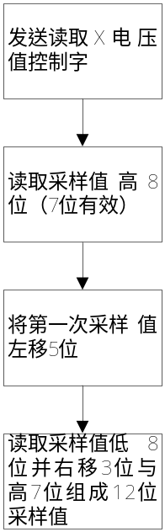
图1读取触摸点x轴电压值
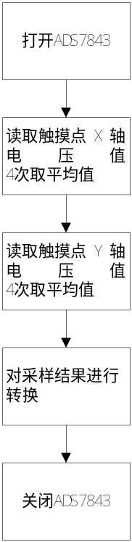
图2 读取触摸点坐标

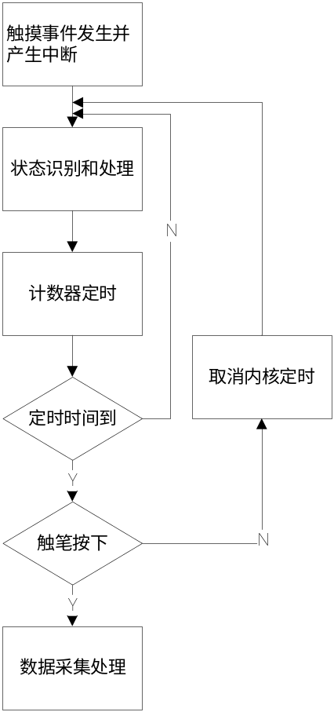
图3 中断处理程序流程

三、实验代码

3.1:MakeFile文件：
CROSS =armv41-unknown-linux-
CC= ${CROSS}gcc
#CC=gcc
#CFLAGS+= -g
#LDFLAGS+= -static
EXTRA_LIBS +=
EXP_INSTALL = install –m 755
EXTRA_LIBS += -lpthread
EXEC = $(INSTALL_DIR)/cm ./cm
OBJS = cm.o
all: $(EXEC)
$(EXEC): $(OBJS)
$(CC) $(LDFLAGS) -o $@ $(OBJS)
# $(EXTRA_LIBS)
install:
$(EXP_INSTALL) $(EXEC) $(INSTALL_DIR)
clean:
-rm -f $(EXEC) *.elf *.elf2flt *.gdb *.o

3.2：cm.c即主程序文件：
//Cm.c
#include<stdio.h>
#include<fcntl.h>
#include<stdlib.h>
#include<errno.h>
#include<sys/mman.h>
#include<linux/fb.h>
#include <sys/stat.h>

#include <string.h>
#include <sys/types.h>
#include <sys/time.h>
#include <unistd.h>
#include <sys/ioctl.h>
#include <time.h>
#include <getopt.h>
#include <linux/rtc.h>
#define FBDEV "/dev/fb/0"
static char * default_framebuffer=FBDEV;
int rt;

typedef struct {
unsigned short pressure;
unsigned short x;
unsigned short y;
unsigned short pad;
} TS_EVENT;

static TS_EVENT ts_event;
int ts_fd;

struct fb_dev
{
int fb;
void *fb_mem;
int fb_width,fb_height,fb_line_len,fb_size;
int fb_bpp;
};
static struct fb_dev fbdev;
static void draw(int color)
{

draw_C(230,205,0x400);
draw_C(230,250,0x400);
draw_C(390,205,0x400);
draw_C(390,250,0x400);

draw8(100,180,0x200);
draw1(100,180,0x400);

draw8(170,180,0x200);
draw2(170,180,0x400);

draw8(260,180,0x200);
draw3(260,180,0x400);

draw8(330,180,0x200);
draw7(330,180,0x400);

draw8(420,180,0x200);
draw8(420,180,0x400);

draw8(490,180,0x200);
draw5(490,180,0x400);
}

void draw_C(int x,int y,int color)
{

int i,j;
unsigned short int *p=(unsigned short int *)fbdev.fb_mem;
for(i=0;i<y;i++,p+=fbdev.fb_line_len/2);
for(i=y;i<y+15;i++,p+=fbdev.fb_line_len/2)
{
for(j=x;j<x+15;j++)
{
p[j]=color;
}
}
}

void draw_V(int x,int y,int color)
{
int i,j;
unsigned short int *p=(unsigned short int *)fbdev.fb_mem;
for(i=0;i<y;i++,p+=fbdev.fb_line_len/2);
for(i=y;i<y+45;i++,p+=fbdev.fb_line_len/2)
{
for(j=x;j<x+10;j++)
{
p[j]=color;
}
}
}

void draw_H(int x,int y,int color)
{

int i,j;
unsigned short int *p=(unsigned short int *)fbdev.fb_mem;
for(i=0;i<y;i++,p+=fbdev.fb_line_len/2);
for(i=y;i<y+10;i++,p+=fbdev.fb_line_len/2)
{
for(j=x;j<x+50;j++)
{
p[j]=color;
}
}
}

void draw0(int x,int y,int color)
{
draw_H(x,y,color);
draw_H(x,y+100,color);
draw_V(x,y+10,color);
draw_V(x,y+55,color);
draw_V(x+40,y+10,color);
draw_V(x+40,y+55,color);
}
void draw1(int x,int y,int color)
{
draw_V(x+40,y,color);
draw_V(x+40,y+45,color);
draw_V(x+40,y+65,color);

}

void draw2(int x,int y,int color)
{
draw_H(x,y,color);
draw_H(x,y+50,color);
draw_H(x,y+100,color);
draw_V(x,y+55,color);
draw_V(x+40,y+10,color);

}
void draw3(int x,int y,int color)
{
draw_H(x,y,color);
draw_H(x,y+50,color);
draw_H(x,y+100,color);
draw_V(x+40,y+10,color);
draw_V(x+40,y+55,color);

}
void draw4(int x,int y,int color)
{
draw_H(x,y+50,color);
draw_V(x,y,color);
draw_V(x,y+10,color);
draw_V(x+40,y,color);
draw_V(x+40,y+45,color);
draw_V(x+40,y+65,color);

}
void draw5(int x,int y,int color)
{
draw_H(x,y,color);
draw_H(x,y+50,color);
draw_H(x,y+100,color);
draw_V(x,y+10,color);
draw_V(x+40,y+55,color);

}
void draw6(int x,int y,int color)
{
draw_H(x,y,color);
draw_H(x,y+50,color);
draw_H(x,y+100,color);
draw_V(x,y+10,color);
draw_V(x,y+55,color);
draw_V(x+40,y+55,color);

}
void draw7(int x,int y,int color)
{
draw_H(x,y,color);
draw_V(x+40,y+10,color);
draw_V(x+40,y+55,color);
draw_V(x+40,y+65,color);

}
void draw8(int x,int y,int color)
{
draw_H(x,y,color);
draw_H(x,y+50,color);
draw_H(x,y+100,color);
draw_V(x,y+10,color);
draw_V(x,y+55,color);
draw_V(x+40,y+10,color);
draw_V(x+40,y+55,color);

}
void draw9(int x,int y,int color)
{
draw_H(x,y,color);
draw_H(x,y+50,color);
draw_H(x,y+100,color);
draw_V(x,y+10,color);
draw_V(x+40,y+10,color);
draw_V(x+40,y+55,color);

}

int framebuffer_open(void)
{
int fb;
struct fb_var_screeninfo fb_vinfo;
struct fb_fix_screeninfo fb_finfo;
char * fb_dev_name;
if(!(fb_dev_name=getenv("FRAMEBUFFER")))
{
fb_dev_name=default_framebuffer;
}
fb=open(fb_dev_name,O_RDWR);
if(fb<0)
{
printf("device %s open failed\n",fb_dev_name);
return -1;
}

//rt = ioctl(fb, 1, (unsigned long) &arg1);

if(ioctl(fb,FBIOGET_VSCREENINFO,&fb_vinfo))
{
printf("Can't get VSCREENINFO:%s\n",strerror(errno));
close(fb);
return -1;
}
if (ioctl(fb,FBIOGET_FSCREENINFO,&fb_finfo))
{
printf("Can't get FSCREENINFO:%s\n",strerror(errno));
return 1;
}
fbdev.fb_bpp = fb_vinfo.red.length + fb_vinfo.green.length + fb_vinfo.blue.length + fb_vinfo.transp.length;
fbdev.fb_width = fb_vinfo.xres;
fbdev.fb_height = fb_vinfo.yres;
fbdev.fb_line_len = fb_finfo.line_length;
fbdev.fb_size = fb_finfo.smem_len;
printf("frame buffer : %d(%d)x%d,%dbpp 0x%xbyte\n",fbdev.fb_width,fbdev.fb_line_len,fbdev.fb_height,fbdev.fb_bpp,fbdev.fb_size);
if (fbdev.fb_bpp != 16)
{
printf("frame buffer must be 16bpp mode\n");
exit(0);
}

fbdev.fb_mem = mmap(NULL, fbdev.fb_size, PROT_READ|PROT_WRITE, MAP_SHARED, fb, 0);
if (fbdev.fb_mem == NULL || (int) fbdev.fb_mem == -1)
{
fbdev.fb_mem = NULL;
printf("mmap failed\n");
close(fb);
return -1;
}
fbdev.fb = fb;
memset(fbdev.fb_mem, 0x0, fbdev.fb_size);
return 0;
}

void framebuffer_close()
{
if (fbdev.fb_mem)
{
munmap(fbdev.fb_mem, fbdev.fb_size);
fbdev.fb_mem = NULL;
}
if (fbdev.fb)
{
close(fbdev.fb);
fbdev.fb = 0;
}
}

int Init()
{
int fd;
//open device file
fd = open("/dev/misc/rtc",O_RDWR);
if(fd < 0)
{
printf("device open fail\n");
return -1;
}
return fd;
}

void drawA(int x,int y,int value)
{
switch(value)
{
case 0: draw8(x,y,0x200);draw0(x,y,0x400);break;
case 1: draw8(x,y,0x200);draw1(x,y,0x400);break;
case 2: draw8(x,y,0x200);draw2(x,y,0x400);break;
case 3: draw8(x,y,0x200);draw3(x,y,0x400);break;
case 4: draw8(x,y,0x200);draw4(x,y,0x400);break;
case 5: draw8(x,y,0x200);draw5(x,y,0x400);break;
case 6: draw8(x,y,0x200);draw6(x,y,0x400);break;
case 7: draw8(x,y,0x200);draw7(x,y,0x400);break;
case 8: draw8(x,y,0x200);draw8(x,y,0x400);break;
case 9: draw8(x,y,0x200);draw9(x,y,0x400);break;
default: break;
}
}

int main(void)
{
int i,fd,temp,temp1,temp2;
int hour,hour1,min,min1,sec,sec1;
int p;
struct rtc_time tm;

tm.tm_year=2014;
tm.tm_mon=12;
tm.tm_mday=16;
tm.tm_wday=2353;

ts_fd = open("/dev/touchscreen/0raw", O_RDONLY | O_NONBLOCK);
if (ts_fd < 0) {
fprintf (stderr, "2410: Can not open touch screen!\n");
return -1;
}

while(1)
{
if(read(ts_fd,&ts_event,sizeof(TS_EVENT)))
{
if(ts_event.pressure == 2){
printf("X=%d,Y=%d,P=%d,pad=%d\n",ts_event.x,ts_event.y,ts_event.pressure,ts_event.pad);
framebuffer_open();
fd=Init();
if (fd>0)
{
ioctl(fd,RTC_RD_TIME,&tm);
printf("%02d:%02d:%2d\n",tm.tm_hour,tm.tm_min,tm.tm_sec);
close(fd);
}
draw_C(230,205,0x400);
draw_C(230,250,0x400);
draw_C(390,205,0x400);
draw_C(390,250,0x400);
temp=tm.tm_hour%24;
hour=temp/10;
hour1=temp%10;
temp1=tm.tm_min%60;
min=temp1/10;
min1=temp1%10;
temp2=tm.tm_sec%60
sec=temp2/10;
sec1=temp2%10;

drawA(100,180,hour);
drawA(170,180,hour1);
drawA(260,180,min);
drawA(330,180,min1);
drawA(420,180,sec);
drawA(490,180,sec1);

framebuffer_close();
}
}
}
}

四、实验流程
1、建立工作目录cjy
2、编写程序源代码cm.c
3、编写Makefile
4、编译应用程序
4.1进入工作目录:cd /arm2410s/exp/basic/cjy
4.2 make
5、下载调试
5.1打开arm板电源，minicom挂载
5.1 加载目录 ：mount -t nfs -o nolock 192.168.0.11:/arm2410s /host
6、运行程序
6.1 进入共走目录cd /host/exp/basic/cjy
6.2 运行程序 ./cm
7、1通过点击触摸屏可以触发按钮的动作。

五、实验结果
每次触摸从sec开始加1，加到60之后min加1，min加满60之后hour加1

实验结果如下图4
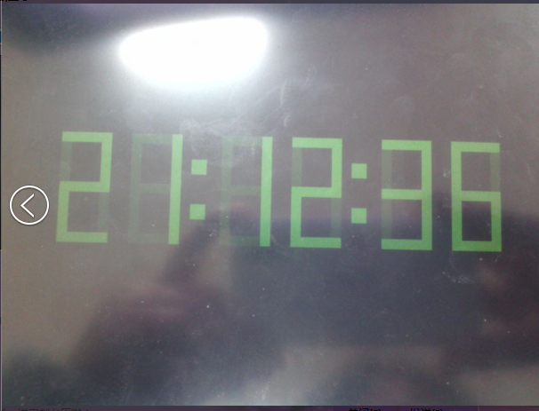
图4： 触摸屏实验拍照

六、实验问题及解决办法
1、触摸屏的校准问题是困扰我们的一个问题。触摸屏漂移较大，不同时刻点击同一点获得的坐标相差较大。我们取键盘区域边界的坐标来定位，同时采样十次，去掉一个最大值和一个最小值后，再计算平均值。通过这些方法提高了屏幕校正的精度。
2、在编写程序是我们查阅了很多资料，包括触摸屏的接口等。在事件触发之后我们用buffer获取触摸点的X,Y坐标以及电压值来进行判定。每次事件结束之后清除缓存。其中也有获取pad的选项，我们认为这个选项没有作用可是在去掉与pad有关的内容是挂载总是timeout,最终我们决定加上pad
3、由于我们这组有一个同学在考研，两个同学在这段时间内都有双学位考试，可能在有些地方做的不够好，望老师见谅。

