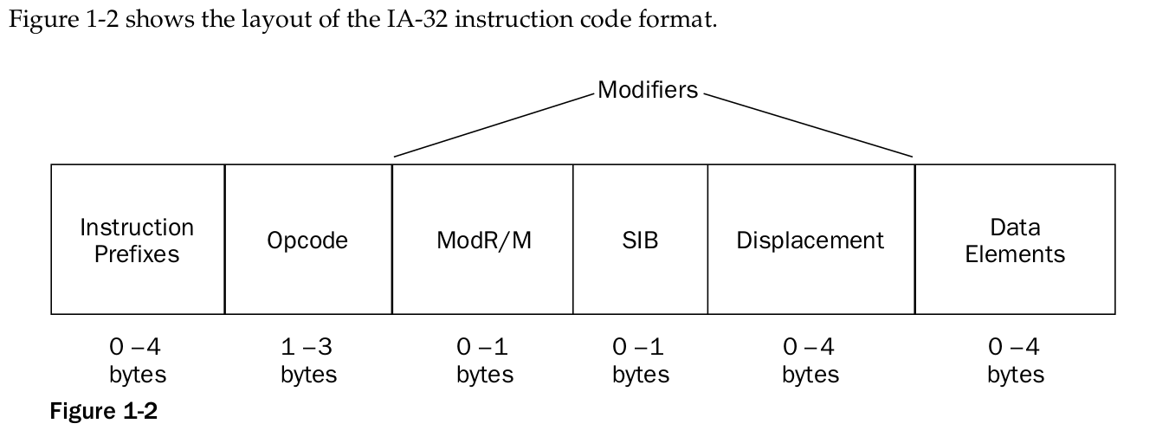

An assembly language program consists of three components that are used to define the program
operations:
❑ Opcode mnemonics
❑ Data sections
❑ Directives

Defining variables in assembly language consists of two parts:
1.A label that points to a memory location
2.A data type and default value for the memory bytes

All assembly language programs have at least three sections that must be declared:
❑ A data section
❑ A bss section
❑ A text section

