DESCRIPTION OF 2M TIMESLOTS USAGE
Louangprabang 7 stations :
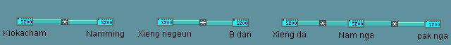

Site Name | Kiokacham | Namming | Remark
E1 | 1-7 | 1-7 | The 8th for monitor
Site Name | Xieng negeun | B dan | Remark
E1 | 1-7 | 1-7 | The 8th for monitor
Site Name | Xieng da | Nam nga | pak nga | Remark
E1 | 1-3 | 1-3
E1 | 4-6 |  | 1-3 | The 8th for monitor

Xaiyaboli Province 5 stations:

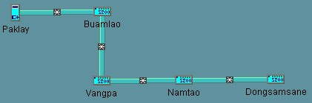

Site Name | Paklay | Buamlao | Vangpa | Namtao | Dongsamsane
E1 | 1-3 | 1-3
E1 | 4-6 |  | 1-3
E1 | 7-9 |  |  | 1-3
E1 | 10-12 |  |  |  | 1-3

Xiengkhouan Province 11 stations:
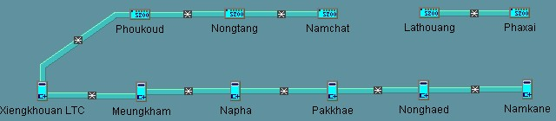

Site Name | Xiengkhouan | Phououd | Nongtang | Namchat
E1(1#) | 1-3 | 1-3
E1(1#) | 4-6 |  | 1-3
E1(1#) | 7-9 |  |  | 1-3
Site Name | Xiengkhouan | M.Kham | Napha | Phakkhae | Nonghaed | Namkane
E1(2#) | 1-5 | 1-5
E1(2#) | 6-8 |  | 1-3
E1(2#) | 9-11 |  |  | 1-3
E1(2#) | 12-14 |  |  |  | 1-3
E1(2#) | 15-21 |  |  |  |  | 1-7
E3(4#) | 1-3 |  |  |  |  | 1-3
E3(5#) | 1-3 |  |  |  |  | 1-3

Site Name | Lathouang | Phaxai | Remark
E1 | 1-7 | 1-7 | The 8th for monitor

