DESCRIPTION OF OPTICAL PIGTAIL LABEL

For clear connection relations between cables or pigtails, and for the convenience of the equipment debugging and maintenance, labels are necessary for the equipment and connection cables.

Some local engineers of LTC are not familiar with the label in our style. Here we are to describe it in detail.

For example, the sending optical interface,Slot No.11, Port 2 of Xiengkhouan LTC is designed to connect with the receiving optical interface, Slot No.5 of Phououd.
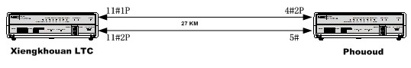
Figure 1 connections between these 2 sites
The fiber pigtails were written as shown in figure 2 on the basis of the actual situation.
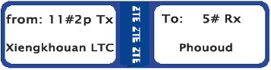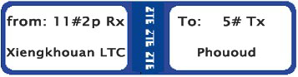
Figure 2 instance of fiber pigtail

In Xiengkhouan, the optical pigtail label written with “from: 11#2p Tx, Xiengkhouan” means one end of the pigtail is connected to Slot No.11, Port No.2, the sending optical interface of Xiengkhouan. “To: 5# Rx Phououd” means the other end of the pigtail is connected to Slot No.5, the receiving optical interface of Phououd.

In short, when you are to insert the optical pigtails into the optical interfaces of the equipment, it should refer to the “from: Slot No.#, Port No.”. When you are to insert the optical pigtails into the optical interfaces of the ODF, it should refer to the “To: Slot No.#, Port No.”.

In some sites, we wrote the optical pigtail label in this style as below on request of LTC local engineer.


It means that one end of the optical fiber is connected to Slot No.11, Port No.2, the receiving optical interface of Xiengkhouan, and the other end is designed to connect to Phououd.
Notes: attached file named “Connections.doc” has the detail.

