Equipment Basic Configuration Information
Xiengkhouan Province 11 stations:
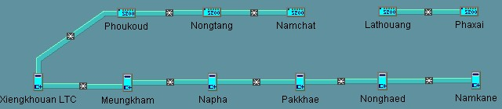

SITENAME | ID | EQUIPMENT | IP | OW
Xiengkhouan LTC | 601 | S325 | 196.1.1.18 | 601
Meungkham | 602 | S325 | 196.1.2.18 | 602
Napha | 603 | S325 | 196.1.3.18 | 603
Pakkhae | 604 | S325 | 196.1.4.18 | 604
Nonghaed | 605 | S325 | 196.1.5.18 | 605
Namkane | 606 | S325 | 196.1.6.18 | 606
Poukoud | 607 | S200 | 196.1.7.18 | 607
Nongtang | 608 | S200 | 196.1.8.18 | 608
Namchat | 609 | S200 | 196.1.9.18 | 609
Lathouang | 610 | S200 | 196.1.10.18 | 610
Phaxai | 611 | S200 | 196.1.11.18 | 611

Louangprabang Province 7 stations:
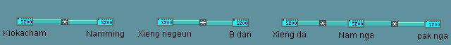

SITENAME | ID | EQUIPMENT | IP | OW
Kiokacham | 301 | S200 | 193.1.1.18 | 301
Nammimg | 302 | S200 | 193.1.2.18 | 302
Xieng ngeun | 303 | S200 | 193.1.3.18 | 303
B. Dan | 304 | S200 | 193.1.4.18 | 304
Xieng da | 305 | S200 | 193.1.5.18 | 305
Nam nga | 306 | S200 | 193.1.6.18 | 306
Pakg nga | 307 | S200 | 193.1.7.18 | 307
Xaiyaboli Province 5 stations:
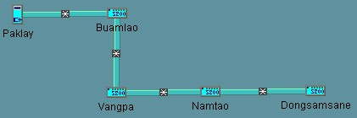

SITENAME | ID | EQUIPMENT | IP | OW
Paklay | 801 | S325 | 198.1.1.18 | 801
Buamlao | 802 | S200 | 198.1.2.18 | 802
Vangpa | 803 | S200 | 198.1.3.18 | 803
Namtao | 804 | S200 | 198.1.4.18 | 804
Dongsamsane | 805 | S200 | 198.1.5.18 | 805

