Restoring Database Operation
The configuration data of Xiengkhouan, Louangprabang and Xaiyaboly these 3 provinces are attached in this document.

Usage: Decompression these WinRAR files, then copy the folders to C:\ZXONM_E300 \db\backup\config\, then follow the operations as follow.

For example, if you want to restore the backed up data saved in the C:\ZXONM_E300 \db\backup\config\Xiengkhouan folder.

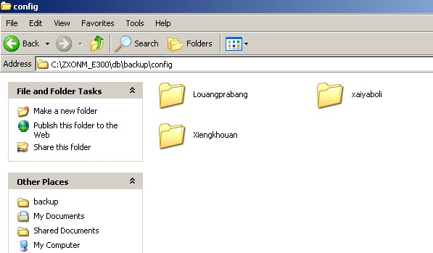

The detail steps:

- Select the menu item System -> System Data Management -> DB Backup or Restore in the main view of the client operation window to access the Database Backup/Restore dialog box.

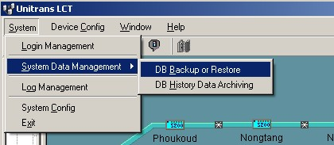

2. Select the Restore radio button in the Backup/Restore area.
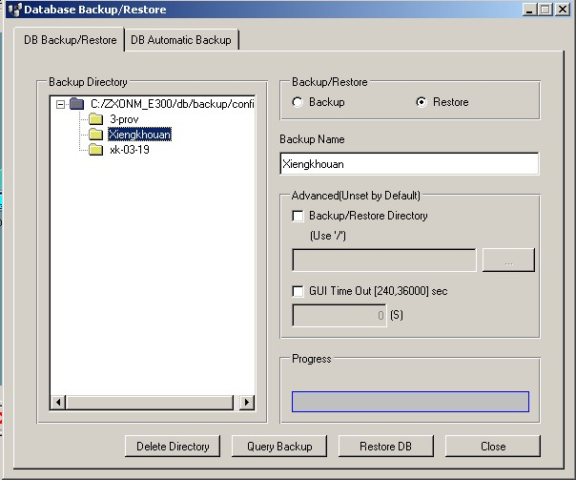
- Click Restore DB button to start restoring the data.
- Upon successful data restoration, the Login Management dialog box pops up, as shown below.
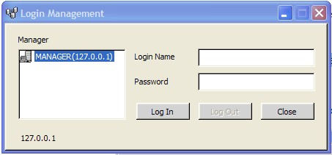
- Close this dialog box, then select Start -> Programs -> ZXONM E300 -> gui to restart the gui to login.

Notes: Login Name: root Password: (blank by default)

6. Click Log In, and then the Select NE to display dialog box pops up as shown below, Select sites you want to monitor from Available NE, and then click ► to add them to the list of Selected NE.
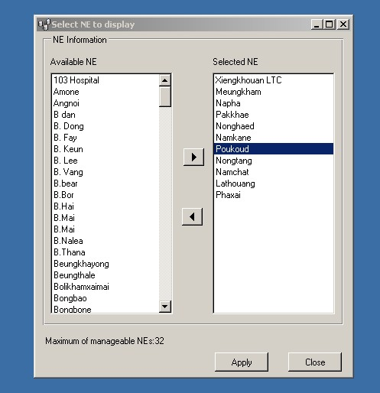

7. Click Apply, and then the Login management dialog box pops up again, after successful login, you will enter the operation window of the LCT client.

