Simple Failure Diagnosis

Some local engineer argued that all optical interface indicators are green but the service still cannot get through. Here we want to explain this issue.

For example, Xieng ngeun is connected with B.dan through 2 pair optical fibers. Slot No.5# of Xieng ngeun is designed to connect with Slot No.6 of B.dan, while Slot No.6 of Xieng ngeun is designed to connect with Slot No.5 of B.dan. Because the protection method we adopted is MSP 1+1 Link, so not only the Tx and Rx, but also the slots have to be connected correctly.
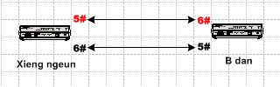

Although all optical interface indicators are green, it doesn’t means that the connection is correct.
Maybe 5# of Xieng ngeun has been connected to 5# of B.dan, and the Tx and Rx is correctly connecting.
So, in this situation, all optical interface indicators are green but the service still cannot get through, you are advised to change the slots, that means 1#TX change to 2#Tx, 1#Rx change to 2#Rx.
