Site Monitor Operation

If the local engineer wants to monitor the equipment, the following steps are recommended as to establish the communication between EMS and NE.

1. Connect the network port of EMS computer with the Qx port of the equipment.

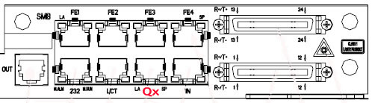
Figure 1 S200 front panel
2. Modify the IP address, mask and gateway address of EMS computer, we have stuck an ID&IP label on each equipment.
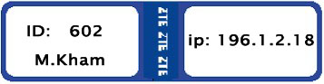
Figure 2 ID&IP label for equipment
For example, when coming to M.Kham, the ip address of the EMS computer should be modified as follows:

IP address: 196.1.2.1
Subnet mask: 255.255.255.0
Default gateway: 196.1.2.18

Notes: if this label cannot be seen clearly or cannot find, you can refer to the attached file named “Equipment Basic Configuration Information.doc”

3. Select Start -> Programs -> ZXONM E300 -> Server to start the EMS, if the progress window disappear, Select Start -> Programs -> ZXONM E300 -> GUI. Login the EMS using “root” as the username, Select the equipment icon, Right Click, then select the menu item “Ping”, if successful, that means the communication between EMS and NE is established.

