ZTE SDH Network Running Report
For LTC

Last Updated: 2009-Feb-12

CONTENT

1 OVERVIEW 3

1.1 THE FORWARDS 3

2 NETWORK BRIEF INTRODUCTION 3

3 NETWORK RUNNING STATE ANALYSIS 4

3.1 EXISTING NETWORK SERVICE 4

3.2 EXISTING NETWORK CONFIGURATION 6

3.2.1 NM CONFIGURATION 6

3.2.2 LINK CONFIGURATION 6

3.2.3 PROTECTION CONFIGURATION 6

3.2.4 TIMING CONFIGURATION 9

3.2.5 ORDERWARE CONFIGURATION 9

3.3 NETWORK ALARMS ANALYSIS 10

3.3.1 NETWORK ALARMS BRIEF INTRODUCTION 10

3.3.2 DETAILED ALARMS ANALYSIS 10

4 NETWORK OPTIMIGATION PROPOSAL 16

4.1 ALARM EVENT CORRELATION 16

4.2 SYNCHRONIZATION OPTIMIGATION PROPOSAL 16

4.3 NETWORK SECURITY OPTIMIGATION PROPOSAL 16

4.4 OTHER NETWORK OPTIMIGATION PROPOSAL 17

1 OVERVIEW

1.1 The Forewords
Since constructed in early 2008, ZTE SDH transmission network for LTC ran well, all performance indicators are excellent, which provides powerful back-up environment for LTC. As the support network of communication network, transmission network need to be given due attention, and regular network running analysis is a must to guarantee it is in safety and efficiency. According to the service expanding requirement of LTC, the 14th phase SDH project has been launched, employing ZTE’s SDH products to construct the network. We schedule to make an existing network running report at this time as to optimize the network and lay the foundation of the new equipments adding to the existing network.

Network Brief Introduction
ZTE SDH transmission network consists of 11 ZXMP S385. All transmission links are constructed by two pair optical fibers, and the transmission rate of each link is 2.5G, except Namphou and Saylom, which use 10G links. Two adjoining sites are configured for MSP 1+1 chain protection. As the access network element, Numphou is accessed to the ONM E300. The existing service is consisted of traditional service and data service. The traditional service includes 2M and 34M circuits, and the data service includes FE and GE.
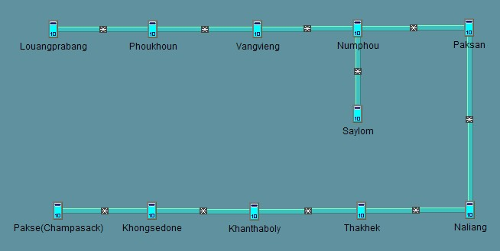
Figure 2.1-1 Existing network topology

Network Running State Analysis

3.1 Existing Network Service
(1) Boards for each NEs
The Common Part:
NCP：1 piece
QXI: 1 piece
SCI: 1 piece
CS: 2 pieces (Numphou and Saylom are using CSE while other sites are using CSA)
OW: 1 piece
FAN: 3 pieces
The Different Part:
NE | OL1 | OL16 | OL64 | RSEB | EPE1 | EP3
Louangprabang | 1 | 2 | 0 | 1 | 4 | 1
Phoukhoun | 0 | 4 | 0 | 0 | 0 | 0
Vangvieng | 0 | 4 | 0 | 1 | 0 | 0
Numphou | 1 | 4 | 2 | 2 | 4 | 1
Saylom | 1 | 0 | 2 | 0 | 6 | 1
Paksan | 1 | 4 | 0 | 1 | 1 | 1
Naliang | 0 | 4 | 0 | 0 | 0 | 0
Thakhek | 1 | 4 | 0 | 1 | 1 | 1
khanthaboly | 1 | 4 | 0 | 1 | 4 | 1
Khongsedone | 0 | 4 | 0 | 0 | 0 | 0
Pakse | 1 | 2 | 0 | 1 | 2 | 1
Table 3.1-1 Boards for each NEs

(2) Existing Network Service
The service is consisted of traditional service and data service. The traditional service includes 2M and 34M circuits, and the data service includes FE and GE.
- E1 Service
Any sites but Phoukhoun, Vangvieng, Naliang and Khongsedone have E1 service.
- E3 Service
There are 2 E3 service between Numphou and khanthaboly. Moreover, there are 1 E3 add/drop through EP3 board of Numphou transmits to the 155M optical board of Khanthaboly.
- Data Service
There are total 4 vlan areas, sites in the same vlan area have data service shown as follows.
NO1. Vlan id=1
Including sites: Numphou, Vangvieng
User ports and system ports used:
Numphou：U7, S5
Vangvieng：U8, S3

NO2. Vlan id=2
Including sites: Louangprabang, Numphou, Paksan, Thakhek, khanthaboly, Pakse
User ports and system ports used:
Louangprabang: U1, S4
Numphou: U1, S4, S6
Paksa: U1, S4, S6
Thakhek: U1, S4, S6
Khanthaboly: U1, S4, S6
Pakse: U1, S4

NO3. Vlan id=5
Including sites: khanthaboly, Numphou
User ports and system ports used:
Khanthaboly: U8, S3
Numphou: U8, S3

NO4. Vlan id=8
Including sites: khanthaboly, Louangprabang, Numphou, Paksan, Thakhek, Pakse
User ports and system ports used:
Khanthaboly: U9, S1, S2
Louangprabang: U9, S1
Numphou: U9, S1, S2
Paksan: U9, S1, S2
Thakhek: U9, S1, S2
Pakse: U9, S1

Network Configuration Analysis
3.2.1 NM Configuration
The network adopts the ZTE ZXONM E300 to carry out the real-time management for all NEs.
E300 Version: 3.18R2
Operation System: Microsoft Windows 2000 Server

3.2.2 Link Configuration
All transmission links are constructed by two pair optical fibers, and the transmission rate of each link is 2.5G, except Namphou and Saylom, which use 10G links.

3.2.3 Protection Configuration
Two adjoining sites are configured for MSP 1+1 chain protection, and there are total 10 protection groups.

Louangprabang | Phoukhoun | Mode | Protection Group ID
7# | 6# | Protection | 1
10# | 7# | Working | 1
Table 3.2-1 Protection Group1 (Louangprabang-----Phoukhoun)

Phoukhoun | Vangvieng | Mode | Protection Group ID
10# | 6# | Protection | 2
11# | 7# | Working | 2
Table 3.2-2 Protection Group 2(Phoukhoun ---- Vangvieng)

Vangvieng | Numphou | Protection | Protection Group ID
10# | 5# | Working | 3
11# | 6# | Protection | 3
Table 3.2-3 Protection Group 3(Vangvieng ----- Numphou)

Numphou | Paksan | Mode | Protection Group ID
11# | 6# | Protection | 4
12# | 7# | Working | 4
Table 3.2-4 Protection Group 4(Numphou ---- Paksan)

Numphou | Saylom | Mode | Protection Group ID
7# | 10# | Protection | 10
10# | 7# | Working | 10
Table 3.2-5 Protection Group 10(Numphou ----- Saylom)

Paksan | Naliang | Mode | Protection Group ID
10# | 6# | Protection | 5
11# | 7# | Working | 5
Table 3.2-6 Protection Group 5(Paksan ----- Naliang)

Naliang | Thakhek | Mode | Protection Group ID
10# | 6# | Protection | 6
11# | 7# | Working | 6
Table 3.2-7 Protection Group 5(Naliang ---- Thakhek)

Thakhek | Khanthaboly | Mode | Protection Group ID
10# | 6# | Protection | 7
11# | 7# | Working | 7
Table 3.2-8 Protection Group 7(Thakhek ----- Khanthaboly)

Khanthaboly | Khongsedone | Mode | Protection Group ID
10# | 6# | Protection | 8
11# | 7# | Working | 8
Table 3.2-9 Protection Group 8(Khanthaboly ----- Khongsedone)

Khongsedone | Pakse（Champasack） | Mode | Protection Group ID
10# | 7# | Protection | 9
11# | 10# | Working | 9
Table 3.2-10 Protection Group 9(Khongsedone ----- Pakse)

3.2.4 Timing Configuration
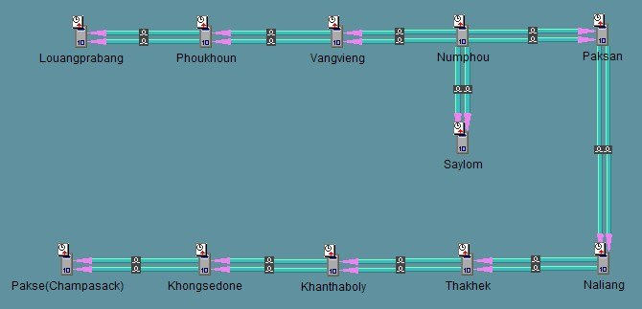
Figure3.2-1 Timing Configuration of each NEs
Numphou is set to use internal clock as its clock source, other NEs gain the timing signal from the links as shown above.
3.2.4 Orderware Configuration
Each site has equipped with OW board, orderware phone is valid. The orderware number is listed as follows.
Louangprabang | Phoukhoun | Vangvieng | Numphou | Paksan | Naliang
101 | 102 | 103 | 104 | 105 | 106
Thakhek | khanthaboly | Khongsedone | Pakse | Saylom
107 | 108 | 109 | 110 | 111
Table 3.2-11 Orderware Number List

Alarm Analysis
    - Alarms Brief Introduction
According to the latest alarm query (2009-Feb-09), there are total 374 alarms, including 33 critical alarms, 333 major alarms and 8 minor alarms. Each site has alarms except Vangvieng and Khongsedone.
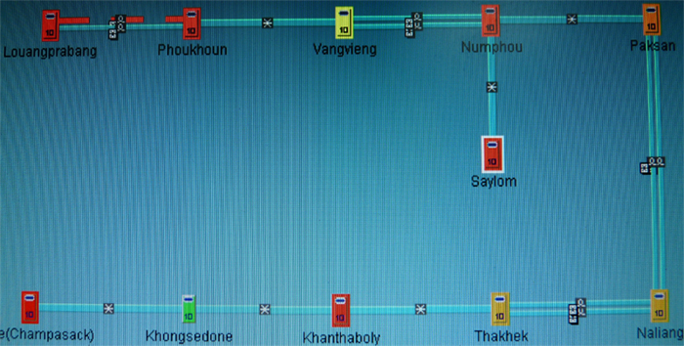FFigure 2.3-1 E300 Alarm Indicators
    - Detailed Alarms Analysis
(1) Louangprabang Alarms Analysis:
At present, Louangprabang has 4 critical alarms, 60 major alarms and 1 minor alarm.
Alarm Level | Alarm Reason | Source | Alarm Reason Analysis | Solution
Critical | PDH 2M LOS | 1#, 2# | Having configured corresponding timeslots for the tributary boards, but none E1 signals have been accessed. | Delete the vacant timeslots
Major | PDH 2M AIS | 1#, 2# | Having configured corresponding timeslots for the tributary boards, and the E1 signals have been accessed, but without any service. | The alarms will disappear when the E1 signals are carrying traffic.
Major | STM-16(Input optical power exceeded threshold) | 10# | Input optical power exceeded threshold | Use optical attenuator
Major | DCC connection failure | 6#, 7# | The 6#OL1 board connects with other manufacture’s equipment, so the DCC channel cannot get through.  The fiber connected to OL16 7# board has been cut off which brings about these alarms, too. | Once the optical cable had been repaired, corresponding alarms will disappear.
minor | Remote Defect Indication(RDI) | 7# | The optical fiber interconnected Louangprabang and Phoukhoun sending from Louangprabang 7# has been cut off. | Optical cable restoration

(2) Phoukhoun Alarms Analysis:
At present, Phoukhoun has 1 critical alarm and 1 major alarm.
Alarm Level | Alarm Reason | Source | Alarm Reason Analysis | Solution
Critical | STM-16 LOS | 6# | The optical fiber interconnected Louangprabang and Phoukhoun sending signal from Louangprabang 7# has been cut off. | Optical cable restoration
Major | DCC connection failure | 6# | The optical fiber interconnected Louangprabang and Phoukhoun sending signal from Louangprabang 7# has been cut off, so the DCC channel cannot get through. | Once the optical cable had been repaired, these alarms will disappear.

(3) Numphou Alarms Analysis:
At present, Numphou has 6 critical alarms, 38 major alarms and 1 minor alarm.
Alarm Level | Alarm Reason | Source | Alarm Reason Analysis | Solution
Critical | PDH 2M LOS | 1#,  2# | Having configured corresponding timeslots for the tributary boards, but none E1 signal have been accessed. | Delete the vacant timeslots
Major | PDH 2M AIS | 1#, 2#, 15# | Having configured corresponding timeslots for the tributary boards, and the E1 signals have been accessed, but without any service. | The alarms will disappear when the E1 signals are carrying traffic.
Major | TU12 AIS | 5#,12# | 5#5-3-2-2(47), 5#5-3-2-3(48), 12#2-3-2-2(47), and 12#2-3-2-3(48) these 4 timeslots are mis-configuration. | Delete these error timeslots
Major | VC3 unequipped(UNEQ) | 3#(4) | The 4th E3 of 3#EP3 hasn’t been equipped | The alarms will disappear when the E3 signal is carrying traffic.
Major | DCC connection failure | 4# | The 4#OL1 board connects with other manufacture’s equipment, so the DCC channel cannot get through. | Needless
Minor | VC4 RDI | 12# | Causing by the AU4 AIS alarm on 7#OL16 board of Paksan. | The alarm will disappear when the AU4 AIS alarm on 7#OL16 board of Paksan disappears.

(4) Saylom Alarms Analysis:
At present, Saylom has 9 critical alarms and 135 major alarms.
Alarm Level | Alarm Reason | Source | Alarm Reason Analysis | Solution
Critical | PDH 2M LOS | 2#, 4#, 5# | Having configured corresponding timeslots for the tributary boards, but none E1 signal have been accessed. | Delete the vacant timeslots
Major | STM1 Laser Module Not Install | 6# | The 2nd and 4th optical modules of 6#OL1 board haven’t active or have broken down. | Active the optical modules or change them
Major | STM1 (Input optical power exceeded threshold) | 6# | Input optical power exceeded threshold | Use optical attenuator
Major | DCC connection failure | 6# | The 6#OL1 board connects with other manufacture’s equipment, so the DCC channel cannot get through. | Needless
Major | PDH 2M AIS | 2#, 4#, 5#, 15#, 16# | Having configured corresponding timeslots for the tributary boards, and the E1 signals have been accessed, but without any service. | The alarms will disappear when the E1 signals are carrying traffic.

(5) Paksan Alarms Analysis:
At present, Numphou has 7 major alarms and 1 minor alarm.
Alarm Level | Alarm Reason | Source | Alarm Reason Analysis | Solution
Major | PDH 2M AIS | 1# | Having configured corresponding timeslots for the tributary boards, and the E1 signals have been accessed, but without any service. | The alarms will disappear when the E1 signals are carrying traffic.
Major | AU4 AIS | 7# | Causing by the AU4 AIS alarm sourced from 4#OL1 board of Numphou. | The alarm will disappear when the AU4 AIS alarm on 4#OL1 board of Numphou disappears.
Major | DCC connection failure | 5# | The 5#OL1 board connects with other manufacture’s equipment, so the DCC channel cannot get through. | Needless
Minor | VC4 Remote Defect Indication(RDI) | 11# | Causing by the AU4 AIS alarm on 7#OL16 board of Naliang. | The alarm will disappear when the AU4 AIS alarm on 7#OL16 board of Naliang disappears.

(6) Naliang Alarms Analysis:
At present, Naliang has 1 major alarm and 1 minor alarm.
Alarm Level | Alarm Reason | Source | Alarm Reason Analysis | Solution
Major | AU4 AIS | 7# | Causing by the AU4 AIS alarm sourced from 4#OL1 board of Numphou. | The alarm will disappear when the AU4 AIS alarm on 4#OL1 board of Numphou disappears.
Minor | VC4 RDI | 11# | Causing by the AU4 AIS alarm on 7#OL16 board of Thkhek. | The alarm will disappear when the AU4 AIS alarm on 7#OL16 board of Thkhek disappears.

(7) Thkhek Alarms Analysis:
At present, Thkhekhas has 8 major alarms and 1 minor alarm.
Alarm Level | Alarm Reason | Source | Alarm Reason Analysis | Solution
Major | PDH 2M AIS | 1# | Having configured corresponding timeslots for the tributary boards, and the E1 signals have been accessed, but without any service. | The alarms will disappear when the E1 signals are carrying traffic.
Major | DCC connection failure | 5# | The 5#OL1 board connects with other manufacture’s equipment, so the DCC channel cannot get through. | Needless
Major | AU4 AIS | 7# | Causing by the AU4 AIS alarm sourced from 4#OL1 board of Numphou. | The alarm will disappear when the AU4 AIS alarm on 4#OL1 board of Numphou disappears.
Minor | VC4 RDI | 11# | Causing by the AU4 AIS alarm on 7#OL16 board of Khanthaboly. | The alarm will disappear when the AU4 AIS alarm on 7#OL16 board of Khanthaboly disappears.

(8) Khanthaboly Alarms Analysis:
At present, Khanthaboly has 6 critical alarms, 62 major alarms and 1 minor alarm.
Alarm Level | Alarm Reason | Source | Alarm Reason Analysis | Solution
Critical | PDH 2M LOS | 1#, 2#, 15# | Having configured corresponding timeslots for the tributary boards, but none E1 signal have been accessed. | Delete the vacant timeslots
Major | PDH 2M AIS | 2#, 15# | Having configured corresponding timeslots for the tributary boards, and the E1 signals have been accessed, but without any service. | The alarms will disappear when the E1 signals are carrying traffic.
Major | DCC connection failure | 5# | The 5#OL1 board connects with other manufacture’s equipment, so the DCC channel cannot get through. | Needless
Major | AU4 AIS | 7# | Causing by the VC4 AIS alarm sourced from 4#OL1 board of Numphou. | The alarm will disappear when the AU4 AIS alarm on 4#OL1 board of Numphou disappears.
Minor | VC4 RDI | 5# | The 2nd port of 5#OL1 is connected with other manufacture’s equipment which carries AU4 AIS alarm | The alarm will disappear when the AU4 AIS alarm of the peer side disappears.

(9) Pakse(Champasack) Alarms Analysis:
At present, Pakse(Champasack) has 8 critical alarms, 23 major alarms.
Alarm Level | Alarm Reason | Source | Alarm Reason Analysis | Solution
Critical | PDH 2M LOS | 1#, 2# | Having configured corresponding timeslots for the tributary boards, but none E1 signal have been accessed. | Delete the vacant timeslots
Critical | STM-1 LOS | 6# | The 2nd and 4th ports of the OL1 6# board don’t have optical connections. | Once all ports have optical connections, these alarms will disappear.
Major | PDH 2M AIS | 1#, 2# | Having configured corresponding timeslots for the tributary boards, and the E1 signals have been accessed, but without any service. | The alarms will disappear when the E1 signals are carrying traffic.
Major | DCC connection failure | 6# | The 6#OL1 board connects with other manufacture’s equipment, so the DCC channel cannot get through. | Needless

Network Optimization Proposal
4.1 Alarm event correlation
Corresponding operations should be taken to maintain the network according to the alarms analysis report shown above.
Almost all alarms caused by physical connection failures, such as no E1 accessed, not optical connections, no traffic carried on E1/E3 signals, etc. If corresponding operations have been taken, most of the alarms will disappear.
4.2 Synchronization Optimization Solution
The clock synchronization is the key link related to the transmit quality and network security of SDH transmit network. At present, the existing network is using internal clock source but not external clock source. To ensure the reliability of clock source, the external reference clock source is recommended.
Furthermore, setting multiple synchronous clock sources is an effective method to ensure the reliability of the network. Separating more synchronous areas according to the synchronous clock source settings is recommended when the network becomes bigger through sustained development. In that case, in a same synchronous area, the NE is synchronized with the reference clock source in its area. If the synchronous clock source is invalid, the NE may lock the synchronous clock source in adjacent synchronous area via the equipment synchronous switchover mechanism, which can ensure the security of synchronization.
4.3 Network Security Optimization Proposal
The supervisor password should be set for safety concerns.
At present, the ONM E300 is using the default security settings, so the supervisor password is empty, which leave behind potential safety hazard of the network.
4.4 Other Optimization Proposal
The optical fibers interconnected Louangprabang and Phoukhoun should be repaired as soon as possible as to ensure the reliability of the network.

