Cut-over Proposal Of Laos LTC 14th Transmission Project

The forewords
There are total 79 sites for the 14th project, including 7 ADM-16 stations. Numphou LTC, Sanakham, Phiengmai, Xaiyaboli and Louangprabang LTC connect with existing stations, Vangvieng and phoukhoun to built a ring and provide ring multiplex section protection, while Louangnamtha and Borkeo consist a chain network and provide MSP 1+1 chain protection.

The main stages of the cut-over process are shown as follows:

- New equipments installation and commissioning.
- New equipments add to the existing network at the access points of Numphou and Louangprabang.
- To build a STM-16 ring from Numphou-Xaiyaboli to Louangprabang, and provide MSP 1+1 chain protection.

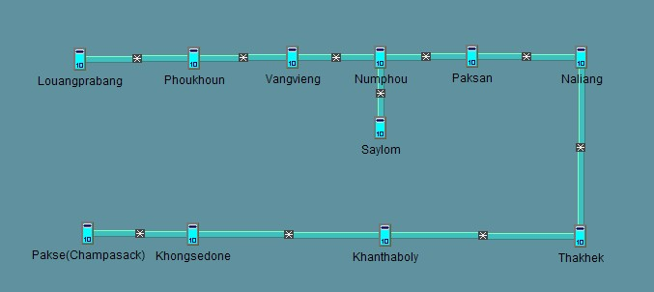
Figure 1-1 Existing network topology

Notes: All sites shown above are ZXMP S385, sites interconnected had been configured for four-fiber bidirectional MS chain protection.

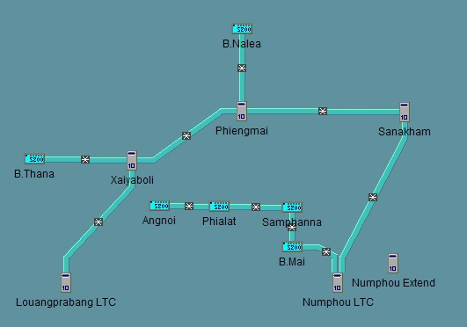
Figure 1-2 New sites to be added to the existing network

Notes: Louangprabang, Xaiyaboli, Phiengmai, Sanakham, Numphou LTC are ZXMP S385，Numphou Extend is the extended-frame of Numphou LTC, others are ZXMP S200.

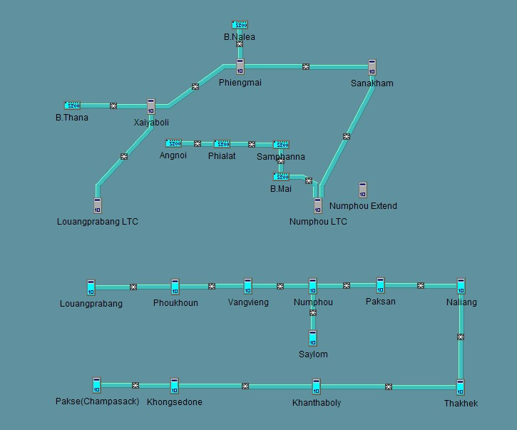
Figure 1-3 Network topology before cut over
Notes: Both access point Louangprabang LTC and Louangprabang, Numphou LTC and Numphou are standing in the same equipment rooms.

2. The proposal of new equipments cut-over to the existing network
2.1 The proposal for Louangprabang LTC

This stage is to accomplish the interconnection between Louangprabang LTC and Louangprabang.

Proposal analysis:

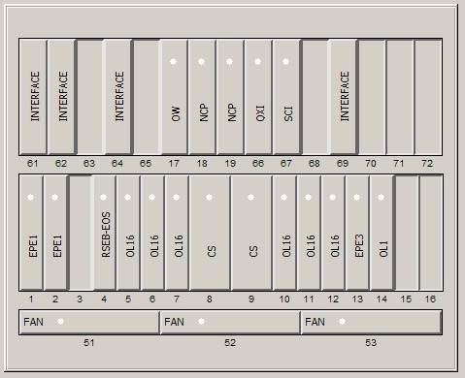
Figure 2.1-1 The face plate of Louangprabang LTC
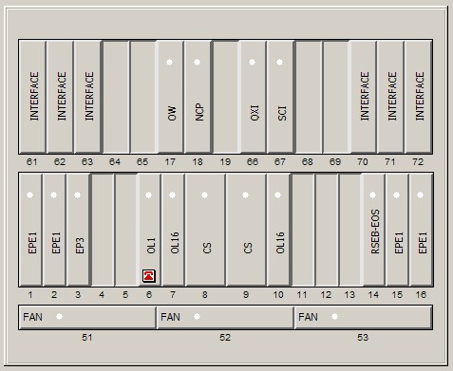
Figure 2.1-2 The face plate of Louangprabang

The new added site of Louangprabang LTC has 6 pieces of OL16, so we can move two pieces to Louangprabang in order to interconnect the two sites

Main operation steps:

(1)Move the 5th and 12th OL16 boards to 5th and 11th slots of the Louangpraba from Louangprabang LTC, then add the new added two boards’ information for Louangprabang in the client operation window of E300.

(2)Accomplish the equipment installation and commissioning of Louangprabang LTC.

(3)Arrange the interconnected fiber between Louangprabang LTC and Louangprabang through the ODF.

Detailed Connections are shown as follows：

Louangprabang LTC | Louangprabang
6# | 5#
11# | 11#
Table 2.1-1 Connections between Louangprabang and Louangprabang LTC

(4) Query the alarms once had finished the connections, in order to check whether some alarms caused by the insertion / extraction of optical boards.

2.2 The proposal for Namphou LTC

This stage is to accomplish the interconnection between Numphou LTC and Numphou.

Proposal analysis:

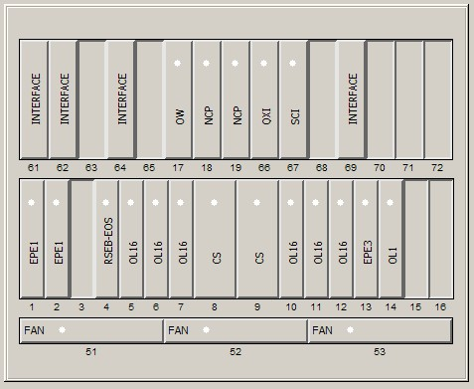
Figure 2.2-1 The face plate of Numphou LTC

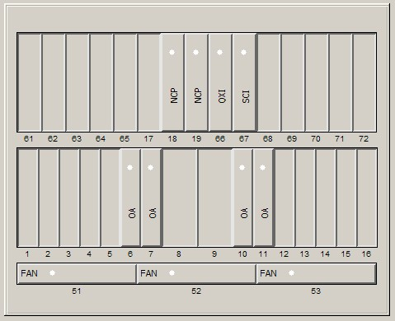
Figure 2.2-2 The face plate of extend frame for Numphou LTC

Notes: The left two “OA” are OBA, while the right two are OPA.

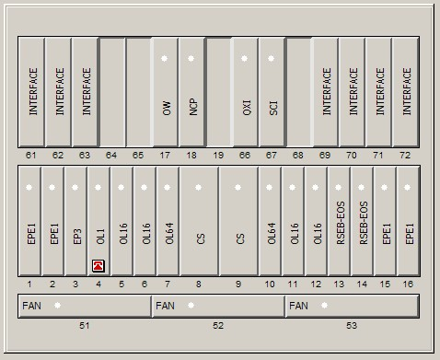
Figure 2.2-3 The face plate of Numphou

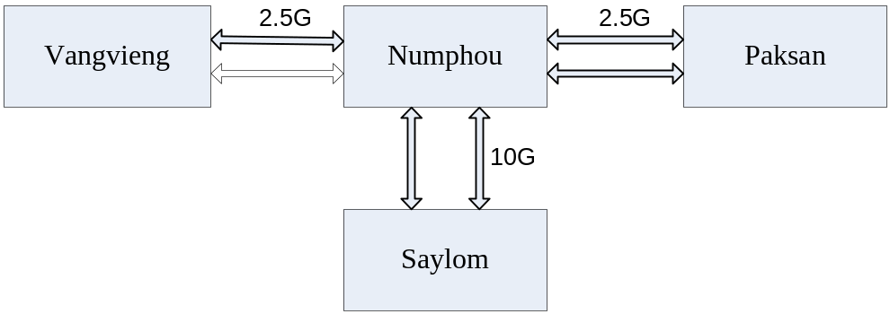
Figure 2.2-4 Fiber connections of Numphou before cut over

At present, Numphou has three fiber directions, all of them are four-fiber mode

Detailed Connections are shown as follows：

Numphou | Vangvieng | Mode
5# | 10# | work
6# | 11# | protection
Table 2.2-1 Connections between Numphou and Vangvieng

Numphou | Saylom | Mode
7# | 10# | protection
10# | 7# | work
Table 2.2-2 Connections between Numphou and Saylom

Numphou | Paksan | Mode
11# | 6# | protection
12# | 7# | work
Table 2.2-3 Connections between Numphou and Paksan

Now, Numphou LTC is designed to interconnected with Numphou in four-fiber mode, but there is no slot can be used. So we are to adopt the following method. The service between Numphou and Paksan are to pass through in Numphou LTC, and the 11th and 12th OL16 boards of Numphou are to connect to Numphou LTC, which formerly connect to Paksan, then Numphou LTC is expected to connect to the Paksan.

Numphou and Paksan now were configured for MSP 1+1 chain protection(protection group id is 4), we are to delete this protection relationship with path protection taking its place. In this case, we can disconnect the protection-mode fiber(11th) of Namphou and then reconnect through Numphou LTC without service interruption. After accomplishing the pass-through timeslot configuration , another couple of optical fiber(12th) can be disconnected and arranged to the designed place.

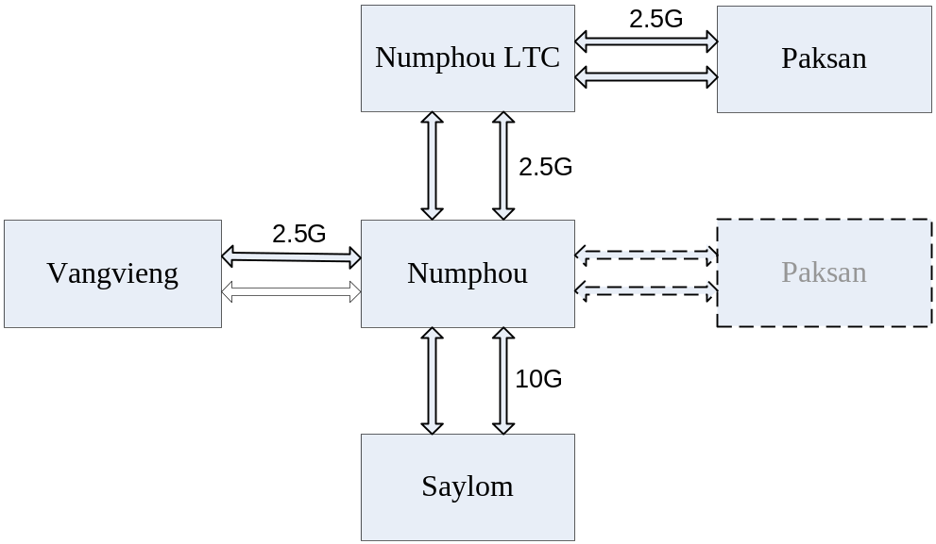

Figure 2.2-5 Cut over schematic diagram
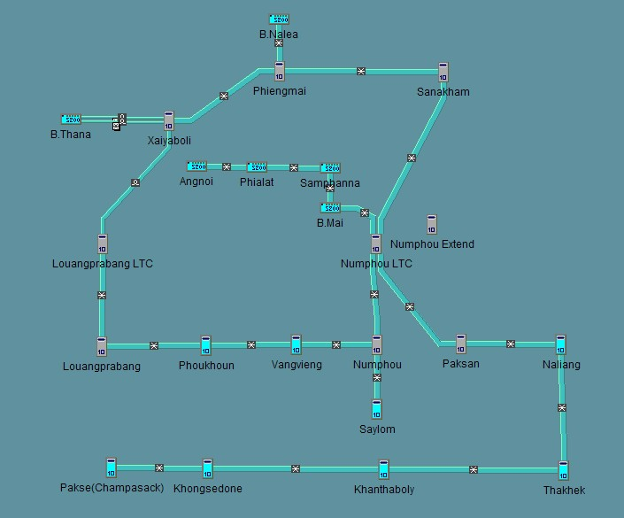
Figure 2.2-6 Network topology after cut over

Main operation steps:

(1) Accomplish the equipment installation and commissioning of Namphou LTC.
(2)Delete the MSP 1+1 chain protection between Numphou and Paksan.
(3)Establish path protection between Numphou and Paksan.
(4)Disconnect the protection-mode fiber(11th) of Namphou, then arrange the optical fiber relationship among Numphou , Numphou LTC and Paksan through their own ODFs.

Detailed Connections are shown as follows:

Numphou | Numphou LTC
11# | 7#
Table 2.2-4 Connections between Numphou and Numphou LTC

Numphou LTC | Paksan
12# | 6#
Table 2.2-5 Connections between Numphou LTC and Paksan

(5) Query the alarms once had finished the connections, If there are abnormal alarms, trouble-shooting must be taken before further operations
(6) Accomplish the pass-through timeslot configuration on Numphou LTC.
(7) Disconnect another couple of optical fiber(12th) and then arrange it to the designed place through the ODFs.

Detailed Connections are shown as follows:

Numphou | Numphou LTC
12# | 10#
Table 2.2-6 Connections between Numphou and Numphou LTC

Numphou LTC | Paksan
11# | 7#
Table 2.2-7 Connections between Numphou LTC and Paksan

(8) Query the alarms once had finished the connections, If there are abnormal alarms, trouble-shooting must be taken before further operations
(9) Delete the timeslot configured for path protection.
(10)Establish four-fiber MS protection for the S385 ring.

Rolling back for operation failure and protective measures:

- Backup the EMS database before any operation.
- It is recommended to take the try- extraction action as to prevent from unexpected accident. Only it is sure that the extraction of optical fiber won’t interrupt the service, the further operation can be done, otherwise the optical fiber must be restore to the original place quickly.

2.3 Proposal for establishing MSP 1+1 chain protection

According to technical design, Numphou LTC, Sanakham, Phiengmai, Xaiyaboli and Louangprabang LTC are to connect with existing stations, Vangvieng and phoukhoun to built a ring and provide ring multiplex section protection.

Main operation steps:

(1)Query the alarms of all sites included in the ring, check which optical fiber works normally, and which does not. Make a note about this.
(2) Outline all sites included in the ring in the client operation window of E300.
(3) Delete the MSP 1+1 chain protection configured for the existing equipments.
(4) Establish the MSP 1+1 protection for the S385 ring, make sure that boards connected with abnormal fiber haven’t been set as working mode.
(5)Starting APS protocol of all related sites.
(6)Online all sites included in the ring in the client operation window of E300, and make sure that all sites can be managed.
(7)Download MSP configuration information to related sites including “Set MS Protect”,”MS Protect Property”,”MSP Protection Switch”,”MS Topology” and ”Set APS”.
(8)Check the working condition of multiplex section, and test whether the MSP works normally.

Rolling back for operation failure and protective measures:

(1) Backup the EMS database before any operation.
(2) If the MSP works abnormally when testing switch function, and trouble-shooting cannot finish within an agreed time, it is recommended to restore the network database.

