Admin

create domain d4

cd d4

create appspace a4

cd a4

create -osgiPort 2105 -httpPort 2035 -agent agent5 appnode n5

start

upload D:/tibco602V7/bw/6.2/samples/EventLisn.application_1.0.0.ear

deploy –as EventLisn.application_1.0.0.ear

TEA

1. 在D:\tibco602V7\bw\6.2\config下的bwagent.ini修改bw.admin.mode=local 将local改为enterprise
2. Start as-agent
3. Start tea.exe
4. **input** **<http://localhost:8777>**
5. Click Agents in the right panel, the Register new agent in the opened page. Click Register new.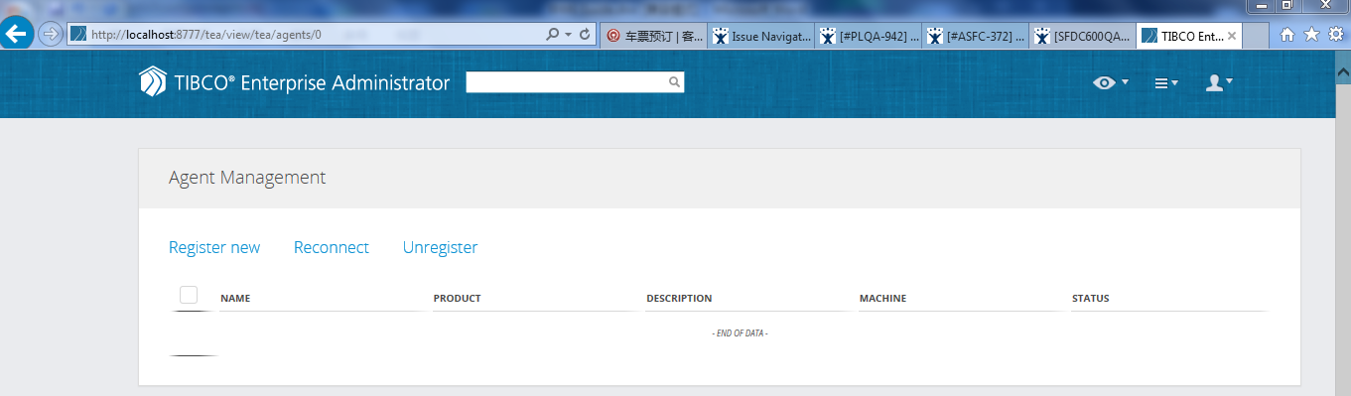

Input below message to register a new agent.

Agent Name: you can input the name such as agent1…..

Agent [URL: http://Johnny-PC:9091/bwta](URL:   http://Johnny-PC:9091/bwta), Johnny-PC it’s my computers name, 9091 we can found this port in bwagent.ini file, bwta, we also can found this in bwagent.ini file.

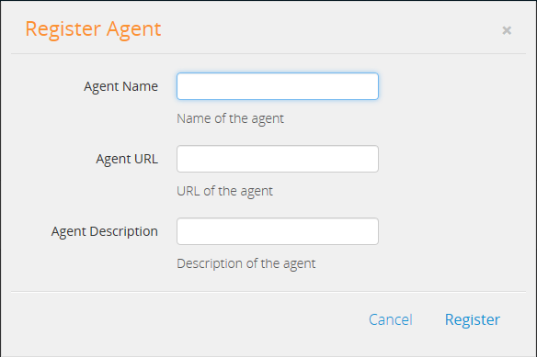

注册完毕后，处于running状态，然后就可以在TEA上创建domain，appspacenode