
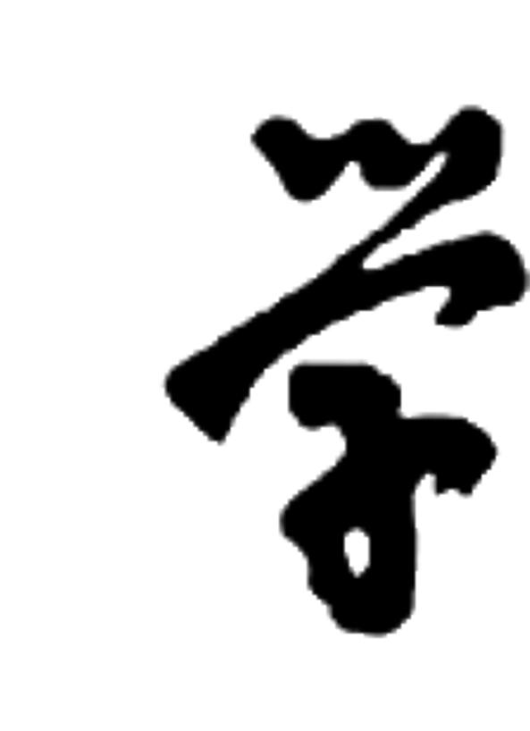
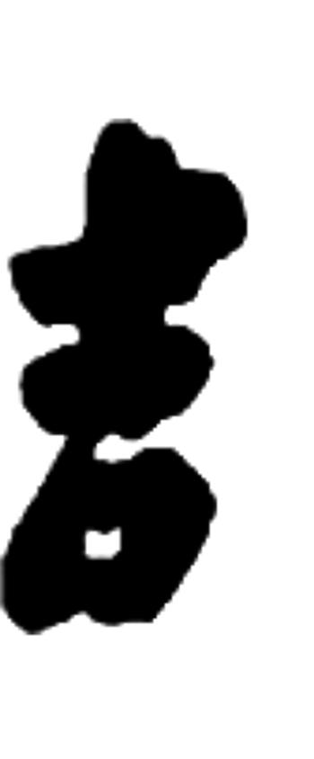
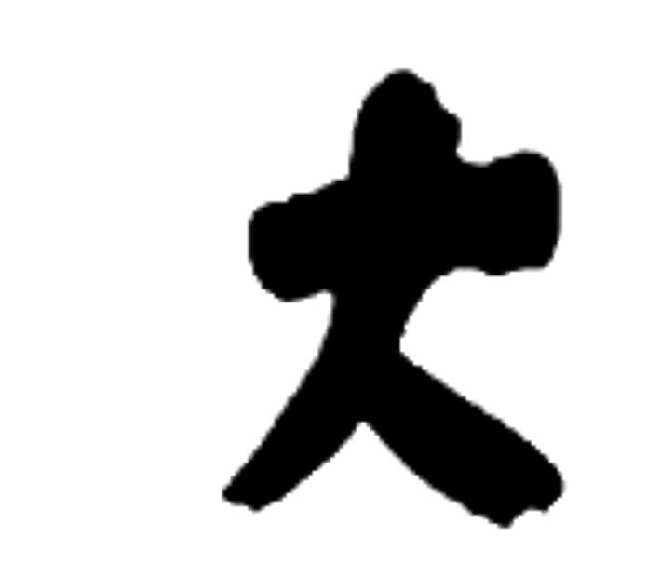
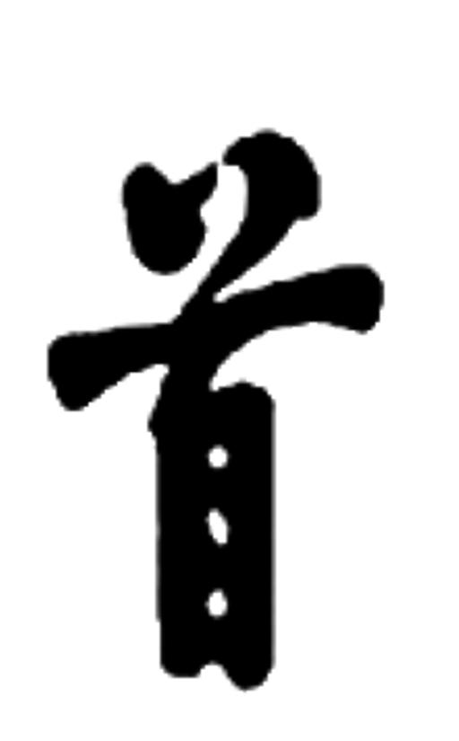

JISHOU UNIVERSITY

程序设计基础
课程设计

题 目： | 泡泡堂
作 者： | 沈旖旎
学 号： | 20164206245
所属学院： | 软件学院
专业年级： | 软件工程2016级1班
指导教师： | 阚文骥
完成时间： | 2016年21日—2016年6月29日

软件学院制

项目描述
目的： 制作一个有趣的双人对战小游戏
意义： 本游戏为双人休闲对战的游戏。可以增加玩家的手指灵敏度，眼力，智商，和好友之间的感情，十分有趣。
项目功能目标
- 游戏说明功能：玩家点击“游戏说明”后有游戏介绍。

- 泡泡地图显示功能：打印背景，泡泡和弓箭。
- 泡泡的发射功能：发射出一个泡泡后，必须等泡泡爆掉或黏附于其他泡泡或在顶端，才能发下一个泡泡。

- 泡泡的消除功能：主要有爆掉和下坠两种方式，前者是后者的基础。 泡泡爆掉是当玩家主动令游戏区形成 3 个或以上的同色泡泡相连，则这些泡泡将爆掉；泡泡下坠 是当爆掉的泡泡造成连接的异色泡泡失去挂点，则这些异色泡泡将下坠，算入消去的泡泡中。（下坠中的泡泡不对其他泡泡发生作用）

- 泡泡的反弹功能：可利用两侧垂直的墙壁进行反弹。
- 泡泡的黏附功能：泡泡飞行途中边界与其他泡泡相触，即被黏附，并停止运动。位置由入射角和原来静止的泡泡位置共同决定。

- 当玩家爆掉多于3个泡泡时，多于3个的部分将被作为附加奖励而增加至泡泡栏。在泡泡栏7个小泡泡会合并成为1个大泡泡。每次使用泡泡时，使用最上面的1个（大或小的泡泡）。给自己使用泡泡时，产生防御效果，消除相应个泡泡[ 泡泡消除1个，大泡泡消除7个]。给非同伙使用泡泡时，产生攻击效果，对方增加相应个泡泡，[小泡泡增加1个，大泡泡增加7个]。
- 胜负判断功能：失败条件：泡泡下压越过下方的 " 警戒线 " ；胜利条件：本人没达到个人失败条件，其他玩家均达到个人失败条件。
- 音乐播放功能。

系统创新点： 1. 在使用泡泡栏的特效时运用数学函数
2．两处函数用递归
系统主要流程
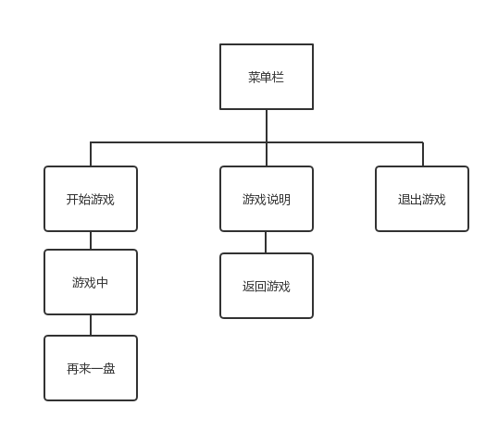
代码
#include<stdio.h>
#include<windows.h>
#include <graphics.h>
#include<time.h>
#include<stdlib.h>
#include<pthread.h>
#include<math.h>
#include <mmsystem.h> //音乐
#pragma comment(lib,"WINMM.LIB")

typedef struct position
{
int x;
int y;
int bubble;
int flag;
int flag1;///消除泡泡
int flag2;///掉落泡泡
int x1;
int y1;
} position;

typedef struct emission
{
int bubble;
int x;
int y;
int x1;
int y1;
} emi;

void *thr_fn(void *args);
void mainloop();
void *play_music(void *ret);//发射音效
int AttachmentJudge(position pos[12][9],int i,int j);///判断泡泡是否附着
time_t start_time, end_time, start_time_1, end_time_1;

pthread_t ppid;//创建音效线程
int pos_bubble[12][9];
position pos[12][9],pos1[12][9];///pos[12][9]是右边，pos1[12][9]是左边；
int b_bubble[20000];
emi b[20000],b1[20000];
emi add_b[7],small_b;///add_b[]是增加泡泡
PIMAGE wheel[33],back1,a[8],lose,win,baozha[7],Spop[2];
PIMAGE bluebmp,redbmp;
PIMAGE bmp[3];
PIMAGE timex,time1[6];
PIMAGE moun,explain;
int score0 = 0,score1 = 0;
int amount[2] = {0};///两边特殊泡泡数量，amount[0]是右边,amount[1]是左边:
int n1 = 500, m1 = 450;///右边要发射的泡泡位置
int n2 = 406, m2 = 473;///右边预发射泡泡位置
int n3 = 455, m3 = 380;///右边弓箭位置
int n11 = 133, m11 = 450;///左边要发射的泡泡位置
int n22 = 39, m22 = 473;///左边预发射泡泡位置
int n33 = 88, m33 = 380;///左边弓箭位置
int p = 16, q = 0;///右边弓箭方向
int p1 = 16,q1 = 0;///左边弓箭方向
int emil[102][2] = {0},z = 0;
int KO = 1;///是否死亡
int angle[33][2] = { -16,-3, ///-80
-16,-4, ///-75
-16,-5, ///-70
-16,-6, ///-65
-17,-10, ///-60
-13,-10, ///-55
-11,-10, ///-50
-10,-10, ///-45
-14,-17, ///-40
-11,-17, ///-35
-10,-17, ///-30
-7,-17, ///-25
-6,-16, ///-20
-5,-16, ///-15
-4,-16, ///-10
-3,-16, ///-5
0,-20, ///0
};
int add_angle[7][2]= { -9,-10, ///横坐标减7，纵坐标减10
-8,-11,
-7,-12,
-6,-12,
-3,-12,
-4,-13,
-2,-13,
};
void Lanuch_Angle()///正向角度
{
int i;
for(i = 17; i<33; i++)
{
angle[i][0] = angle[32-i][0]*(-1);
angle[i][1] = angle[32-i][1];
}
}

void Init_Pop()///初始化泡泡
{
int i;
for(i = 0; i<8; i++)
a[i] = newimage();
getimage(a[0],"black.png");
getimage(a[1],"red.png");
getimage(a[2],"blue.png");
getimage(a[3],"orange.png");
getimage(a[4],"green.png");
getimage(a[5],"white.png");
getimage(a[6],"yellow.png");
getimage(a[7],"purple.png");
}

void Init_drap_Pop()///爆炸动画
{
int i;
for(i = 0; i<7; i++)
baozha[i] = newimage();
getimage(baozha[0],"1.png");
getimage(baozha[1],"2.png");
getimage(baozha[2],"3.png");
getimage(baozha[3],"4.png");
getimage(baozha[4],"555.png");
getimage(baozha[5],"6.png");
getimage(baozha[6],"7.png");
}

void Init_time()
{
int i;
timex = newimage();
for(i = 1; i<6; i++)
time1[i] = newimage();
getimage(timex,"time.png");
getimage(time1[1],timex,2,2,37,57);
getimage(time1[2],timex,38,1,50,58);
getimage(time1[3],timex,85,0,37,58);
getimage(time1[4],timex,126,1,37,58);
getimage(time1[5],timex,170,1,37,58);
}

void Init_Wheel()
{
int i;
for(i= 0; i<33; i++)
wheel[i] = newimage();
getimage(wheel[0],"-80.png");
getimage(wheel[1],"-75.png");
getimage(wheel[2],"-70.png");
getimage(wheel[3],"-65.png");
getimage(wheel[4],"-60.png");
getimage(wheel[5],"-55.png");
getimage(wheel[6],"-50.png");
getimage(wheel[7],"-45.png");
getimage(wheel[8],"-40.png");
getimage(wheel[9],"-35.png");
getimage(wheel[10],"-30.png");
getimage(wheel[11],"-25.png");
getimage(wheel[12],"-20.png");
getimage(wheel[13],"-15.png");
getimage(wheel[14],"-10.png");
getimage(wheel[15],"-5.png");
getimage(wheel[16],"0.png");
getimage(wheel[17],"5.png");
getimage(wheel[18],"10.png");
getimage(wheel[19],"15.png");
getimage(wheel[20],"20.png");
getimage(wheel[21],"25.png");
getimage(wheel[22],"30.png");
getimage(wheel[23],"35.png");
getimage(wheel[24],"40.png");
getimage(wheel[25],"45.png");
getimage(wheel[26],"50.png");
getimage(wheel[27],"55.png");
getimage(wheel[28],"60.png");
getimage(wheel[29],"65.png");
getimage(wheel[30],"70.png");
getimage(wheel[31],"75.png");
getimage(wheel[32],"80.png");
}

void Init_SpecialPop()
{
int i;
for(i =0; i<2; i++)
Spop[i] = newimage();
getimage(Spop[0],"big.png");
getimage(Spop[1],"small.png");
}

void Init_Bmp()
{
redbmp = newimage();
bluebmp = newimage();
getimage(redbmp,"red2.png");
getimage(bluebmp,"blue2.png");
int i;
for(i =0; i<3; i++)
bmp[i] = newimage();
getimage(bmp[0],redbmp,5,5,27,29);
getimage(bmp[1],redbmp,238,6,29,29);
getimage(bmp[2],bluebmp,238,4,29,29);

}
void Init_Add_b(int s)///给对手放泡后随机生成的泡泡
{
srand(time(0));
int i;
for(i = 0; i<7; i++)
{
add_b[i].bubble = rand()%8;
if(s == 2 )
{
add_b[i].x = 649;
add_b[i].y = 513;
}
if(s == 7)
{
add_b[i].x = 288;
add_b[i].y = 513;
}
}
}

void Init_bubble()///初始化flag,坐标和四行泡泡
{
srand(time(0));
int i,j,w,n = 363,m = 64;
for(i = 0; i<12; i++)
{
for(j = 0; j<9; j++)
{
pos[i][j].flag = 0;
pos1[i][j].flag = 0;
}
}
for(i = 0; i<12; i++)
{
if(i%2 == 0)
{
w = 9;
n = 363;
}
else
{
w = 8;
n = 379;
}
for(j = 0; j<w; j++)
{
pos[i][j].x = n;
pos[i][j].y = m;
pos[i][j].x1 = n+16;
pos[i][j].y1 = m+16;///右边
pos1[i][j].x = n-363;
pos1[i][j].y = m;
pos1[i][j].x1 = n-363+16;
pos1[i][j].y1 = m+16;///左边
n+=32;
}
m+=30;
}
for(i = 0; i<4; i++) ///打印四行泡泡
{
if(i%2==0) w = 9;
else w = 8;
for(j = 0; j<w; j++)
{
pos_bubble[i][j] = rand()%8;
pos[i][j].bubble=pos_bubble[i][j];
pos1[i][j].bubble=pos_bubble[i][j];
pos[i][j].flag = 1;
pos1[i][j].flag = 1;
}
}
}

void Init_Emission()///初始化20000个泡泡
{
srand(time(0));
int i;
for(i = 0; i<20000; i++)
{
b_bubble[i] = rand()%8;
b[i].bubble = b_bubble[i];
b[i].x = n1;
b[i].y = m1;
b1[i].bubble = b_bubble[i];
b1[i].x = n11;
b1[i].y = m11;
}
}
void Init_flag2(position pos[12][9])
{
int i,j;
for(i = 0; i<12; i++)
for(j = 0; j<9; j++)
pos[i][j].flag2 = 0;
for(i = 0 ; i<9; i++)
if(pos[0][i].flag==1)
{
pos[0][i].flag2 = 1;
break;
}
AttachmentJudge(pos,0,i);
}

void score_print()
{
char s[] = "";
setcolor(EGERGB(0xEA, 0x9A, 0xBB));
setfont(21,20, "华文隶书");
sprintf(s, "%d", score1);
outtextxy(75, 38, s);
sprintf(s, "%d", score0);
outtextxy(438, 38, s);
}
void play_BK_BGM()
{
mciSendString(TEXT("open bk.mp3 alias BGM"), NULL, 0, NULL);
mciSendString(TEXT("play BGM repeat"), NULL, 0, NULL);
}
void close_BK_BGM()
{
mciSendString(TEXT("stop bk.mp3 alias BGM"), NULL, 0, NULL);
mciSendString(TEXT("close BGM"), NULL, 0, NULL);
}
void play_BK1_BGM()
{
mciSendString(TEXT("open bk1.mp3 alias BGM"), NULL, 0, NULL);
mciSendString(TEXT("play BGM repeat"), NULL, 0, NULL);
}
void close_BK1_BGM()
{
mciSendString(TEXT("stop bk1.mp3 alias BGM"), NULL, 0, NULL);
mciSendString(TEXT("close BGM"), NULL, 0, NULL);
}
void *play_music(void *ret)//发射音效
{
char temp = *(char *)ret;
if (temp == 't')
{
mciSendString(TEXT("open begin.mp3 alias begin"), NULL, 0, NULL);
mciSendString(TEXT("play begin"), NULL, 0, NULL);
}
else if (temp == 'e')
{
mciSendString(TEXT("open win.mp3 alias win"), NULL, 0, NULL);
mciSendString(TEXT("play win"), NULL, 0, NULL);
}
else if (temp == 'r')
{
mciSendString(TEXT("open fantan.mp3 alias fantan"), NULL, 0, NULL);
mciSendString(TEXT("play fantan"), NULL, 0, NULL);
}
else if (temp == 'y')
{
mciSendString(TEXT("open playpao.mp3 alias playpao"), NULL, 0, NULL);
mciSendString(TEXT("play playpao"), NULL, 0, NULL);
}
else if (temp == 'u')
{
mciSendString(TEXT("open xiaochu.mp3 alias xiaochu"), NULL, 0, NULL);
mciSendString(TEXT("play xiaochu"), NULL, 0, NULL);
}
else if (temp == 'i')
{
mciSendString(TEXT("open playtoenemy.mp3 alias playtoenemy"), NULL, 0, NULL);
mciSendString(TEXT("play playtoenemy"), NULL, 0, NULL);
}
else if (temp == 'o')
{
mciSendString(TEXT("open diaoluo.mp3 alias diaoluo"), NULL, 0, NULL);
mciSendString(TEXT("play diaoluo"), NULL, 0, NULL);
}

}
void map_1()///打印泡泡
{
int i,j;
for(i = 0; i<12; i++)
for(j = 0; j<9; j++)
{
if(pos[i][j].flag == 1)
{
putimage_transparent(NULL,a[pos[i][j].bubble],pos[i][j].x,pos[i][j].y,BLACK);
}
if(pos1[i][j].flag == 1)
{
putimage_transparent(NULL,a[pos1[i][j].bubble],pos1[i][j].x,pos1[i][j].y,BLACK);
}
}
if(amount[0]!=0 || amount[1]!=0)
{
int x = 336, y = 49;
int x1 = 293,y1 = 49;
for(i = 0; i<amount[0]/7; i++)
{
putimage_transparent(NULL,Spop[0],x,y,BLACK);
y+=20;
}
for(i = 0; i<amount[0]%7; i++)
{
putimage_transparent(NULL,Spop[1],x-2,y,BLACK);
if((i+1)%3) x+=8;
else
{
x= 336;
y+=8;
}
}
for(i = 0; i<amount[1]/7; i++)
{
putimage_transparent(NULL,Spop[0],x1,y1,BLACK);
y1+=20;
}
for(i = 0; i<amount[1]%7; i++)
{
putimage_transparent(NULL,Spop[1],x1,y1,BLACK);
if((i+1)%3) x1+=8;
else
{
x1= 293;
y1+=8;
}
}
}
}

void InitFlag1()///初始化flag1（标记这个泡泡是不是跟放上去的泡泡相同）
{
int i,j;
for(i = 0; i<12; i++)
for(j = 0; j<9; j++)
{
pos[i][j].flag1 = 0;
pos1[i][j].flag1 = 0;
}
}

void eliminate(int i, int j,emi b[],int q,position pos[12][9])///判断发射的泡泡周围是否有相同颜色的泡泡
{
emil[z][0] = i;
emil[z++][1] = j;
pos[i][j].flag1 = 1;
if(i%2==0)///奇数排
{
if(i>0 && j>0 && pos[i-1][j-1].flag==1 &&pos[i-1][j-1].flag1==0)///左上
if(pos[i-1][j-1].bubble==b[q].bubble)
{
eliminate(i-1,j-1,b,q,pos);
}
if(i>0 && j<8 && pos[i-1][j].flag==1 &&pos[i-1][j].flag1==0)///右上
if(pos[i-1][j].bubble==b[q].bubble)
{
eliminate(i-1,j,b,q,pos);
}
if(j>0 && pos[i][j-1].flag==1 &&pos[i][j-1].flag1==0)///左边
if(pos[i][j-1].bubble==b[q].bubble)
{
eliminate(i,j-1,b,q,pos);
}
if(j<8 && pos[i][j+1].flag==1 &&pos[i][j+1].flag1==0)///右边
if(pos[i][j+1].bubble==b[q].bubble)
{
eliminate(i,j+1,b,q,pos);
}
if(i<12 && j>0 && pos[i+1][j-1].flag==1 &&pos[i+1][j-1].flag1==0)///左下
if(pos[i+1][j-1].bubble==b[q].bubble)
{
eliminate(i+1,j-1,b,q,pos);
}
if(i<12 && j<8 && pos[i+1][j].flag==1 &&pos[i+1][j].flag1==0)///右下
if(pos[i+1][j].bubble==b[q].bubble)
{
eliminate(i+1,j,b,q,pos);
}
}
else
{
if(pos[i-1][j].flag==1 &&pos[i-1][j].flag1==0)///左上
if(pos[i-1][j].bubble==b[q].bubble)
{
eliminate(i-1,j,b,q,pos);
}
if(pos[i-1][j+1].flag==1 &&pos[i-1][j+1].flag1==0)///右上
if(pos[i-1][j+1].bubble==b[q].bubble)
{
eliminate(i-1,j+1,b,q,pos);
}
if(j>0 && pos[i][j-1].flag==1 &&pos[i][j-1].flag1==0)///左边
if(pos[i][j-1].bubble==b[q].bubble)
{
eliminate(i,j-1,b,q,pos);
}
if(j<7 && pos[i][j+1].flag==1 &&pos[i][j+1].flag1==0)///右边
if(pos[i][j+1].bubble==b[q].bubble)
{
eliminate(i,j+1,b,q,pos);
}
if(pos[i+1][j].flag==1 &&pos[i+1][j].flag1==0)///左下
if(pos[i+1][j].bubble==b[q].bubble)
{
eliminate(i+1,j,b,q,pos);
}
if(pos[i+1][j+1].flag==1 &&pos[i+1][j+1].flag1==0)///右下
if(pos[i+1][j+1].bubble==b[q].bubble)
{
eliminate(i+1,j+1,b,q,pos);
}
}
}
void print_2()
{
putimage(0,0,back1);
putimage_transparent(NULL,wheel[p],n33,m33,BLACK);
putimage_transparent(NULL,wheel[p],n3,m3,BLACK);
score_print();
}

void GameOver(position pos[12][9])///游戏结束
{
int i,j,y1 = 0;
print_2();
char t;
t = 'e';
pthread_create(&ppid,NULL,play_music,&t);
if(pos[0][0].x ==0)
{
score0 += 10;
score1 -= 10;
for(i = 0; i<20; i++)
{
print_2();
putimage_transparent(NULL,lose,40,y1,BLACK);
putimage_transparent(NULL,win,403,y1,BLACK);
y1+=10;
Sleep(50);
}
}
else
{
score1 += 10;
score0 -= 10;
for(i = 0; i<20; i++)
{
print_2();
putimage_transparent(NULL,lose,403,y1,BLACK);
putimage_transparent(NULL,win,40,y1,BLACK);
y1 += 10;
Sleep(50);
}
}
int Prompt;
Prompt= MessageBox(NULL,"请问要再玩一盘吗？","提示",MB_YESNO);
if(Prompt==6)
{
mainloop();
}
else
exit(0);
}

void Location(int n, int m,int i, int j,int n4,position pos[12][9],emi b[],int q)///泡泡定位
{
if(i%2==0)
{
if(n>=16 && m>=0 && pos[i-1][j-1].flag == 0 && n4 >=0)
{
pos[i-1][j-1].flag = 1;
pos[i-1][j-1].bubble = b[q].bubble;
eliminate(i-1,j-1,b,q,pos);
}
else if(n<=-16 &&m>=0 && pos[i-1][j].flag == 0 && n4<=0)
{
pos[i-1][j].flag = 1;
pos[i-1][j].bubble = b[q].bubble;
eliminate(i-1,j,b,q,pos);
}
else if(n>=16 &&j!=0&&pos[i][j-1].flag==0)
{
pos[i][j-1].flag = 1;
pos[i][j-1].bubble = b[q].bubble;
eliminate(i,j-1,b,q,pos);
}
else if(n<=-16 && pos[i][j+1].flag==0)
{
pos[i][j+1].flag = 1;
pos[i][j+1].bubble = b[q].bubble;
eliminate(i,j+1,b,q,pos);
}
else if((0<=n && pos[i+1][j-1].flag==0 &&j!=0) || (m<0 && j==8 && pos[i+1][j-1].flag==0))
{
pos[i+1][j-1].flag = 1;
pos[i+1][j-1].bubble = b[q].bubble;
if(i+1 >9) GameOver(pos);
eliminate(i+1,j-1,b,q,pos);
}
else if((n<=0 && pos[i+1][j].flag ==0) || (m<0 &&j ==0 && pos[i+1][j].flag==0))
{
pos[i+1][j].flag = 1;
pos[i+1][j].bubble = b[q].bubble;
if(i+1>9) GameOver(pos);
eliminate(i+1,j,b,q,pos);
}

}
if(i%2==1)
{
if(n>=16 && m>=0 && pos[i-1][j].flag == 0 && n4 >=0)
{
pos[i-1][j].flag = 1;
pos[i-1][j].bubble = b[q].bubble;
eliminate(i-1,j,b,q,pos);
}
else if(n<=-16 &&m>=0 && pos[i-1][j+1].flag == 0 && n4<=0)
{
pos[i-1][j+1].flag = 1;
pos[i-1][j+1].bubble = b[q].bubble;
eliminate(i-1,j+1,b,q,pos);
}
else if( n>=16 &&pos[i][j-1].flag==0 &&j!=0)
{
pos[i][j-1].flag = 1;
pos[i][j-1].bubble = b[q].bubble;
eliminate(i,j-1,b,q,pos);
}
else if(n<=-16 && pos[i][j+1].flag==0 &&j!=7)
{
pos[i][j+1].flag = 1;
pos[i][j+1].bubble = b[q].bubble;
eliminate(i,j+1,b,q,pos);
}
else if( 0<=n && pos[i+1][j].flag==0)
{
pos[i+1][j].flag = 1;
pos[i+1][j].bubble = b[q].bubble;
if(i+1>10) GameOver(pos);

eliminate(i+1,j,b,q,pos);
}
else if(n<=0 && pos[i+1][j+1].flag ==0)
{
pos[i+1][j+1].flag = 1;
pos[i+1][j+1].bubble = b[q].bubble;
if(i+1>10) GameOver(pos);
eliminate(i+1,j+1,b,q,pos);
}
}
}
void Location_add(int n, int m,int i, int j,position pos[12][9],emi b)///泡泡定位2
{
if(i%2==0)
{
if(n<=-16 &&m>=0 && pos[i-1][j].flag == 0)
{
pos[i-1][j].flag = 1;
pos[i-1][j].bubble = b.bubble;
}
else if(n>=16 &&j!=0&&pos[i][j-1].flag==0)
{
pos[i][j-1].flag = 1;
pos[i][j-1].bubble = b.bubble;
}
else if(n<=-16 && pos[i][j+1].flag==0)
{
pos[i][j+1].flag = 1;
pos[i][j+1].bubble = b.bubble;
}
else if((0<=n && pos[i+1][j-1].flag==0 &&j!=0) || (m<0 && j==8 && pos[i+1][j-1].flag==0))
{
pos[i+1][j-1].flag = 1;
pos[i+1][j-1].bubble = b.bubble;
if(i+1 >9) GameOver(pos);
}
else if((n<=0 && pos[i+1][j].flag ==0) || (m<0 &&j ==0 && pos[i+1][j].flag==0))
{
pos[i+1][j].flag = 1;
pos[i+1][j].bubble = b.bubble;
if(i+1>9) GameOver(pos);
}

}
if(i%2==1)
{
if(n<=-16 &&m>=0 && pos[i-1][j+1].flag == 0)
{
pos[i-1][j+1].flag = 1;
pos[i-1][j+1].bubble = b.bubble;
}
else if( n>=16 &&pos[i][j-1].flag==0 &&j!=0)
{
pos[i][j-1].flag = 1;
pos[i][j-1].bubble = b.bubble;
}
else if(n<=-16 && pos[i][j+1].flag==0 &&j!=7)
{
pos[i][j+1].flag = 1;
pos[i][j+1].bubble = b.bubble;
}
else if( 0<=n && pos[i+1][j].flag==0)
{
pos[i+1][j].flag = 1;
pos[i+1][j].bubble = b.bubble;
if(i+1>10) GameOver(pos);
}
else if(n<=0 && pos[i+1][j+1].flag ==0)
{
pos[i+1][j+1].flag = 1;
pos[i+1][j+1].bubble = b.bubble;
if(i+1>10) GameOver(pos);
}
}
}

void Cover_Back()///覆盖背景
{
putimage(0,0,back1);
map_1();
score_print();
putimage_transparent(NULL,wheel[p],n3,m3,BLACK);
putimage_transparent(NULL,a[b[q].bubble],n1,m1,BLACK);
putimage_transparent(NULL,a[b[q+1].bubble],n2,m2,BLACK);
putimage_transparent(NULL,wheel[p1],n33,m33,BLACK);
putimage_transparent(NULL,a[b1[q1].bubble],n11,m11,BLACK);
putimage_transparent(NULL,a[b1[q1+1].bubble],n22,m22,BLACK);
}

int AttachmentJudge(position pos[12][9],int i,int j)
{
// printf("i = %d j = %d\n",i,j);
if(i%2==0)
{
if(i!=0 && j!= 0 && pos[i-1][j-1].flag == 1 && pos[i-1][j-1].flag2 != 1)
{
pos[i-1][j-1].flag2 = 1;
AttachmentJudge(pos,i-1,j-1);
}
if(i!=0 && j!= 8&& pos[i-1][j].flag == 1 && pos[i-1][j].flag2 != 1)
{
pos[i-1][j].flag2 = 1;
AttachmentJudge(pos,i-1,j);
}
if(j!=0 && pos[i][j-1].flag==1 && pos[i][j-1].flag2 != 1)
{
pos[i][j-1].flag2 = 1;
AttachmentJudge(pos,i,j-1);
}
if(j!=8 && pos[i][j+1].flag==1 && pos[i][j+1].flag2 != 1)
{
pos[i][j+1].flag2 = 1;
AttachmentJudge(pos,i,j+1);
}
if(j!=0 && pos[i+1][j-1].flag==1 && pos[i+1][j-1].flag2 != 1)
{
pos[i+1][j-1].flag2 = 1;
AttachmentJudge(pos,i+1,j-1);
}
if(j!=8 && pos[i+1][j].flag==1 && pos[i+1][j].flag2 != 1)
{
pos[i+1][j].flag2 = 1;
AttachmentJudge(pos,i+1,j);
}

}
if(i%2==1)
{
if(pos[i-1][j].flag == 1 && pos[i-1][j].flag2 != 1)
{
pos[i-1][j].flag2 = 1;
AttachmentJudge(pos,i-1,j);
}
if(pos[i-1][j+1].flag == 1 && pos[i-1][j+1].flag2 != 1)
{
pos[i-1][j+1].flag2 = 1;
AttachmentJudge(pos,i-1,j+1);
}
if(j!=0 &&pos[i][j-1].flag == 1 && pos[i][j-1].flag2 != 1)
{
pos[i][j-1].flag2 = 1;
AttachmentJudge(pos,i,j-1);
}
if(j!=7 &&pos[i][j+1].flag == 1 && pos[i][j+1].flag2 != 1)
{
pos[i][j+1].flag2 = 1;
AttachmentJudge(pos,i,j+1);
}
if(pos[i+1][j].flag == 1 && pos[i+1][j].flag2 != 1)
{
pos[i+1][j].flag2 = 1;
AttachmentJudge(pos,i+1,j);
}
if(pos[i+1][j+1].flag == 1 && pos[i+1][j+1].flag2 != 1)
{
pos[i+1][j+1].flag2 = 1;
AttachmentJudge(pos,i+1,j+1);
}
}
}
int Pop_drap(position pos[12][9])///泡泡附着及掉落判断
{
int i,j;
int l[102][2] = {0},t = 0;
for(i = 0; i<11; i++)
for(j = 0; j<9; j++)
{
if(pos[i][j].flag == 1 && pos[i][j].flag2==0)
{
l[t][0] = i*10+j;
l[t++][1] = pos[i][j].bubble;
pos[i][j].flag = 0;
}
}
if(t!=0)
{
if(pos[0][0].x==0)
amount[1]+=t;
else amount[0]+=t;
char k = 'o';
pthread_create(&ppid,NULL,play_music,&k);
}
for(i = 0; i<5; i++)///掉落实现
{
Cover_Back();
for(j = 0; j<t; j++)
{
putimage_transparent(NULL,a[l[j][1]],pos[l[j][0]/10][l[j][0]%10].x,pos[l[j][0]/10][l[j][0]%10].y+i*50,BLACK);
}
Sleep(20);
}
}

void JudgeMoreThree(position pos[12][9])///是否三个以上，泡泡爆炸
{
int i,j;
if(z<3)
{
z = 0;
InitFlag1();
}
else
{
if(pos[0][0].x==0)
{
amount[1]+=(z-3);
}
else amount[0]+=(z-3);
for(i = 0; i<z; i++)
{
pos[emil[i][0]][emil[i][1]].flag = 0;
}
for(i = 0; i<5; i++)
{
Cover_Back();
for(j = 0; j<z; j++)
{
putimage_transparent(NULL,baozha[i],pos[emil[j][0]][emil[j][1]].x,pos[emil[j][0]][emil[j][1]].y,BLACK);
}
Sleep(20);
}
InitFlag1();
Init_flag2(pos);
Pop_drap(pos);
z = 0;
}
}

int Judgement(int n4,position pos[12][9],emi b[],int p, int q)///判断是不是碰到泡泡
{
b[q].x1 = b[q].x + 16;
b[q].y1 = b[q].y + 16;
int i,j,z,n,m;
for(i = 11; i>=0; i--)
for(j = 9; j>=0; j--)
{
n = (pos[i][j].x1-b[q].x1);///已知泡泡的横坐标-发射泡泡的横坐标
m = (pos[i][j].y1-b[q].y1);///已知泡泡的纵坐标-发射泡泡的纵坐标
z = n*n + m*m;
if(pos[i][j].flag==1 && z<=2048)
{
InitFlag1();
Location(n,m,i,j,n4,pos,b,q);///定位
JudgeMoreThree(pos);///泡泡爆炸
return 1;
}
}
return 0;
}
int Judgement_add(position pos[12][9],emi b)///判断是不是碰到泡泡
{
b.x1 = b.x + 16;
b.y1 = b.y + 16;
int i,j,z,n,m;
for(i = 11; i>=0; i--)
for(j = 8; j>=0; j--)
{
n = (pos[i][j].x1-b.x1);///已知泡泡的横坐标-发射泡泡的横坐标
m = (pos[i][j].y1-b.y1);///已知泡泡的纵坐标-发射泡泡的纵坐标
z = n*n + m*m;
if(pos[i][j].flag==1 && z<=2048)
{
Location_add(n,m,i,j,pos,b);///定位
return 1;
}
}
return 0;
}
void Init_All()
{
back1 = newimage();
lose = newimage();
win = newimage();
getimage(back1,"-11.png");
getimage(lose,"lose.png",100,75);
getimage(win,"win.png",100,75);
Init_SpecialPop();
Init_drap_Pop();
Init_Pop();
Init_time();
Init_Wheel();
Init_bubble();
Init_Emission();
Init_Bmp();
Lanuch_Angle();
Cover_Back();
}

void close_mp3()
{
mciSendString(TEXT("stop bk.mp3"), NULL, 0, NULL);
mciSendString(TEXT("close BGM"), NULL, 0, NULL);
mciSendString(TEXT("stop ready.mp3"), NULL, 0, NULL);
mciSendString(TEXT("close BGM"), NULL, 0, NULL);
mciSendString(TEXT("stop go.mp3"), NULL, 0, NULL);
mciSendString(TEXT("close BGM"), NULL, 0, NULL);
}
void fashe_pop(position pos[12][9], emi b[], int p, int q)
{
int n4,m4,z1,z2;
n4 = angle[p][0];
m4 = angle[p][1];
if(pos[0][0].x==0)
{
z1 = 0;
z2 = 256;
}
else
{
z1 = 363;
z2 = 618;
}
while(!Judgement(n4,pos,b,p,q))
{
if(b[q].x<=z1)
{
n4 *= -1;
b[q].x = z1;
putimage_transparent(NULL, a[b[q].bubble],b[q].x,b[q].y,BLACK);
}
if(b[q].x>=z2)
{
n4 *= -1;
b[q].x = z2;
putimage_transparent(NULL, a[b[q].bubble],b[q].x,b[q].y,BLACK);

}
b[q].x+=n4;
b[q].y+=m4;
putimage_transparent(NULL, a[b[q].bubble],b[q].x,b[q].y,BLACK);
Sleep(20);
Cover_Back();
}
q++;
}
void Add_seven_pop(position pos[12][9],int s)///增加7个泡泡
{
Init_Add_b(s);

int n = 0,i = 0,j,temp[7] = {0};
while(n!=7)
{
for(i = 0; i<7; i++)
{
if(temp[i] == 0 && Judgement_add(pos,add_b[i]))
{
n++;
temp[i] = 1;
}
else if(temp[i]==0 && (!Judgement_add(pos,add_b[i])))
{
add_b[i].x += add_angle[i][0];
add_b[i].y += add_angle[i][1];
}
}
for(j = 0; j<7; j++)
{
putimage_transparent(NULL,a[add_b[j].bubble],add_b[j].x,add_b[j].y,BLACK);
}
Sleep(20);
Cover_Back();
}
}
void Add_one_pop(position pos[12][9],int s)///增加1个泡泡
{
srand(time(0));
small_b.bubble = rand()%8;
if(s==2)
{
small_b.x = 388+rand()%220;
small_b.y = 513;
amount[1]-=1;
}
else if(s==7)
{
small_b.x = 15+rand()%220;
small_b.y = 513;
amount[0]-=1;
}
while(!Judgement_add(pos,small_b))
{
small_b.y-=15;
putimage_transparent(NULL,a[small_b.bubble],small_b.x,small_b.y,BLACK);
Sleep(20);
Cover_Back();
}
}

void Bomp_Self_more7(position pos[12][9])///消除自己的7个泡泡
{
int i,j,n = 0,bomp[7][2];
for(i = 11; i>=0; i--)
{
for(j = 8; j>=0; j--)
{
if(pos[i][j].flag==1)
{
pos[i][j].flag = 0;
bomp[n][0] = i;
bomp[n++][1] = j;
}
if(n==7)
break;
}
if(n==7)
break;
}

for(i = 0; i<5; i++)
{
Cover_Back();
for(j = 0; j<7; j++)
{
putimage_transparent(NULL,baozha[i],pos[bomp[j][0]][bomp[j][1]].x,pos[bomp[j][0]][bomp[j][1]].y,BLACK);
}
Sleep(30);
}
Pop_drap(pos);
Cover_Back();
}

void Bomp_Self_one(position pos[12][9])///消除自己1个泡泡
{
srand(time(0));
int i,j,o,flag = 0,n = 0,temp[9] = {0},z;
for(i = 11; i>=0; i--)
{
for(j = 8; j>=0; j--)
if(pos[i][j].flag==1)
{
flag = 1;
break;
}
if(flag==1)
break;
}
for(j = 0; j<8; j++)
{
if(pos[i][j].flag==1)
{
temp[n++] = j;
}
}
z = rand()%n;
pos[i][z].flag = 0;
for(o = 0; o<5; o++)
{
Cover_Back();
pos[i][temp[z]].flag = 0;
putimage_transparent(NULL,baozha[o],pos[i][temp[z]].x,pos[i][temp[z]].y,BLACK);
Sleep(30);
}
Pop_drap(pos);
Cover_Back();
}

void mainloop()///游戏
{
Init_All();///初始化全部值
time(&start_time);
time(&start_time_1);
for ( ; is_run(); delay_fps(60) )
{
char k;
double i1;
char t;
if(GetAsyncKeyState(VK_UP) & 0X8000)///按上 发射
{
t = 'y';
pthread_create(&ppid,NULL,play_music,&t);
time(&start_time);
int n4,m4;
n4 = angle[p][0];
m4 = angle[p][1];
while(!Judgement(n4,pos,b,p,q))
{
if(b[q].x<=363)
{
t = 'r';
pthread_create(&ppid,NULL,play_music,&t);
n4 *= -1;
b[q].x = 363;
putimage_transparent(NULL, a[b[q].bubble],b[q].x,b[q].y,BLACK);
}
else if(b[q].x>=618)
{
t = 'r';
pthread_create(&ppid,NULL,play_music,&t);
n4 *= -1;
b[q].x = 618;
putimage_transparent(NULL, a[b[q].bubble],b[q].x,b[q].y,BLACK);

}
b[q].x+=n4;
b[q].y+=m4;
putimage_transparent(NULL, a[b[q].bubble],b[q].x,b[q].y,BLACK);
Sleep(20);
Cover_Back();
}
q++;
}
if(GetAsyncKeyState(VK_LEFT) & 0X8000)
{
p--;
if(p<0) p = 32;
}
if(GetAsyncKeyState(VK_RIGHT) & 0X8000)
{
p++;
if(p>32) p = 0;
}
while(GetAsyncKeyState('1') & 0X8000)
{
if(amount[1])
{
t = 'u';
pthread_create(&ppid,NULL,play_music,&t);
for(i1 = 0; i1<1.56; i1+=0.08)
{
Cover_Back();
putimage_transparent(NULL,bmp[2],258-80*i1,481-180*sin(i1),BLACK);//蓝左
Sleep(50);
}
if(amount[1]>6)
{
Bomp_Self_more7(pos1);
amount[1]-=7;
}
else
{
Bomp_Self_one(pos1);
amount[1]-=1;
}
}
}
while(GetAsyncKeyState('2') & 0X8000)
{

if(amount[1]!=0)
{
t = 'i';
pthread_create(&ppid,NULL,play_music,&t);
for(i1 = 0; i1<1.56; i1+=0.08)
{
Cover_Back();
putimage_transparent(NULL,bmp[0],258+160*i1,481-180*sin(i1),BLACK);//红左
Sleep(50);
}
if(amount[1]>6)
{
Add_seven_pop(pos,2);
amount[1]-=7;
}
else
{
Add_one_pop(pos,2);
}
}
}
while(GetAsyncKeyState('6') & 0X8000)
{
if(amount[0]!=0)
{
t = 'u';
pthread_create(&ppid,NULL,play_music,&t);
for(i1 = 0; i1<1.56; i1+=0.08)
{
Cover_Back();
putimage_transparent(NULL,bmp[2],620-80*i1,481-180*sin(i1),BLACK);//蓝右
Sleep(50);
}
if(amount[0]>6)
{
Bomp_Self_more7(pos);
amount[0]-=7;
}
else
{
Bomp_Self_one(pos);
amount[0]-=1;
}
}
}
while(GetAsyncKeyState('7') & 0X8000)
{
if(amount[0]!=0)
{
t = 'i';
pthread_create(&ppid,NULL,play_music,&t);
for(i1 = 0; i1<1.56; i1+=0.08)
{
Cover_Back();
putimage_transparent(NULL,bmp[1],620-300*i1,481-180*sin(i1),BLACK);//红右
Sleep(50);
}
if(amount[0]>6)
{
Add_seven_pop(pos1, 7);
amount[0]-=7;
}
else
{
Add_one_pop(pos1,7);
}
}
}
if(GetAsyncKeyState('W') & 0X8000)
{
t = 'y';
pthread_create(&ppid,NULL,play_music,&t);
int n4,m4;
n4 = angle[p1][0];
m4 = angle[p1][1];
while(!Judgement(n4,pos1,b1,p1,q1))
{
if(b1[q1].x<=0)
{
t = 'r';
pthread_create(&ppid,NULL,play_music,&t);
n4 *= -1;
b1[q1].x = 0;
putimage_transparent(NULL, a[b1[q1].bubble],b1[q1].x,b1[q1].y,BLACK);
}
if(b1[q1].x>=256)
{
t = 'r';
pthread_create(&ppid,NULL,play_music,&t);
n4 *= -1;
b1[q1].x = 256;
putimage_transparent(NULL, a[b1[q1].bubble],b1[q1].x,b1[q1].y,BLACK);

}
b1[q1].x+=n4;
b1[q1].y+=m4;
putimage_transparent(NULL, a[b1[q1].bubble],b1[q1].x,b1[q1].y,BLACK);
Sleep(20);
Cover_Back();

}
q1++;
}
if(GetAsyncKeyState('A') & 0X8000)
{
p1--;
if(p1<0) p1 = 32;
}
if(GetAsyncKeyState('D') & 0X8000)
{
p1++;
if(p1>32) p1 = 0;
}
Cover_Back();
/*time(&end_time);

if(end_time-start_time>5 &&end_time-start_time<10)
{
int err;
pthread_t ntid;///创建线程
pthread_create(&ntid, NULL, thr_fn,NULL);
pthread_join(ntid,NULL);
}
else if(end_time-start_time==10)
time(&start_time);*/
}
}

/*void *thr_fn(void *arg)///时间线程
{
int n = 5;
while(n)
{
Cover_Back();
putimage_transparent(NULL,time1[n],400,370,BLACK);
Sleep(1000);
n--;
}
return NULL;
}*/

int main(void)
{
// 各种初始化
// setinitmode设置初始化模式：
// INIT_DEFAULT ege默认配置
// INIT_NOFORCEEXIT 点了右上角X的时候不强制退出程序，由程序本身检测和控制结束
// INIT_RENDERMANUAL 与以下的setrendermode(RENDER_MANUAL)等效
setinitmode(0);
initgraph(650, 593);
setcaption("Pop Dragon");

// 随机数初始化，如果需要使用随机数的话
randomize();
// 绘图更新模式设置为手动，仅调用delay_fps/delay_ms等函数时才刷新，避免闪烁
// 区别是在RENDER_AUTO模式下，任何绘图操作进行时都可能刷新，甚至刚cleardevice就显示
// 导致屏幕上有时仅显示一个背景而没有其它内容导致闪烁
setrendermode(RENDER_MANUAL);
// 程序主循环

moun = newimage();
explain =newimage();
getimage(moun,"jiemian2.png");
getimage(explain,"explain.png");
setcolor(EGERGB(0xD2, 0x69, 0x1E));
setfont(28, 0, "隶书");
setbkmode(TRANSPARENT);
play_BK_BGM();
mouse_msg msg = {0};
for ( ; is_run(); delay_fps(60))
{
putimage(0,0,moun);
outtextxy(244,240,"开 始 游 戏");
outtextxy(244,314,"游 戏 规 则");
outtextxy(244,387,"退 出 游 戏");
while (mousemsg())
{
msg = getmouse();
}
if((int)msg.is_left() && (int)msg.is_up())
{
if(msg.x>=234 &&msg.x<=401 && msg.y>=232 && msg.y<=274)
{
char t = 't';
close_BK_BGM();
pthread_create(&ppid,NULL,play_music,&t);
play_BK1_BGM();
mainloop();
}
if(msg.x>=234 &&msg.x<=401 && msg.y>=306 && msg.y<=347)
{
putimage_transparent(NULL,explain,190,90,BLACK);
getch();
}
if(msg.x>=234 &&msg.x<=401 && msg.y>=379 && msg.y<=421)
exit(0);
}

}

closegraph();
return 0;
}

项目实施
1.结构体说明
运用两个结构体定义附着的泡泡和发射的泡泡
typedef struct position
{
int x;
int y;
int bubble;
int flag;
int flag1;///消除泡泡
int flag2;///掉落泡泡
int x1;
int y1;
} position;

typedef struct emission
{
int bubble;
int x;
int y;
int x1;
int y1;
} emi;
课程设计总结
本次实训收货颇大，代码出现bug不可怕，只要不断的调试，你会发现你所产生的bug只是一些小问题或者小细节，但是出现bug确实能让人奔溃，所以在敲代码的时候要想清楚再动手。我认为这次课程设计不仅仅充实我的专业知识，更重要的是教给我很多学习的方法以及处事的道理。而这是以后最实用的。在步入社会以后，也要勇于接受社会的挑战实践总结，再实践，再总结，在这个循环的过程中不断的充实自己，提高自身，实现个人的不断进步。回顾这次课程设计，至今仍感受良多，从最初的一脸茫然，到最后的加班加点甚至通宵达旦，回忆起来，苦楚多多，不过看到自己已经可以熟练的运用图形库，才深知实践的重要性，不仅培养了独立思考、动手操作的能力，在各种其它能力上也都有了提高。知识的获得是无止境的，只要你想学，只要你行动，没有什么会难倒我们的。谢谢老师对我们的不懈帮助，谢谢学校给了我们这一次实践的机会。

