# 贪吃蛇任务1

## 1.1 任务要点

游戏界面模板的确立

## 1.2 任务内容

1．确立了图片背景

2．放入泡泡和弓箭

3．实现旋转功能

## 1.3 任务实现

**流程图：**

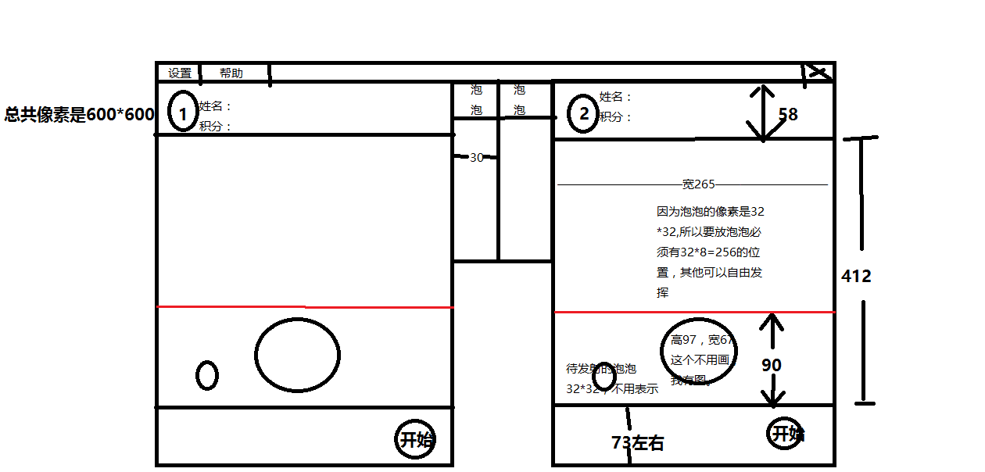

**实现效果：**

**像素是650*593**

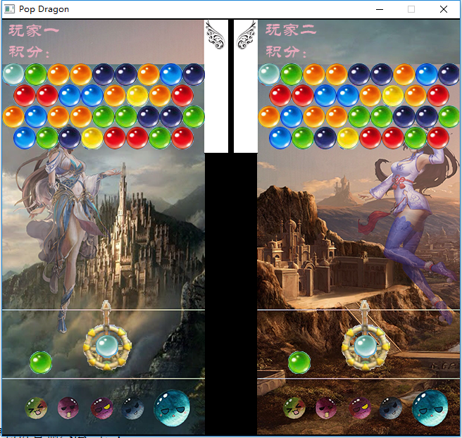

**核心代码：**

typedef struct position

{

int x;

int y;

int bubble;

int flag;

int flag1;///消除泡泡

int flag2;///掉落泡泡

int x1;

int y1;

} position;

void Init_Pop()///初始化泡泡

{

int i;

for(i = 0; i<8; i++)

a[i] = newimage();

getimage(a[0],"black.png");

getimage(a[1],"red.png");

getimage(a[2],"blue.png");

getimage(a[3],"orange.png");

getimage(a[4],"green.png");

getimage(a[5],"white.png");

getimage(a[6],"yellow.png");

getimage(a[7],"purple.png");

}

void Init_bubble()///初始化flag,坐标和四行泡泡

{

srand(time(0));

int i,j,w,n = 363,m = 64;

for(i = 0; i<12; i++)

{

for(j = 0; j<9; j++)

{

pos[i][j].flag = 0;

pos1[i][j].flag = 0;

}

}

for(i = 0; i<12; i++)

{

if(i%2 == 0)

{

w = 9;

n = 363;

}

else

{

w = 8;

n = 379;

}

for(j = 0; j<w; j++)

{

pos[i][j].x = n;

pos[i][j].y = m;

pos[i][j].x1 = n+16;

pos[i][j].y1 = m+16;///右边

pos1[i][j].x = n-363;

pos1[i][j].y = m;

pos1[i][j].x1 = n-363+16;

pos1[i][j].y1 = m+16;///左边

n+=32;

}

m+=30;

}

for(i = 0; i<4; i++) ///打印四行泡泡

{

if(i%2==0) w = 9;

else w = 8;

for(j = 0; j<w; j++)

{

pos_bubble[i][j] = rand()%8;

pos[i][j].bubble=pos_bubble[i][j];

pos1[i][j].bubble=pos_bubble[i][j];

pos[i][j].flag = 1;

pos1[i][j].flag = 1;

}

}

}

void map_1()///打印泡泡

{

int i,j;

for(i = 0; i<12; i++)

for(j = 0; j<9; j++)

{

if(pos[i][j].flag == 1)

{

putimage_transparent(NULL,a[pos[i][j].bubble],pos[i][j].x,pos[i][j].y,BLACK);

}

if(pos1[i][j].flag == 1)

{

putimage_transparent(NULL,a[pos1[i][j].bubble],pos1[i][j].x,pos1[i][j].y,BLACK);

}

}

if(amount[0]!=0 || amount[1]!=0){

int x = 336, y = 49;

int x1 = 293,y1 = 49;

for(i = 0; i<amount[0]/7; i++){

putimage_transparent(NULL,Spop[0],x,y,BLACK);

y+=20;

}

for(i = 0; i<amount[0]%7; i++)

{

putimage_transparent(NULL,Spop[1],x-2,y,BLACK);

if((i+1)%3) x+=8;

else {x= 336; y+=8;}

}

for(i = 0; i<amount[1]/7; i++){

putimage_transparent(NULL,Spop[0],x1,y1,BLACK);

y1+=20;

}

for(i = 0; i<amount[1]%7; i++)

{

putimage_transparent(NULL,Spop[1],x1,y1,BLACK);

if((i+1)%3) x1+=8;

else {x1= 293; y1+=8;}

}}

}