微信小程序支付接口
- 业务流程
参考资料：https://pay.weixin.qq.com/wiki/doc/api/wxa/wxa_api.php?chapter=7_4&index=3
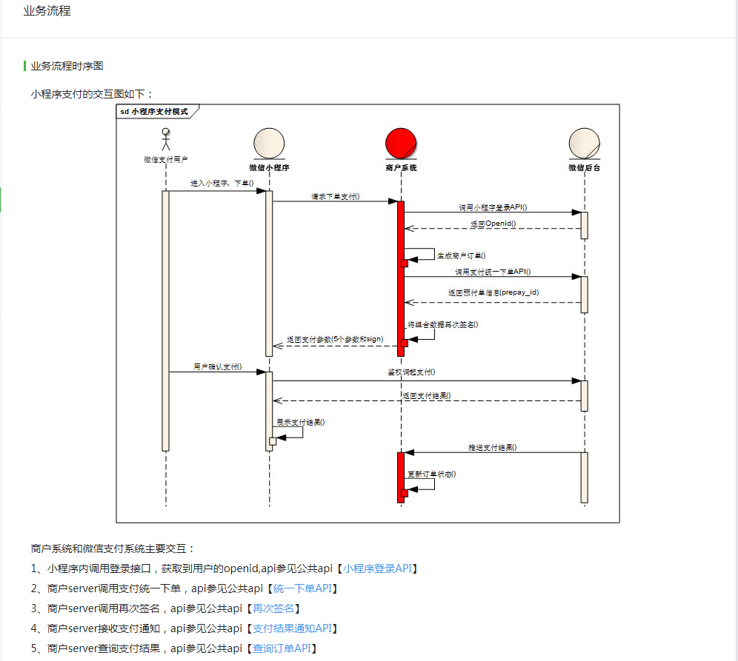
- 小程序内调用登录接口，获得openid
wx.login({
success(res) {
if (res.code) {
//发起网络请求
wx.request({
url: 'https://api.weixin.qq.com/sns/jscode2session?appid=' + config.appConfig.appId + '&secret=' + config.appConfig.AppSecret + '&js_code=' + res.code +'&grant_type=authorization_code',
success:function(res){
that.openid = res.data.openid;
}
});
}
}
}}
- 服务器端调用同意下单接口
Java后台框架使用的是JFinal框架，下载对应的jar包
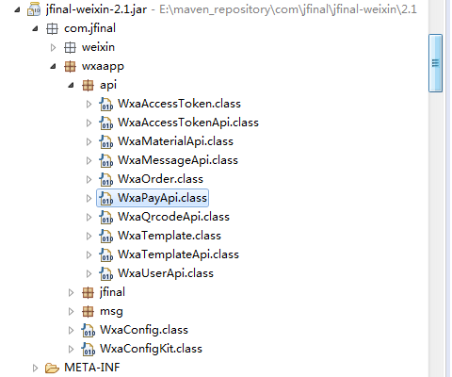
数据库中两张表：订单表和支付日志表
参考：https://pay.weixin.qq.com/wiki/doc/api/wxa/wxa_api.php?chapter=9_1&index=1
public void createOrder() {
Map<String,Object> map = new HashMap<>();
String appId = "wxd678efh567hg6787";
String mchId = "1230000109";
String signKey = "C380BEC2BFD727A4B6845133519F3AD6";
String orderFee = "0.01";
String orderNo = UUID.randomUUID().toString().replace("-", "");

BigDecimal orderFeeBD = new BigDecimal(orderFee);
String totalFee = amountFormat.format(orderFeeBD.multiply(new BigDecimal(100)));
//初始化小程序订单
WxaOrder wxaOrder = new WxaOrder(appId, mchId, signKey);
wxaOrder.setBody("腾讯充值中心-QQ会员充值");
wxaOrder.setOpenId(openid);
wxaOrder.setOutTradeNo(orderNo);
wxaOrder.setNotifyUrl("http://www.weixin.qq.com/wxpay/pay.php");
wxaOrder.setTotalFee(totalFee);

WxaPayApi wxaPayApi = new WxaPayApi();
try {
Map<String, String> dataMap = wxaPayApi.unifiedOrder(wxaOrder);
dataMap.put("orderInfoId", orderInfo.getId().toString());
map.put("data",dataMap);
} catch (PaymentException e) {
e.printStackTrace();
map.put("error_msg",e.getMessage());
map.put("result","2");
}
renderJson(apiRet);
}
其中，WxaOrder 是下载jar包中带的方法：
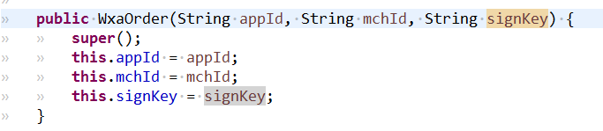
wxaOrder.setNotifyUrl("http://www.weixin.qq.com/wxpay/pay.php");
setNotifyUrl是回调函数地址：
支付成功后程序自动调用的方法
WxaPayApi ：
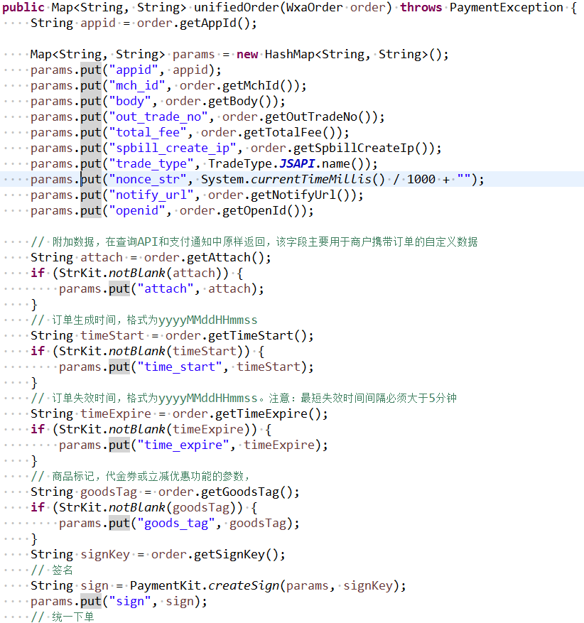

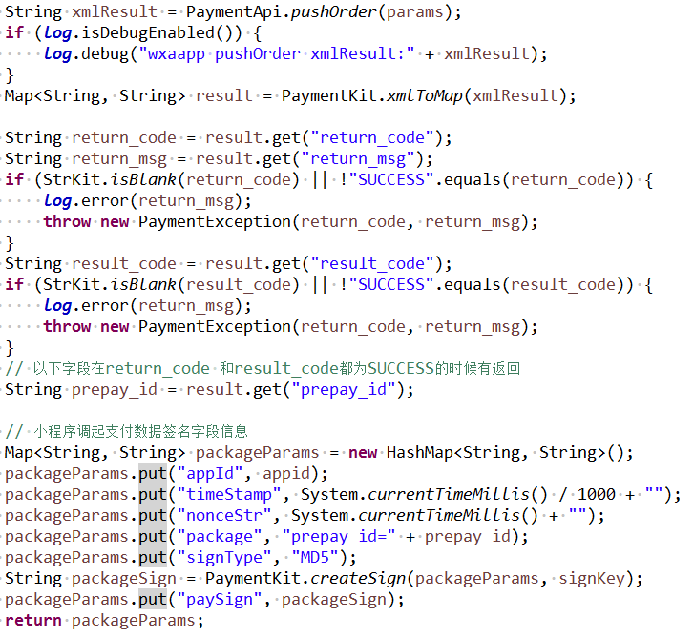
- 小程序端调起支付
wx.requestPayment({
success:function(e){
//调用wx.requestPayment(OBJECT)发起微信支付
},
})
- 微信小程序支付后台：小程序端接收展示
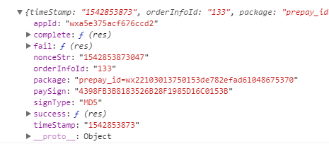

payment_param.success = function (res) {//支付成功
setTimeout(function () {
wx.reLaunch({
url: '../payResult/payResult?result=Y'
})
}, 500);
}
payment_param.fail = function (res) {//支付失败
setTimeout(function () {
wx.reLaunch({
url: '../payResult/payResult?result=N'
})
}, 500);
}
payment_param.complete = function (res) {//成功和失败都要执行
service.hideLoading();
}
wx.requestPayment(payment_param);
- 回调函数
<xml><appid><![CDATA[wxa5e375acf676ccd2]]></appid>
<bank_type><![CDATA[CFT]]></bank_type>
<cash_fee><![CDATA[1]]></cash_fee>
<fee_type><![CDATA[CNY]]></fee_type>
<is_subscribe><![CDATA[N]]></is_subscribe>
<mch_id><![CDATA[1420600602]]></mch_id>
<nonce_str><![CDATA[1542848198]]></nonce_str>
<openid><![CDATA[o9V8j0Y0vAuGtKXyv4jk3VZRfrZE]]></openid>
<out_trade_no><![CDATA[2018112200001]]></out_trade_no>
<result_code><![CDATA[SUCCESS]]></result_code>
<return_code><![CDATA[SUCCESS]]></return_code>
<sign><![CDATA[EA3C4EDCA152392A24AEE88A4F345B7A]]></sign>
<time_end><![CDATA[20181122085604]]></time_end>
<total_fee>1</total_fee>
<trade_type><![CDATA[JSAPI]]></trade_type>
<transaction_id><![CDATA[4200000189201811224215475896]]></transaction_id>
</xml>
使用：
Map<String,String> result = PaymentKit.xmlToMap(xmlMsg);
获得：
{
transaction_id=4200000189201811224215475896,
nonce_str=1542848198,
bank_type=CFT,
openid=o9V8j0Y0vAuGtKXyv4jk3VZRfrZE,
sign=EA3C4EDCA152392A24AEE88A4F345B7A,
fee_type=CNY,
mch_id=1420600602,
cash_fee=1,
out_trade_no=2018112200001,
appid=wxa5e375acf676ccd2,
total_fee=1,
trade_type=JSAPI,
result_code=SUCCESS,
time_end=20181122085604,
is_subscribe=N,
return_code=SUCCESS
}
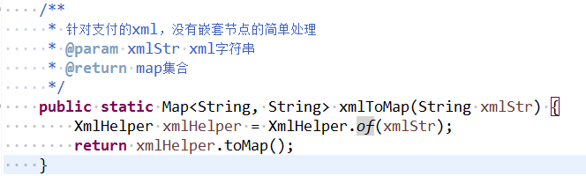
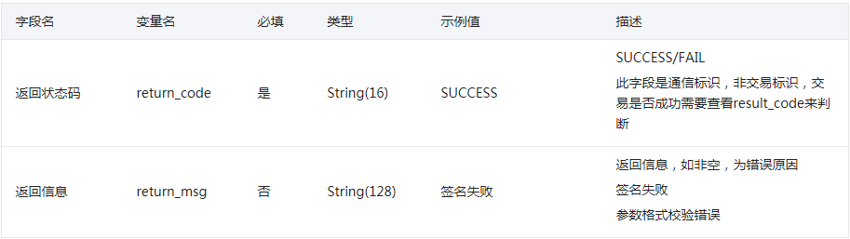
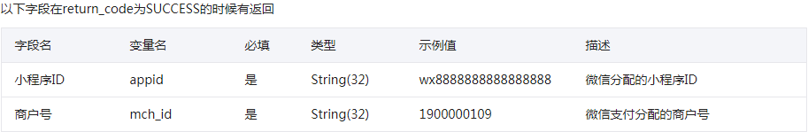
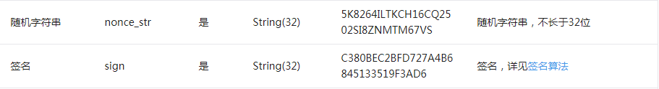
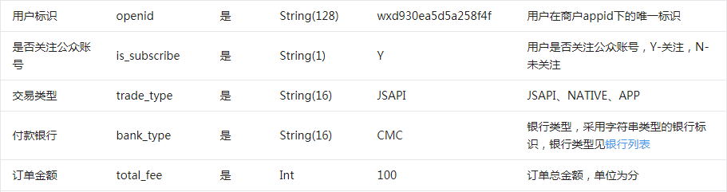
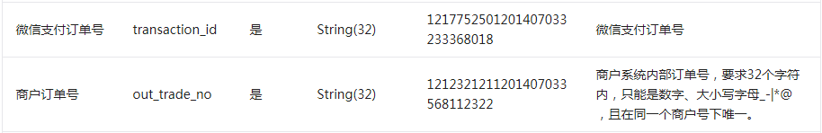
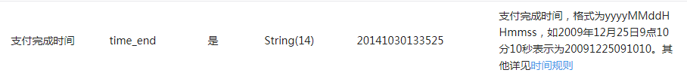
所以回调方法分三个情况：
- return_code为FAIL
if(StringUtils.isNotEmpty(err_code)){
//支付异常
payLog.setPayStatus(PayStatus.PAY_FAIL.getOrdinal());
payLog.setErrorResult(err_code_des);
payLog.setUpdateTime(new Date());
payLog.update();
Map<String, String> xml = new HashMap<String, String>();
xml.put("return_code", "FAIL");
xml.put("return_msg", err_code_des);
renderText(PaymentKit.toXml(xml));
return ;
}
- return_code为SUCCESS
Map<String, String> xml = new HashMap<String, String>();
xml.put("return_code", "SUCCESS");
xml.put("return_msg", "OK");
renderText(PaymentKit.toXml(xml));
return;

