点击性别跳转到性别选择modal页面

1. 创建性别选择modal 页面

ionic g page mine-input



1. 在app.module.ts中注册

**import** { MineInputGenderPageModule } from '../pages/mine-input-gender/mine-input-gender.module';

添加到imports中：

@NgModule({

declarations: [

MyApp

],

imports: [MineInputGenderPageModule ],

});

1. 在父页面module.ts中注册

entryComponents: [

MineInputPage,

]

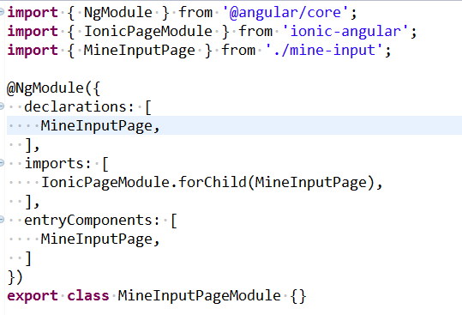

1. 在父页面导入modal

**import** { IonicPage, NavController,ModalController } from 'ionic-angular';

constructor(

**public** navCtrl: NavController,

**public** storage: Storage,

**public** httpser: HttpSerProvider,

**public** popser: PopSerProvider,

**public** utils: UtilsProvider,

**public** modalCtrl: ModalController,

) {

}

1. 测试

//性别选择页面

goMineGenderPage(){

**let** that = **this**;

**let** genderModal = **this**.modalCtrl.create(MineInputGenderPage);

genderModal.onDidDismiss(data=>{

**let** _page_data = that.page_data;

_page_data.gender = data.value;

_page_data.gender_str = data.gender;

that.page_data = _page_data;

});

genderModal.present();

}