Summernote上传图片

<label class=*"col-md-3 form-control-label"* for=*"name"*>教程：</label>

<div class=*"col-md-8"*>

<script type=*"text/plain"* id=*"myEditor"*>

<p>这里我可以写一些输入提示</p>

</script>

</div>

Js:

//实例化编辑器

**var** summernote = $('#myEditor').summernote({

height:250,

minHeight:250,

maxHeight:250,

lang:'zh-CN',

dialogsInBody: **true**,

focus:**true**,

callbacks:{

//图片上传

onImageUpload: **function**(files, editor, $editable) {

sendFile(files[0],editor,$editable);

}

}

});

//上传图片

**function** sendFile(file, editor, $editable){

**var** formdata = **new** FormData();

**var** fileName = file['name'];

formdata.append("file", file);

$.ajax({

//图片上传出来的url，返回的是图片上传后的路径，http格式

url : "${ctx}/attach/qcloud/file/upload",

type : "POST",

data : formdata,

cache : **false**,

contentType : **false**,

processData : **false**,

dataType : "json",

success: **function**(result) {

//url:图片路径 filename：图片名称

$('#myEditor').summernote('insertImage', url, filename);

},

error:**function**(){

alert("上传失败");

}

});

}

Java:

**public** **void** index() {

UploadFile uploadFile = getFile();

**if** (uploadFile == **null**) {

renderJson(RetKit.*fail*("未选择上传文件！"));

**return**;

}

**if** (uploadFile != **null**) {

//上传文件

Map<String, String> result = storeUploadFile(uploadFile);

//返回

result.put("url", realPath);

renderJson(result);

**return**;

}

}

问题：The given range isn't in document.

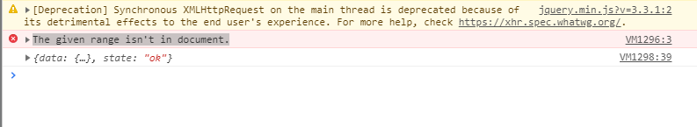

解决方式：$('#myEditor').summernote({dialogsInBody: **true**,});