1. Android toolchain - develop for Android devices

解决方案：

<https://blog.csdn.net/houjiafang/article/details/122010241>

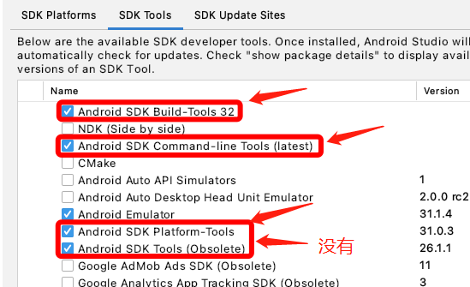

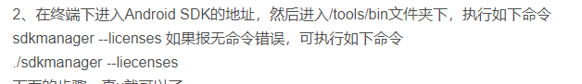

2.