ELEC5305 Project Feedback TWO

1 Project Title
  - Environmental Sound Classification Using MFCC Mel Spectrograms and CNNs

2 Student Information
Xiao Hu
Student ID 530773753
GitHub https://github.com/xihu0648/elec5305-project-530773753

Project overview
This project compares compact neural classifiers for urban sound recognition on UrbanSound8K. The central question is whether retaining temporal structure and changing the acoustic representation improve classification relative to a summary-based MFCC baseline. Three models were evaluated using the official ten-fold partition: an MFCC multilayer perceptron, a temporal MFCC convolutional neural network, and a log-Mel convolutional neural network.
The log-Mel CNN achieved the highest observed mean accuracy, 64.22%, and mean Macro-Macro-F1 score, 0.6527. The temporal MFCC CNN achieved 63.00% accuracy, compared with 60.23% for the MFCC MLP. These results support further investigation of time-frequency representations, but the differences are descriptive: no statistical significance has been established. Class-level results also show that log-Mel features do not improve every sound category.

3 Project Feedback One Response to Supervisor Comments
Following Craig Jin's feedback, the research question was refined from a two-system MFCC-MLP versus log-Mel-CNN comparison to the effect of temporal preservation and acoustic representation. The revised question asks how much classification performance is gained by retaining temporal structure rather than summarizing a recording, and how that gain depends on the representation. Model B was added to make the MFCC-versus-log-Mel comparison within a common CNN architecture. The A-versus-B comparison remains a comparison of complete systems because the classifier also changes.
The revised evaluation uses eight official folds for training, the next official fold for validation, and one fold for testing, rotating the held-out test fold. Configuration verification specifies training-fold-only normalization and disables per-recording peak normalization (Figure 9). The real Fold 1 CNN execution shows test Fold 1 and validation Fold 2 (Figure 14). Augmentation and SNR robustness experiments from the original proposal remain deferred.
The interpretation now addresses persistent confusion between similar mechanical sounds, the effect of zero-padding on an illustrative air-conditioner clip, and the limits of claims about efficiency and published baselines. Per-model inference latency has not been measured, and reproduction of a published baseline has not been confirmed. These items remain part of the next-stage validation rather than completed outcomes.

Project objectives and progress
The implemented study establishes a compact classification baseline, compares summary and temporal MFCC representations, and compares MFCC and log-Mel inputs using CNN models with the same reported parameter count. Ten-fold aggregate metrics and four illustrative sound analyses are available. The next stage is to consolidate reproducibility evidence, test whether improvements are consistent across folds, and evaluate deployment cost on a specified device.

4 Results Presentation

4.1 Dataset and evaluation protocol
UrbanSound8K contains 8,732 labelled audio excerpts from ten classes: air conditioner, car horn, children playing, dog bark, drilling, engine idling, gun shot, jackhammer, siren, and street music. The dataset provides ten official folds. This study reports aggregate outcomes across those ten folds. The official partition should be retained because randomly reshuffling related excerpts can inflate evaluation scores [1].
Each official fold serves as the test fold once. The shared configuration selects the next official fold for validation and fits normalization on the training folds only (Figure 9). Figure 14 documents the real Fold 1 split. Figure 15 contains the completed aggregate results; unrecorded random seeds and repeated-seed stability remain reproducibility limitations.

4.2 Audio preprocessing and feature extraction
Setting | Value
Sampling rate | 22,050 Hz
Input duration | 4 s; shorter excerpts zero-padded
FFT size | 1,024 samples
Hop length | 512 samples
MFCC representation | 40 coefficients
Mel representation | 128 bands; logarithmic energy
Figures 5-7 retain earlier synthetic software checks. They verify feature extraction, frame aggregation and training execution; their synthetic scores do not substantiate real-dataset performance.
Real feature extraction completed for all 8,732 recordings. Figure 12 shows the 80-dimensional aggregated MFCC cache; Figure 13 shows temporal MFCC and log-Mel caches with shapes (8732, 40, 173) and (8732, 128, 173). Temporal matrices retain frame ordering, whereas global mean/std summaries discard it. Figure 9 substantiates the audio preprocessing settings.

4.3 Models and training configuration
Model | Representation and classifier | Parameters
A | 80-dimensional MFCC summary; MLP | 19,274
B | Temporal MFCC; CNN | 24,170
C | Log-Mel spectrogram; CNN | 24,170
All models use batch size 32, learning rate 0.001, a maximum of 50 epochs, and early-stopping patience of 8. Figures 9-11 and 19 document shared settings and parameter counts; these are configuration/self-test outputs, not real-dataset performance measurements. Model A combines mean and standard deviation for each MFCC coefficient into an 80-dimensional input. Models B and C use a common CNN architecture. Figure 14 independently confirms the MFCC CNN parameter count during real-data execution. The parameter-count comparison alone does not measure inference speed.

4.4 Overall ten fold performance
Model | Accuracy mean | Accuracy SD | Macro-F1 mean | Macro-F1 SD
A MFCC MLP | 60.2330% | 5.2844 pp | 0.606483 | 0.049939
B MFCC CNN | 63.0037% | 7.4005 pp | 0.635801 | 0.066192
C Log-Mel CNN | 64.2163% | 6.4850 pp | 0.652673 | 0.058329
All aggregate values are cross-checked against the original summary.json terminal screenshot (Figure 15). Figure 16 reproduces the original comparison plot. The exact proportions are preserved in Appendix A.
SD denotes standard deviation across the ten folds, not standard error or a confidence interval. The recorded metric is Macro-F1 (Figure 15). Fold means need not equal metrics from pooled predictions because folds have different sizes. No statistical significance has been established.
Model B exceeds Model A by 2.77 percentage points in mean accuracy and 0.0293 in mean Macro-F1. This is consistent with a benefit from retaining temporal information, although the comparison changes both the input representation and the classifier, so it does not isolate temporal information alone. Model C exceeds Model B by 1.21 percentage points in accuracy and 0.0169 in F1. With the same reported CNN parameter count, this comparison provides a more direct indication of representation effects, subject to confirming all other implementation settings.
The fold variation is substantial relative to the mean accuracy differences (Figures 15-16). Parameter counts in Figures 10-11 describe model size; per-model inference latency has not been measured. Paired fold scores and repeated seeds are needed to evaluate the reliability of the observed ranking.

4.5 Class specific outcomes
True class | MFCC CNN | Log-Mel CNN | Change
Car horn | ~0.68 | ~0.73 | +0.05
Children playing | ~0.58 | ~0.65 | +0.07
Dog bark | ~0.63 | ~0.64 | +0.01
Siren | ~0.66 | ~0.59 | -0.07
Street music | ~0.70 | ~0.67 | -0.03
Drilling | ~0.62 | ~0.76 | +0.14
Jackhammer | ~0.65 | ~0.71 | +0.06
Gun shot | ~0.80 | ~0.91 | +0.11
Air conditioner | ~0.58 | ~0.46 | -0.12
Engine idling | ~0.55 | ~0.50 | -0.05
Figures 17 and 18 reproduce the original MFCC CNN and log-Mel CNN ten-fold normalized confusion matrices. Every class value and cross-confusion discussed below is read from those images.
These are approximate diagonal entries read from the two-decimal annotations in the original row-normalized matrices (Figures 17-18). They represent class recall at the displayed precision, not exact recomputed metrics. Rounding means rows need not sum exactly to one. Full raw prediction counts and the matrix aggregation implementation have not been independently audited.
The log-Mel improvement is strongest among the selected drilling and gun-shot results, while the lower air-conditioner and engine-idling values show an important trade-off. A higher overall score therefore does not imply uniformly better recognition. Additional class-balanced metrics and complete confusion counts are needed before choosing a representation for an application with specific class priorities.

4.6 Acoustic interpretation of the observed confusions
Drilling is classified as jackhammer in approximately 0.08 of cases for the MFCC CNN and 0.04 for the log-Mel CNN. Both selected recordings contain broad spectral energy and mechanical texture, but the drilling example shows changing bands and a slowly varying envelope, whereas the jackhammer example has a pronounced early onset and a relatively sustained broadband structure. Log-Mel features preserve these local frequency-time patterns, which offers a plausible explanation for the lower drilling-to-jackhammer confusion. This is an interpretation of examples, not evidence that these cues explain every prediction.
Engine idling is classified as air conditioner in approximately 0.19 of cases for the MFCC CNN and 0.24 for the log-Mel CNN. The inspected engine example contains strong low-frequency energy and visible envelope fluctuations. The air-conditioner example is also dominated by low-frequency energy and has a relatively stable active segment. Their shared spectral structure can reduce separability, consistent with the persistent confusion and the lower diagonal entries for these classes in the log-Mel model. The retrieved discussion additionally reports approximately 0.11 for air conditioner to engine idling in the log-Mel model; this value is likewise approximate.

4.7 Representative sound analyses and padding effects
Figures 1-4 reproduce the available user-supplied analyses of drilling, jackhammer, engine idling, and air conditioner. Each contains a waveform, STFT spectrogram, 40-coefficient MFCC display, 128-band log-Mel display, RMS envelope, and envelope modulation spectrum. They illustrate possible acoustic distinctions but are individual examples rather than class-level summaries. Different amplitude scales and plotting ranges prevent direct comparisons of absolute spectral or modulation magnitudes without a common calibration.
In the drilling example, the RMS envelope decreases after an early rise and grows again toward the end, with repeated local fluctuations. The spectrogram includes time-varying bands and broadband components. The jackhammer example shows an increase near 0.2 s followed by sustained broadband energy and a comparatively steady RMS level. Although jackhammer sounds can be impulsive, the displayed envelope does not establish a universal impact rate or a class-wide periodicity.
The engine-idling example shows persistent low-frequency concentration throughout the four-second interval. Its RMS envelope has stronger excursions early in the clip and smaller irregular fluctuations later. The air-conditioner clip, identified in its figure as 127873-0-0.wav from Fold 1, has only approximately 2.05 s of active audio followed by zero-padding to 4 s. The RMS drop at that boundary indicates the end of the excerpt, not a demonstrated physical shutdown of the source. Spectral and MFCC values after the boundary primarily reflect the padding and numerical feature conventions.
A modulation spectrum derived from the full padded envelope combines source variation with the abrupt transition to silence and the finite observation window. The envelope mean contributes a DC component; truncation and padding can introduce low-frequency structure and spectral leakage. The strong near-zero component in the air-conditioner plot must therefore not be interpreted as a distinctive physical modulation frequency. A better follow-up is to analyse the active segment, remove the envelope mean, and apply a documented window before comparing spectra. The RMS hop limits the modulation bandwidth that can be resolved.

5 Code and Results
The project repository is https://github.com/xihu0648/elec5305-project-530773753. Its currently accessible main branch contains the original proposal PDF and README. The earlier report names audio_features.py, visualize.py, dataset.py, cnn_dataset.py, train_mlp.py, train_cnn.py, evaluate.py, model_metrics.py, config.py, and config.json as local implementation components. These local files and final result artifacts are not present in the retrieved main-branch inventory, so repository availability is not evidence that the completed experiments have been published.

6 Discussion and Next Steps
The current evidence establishes an observed ranking for the reported ten-fold experiment, but does not establish statistical significance, real-time operation, or successful reproduction of a published baseline. The approximate confusion entries do not replace complete prediction counts. The four audio examples are nonrepresentative and cannot demonstrate class-wide acoustic distributions or causal explanations for model decisions.
The first next step is to publish fold-level scores, test predictions, seeds, model definitions, and final configuration files alongside the existing proposal. The recovered configuration and execution screenshots establish the reported settings and aggregate results, while exact reproducibility still requires the machine-readable experiment artifacts. Paired fold comparisons and repeated-seed runs can assess the small log-Mel advantage with attention to dependence between cross-validation runs.
The second step is to investigate mechanical-sound confusions with more recordings per class and with separate summaries of correctly and incorrectly classified clips. An ablation should compare padded and active-segment analyses, and test length-aware pooling or masking so that silence does not dominate temporal statistics. Any augmentation or tuning must be selected using validation data rather than the held-out test folds.
The third step is to measure per-model inference latency on a named device, with preprocessing time reported separately and together with end-to-end prediction time. Batch-one timing, warm-up, repeated measurements, and the software environment should be documented. A published baseline should then be reproduced using its specified architecture, features, and evaluation protocol before claiming comparability or improvement over the literature.

6.1 Conclusion
The completed comparison shows mean accuracy increasing from 60.23% for the MFCC MLP to 63.00% for the temporal MFCC CNN and 64.22% for the log-Mel CNN. Log-Mel also achieves the highest reported mean Macro-F1, 0.6527. The selected confusion results indicate better recognition of drilling, jackhammer, and gun shot, alongside weaker recognition of air conditioner and engine idling. These findings favour the log-Mel CNN as the current candidate for further validation, while retaining the MFCC models as useful baselines. The next phase will establish reproducibility, evaluate uncertainty, and measure inference cost.

7 References
[1] Urban Sound Datasets. UrbanSound8K dataset description and official evaluation guidance. https://urbansounddataset.weebly.com/urbansound8k.html
[2] Xiao Hu. ELEC5305 project repository. https://github.com/xihu0648/elec5305-project-530773753
Experimental figures are original user-supplied outputs recovered from the prior project conversation. Browser captures of terminal and matrix attachments have been cropped to the attachment area without changing their values. Synthetic verification figures are explicitly distinguished from real UrbanSound8K evaluation.

Appendix A Exact reported aggregate metrics
The table below preserves the supplied numerical precision. Values are proportions rather than percentages; SD is across folds. No individual fold scores or confidence intervals are reconstructed.
Metric | Model A | Model B | Model C
Accuracy mean | .6023299298328873 | .6300366144006662 | .6421632534861046
Accuracy SD | .052844392294001674 | .07400468886404894 | .06485022998783432
Macro-F1 mean | .6064826098853974 | .6358008216437732 | .652673015972482
Macro-F1 SD | .04993901278952428 | .06619160346168546 | .05832874272556441

Appendix B Original sound analysis figures
Figures 1-4 reproduce the original real-audio analyses. Figures 5-7 preserve earlier synthetic software validation. Figures 8-19 provide original operating evidence for dataset preparation, configuration, feature caches, model size, aggregate metrics, and normalized confusion results. Calculated differences in the prose are derived from the visually verified scores, rather than separate experimental measurements.

Figure 1 Drilling sound analysis
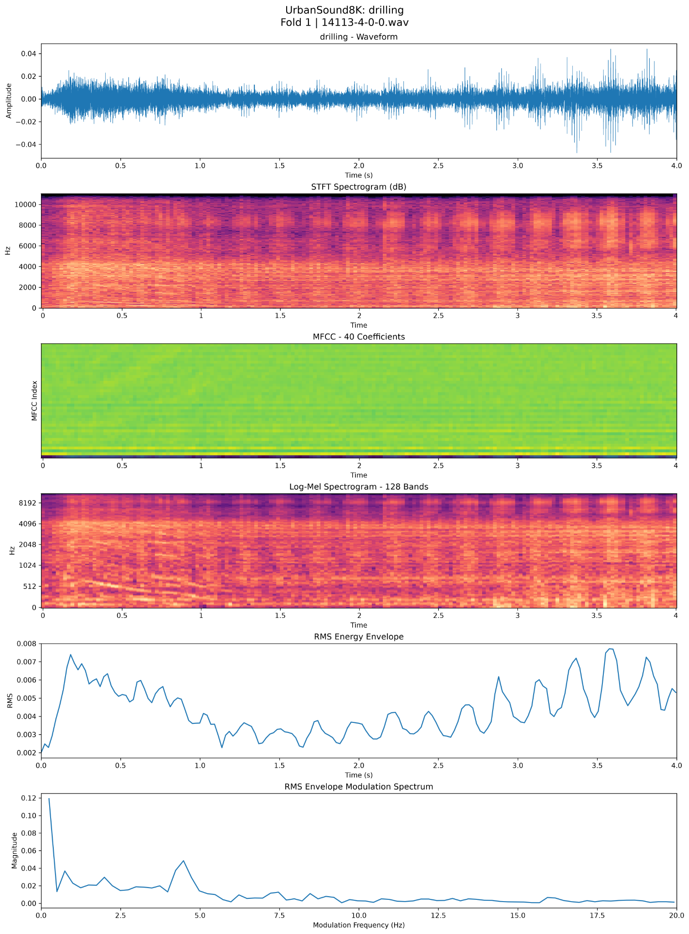
Figure 1. The waveform and spectral displays show temporal variation; envelope peaks must not be generalized to the class.

Figure 2 Jackhammer sound analysis
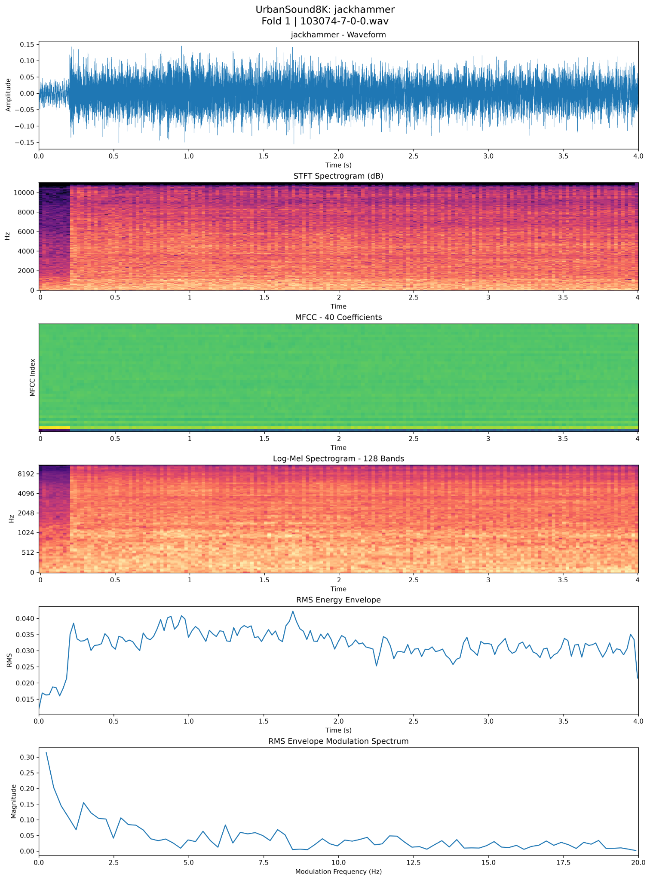
Figure 2. The selected clip has an early onset and sustained broadband energy.

Figure 3 Engine idling sound analysis
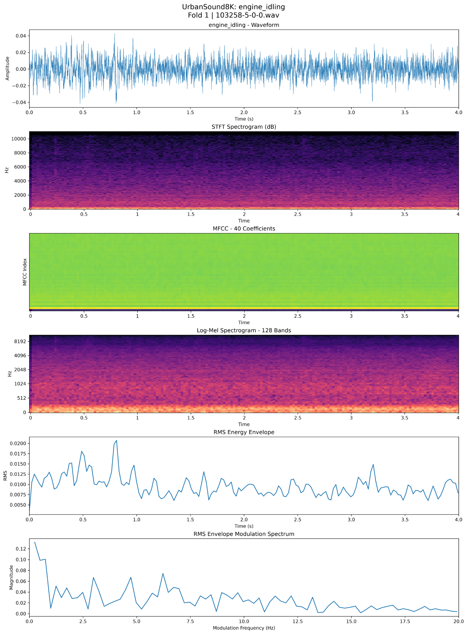
Figure 3. Low-frequency energy persists over the displayed interval, with irregular envelope fluctuations.

Figure 4 Air conditioner sound analysis
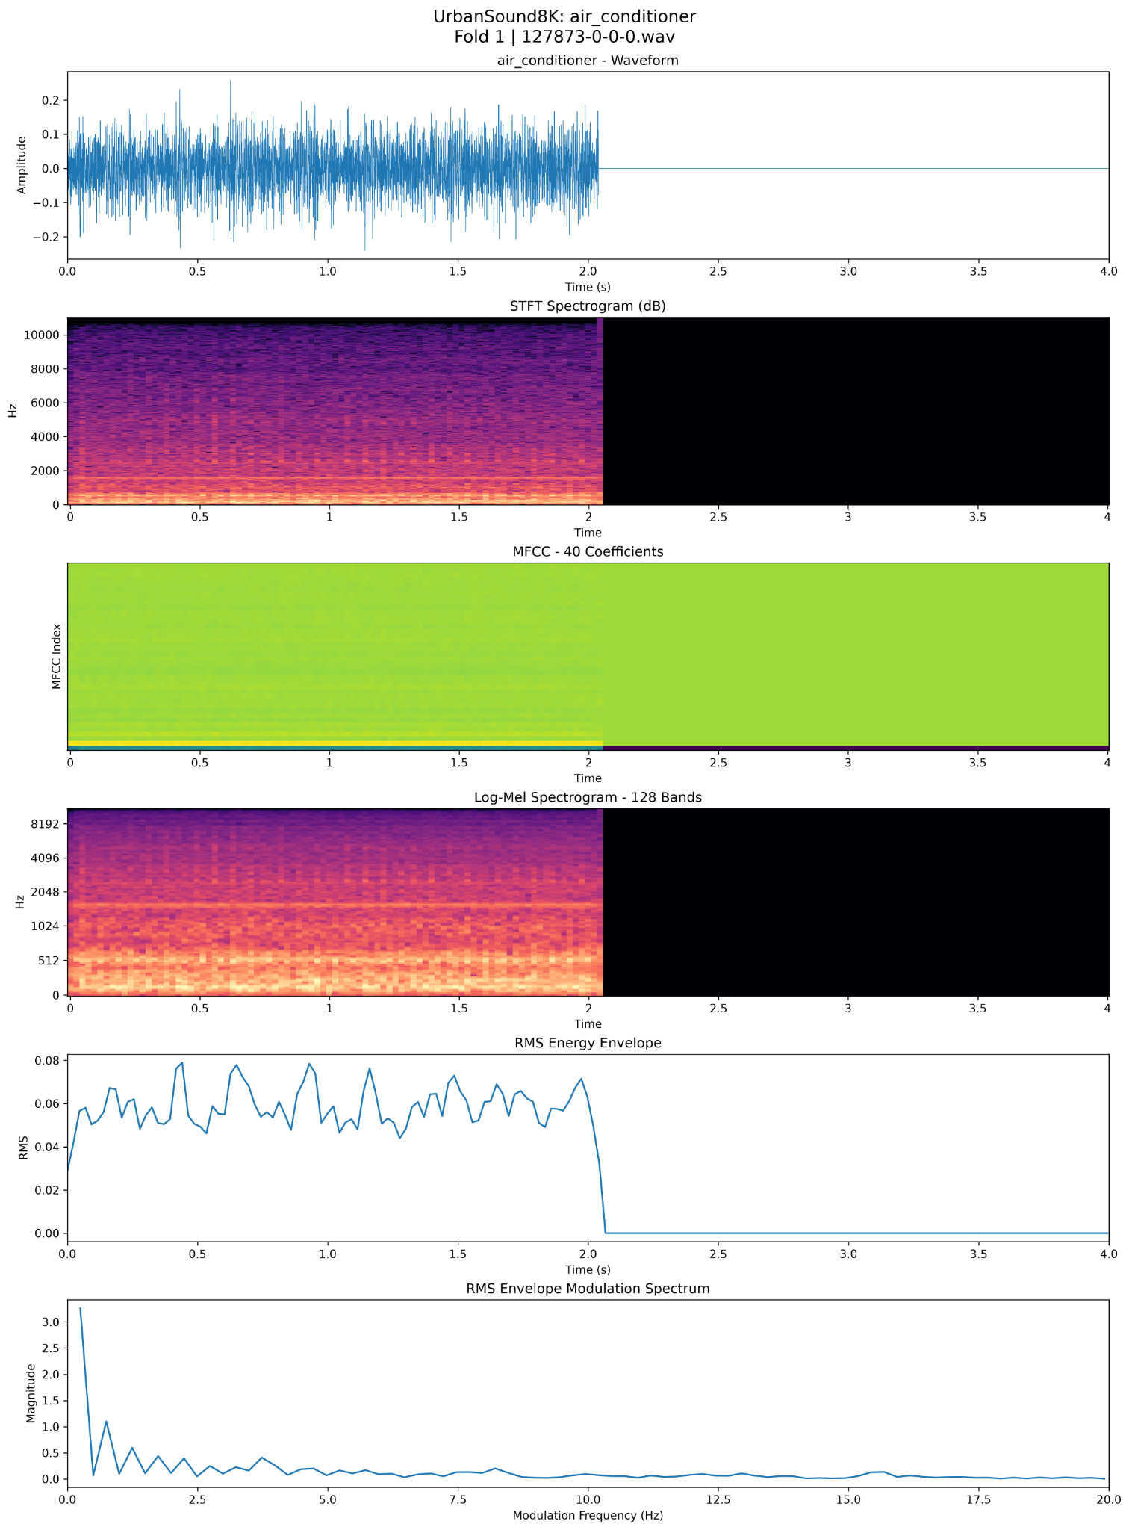
Figure 4. Fold 1 clip 127873-0-0.wav has approximately 2.05 s of active audio and zero-padding thereafter. Near-zero modulation energy includes padding and window effects.

Appendix C Earlier software verification figures
The original images below were recovered from the earlier Feedback TWO document. They are software-verification outputs on synthetic data, not UrbanSound8K classification results. Their scope is limited to the feature extraction, aggregation mechanism, and training routine that they display.

Figure 5 Synthetic feature extraction
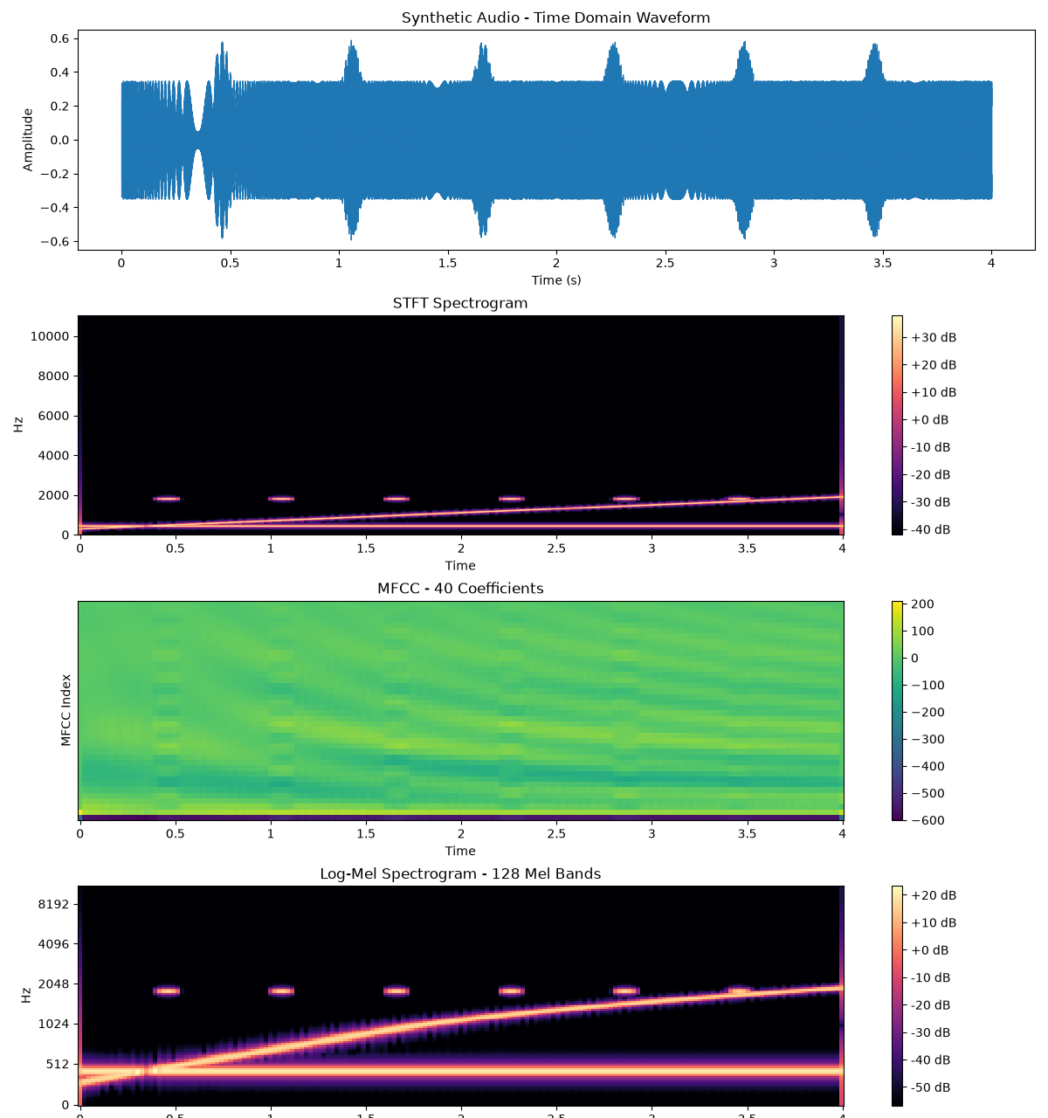
Figure 5. Original software output showing waveform, STFT, 40-coefficient MFCC and 128-band log-Mel representations. This is a synthetic signal.

Figure 6 MFCC temporal shuffling
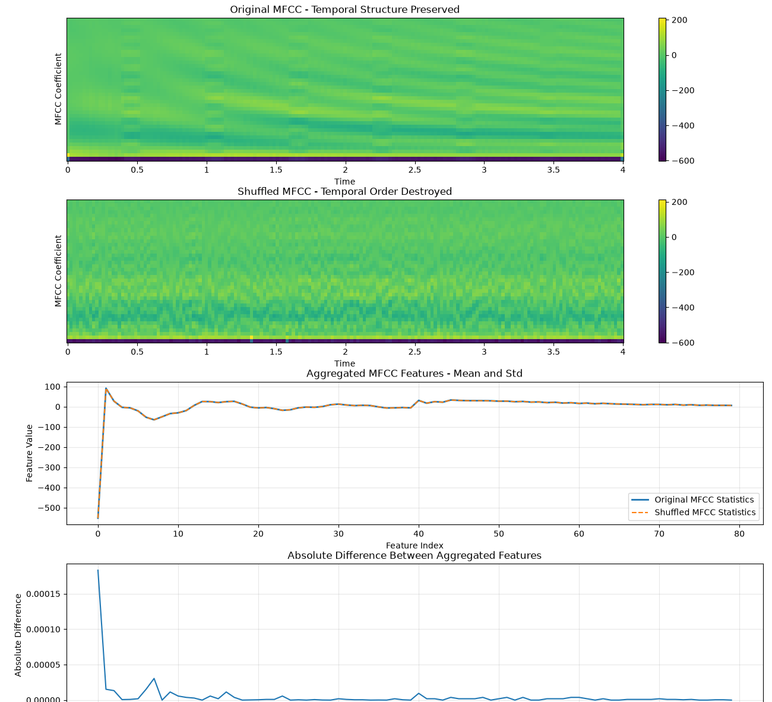
Figure 6. Original software output comparing original and shuffled MFCC frames and their mean/std summaries. It illustrates loss of temporal ordering under aggregation.

Figure 7 Synthetic MLP training curves
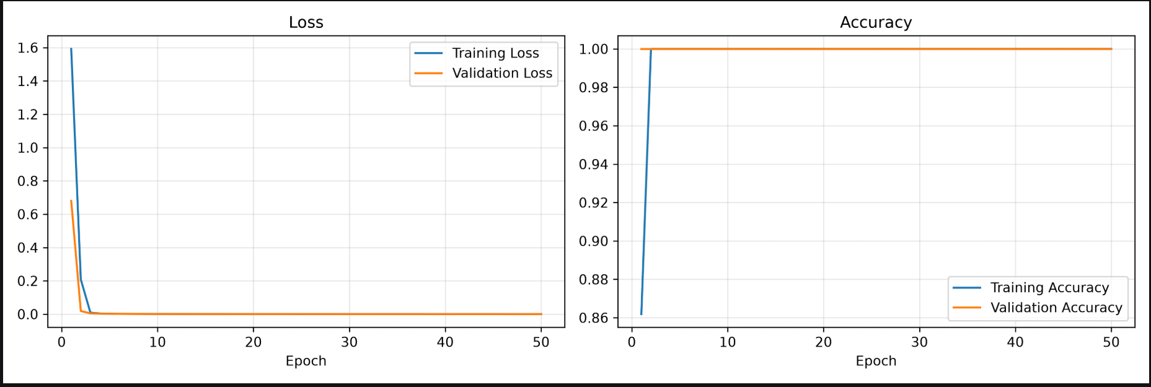
Figure 7. Original synthetic MLP training and validation loss and accuracy curves. These curves do not support the reported real-dataset scores.

Appendix D Original operating evidence
The following attachments were recovered from the original experiment conversation. Configuration and synthetic self-test outputs verify settings and model sizes only. Real dataset extraction and evaluation outputs are identified separately. Figure references in the main text connect quantitative claims to these original images.

Figure 8 Real dataset inspection
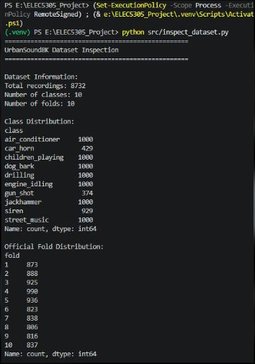
Figure 8. The terminal reports 8,732 recordings, ten classes and ten official folds, with the original class and fold distributions.

Figure 9 Shared configuration verification
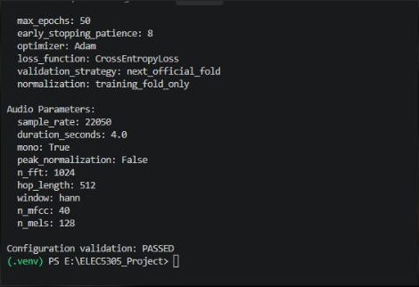
Figure 9. Original configuration output: 22,050 Hz, 4 s, FFT 1024, hop 512, 40 MFCCs, 128 Mel bands, Adam, maximum 50 epochs, patience 8, next-fold validation and training-fold-only normalization.

Figure 10 MLP parameter verification
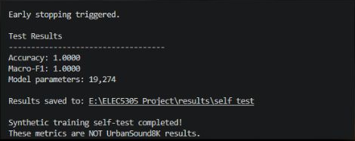
Figure 10. Synthetic self-test reports 19,274 model parameters. Its accuracy and Macro-F1 are synthetic checks and are not UrbanSound8K results.

Figure 11 CNN settings and parameter verification
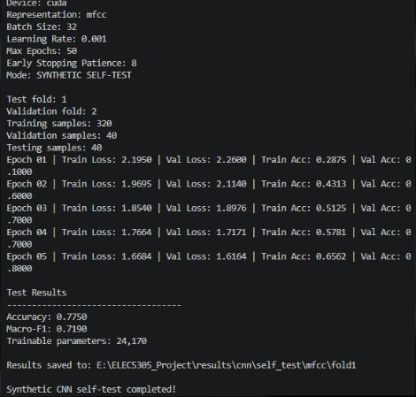
Figure 11. Synthetic MFCC CNN self-test reports batch 32, learning rate 0.001, maximum 50 epochs, patience 8 and 24,170 trainable parameters.

Figure 12 Real aggregated MFCC cache
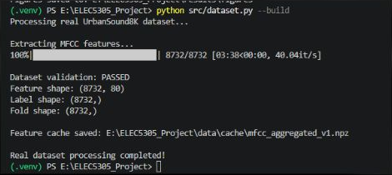
Figure 12. All 8,732 recordings were processed. Feature shape (8732, 80) verifies the aggregated MFCC input.

Figure 13 Real temporal feature caches
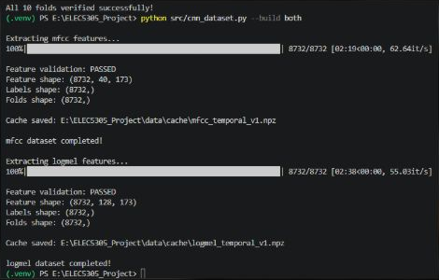
Figure 13. Both real-data caches passed validation: temporal MFCC (8732, 40, 173) and log-Mel (8732, 128, 173).

Figure 14 Real CNN execution and fold allocation
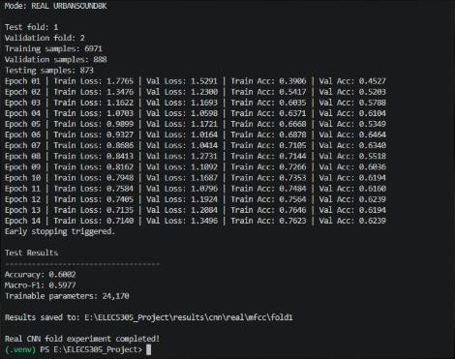
Figure 14. Real MFCC CNN Fold 1 execution shows test Fold 1, validation Fold 2 and 24,170 trainable parameters. This single-fold output is not the ten-fold mean.

Figure 15 Exact ten-fold aggregate results
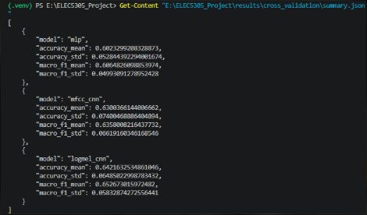
Figure 15. Original summary.json terminal output contains accuracy mean and SD and Macro-F1 mean and SD for all three models. All exact metrics in Appendix A are transcribed from this output.

Figure 16 Original three-model comparison
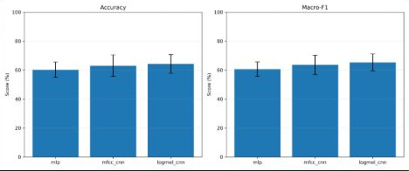
Figure 16. Original accuracy and Macro-F1 comparison plot, with error bars displaying variation across folds.

Figure 17 MFCC CNN normalized confusion matrix
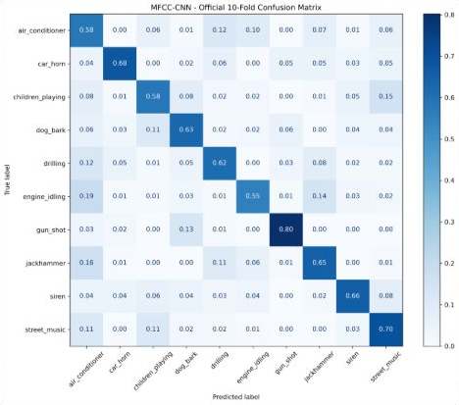
Figure 17. Original official ten-fold normalized confusion matrix. Values in the report are approximate readings of its two-decimal row-normalized annotations.

Figure 18 Log-Mel CNN normalized confusion matrix
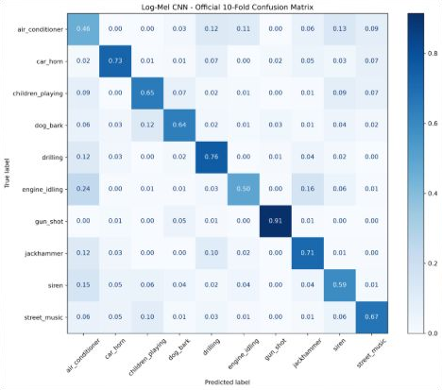
Figure 18. Original official ten-fold normalized confusion matrix. It substantiates class recall and the cross-confusions discussed in Sections 4.5-4.6.

Figure 19 Log-Mel CNN parameter verification
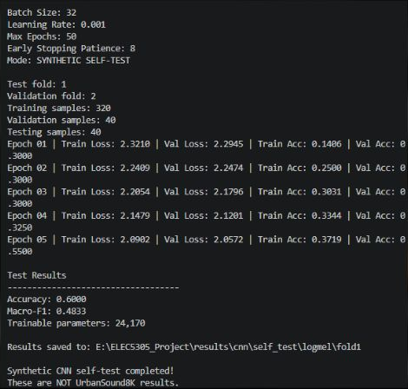
Figure 19. Synthetic log-Mel CNN self-test documents the same shared training settings and 24,170 trainable parameters. Synthetic scores are not real-dataset results.

