官方文档：

<https://confluence.atlassian.com/adminjiraserver072/administering-jira-applications-7-2-828787537.html>

#安装依赖环境

Oracle JRE / JDK    (tick) 1.7

MySQL               (tick) 5.1, 5.5, 5.6 (5.6.16 and later only)

一，下载jira linux bin安装文件

wget <https://downloads.atlassian.com/software/jira/downloads/atlassian-jira-software-7.1.2-jira-7.1.2-x64.bin>

chmod 755 [atlassian-jira-software-7.1.2-jira-7.1.2-x64.bin](https://downloads.atlassian.com/software/jira/downloads/atlassian-jira-software-7.1.2-jira-7.1.2-x64.bin)

./atlassian-jira-software-7.1.2-jira-7.1.2-x64.bin

----------------------------------------------------------------------------------------------

Unpacking JRE ...

Starting Installer ...

This will install JIRA Software 7.1.2 on your computer.

OK [o, Enter], Cancel [c]

o

Choose the appropriate installation or upgrade option.

Please choose one of the following:

Express Install (use default settings) [1], Custom Install (recommended for advanced users) [2, Enter], Upgrade an existing JIRA installation [3]

1

Details on where JIRA Software will be installed and the settings that will be used.

Installation Directory: /opt/atlassian/jira

Home Directory: /var/atlassian/application-data/jira

HTTP Port: 8080

RMI Port: 8005

Install as service: Yes

Install [i, Enter], Exit [e]

i

Extracting files ...

Please wait a few moments while JIRA Software starts up.

Launching JIRA Software ...

Installation of JIRA Software 7.1.2 is complete

Your installation of JIRA Software 7.1.2 is now ready and can be accessed

via your browser.

JIRA Software 7.1.2 can be accessed at http://localhost:8080

Finishing installation ...

----------------------------------------------------------------------------------------------

#配置mysql

CREATE DATABASE jira CHARACTER SET utf8 COLLATE utf8_bin;

GRANT ALL PRIVILEGES ON jira.* TO 'jira'@'localhost' IDENTIFIED BY 'jira';

#下载增加mysql jdbc驱动

wget <http://dev.mysql.com/get/Downloads/Connector-J/mysql-connector-java-5.1.40.zip>

**Extract the jar for the driver (e.g. mysql-connector-java-5.x.x-bin.jar) from the archive.**

cp mysql-connector-java-5.1.40-bin.jar /opt/atlassian/jira/lib/

#重启jira

/etc/init.d/jira stop

/etc/init.d/jira start

二，配置jiar

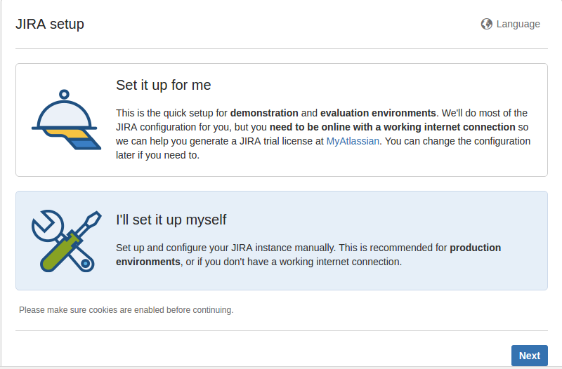

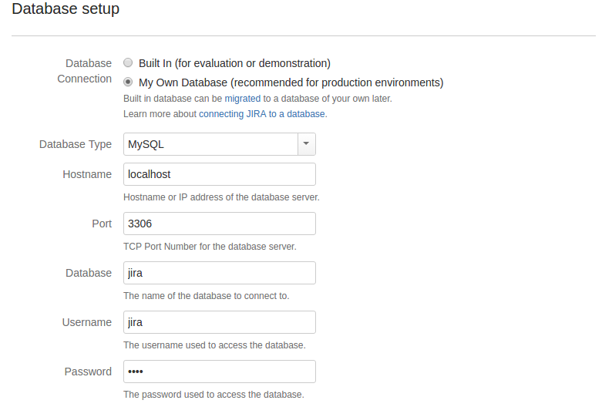

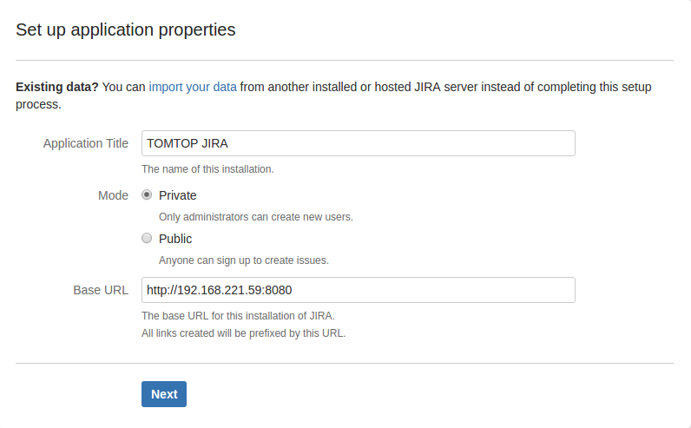

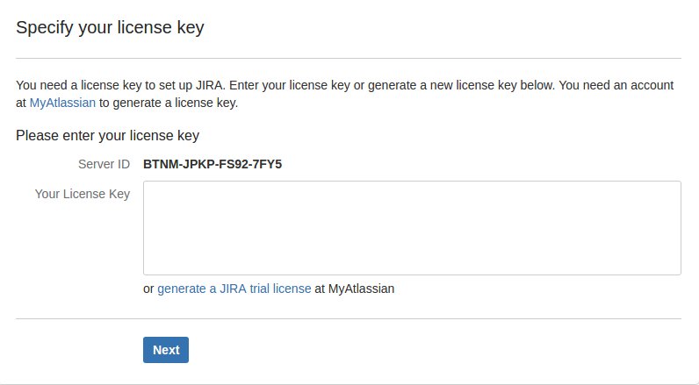

打开[http://192.168.221.59:8080](http://192.168.60.60/8090)后,点击页面上的链接generate an evaluation license online按照官方提示,获取试用key并配置完成安装.

#设置管理员帐号

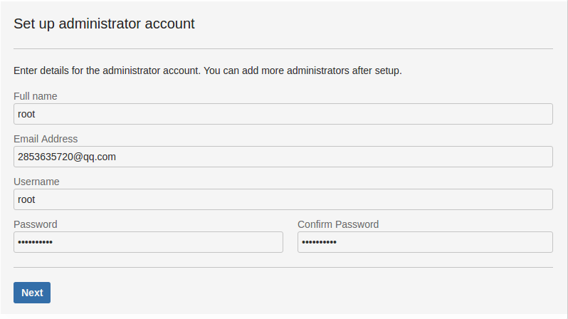

**破解、汉化：**

<http://down.51cto.com/data/2250367>

cp atlassian-extras-3.1.2.jar /opt/atlassian/jira/atlassian-jira/WEB-INF/lib/

/etc/init.d/jira stop

/etc/init.d/jira start

**官方汉化：**

https://translations.atlassian.com/dashboard/download?lang=zh_CN#/JIRA Software/7.1.0-m02

**LDAP用户认证：**

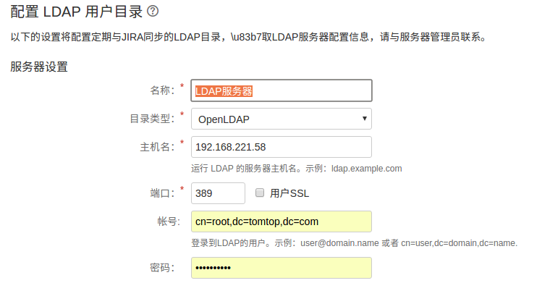

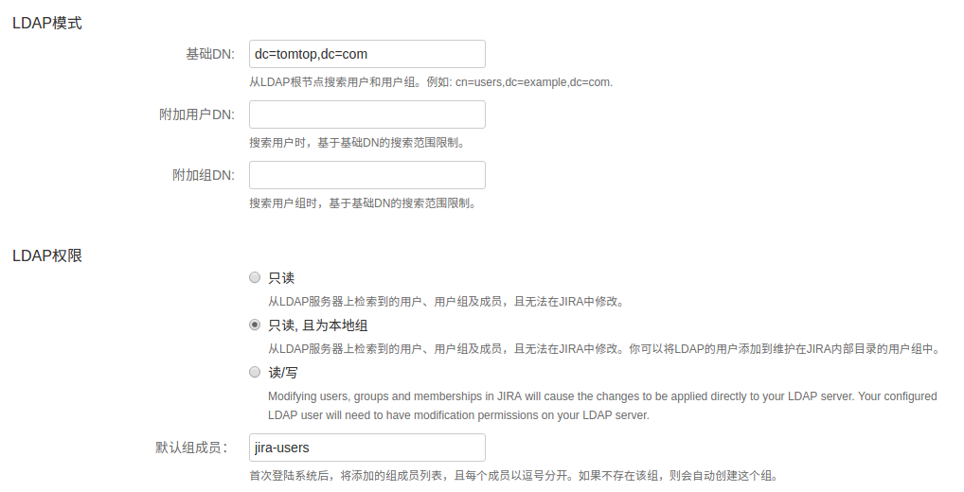

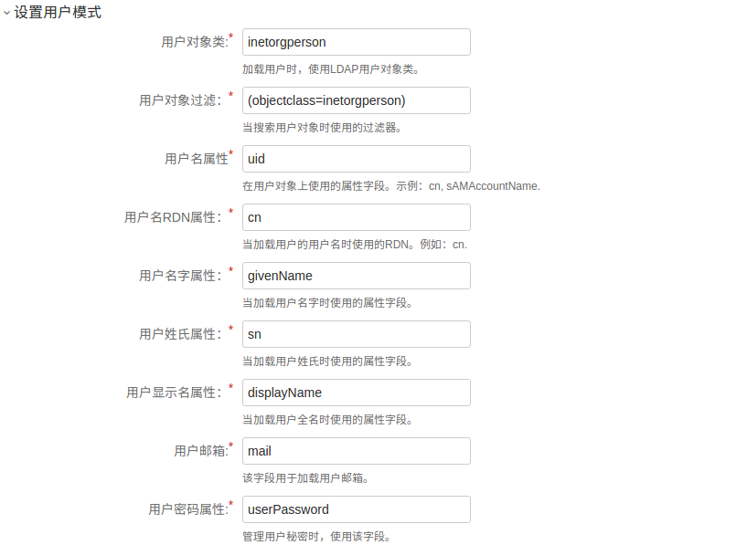

**集成confluence:**

<https://confluence.atlassian.com/doc/integrating-jira-and-confluence-2825.html>

<http://blog.csdn.net/tshangshi/article/details/53081273>