PAWS & WHISKERS ANIMAL RESCUE

CONTENT RESEARCH AND SOURCING

Student Name: Xikombiso Dhlamini
Student Number: ST10533536
Subject: Web Development
Project: Part 1 – Building the Foundation
Approved Organisation: Paws & Whiskers Animal Rescue

1. ORGANISATION OVERVIEW

Organisation Name: Paws & Whiskers Animal Rescue

Organisation Type: Non-Profit Organisation (NPO)

Established: 2021

Paws & Whiskers Animal Rescue is a fictional non-profit organisation established in 2021 with the purpose of rescuing, rehabilitating, and rehoming abandoned, neglected, and abused animals. The organisation provides rescued animals with temporary shelter, food, veterinary care, and emotional support while working to find them safe and permanent homes.

The organisation also aims to educate communities about responsible pet ownership, animal welfare, adoption, and the importance of providing animals with safe and caring environments. Paws & Whiskers works with volunteers, foster families, veterinarians, donors, and community members to support its rescue activities.

2. TARGET AUDIENCE

The Paws & Whiskers Animal Rescue website is intended for:

• Individuals interested in adopting animals.
• Families looking to adopt dogs or cats.
• People interested in volunteering with an animal rescue organisation.
• Individuals or families interested in fostering rescued animals.
• Donors and animal welfare supporters.
• Individuals interested in sponsoring animals.
• Local businesses interested in sponsorship opportunities.
• Community members looking for information about responsible pet ownership and animal welfare.

3. WEBSITE CONTENT RESEARCH

3.1 HOME PAGE

Purpose:

The Home Page will introduce visitors to Paws & Whiskers Animal Rescue and direct them towards the organisation's main activities, including adoption, volunteering, fostering, sponsorship, and donations.

Content Required:

• Hero banner featuring rescued animals.
• Short introduction to the organisation.
• Featured animals available for adoption.
• "Adopt an Animal" call-to-action.
• "Volunteer With Us" call-to-action.
• "Donate" call-to-action.
• Latest rescue stories.
• Animal adoption success stories.
• Upcoming fundraising campaigns and events.
• Information about why visitors should support the organisation.
• Footer containing important links and contact information.

3.2 ABOUT US PAGE

Purpose:

The About Us Page will provide visitors with information about the organisation, its history, purpose, and approach to animal rescue.

Content Required:

• Organisation history.
• Mission statement.
• Vision statement.
• Core values.
• Animal rescue process.
• Information about the organisation's team.
• Volunteer information.
• Achievements.
• Rescue and adoption success stories.
• Information about responsible pet ownership.

3.3 ADOPTION PAGE

Purpose:

The Adoption Page will provide information about animals currently available for adoption and explain how visitors can begin the adoption process.

Content Required:

• Available animal profiles.
• Animal photographs.
• Animal names.
• Animal type.
• Breed.
• Age.
• Gender.
• Personality description.
• Background information where appropriate.
• Adoption requirements.
• Adoption process.
• Frequently Asked Questions.
• Adoption enquiry button.

Example Animal Profiles:

Buddy

• Animal Type: Dog
• Breed: Mixed Breed
• Age: 2 years
• Gender: Male
• Personality: Friendly, playful, and energetic.
• Suitable For: Active individuals or families.

Luna

• Animal Type: Cat
• Breed: Domestic Short Hair
• Age: 1 year
• Gender: Female
• Personality: Gentle, affectionate, and curious.
• Suitable For: Families or individuals looking for a calm companion.

Max

• Animal Type: Dog
• Breed: Labrador Mix
• Age: 4 years
• Gender: Male
• Personality: Loyal, friendly, and well-mannered.
• Suitable For: Families with enough space for an active dog.

Note: The animal profiles are fictional and created for the purposes of this website project.

3.4 VOLUNTEER & SPONSORSHIP ENQUIRY PAGE

Purpose:

The Volunteer & Sponsorship Enquiry Page will allow visitors to express interest in volunteering, fostering, or financially supporting the organisation.

Volunteer Opportunities:

• Animal care assistance.
• Cleaning and maintaining animal areas.
• Helping at adoption events.
• Community outreach.
• Fundraising activities.
• Administrative assistance.
• Transport assistance.
• Foster care.

Volunteer Enquiry Form:

• Full Name.
• Phone Number.
• Email Address.
• Age.
• Preferred Volunteer Activity.
• Availability.
• Previous Animal Care Experience.
• Additional Information.
• Submit Application Button.

Sponsorship Enquiry Form:

• Full Name.
• Organisation/Business Name (Optional).
• Phone Number.
• Email Address.
• Sponsorship Type.
• Sponsorship Amount.
• Additional Notes.
• Submit Enquiry Button.

3.5 DONATION & SUPPORT PAGE

Purpose:

The Donation & Support Page will explain how visitors can financially support Paws & Whiskers Animal Rescue and how their contributions can assist with animal care.

Content Required:

• Why donations are important.
• One-time donation options.
• Monthly sponsorship options.
• Fundraising campaigns.
• Donation call-to-action.
• Information about how donations support rescued animals.

One-Time Donation Options:

• General Donation — R100.
• Animal Care Donation — R250.
• Veterinary Care Donation — R500.
• Shelter Support Donation — R750.
• Custom Donation — Visitor chooses amount.

Monthly Sponsorship Options:

• Food and Nutrition Sponsorship — From R150 per month.
• Veterinary Care Sponsorship — From R300 per month.
• Shelter Support Sponsorship — From R500 per month.
• General Animal Care Sponsorship — From R750 per month.
• Custom Sponsorship — Amount agreed between the organisation and sponsor.

Fundraising Campaigns:

• Community Fundraising Campaign — From R100.
• Animal Rescue Campaign — From R250.
• Emergency Animal Care Campaign — From R500.
• Shelter Support Campaign — From R750.
• Custom Fundraising Contribution — Visitor chooses amount.

Note: The donation, sponsorship, and fundraising amounts are fictional estimates created for the purposes of this website project.

3.6 CONTACT PAGE

Purpose:

The Contact Page will provide visitors with different ways to communicate with Paws & Whiskers Animal Rescue.

Contact Information:

• Telephone Number: 012 555 0147
• Email Address: info@pawsandwhiskers.org.za
• Operating Hours: Monday–Friday, 08:00–17:00
• Saturday: 09:00–13:00
• Sunday: Closed

Branch Locations:

Branch 1 – Pretoria Animal Rescue Centre

• Location: Pretoria, Gauteng
• Google Maps location will be embedded on the website.

Branch 2 – Johannesburg Animal Rescue Centre

• Location: Johannesburg, Gauteng
• Google Maps location will be embedded on the website.

Contact Form:

• Name.
• Email.
• Subject.
• Message.
• Send Message Button.

Social Media:

• Facebook.
• Instagram.
• WhatsApp.

Note: Contact details and locations are fictional and created for the purposes of this website project.
4. IMAGE AND ASSET RESEARCH

Images and other website assets will be sourced legally from reputable platforms that provide images for permitted use. The website will use animal rescue, animal shelter, adoption, volunteering, and pet-related images to support the content of each page.

The Paws & Whiskers Animal Rescue logo will be used as the main branding asset throughout the website.

Planned Image and Asset Sources:

• Pexels — Free stock photography.
• Unsplash — Free stock photography.
• Pixabay — Free stock photography.
• Google Fonts — Website typography.

Images will be checked for their applicable licence or usage requirements before being included in the website. Source information for each selected image will be recorded and included in the project's references.

Image and Asset Record:

• Paws & Whiskers Logo — Original project asset — Website branding.
• Dog Photograph — Pexels/Unsplash — Home Page.
• Cat Photograph — Pexels/Unsplash — Adoption Page.
• Animal Shelter Photograph — Pexels/Unsplash — About Us Page.
• Volunteer Photograph — Pexels/Unsplash — Volunteer Page.
• Animal Adoption Photograph — Pexels/Unsplash — Adoption Page.

Note: Specific image source links will be recorded after the final images have been selected.

5. WEBSITE CONTENT AND ASSET REQUIREMENTS

The following resources will be required to develop the website:

• Paws & Whiskers Animal Rescue logo.
• Animal photographs.
• Animal adoption profile photographs.
• Volunteer and animal care photographs.
• Icons for website sections where appropriate.
• Poppins font for headings.
• Open Sans font for body text.
• Written website content.
• Contact information.
• Google Maps locations.
• Social media links.
• Donation and sponsorship information.

6. FILE ORGANISATION

The project will use a clear folder structure to keep HTML files, images, CSS, JavaScript, and research documents organised.

Paws-and-Whiskers/
• index.html
• about.html
• adoption.html
• enquiry.html
• donation.html
• contact.html

css/

• style.css

js/

• script.js

images/

documents/

• Content-Research.docx

Clear and consistent file names will be used throughout the project to make the website files easier to manage and maintain.

7. RESEARCH SOURCES AND REFERENCES

• Google Fonts. (2026). Google Fonts. https://fonts.google.com

• Pexels. (2026). Free Stock Photos. https://www.pexels.com

• Unsplash. (2026). Free Images. https://unsplash.com

• Pixabay. (2026). Free Images and Media. https://pixabay.com

• National Council of SPCAs (NSPCA). (2026). Animal Welfare Information.

• Society for the Prevention of Cruelty to Animals (SPCA South Africa). (2026). Responsible Pet Ownership Resources.

Note: Specific image links and additional research sources will be added to the reference list once the final website assets and content sources have been selected.

7.1. Sitemap
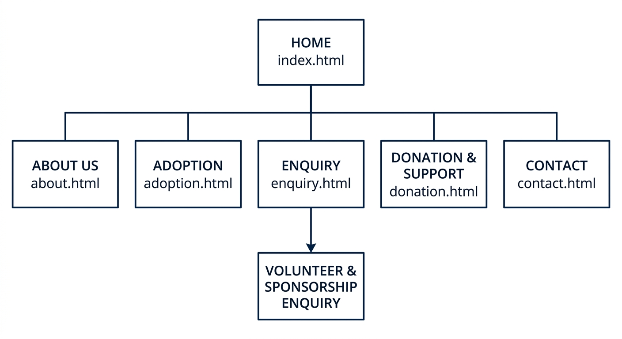

7.2 Wireframe
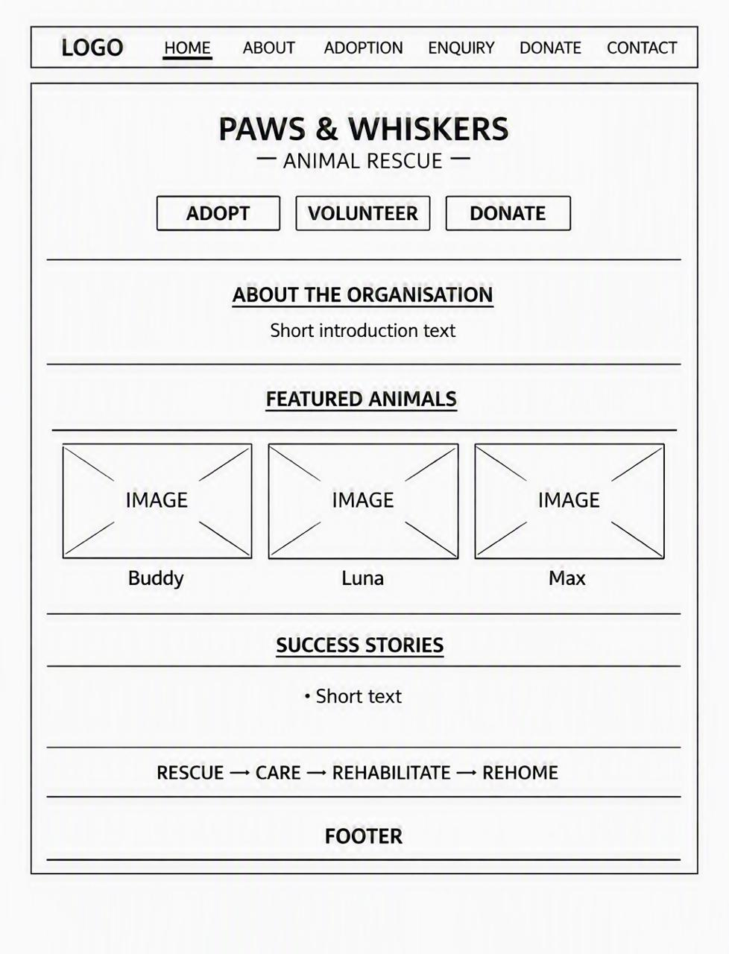
wireframe-home.png 1

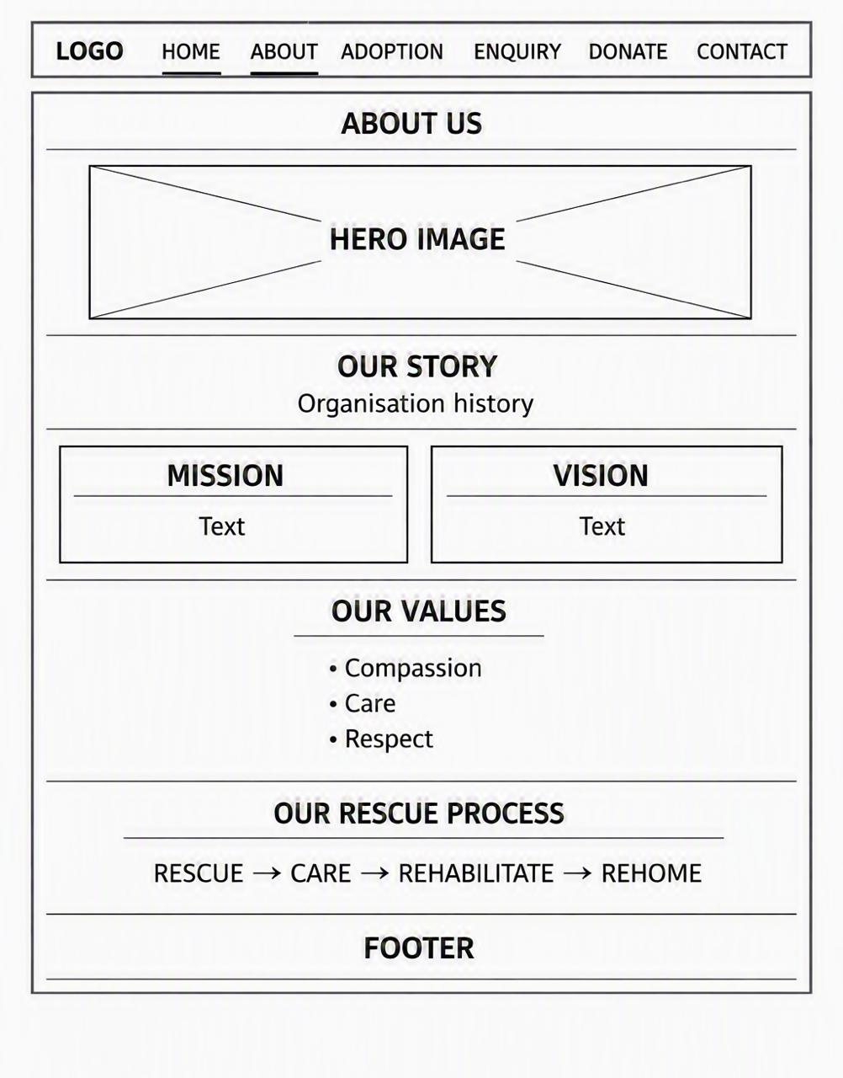
wireframe-about.png 1

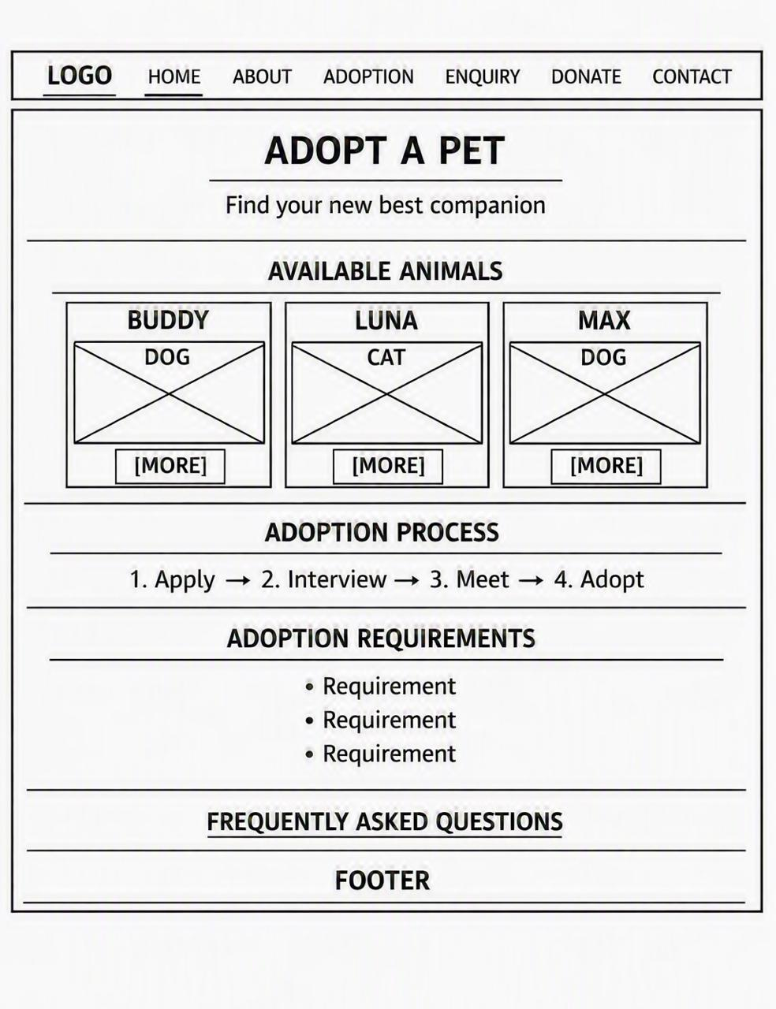
wireframe-adoption.png 1

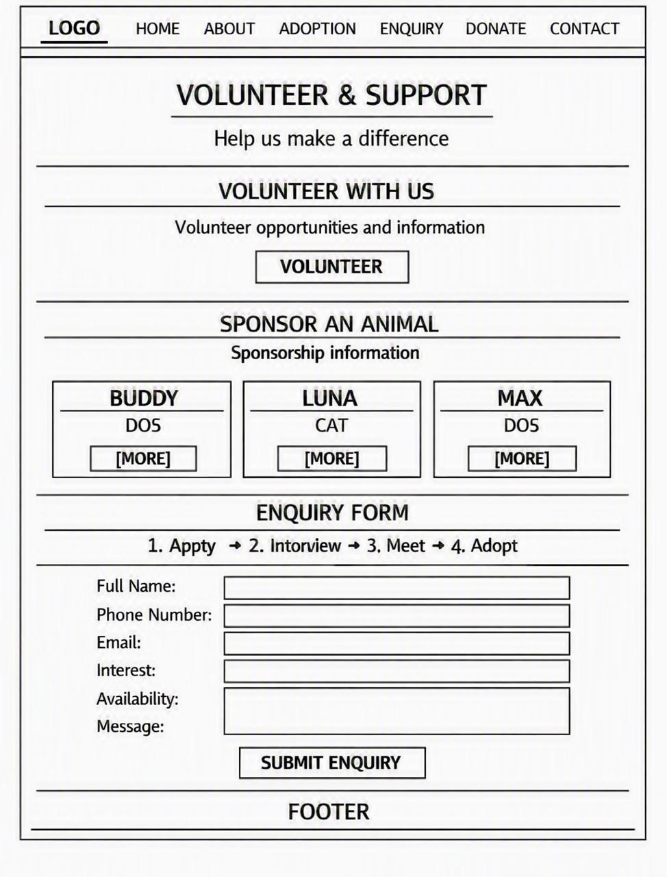
wireframe-enquiry.png 1

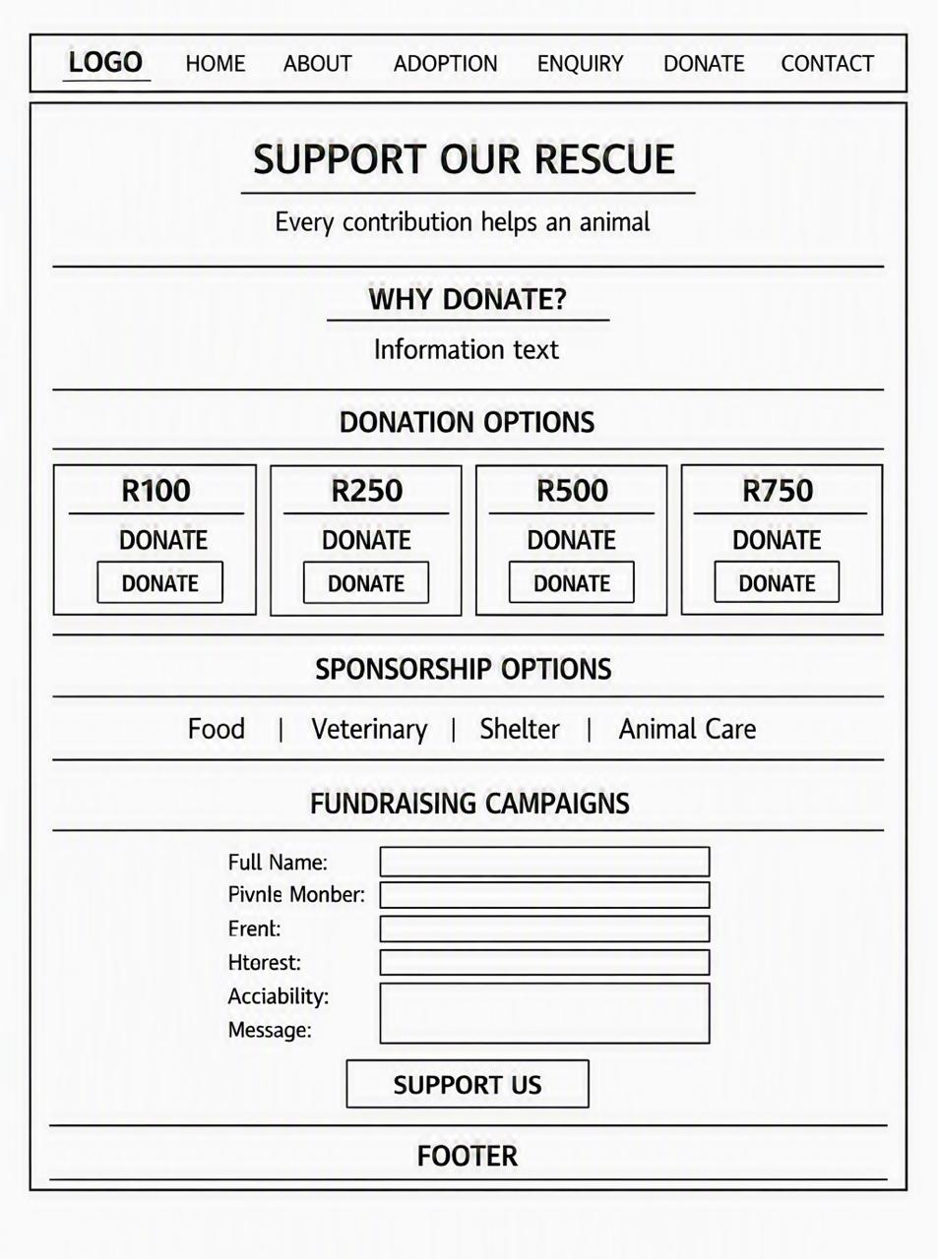
wireframe-donation.png 1

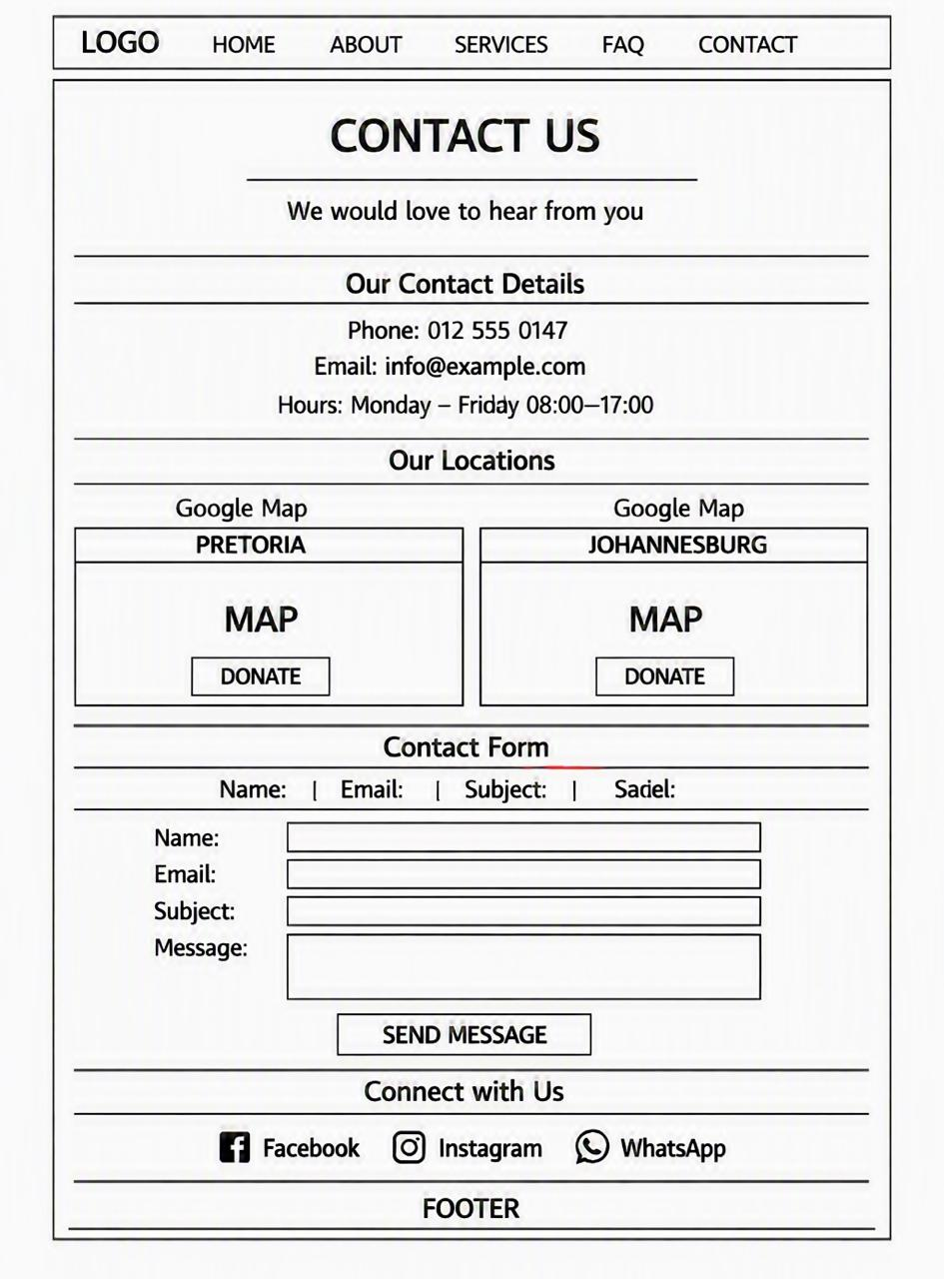
wireframe-contact.png 1

