The instruction is well written, so the first few steps are completed quickly and easily. My screen shots will start from the installation of mysql.

Mysql is successfully installed and running:

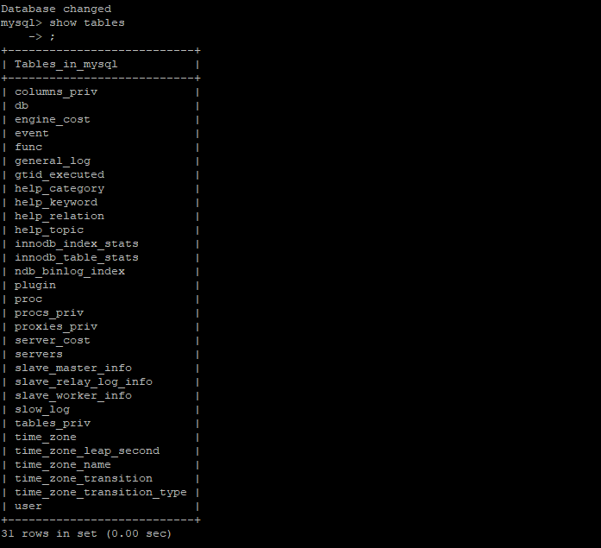

PHP is successfully installed and running:

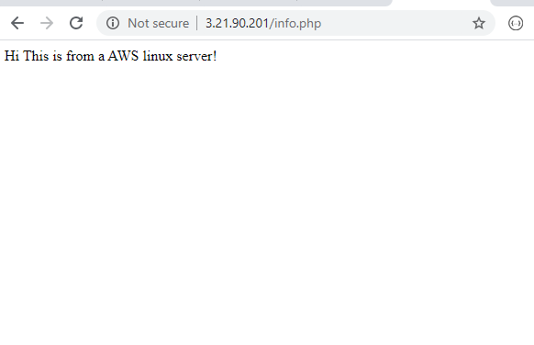

Apache server is now accepting HTTPS connections:

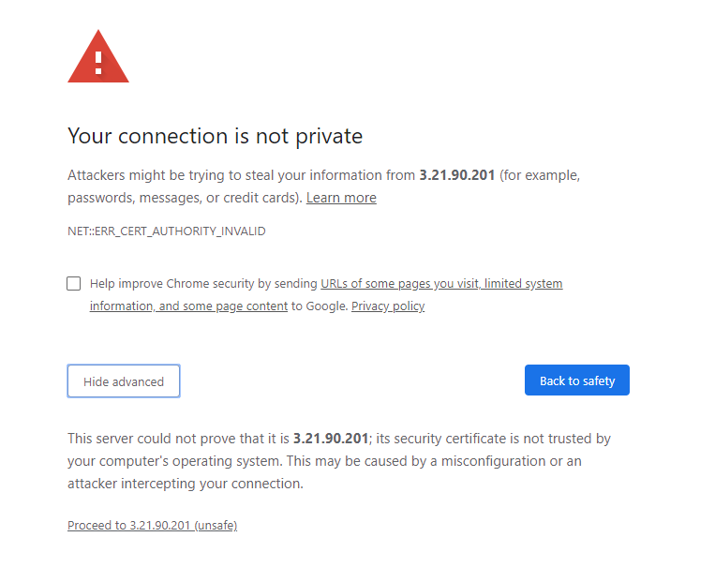

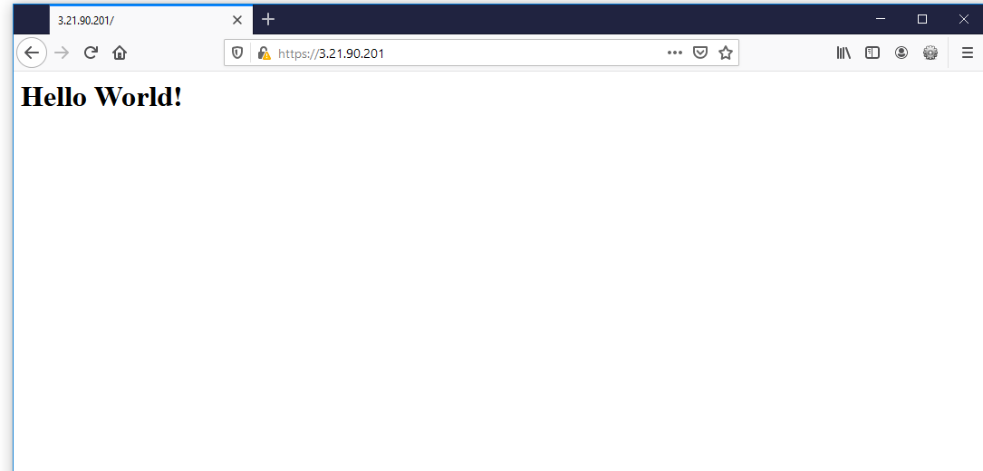

Replace the ssl certificate:

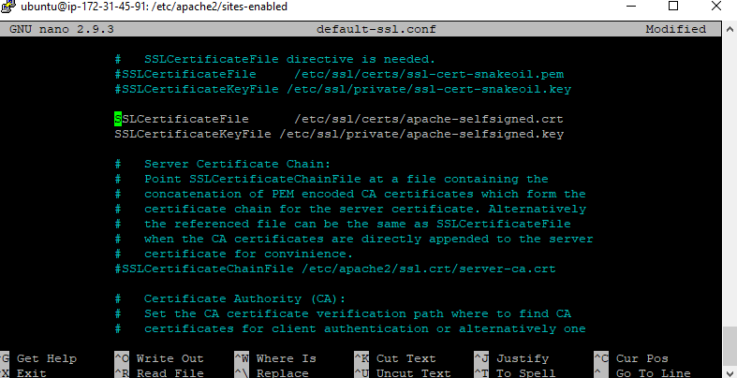

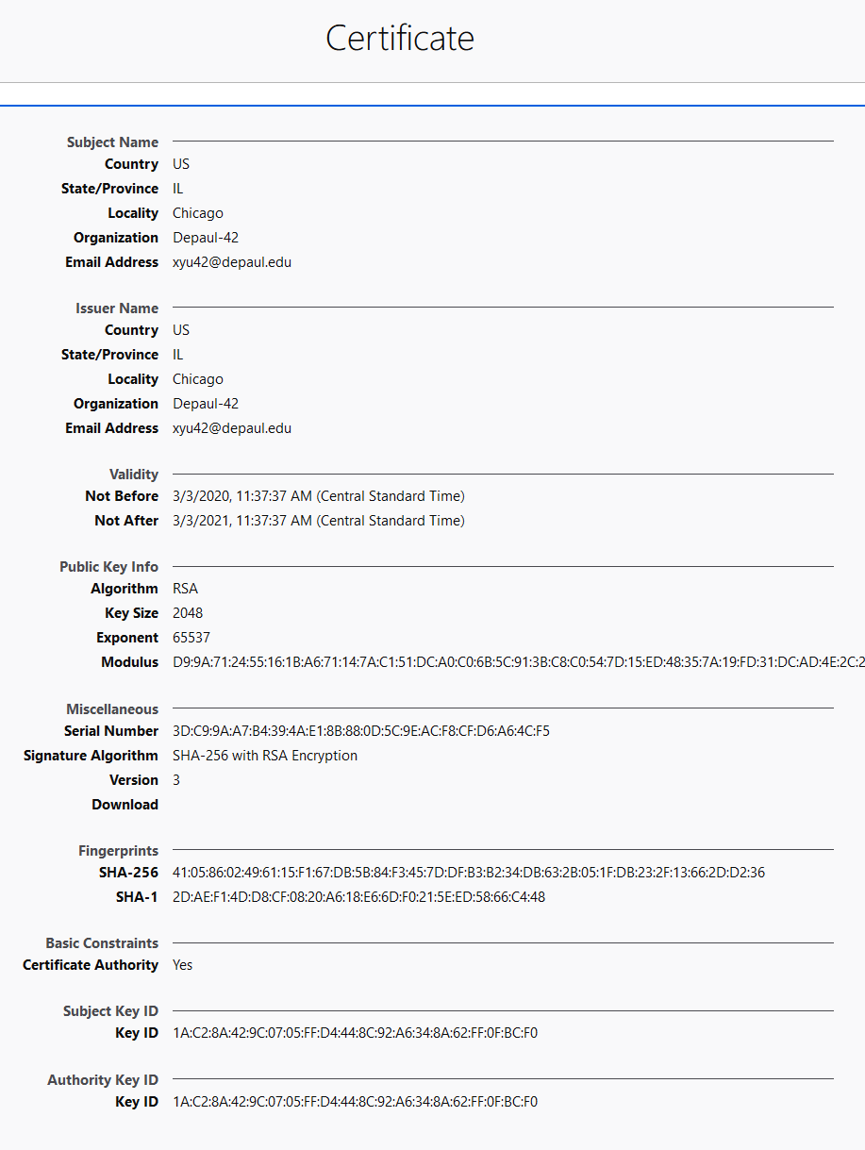

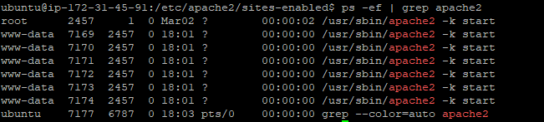

Added Basic Authentication to your Apache Web Server:

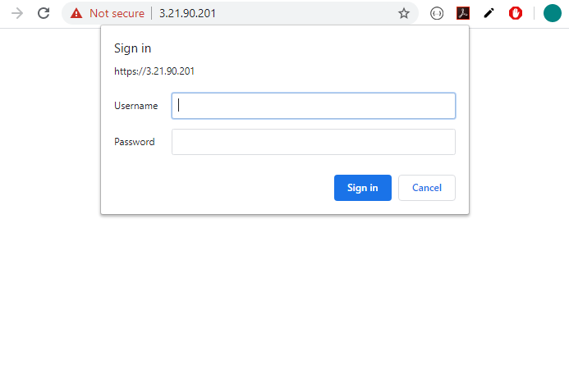

Installed phpadimn:

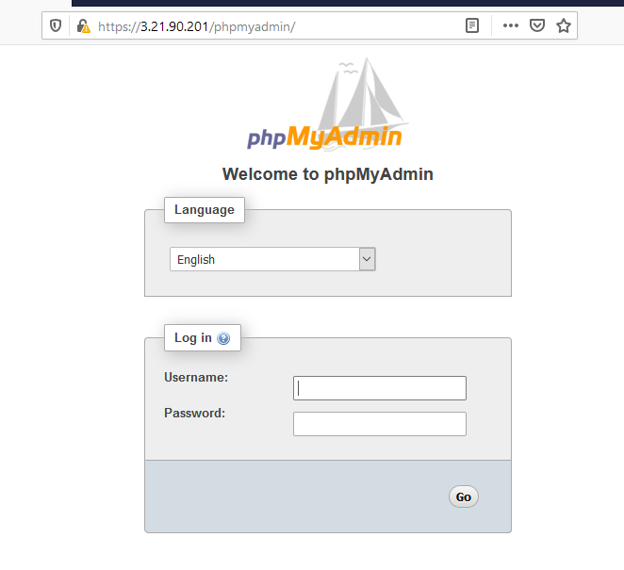

Preparation for installing WordPress to support our web applications:

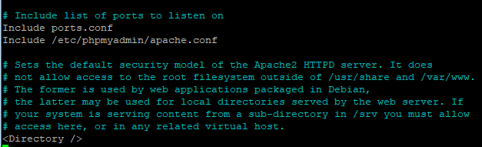

Brought up wordpress in browser:

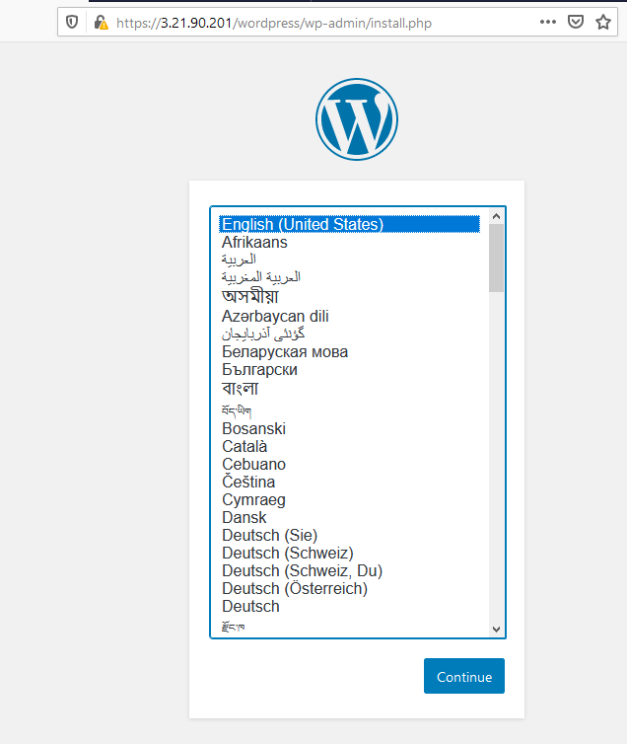

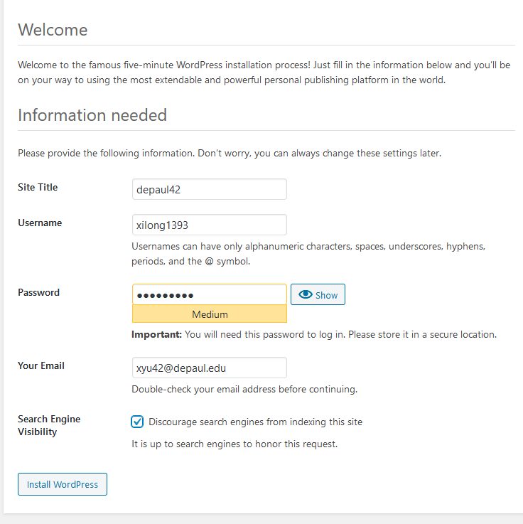

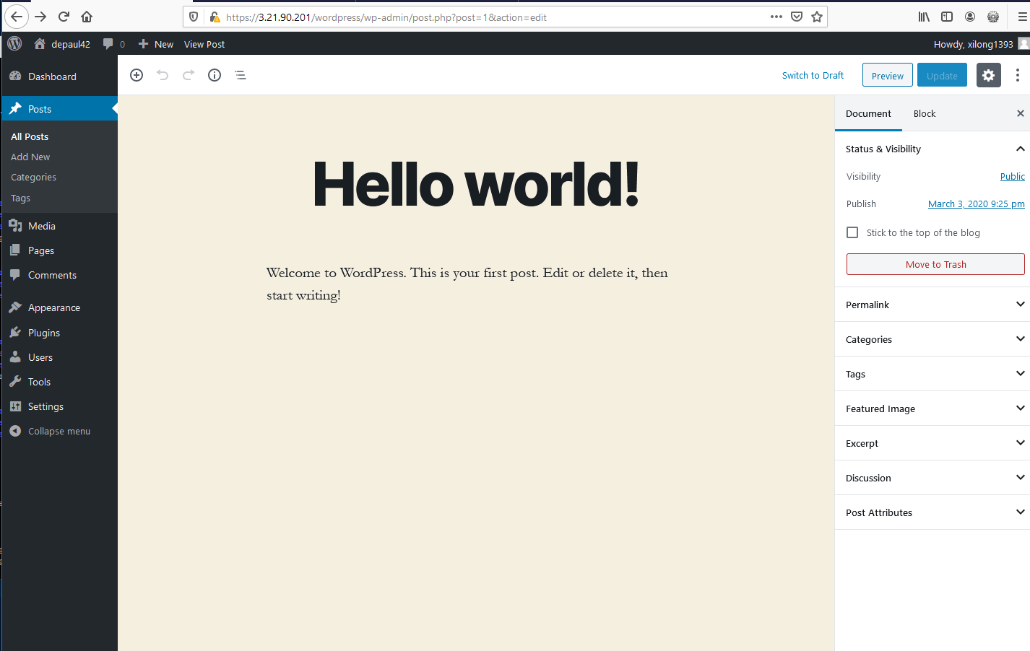

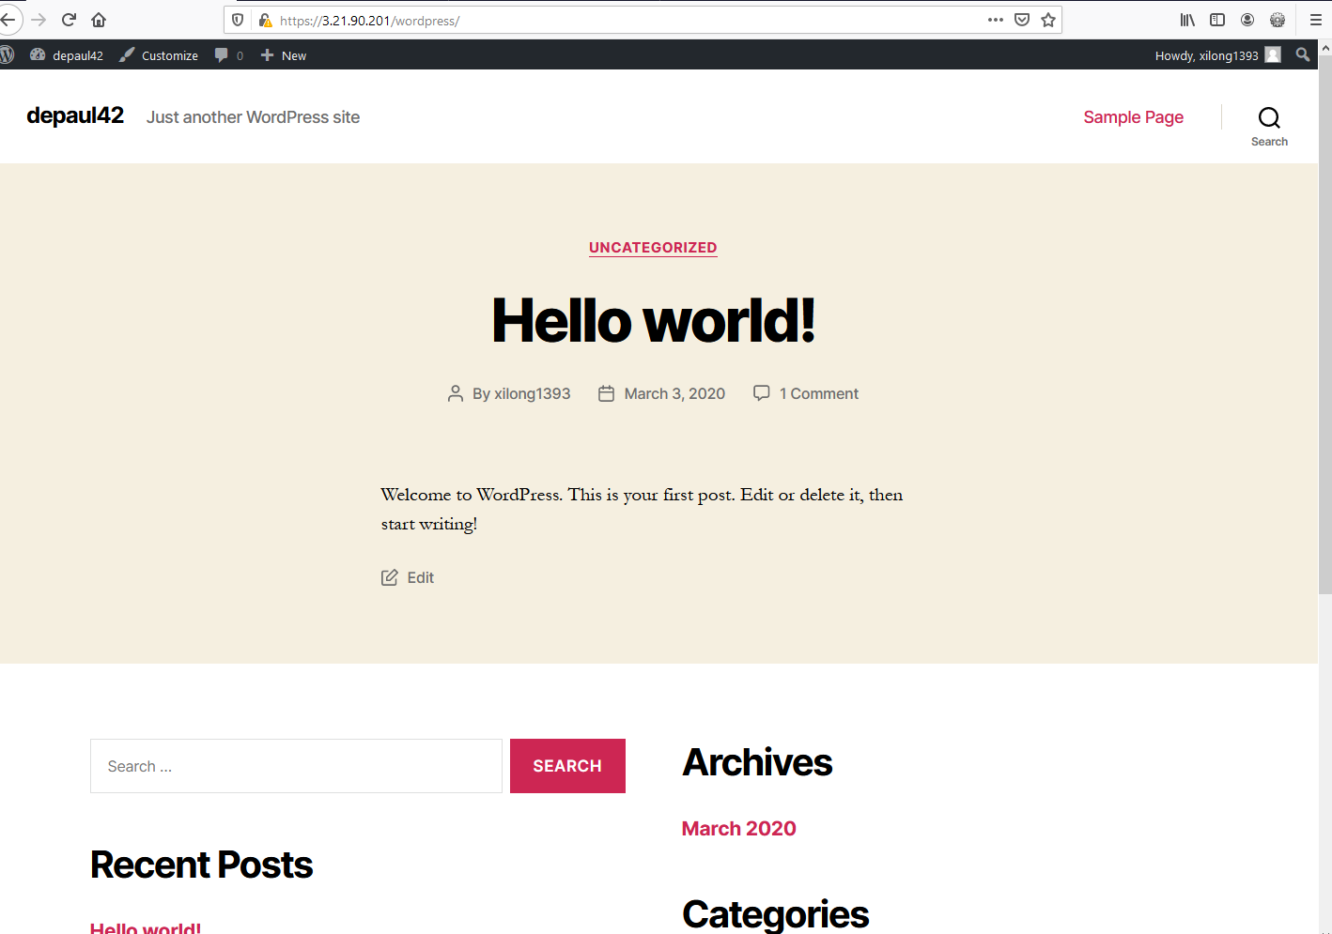

This project is really useful to me. Just by following the instruction given by Professor Elliott. I learned how to build a web server from scratch. The contents covered are really comprehensive, which includes front end, backend, security, and database. I also familiarized myself with linux system, SSL, how to do anthentication on apache server. Every detail of this project is worth looking into!