GHW#3: HIVE DW on DATAPROC

Full Name: Yuansheng Lin
NYU ID: N16341534
NetID: yl15687
Course: CSGY-6513-E Big Data
Section: E
Semester: Fall 2026

Part A: Prepare HDFS and create the managed table (15 points)
A.1
(1 point) Upload music_streams.csv to your Dataproc home directory.
A.2
(2 points) From the Linux shell, create two HDFS directories and put a copy of the CSV into each one:
hdfs dfs -mkdir -p input
hdfs dfs -mkdir -p ext_streams
hdfs dfs -put music_streams.csv input/
hdfs dfs -put music_streams.csv ext_streams/
hdfs dfs -ls input
hdfs dfs -ls ext_streams
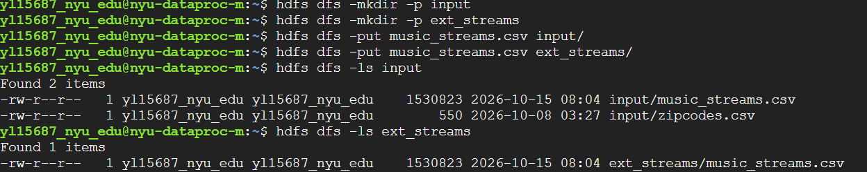

A.3
(2 points) Start Beeline and select your database:
beeline -u jdbc:hive2://localhost:10000
use yl15687_nyu_edu;
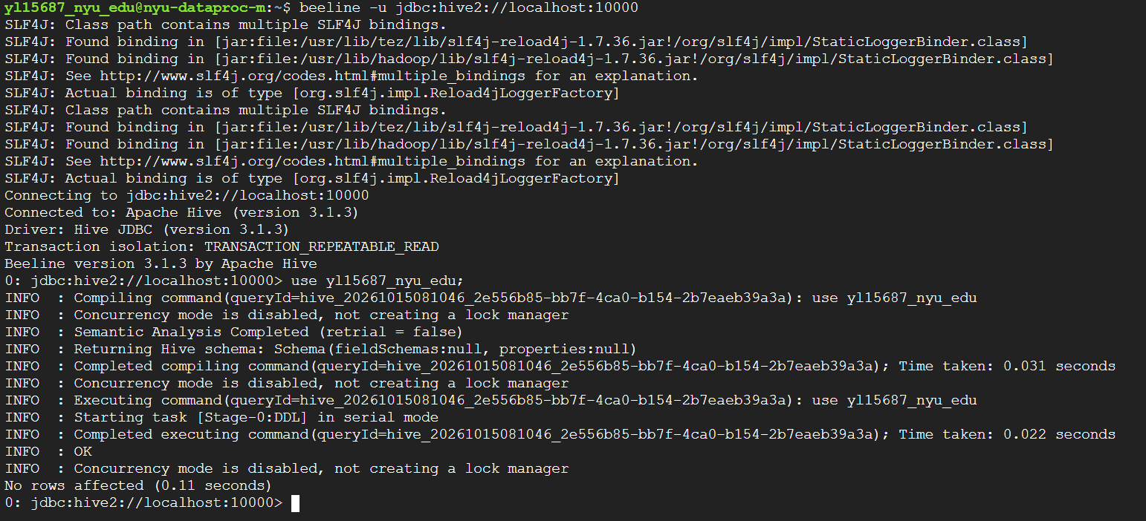

A.4
(2 points) Create a managed table named yl15687_streams, STORED AS TEXTFILE, with a schema matching the CSV, fields terminated by ‘,’, and configured to skip the header row.
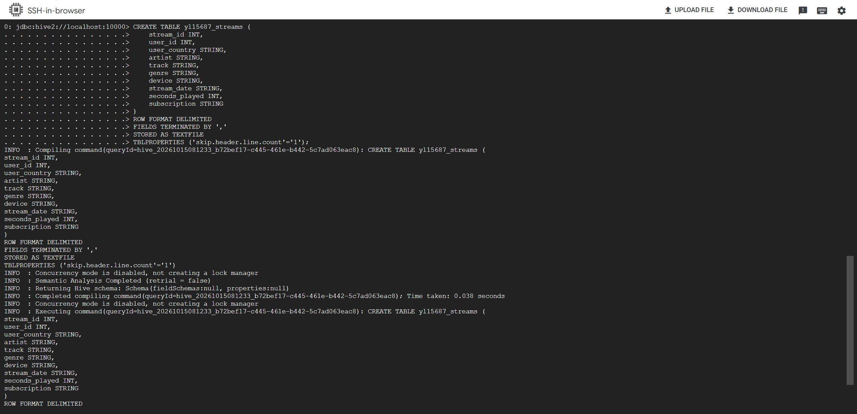

A.5
(2 points) Load music_stream.csv in input directory into yl15687_streams table.
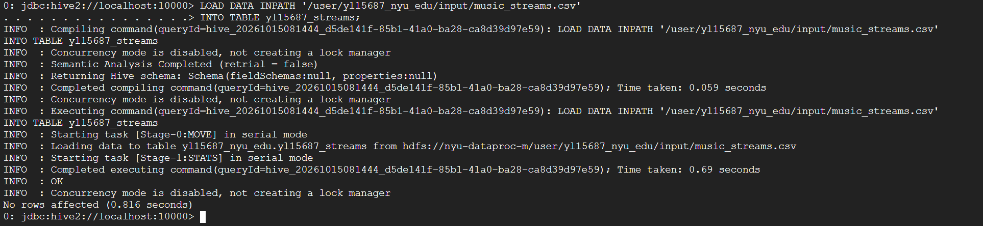

A.6
(2 points) Verify the load: run
DESCRIBE yl15687_streams;
SELECT * FROM yl15687_streams LIMIT 5;
SELECT COUNT(*) FROM yl15687_streams;
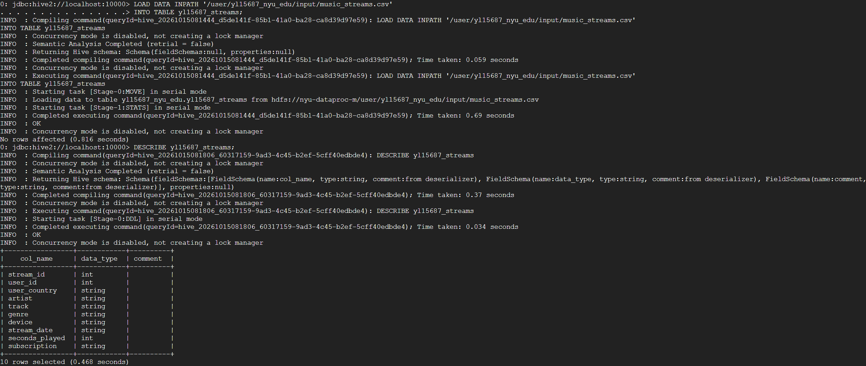

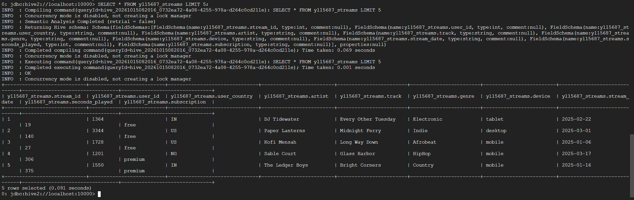

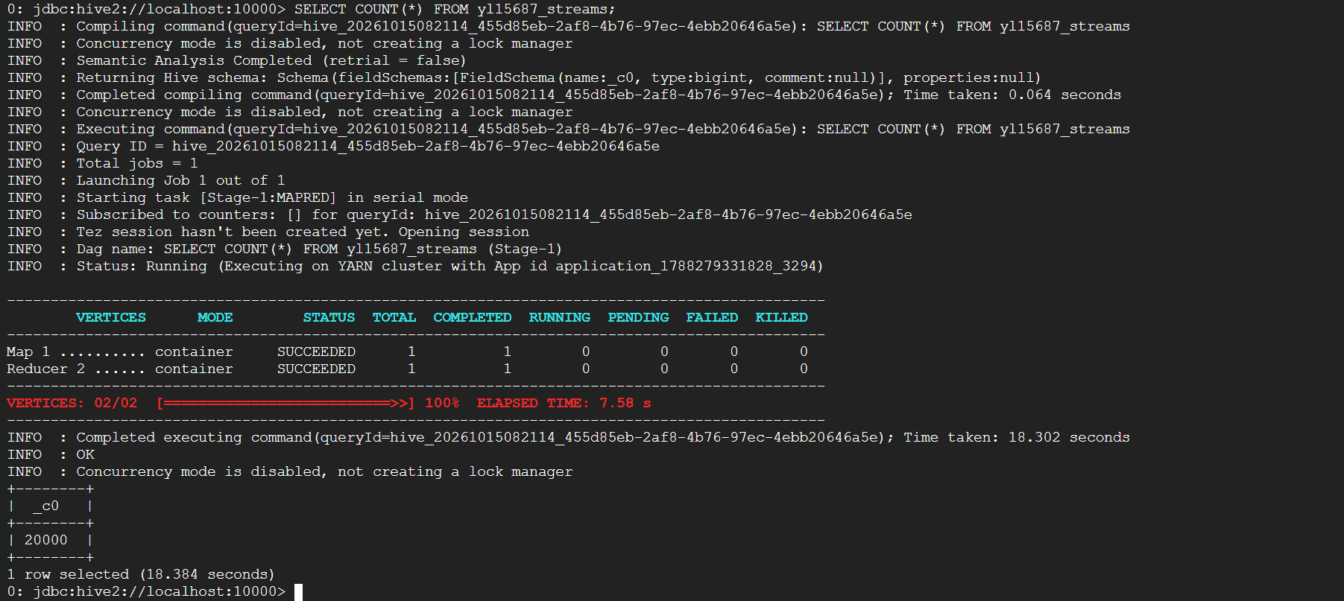

A.7
(2 points) Back in the Linux shell, run hdfs dfs -ls input again.
Submit: screenshots of all HDFS and HQL commands above.
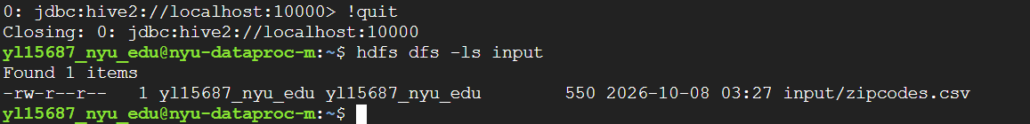

A.a
Answer in writing (A.a): input directory no longer contains music_streams.csv after the load. What happened to it, and where did it go? (2 points)
Answer: The LOAD DATA command moved music_streams.csv from the HDFS input directory into the Hive managed table's warehouse directory. Therefore, the file no longer remains in the original input directory.

Part B: Create an external table and compare the two (15 points)
B - Create the external table
(3 points) Create an external table named yl15687_streams_ext with the same schema, pointing at the directory holding your second copy of the file under ext_streams directory, i.e. /user/yl15687_nyu_edu/ext_streams
Skip the header row here as well.
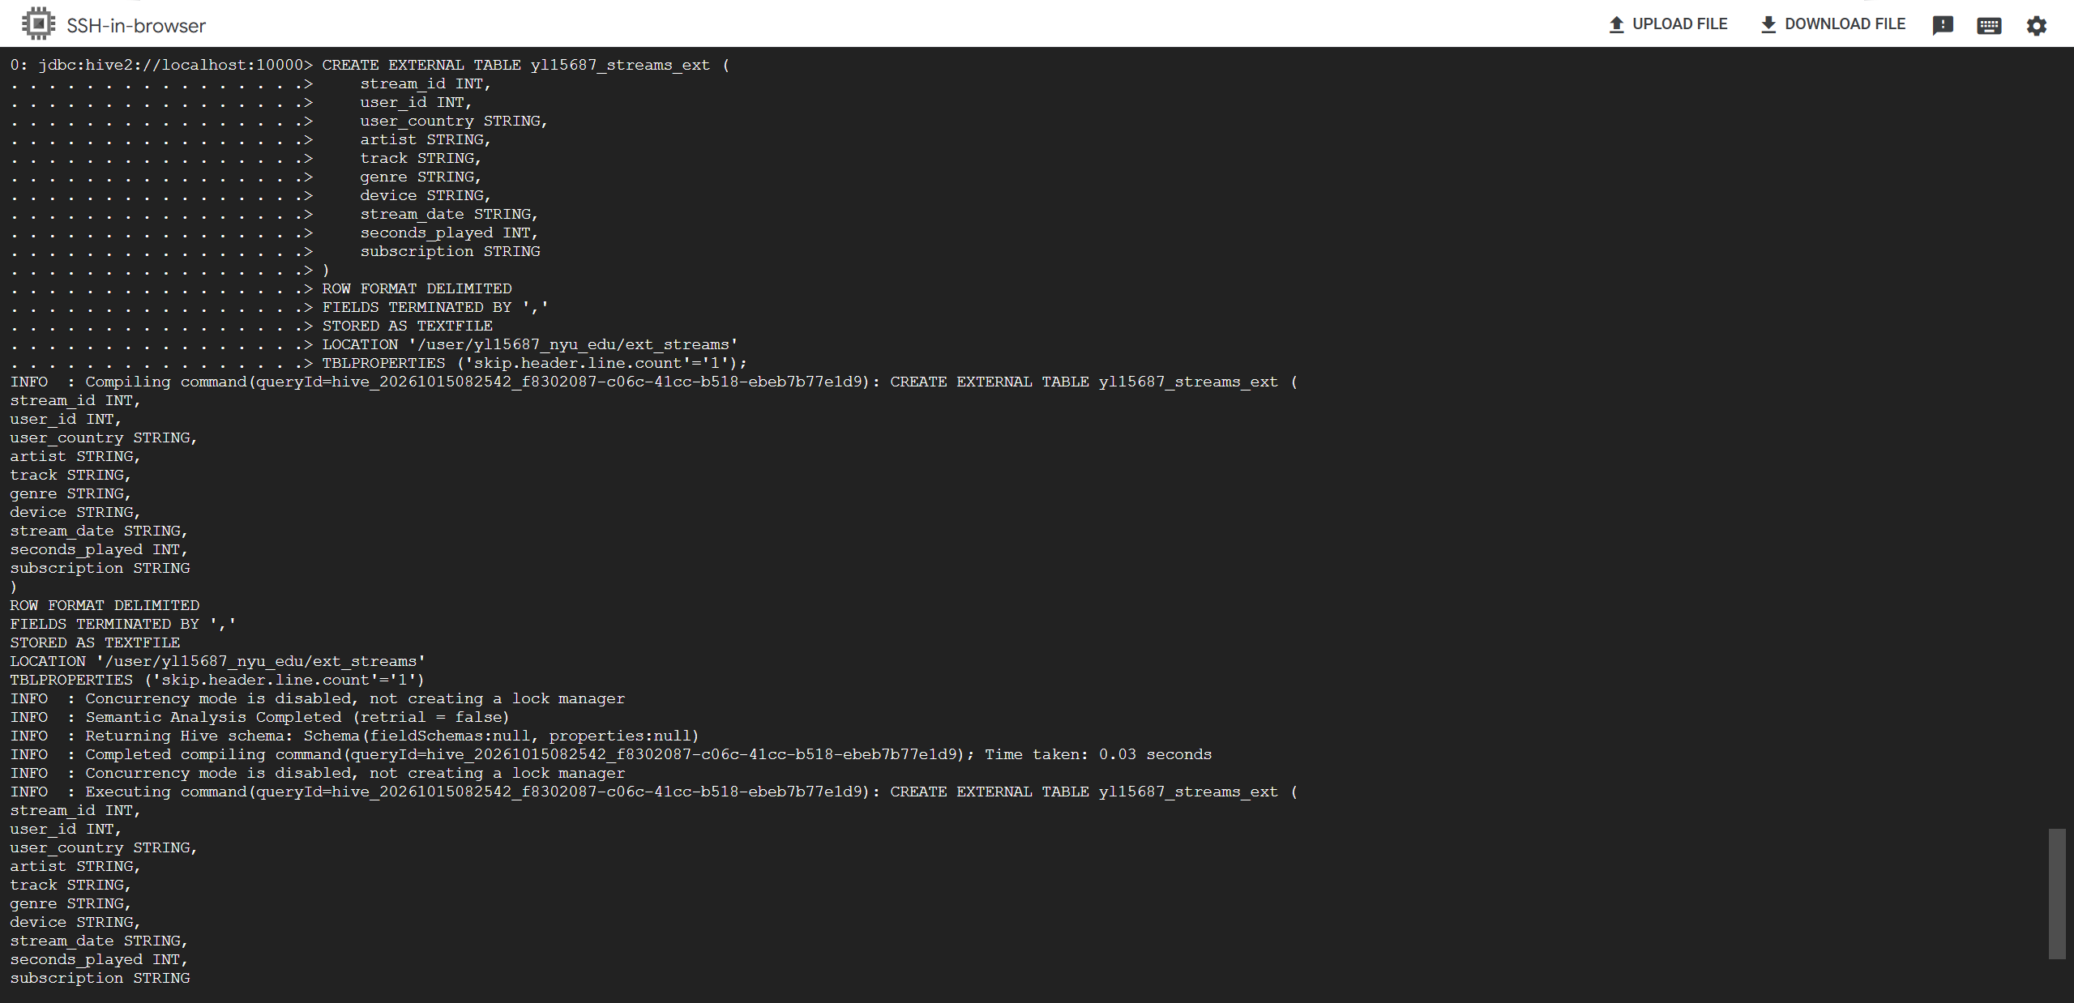
B.1
(3 points) Run SELECT COUNT(*) FROM yl15687_streams_ext; and confirm it matches Part A.

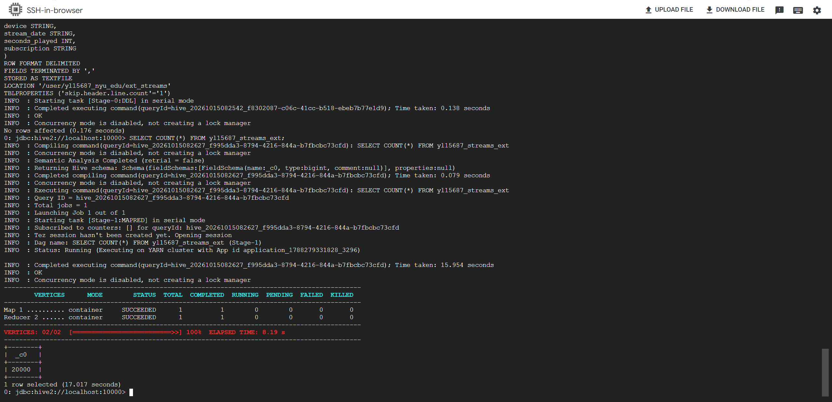

B.2
(3 points) Run DESCRIBE FORMATTED on both tables, yl15687_streams and yl15687_streams_ext
Submit: screenshots of the commands above.
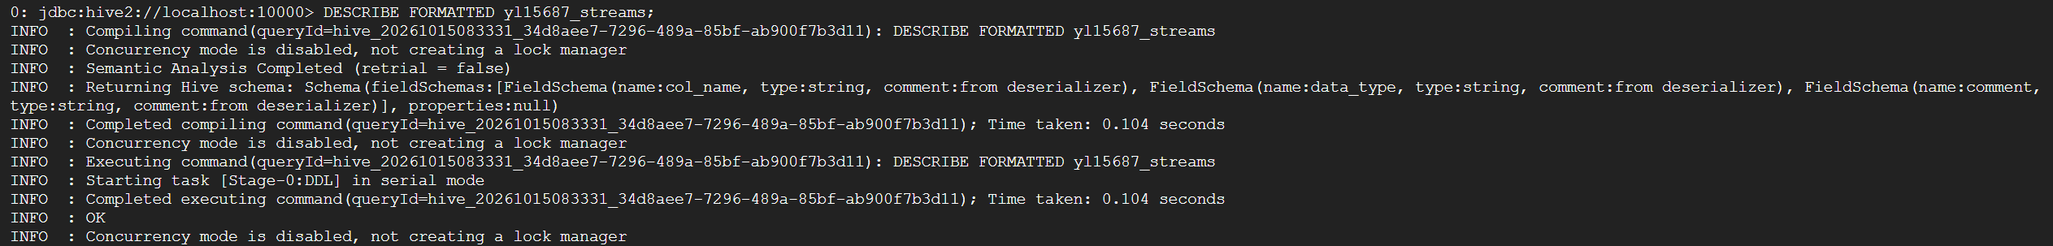
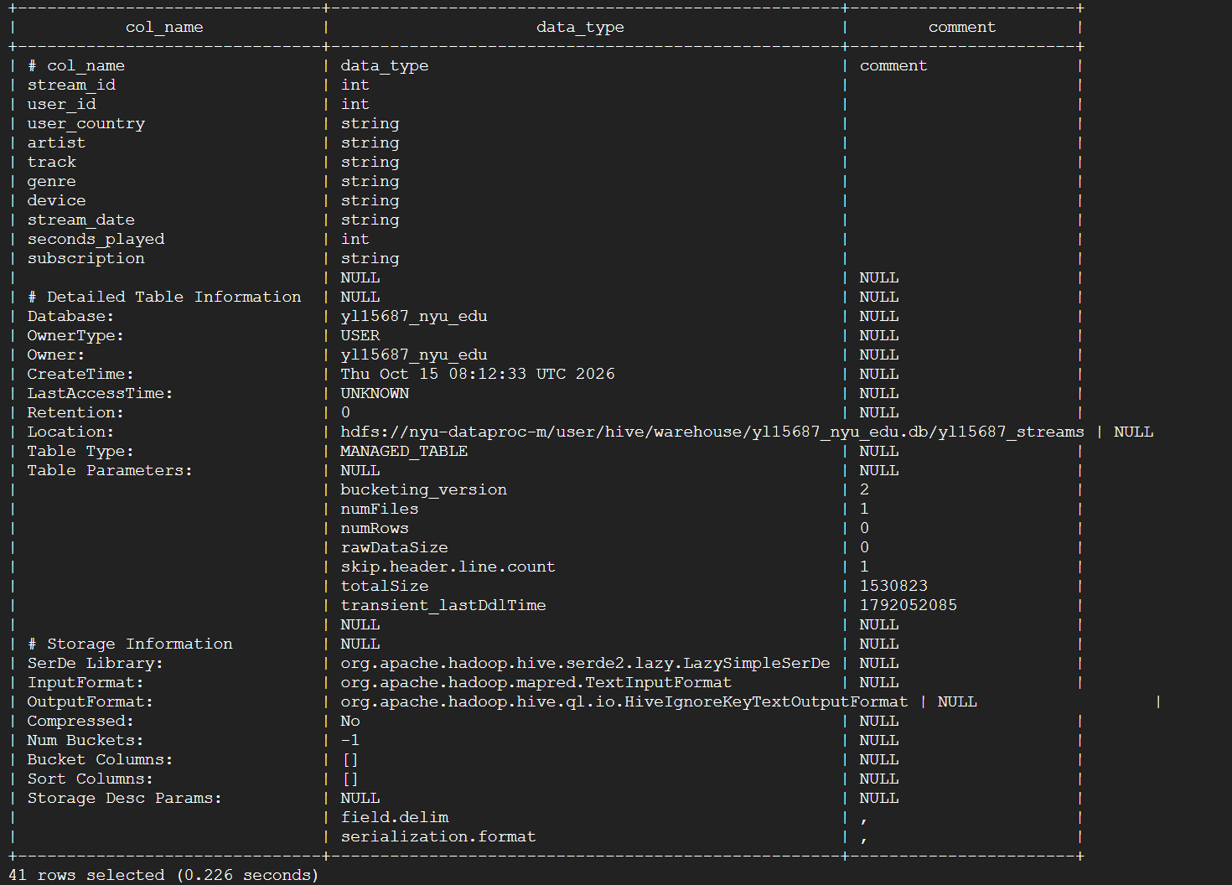

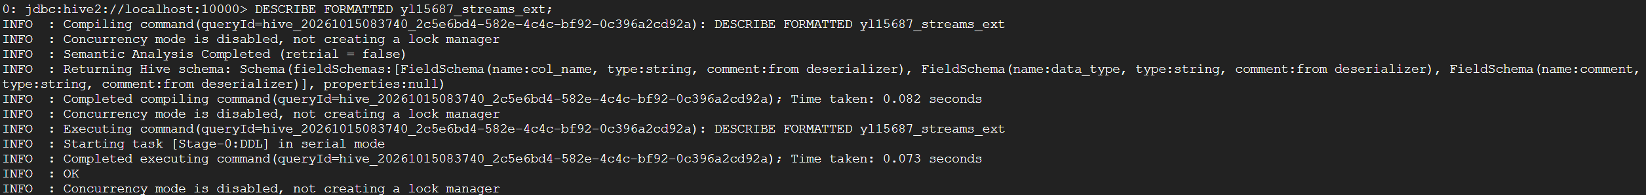
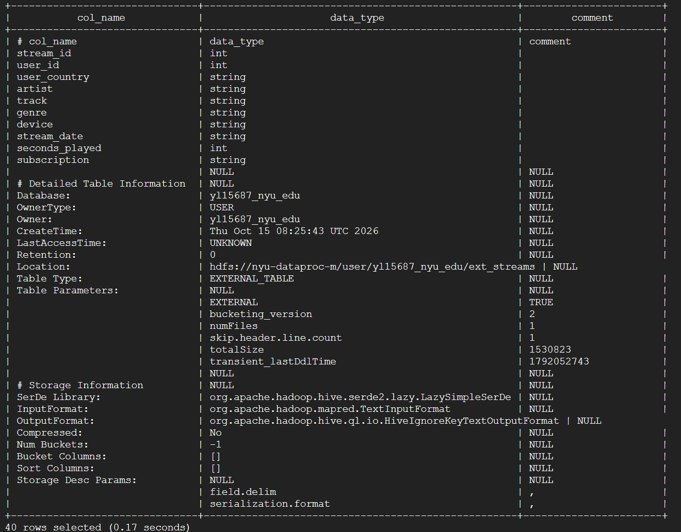
B.a
Answer in writing (B.a): Review the Table Type: line and the Location: line from each DESCRIBE FORMATTED output, and state in one sentence what is different about where each table's data lives. (6 points)
Answer: The managed table stores its data in Hive's warehouse directory, while the external table points to data stored in the user-specified HDFS directory /user/yl15687_nyu_edu/ext_streams.

Part C: Row-level inserts and filtering (15 points)
Work on a test table so the original table stays clean for Part D.
C.1
C.1 Create a test table yl15687_streams_test containing all the data from yl15687_streams, using CREATE TABLE ... AS SELECT.
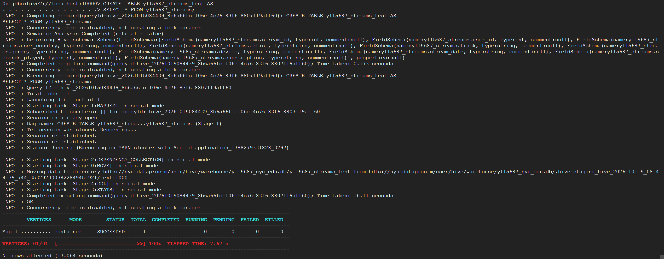
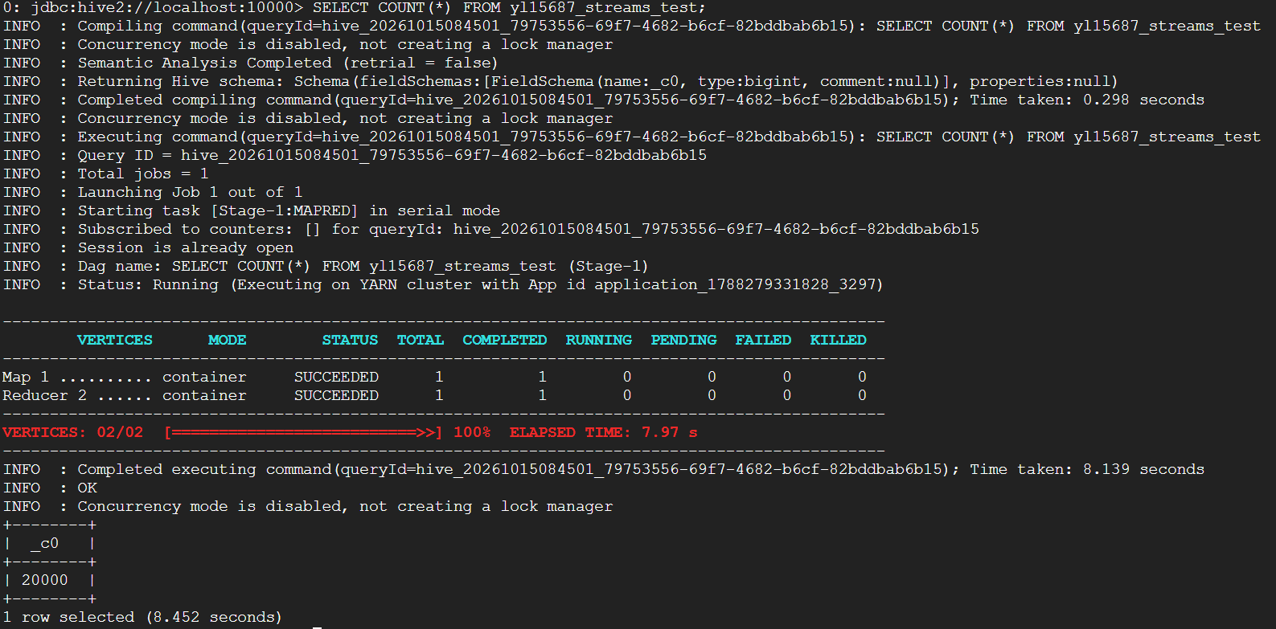

Then insert the following five records using a single INSERT ... VALUES statement, and show the new row count. (5 points)
(20001, 4101, 'US', 'Mira Solano', 'Neon Rain', 'Pop', 'mobile', '2025-07-02', 212, 'premium'),
(20002, 4102, 'IN', 'Ravi Deshmukh', 'Winter Transit', 'Classical', 'smart_speaker', '2025-07-02', 388, 'premium'),
(20003, 4103, 'BR', 'Kofi Mensah', 'Golden Hour', 'Afrobeat', 'car', '2025-07-03', 17, 'free'),
(20004, 4104, 'GB', 'Iron Sparrow', 'Long Way Down', 'Rock', 'desktop', '2025-07-03', 145, 'free'),
(20005, 4105, 'JP', 'Hana Okabe', 'Quiet Machines', 'Classical', 'tablet', '2025-07-04', 264, 'premium')
Then show that the new rows are really there: SELECT * FROM yl15687_streams_test WHERE stream_id > 20000;
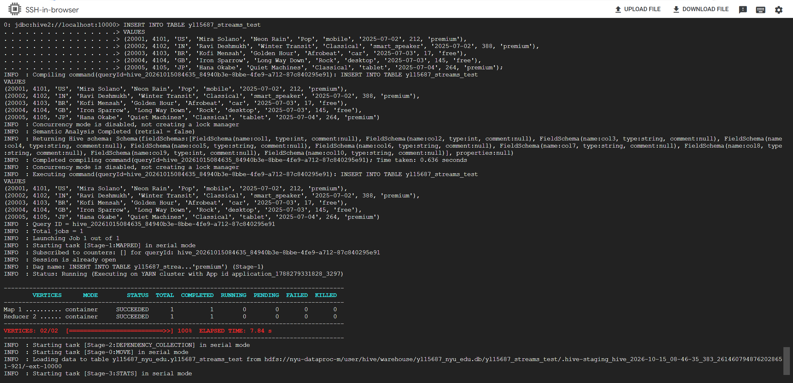
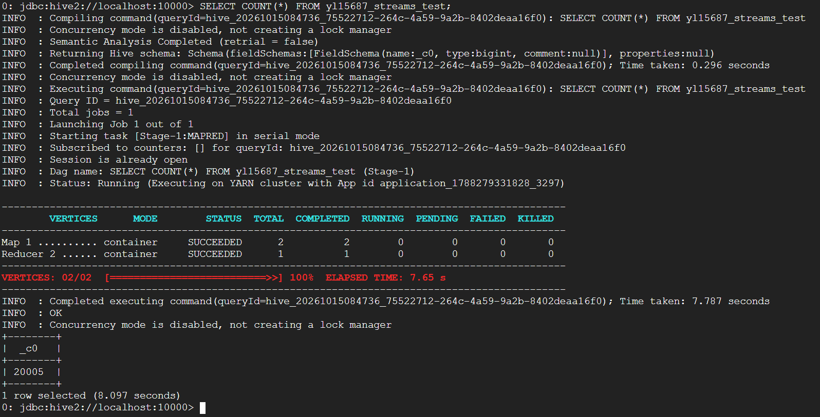
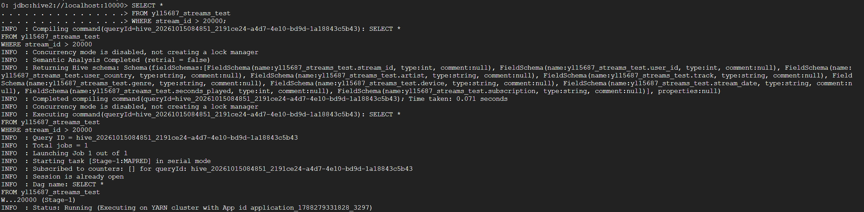
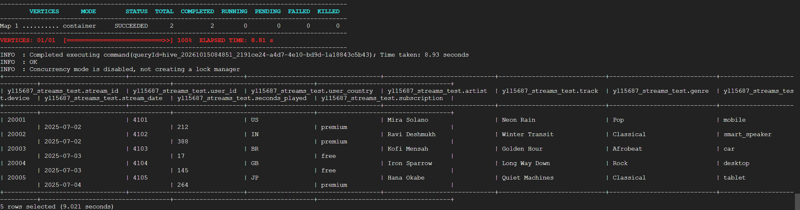

C.2 Write following three separate queries against yl15687_streams_test. For each, submit the number of matching rows (count(*)) and show the first 10 rows of the result.
C.2.1
C.2.1 All streams of one genre of your choice. State which genre you choose. (5 points)
Chosen genre: Pop
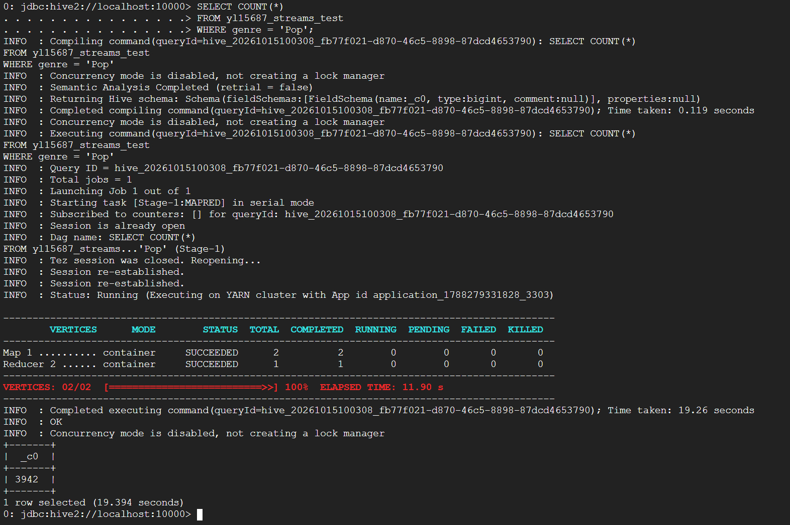

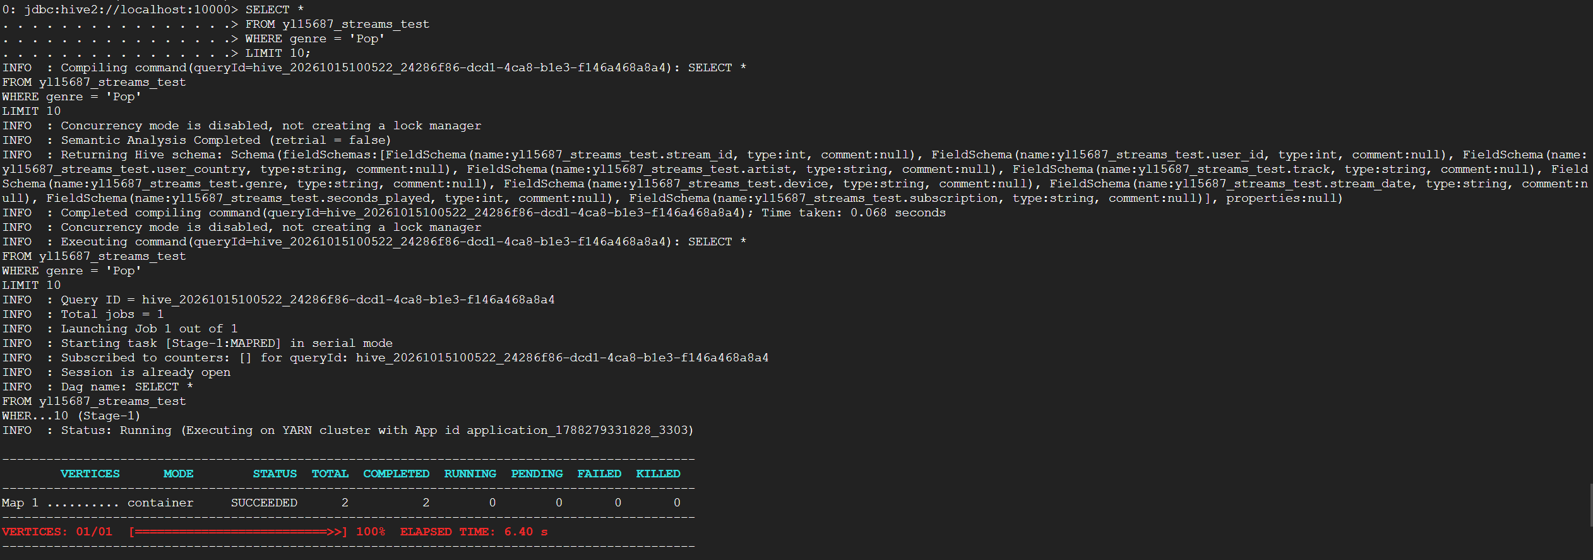
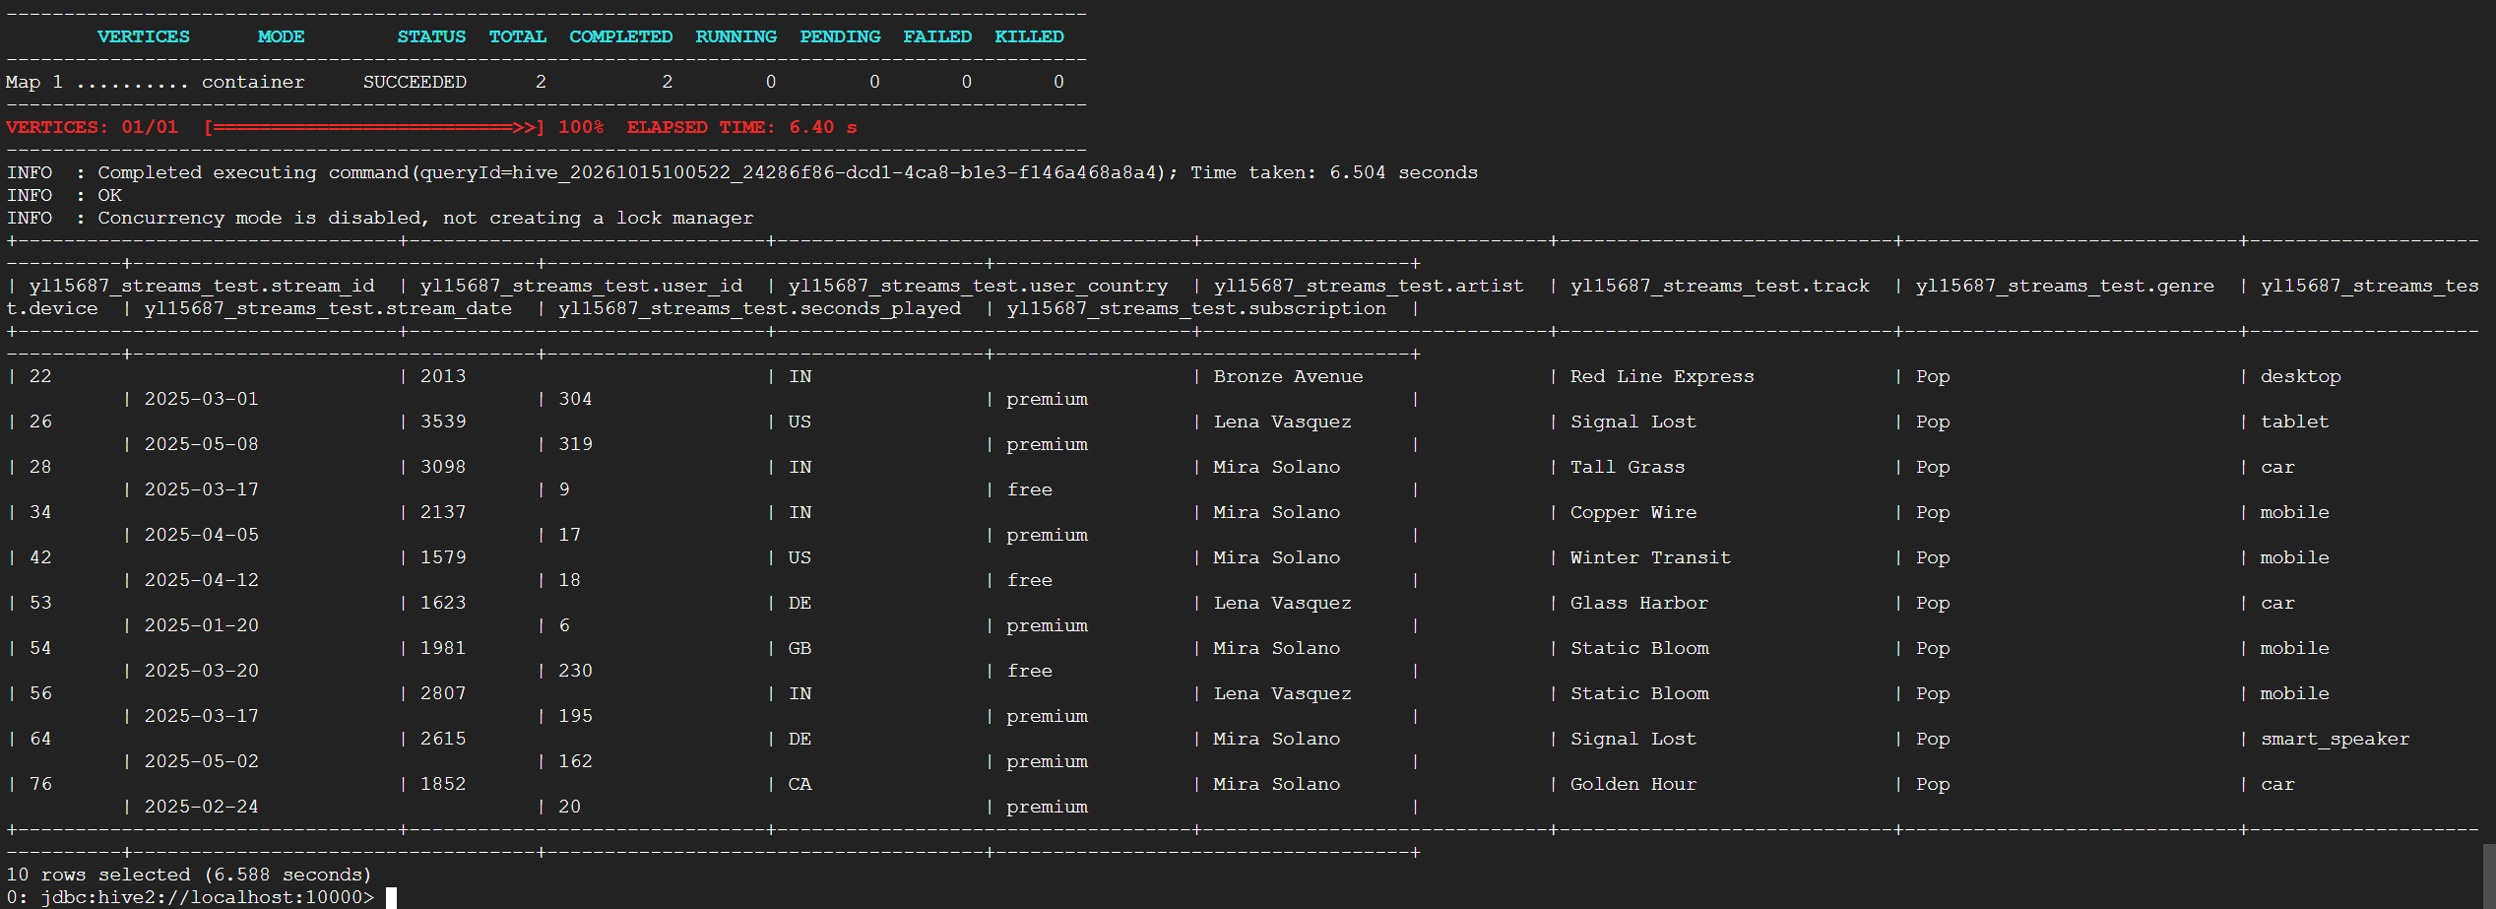
C.2.2
C.2.2 All streams from the final week of the reporting window, which ends on 2025-06-30. Use Hive's DATEDIFF function to compute how many days before the cut-off each stream happened, show that value as a column alias named as days_before_cutoff, and keep only streams where DATEDIFF is between 0 and 6. (5 points)
Note: DATEDIFF(end_date, start_date) returns the number of days between two dates and accepts 'yyyy-MM-dd' strings directly, so DATEDIFF('2025-06-30', stream_date) works on this column.
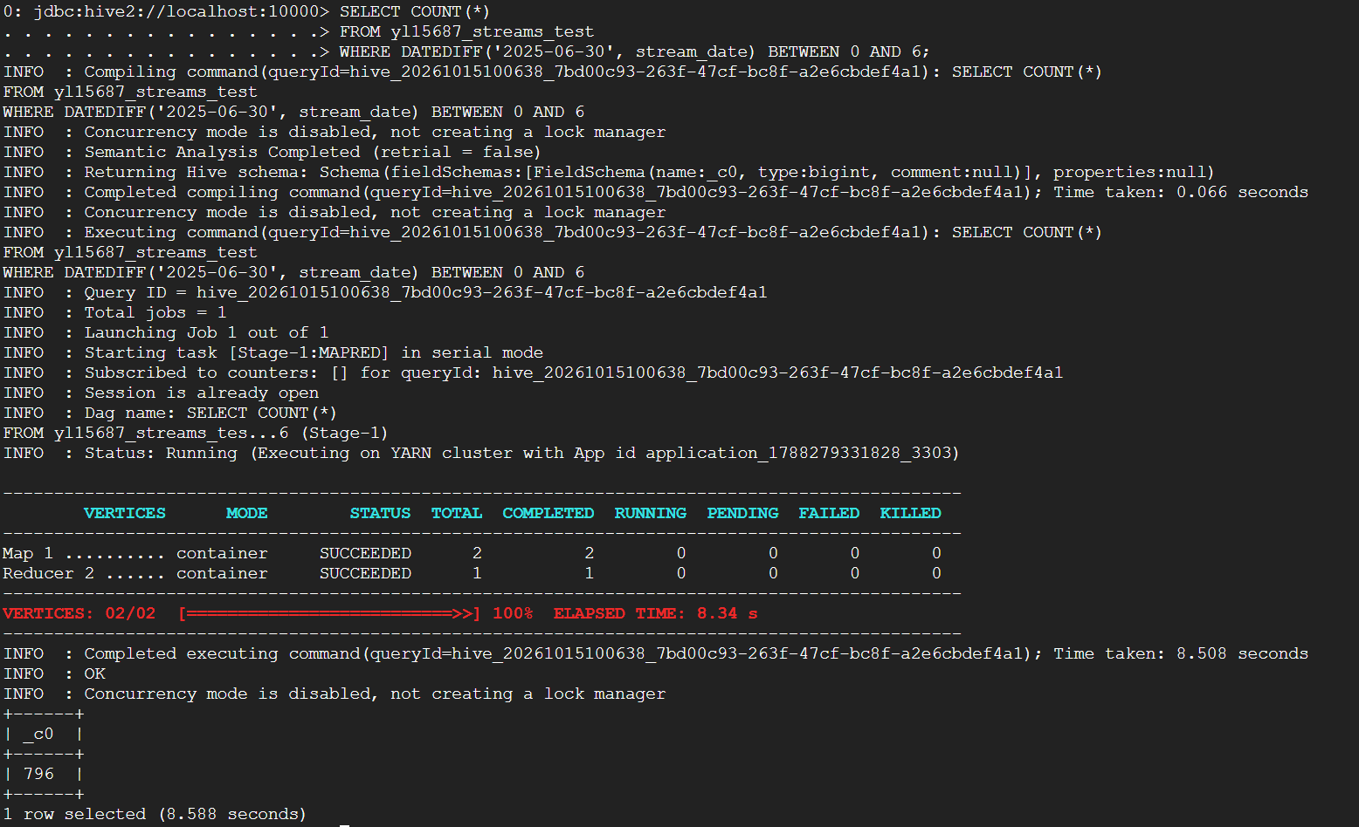
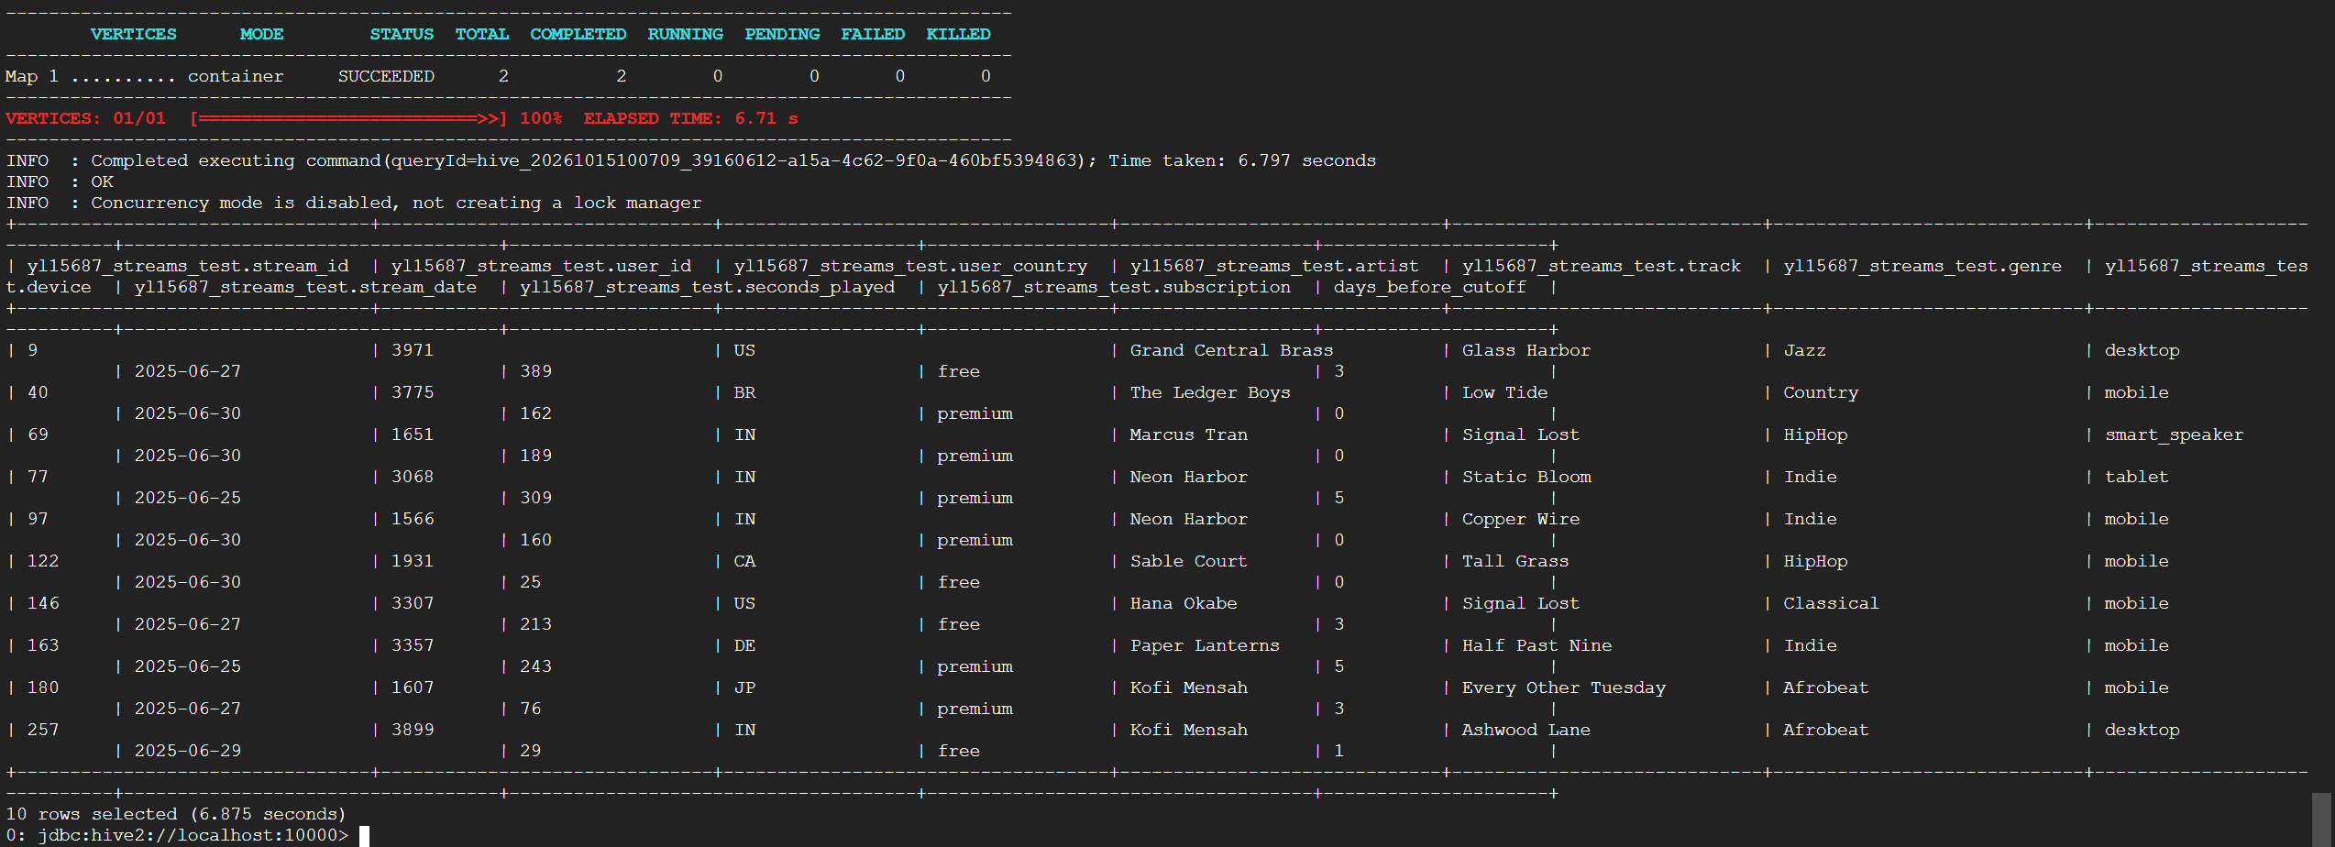

C.2.3
C.2.3 All streams of one genre of your choice that are both on a smart_speaker and from a free subscriber. (5 points)
Chosen genre: Pop
Submit: screenshots of commands and results for all four subparts (C.1, C.2.1, C.2.2, C.2.3)
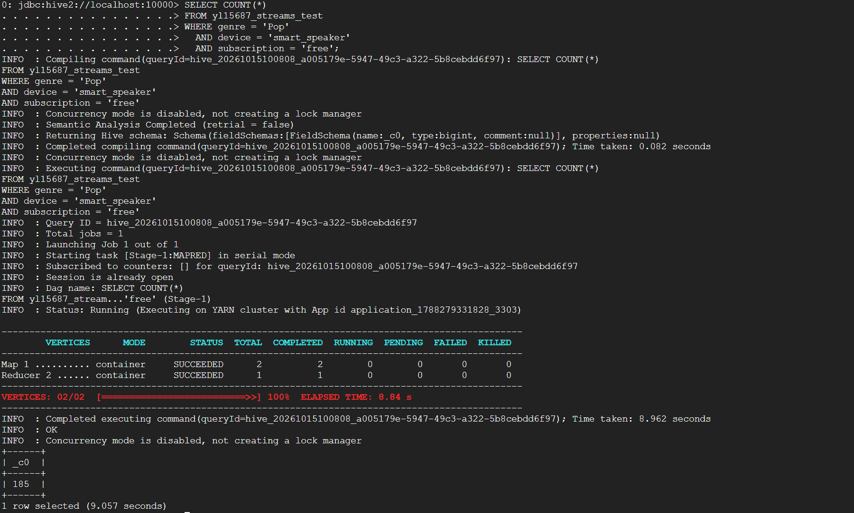
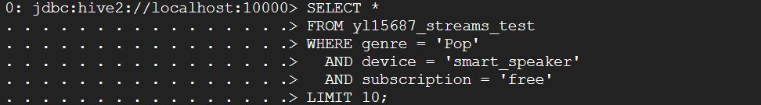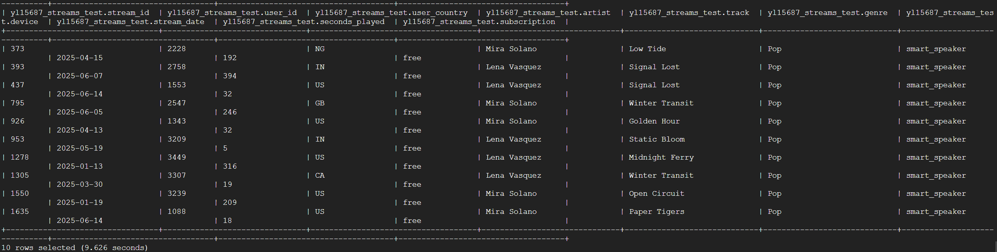

Part D: Analysis queries (16 points)
Use yl15687_streams (the original table, not the test copy). Each query must produce the columns described, and sorted so the answer is unambiguous.
D.1
D.1: (4 points) Top artists. For each artist, report the number of streams and the total minutes played. Show the top 5 artists by total minutes, highest first.
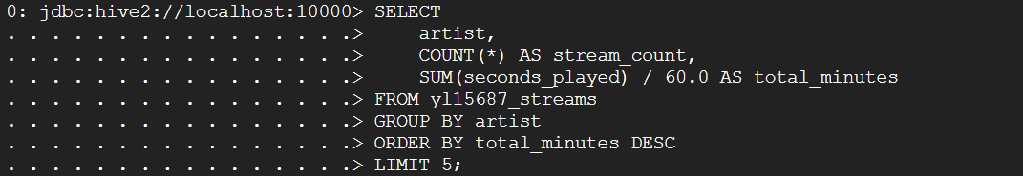
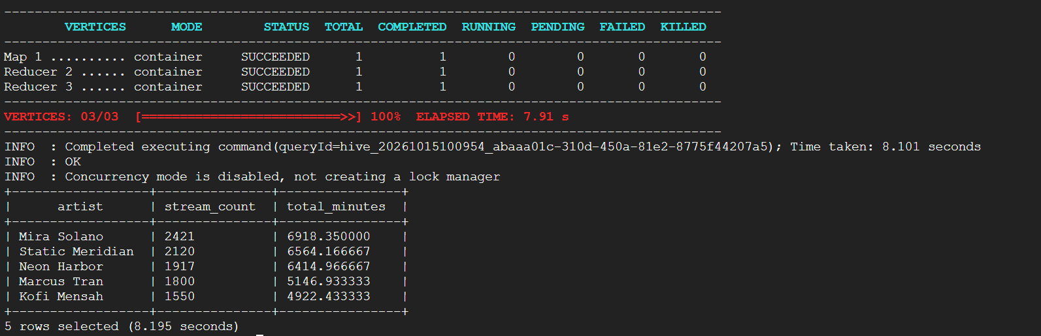

D.2
D.2: (4 points) Genre summary. For each genre, report the number of streams, the number of distinct listeners, and the average seconds played. Keep only genres with more than 1,500 streams. Order by number of streams, highest first.
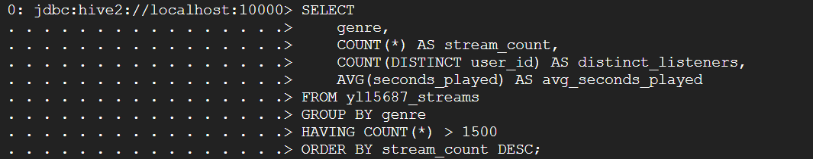
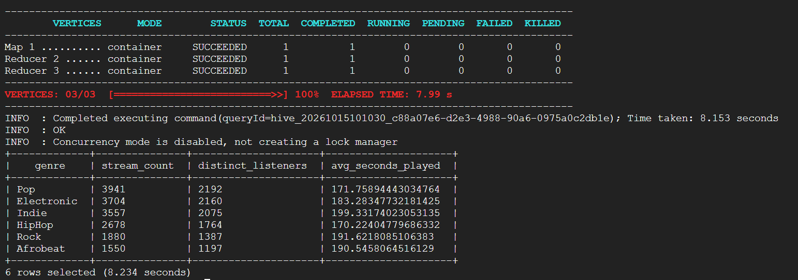

D.3
D.3: (4 points) Monthly trend. For each calendar month, report the number of streams and the total listening hours. Order by month. (Derive the month from stream_date with a string function.)
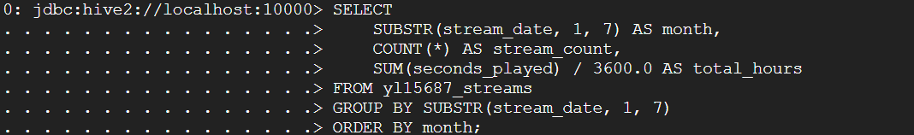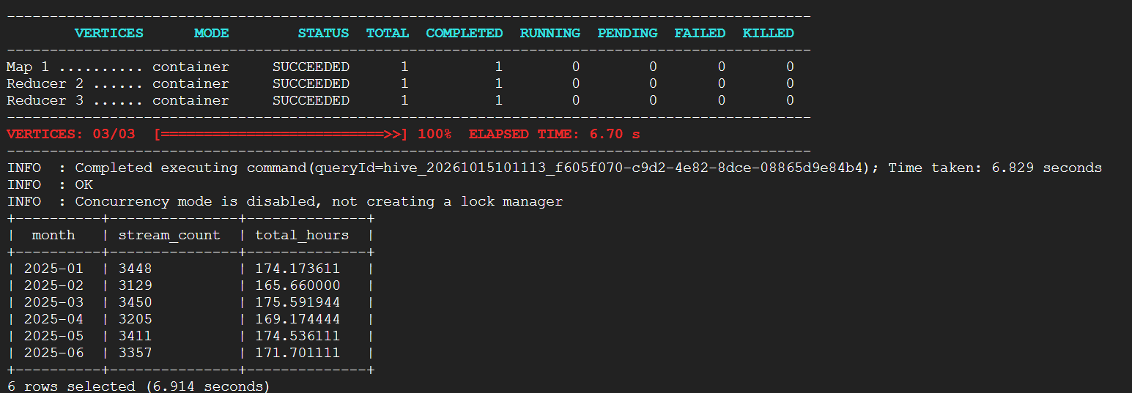

D.4
D.4: (4 points) Skip rate by genre. A skip is a stream with seconds_played < 30. For each genre, report the number of streams, the number of skips, and the skip rate as a percentage. Order by skip rate, highest first.
Submit: screenshot of each query and corresponding result.
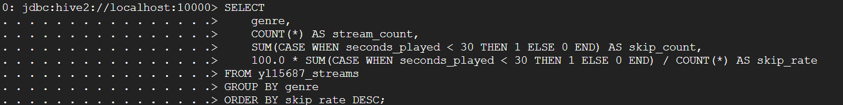
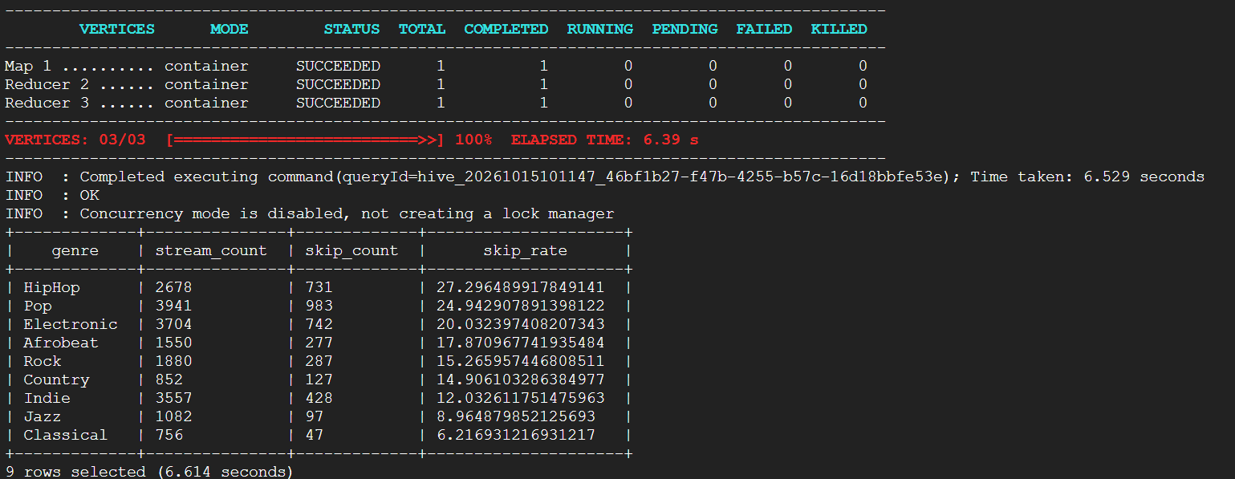

Part E: Schema evolution and views (15 points)
Run these in order on yl15687_streams, showing the result of each step:
E.1
(3 points) Add a column campaign_id STRING. Run DESCRIBE to confirm.
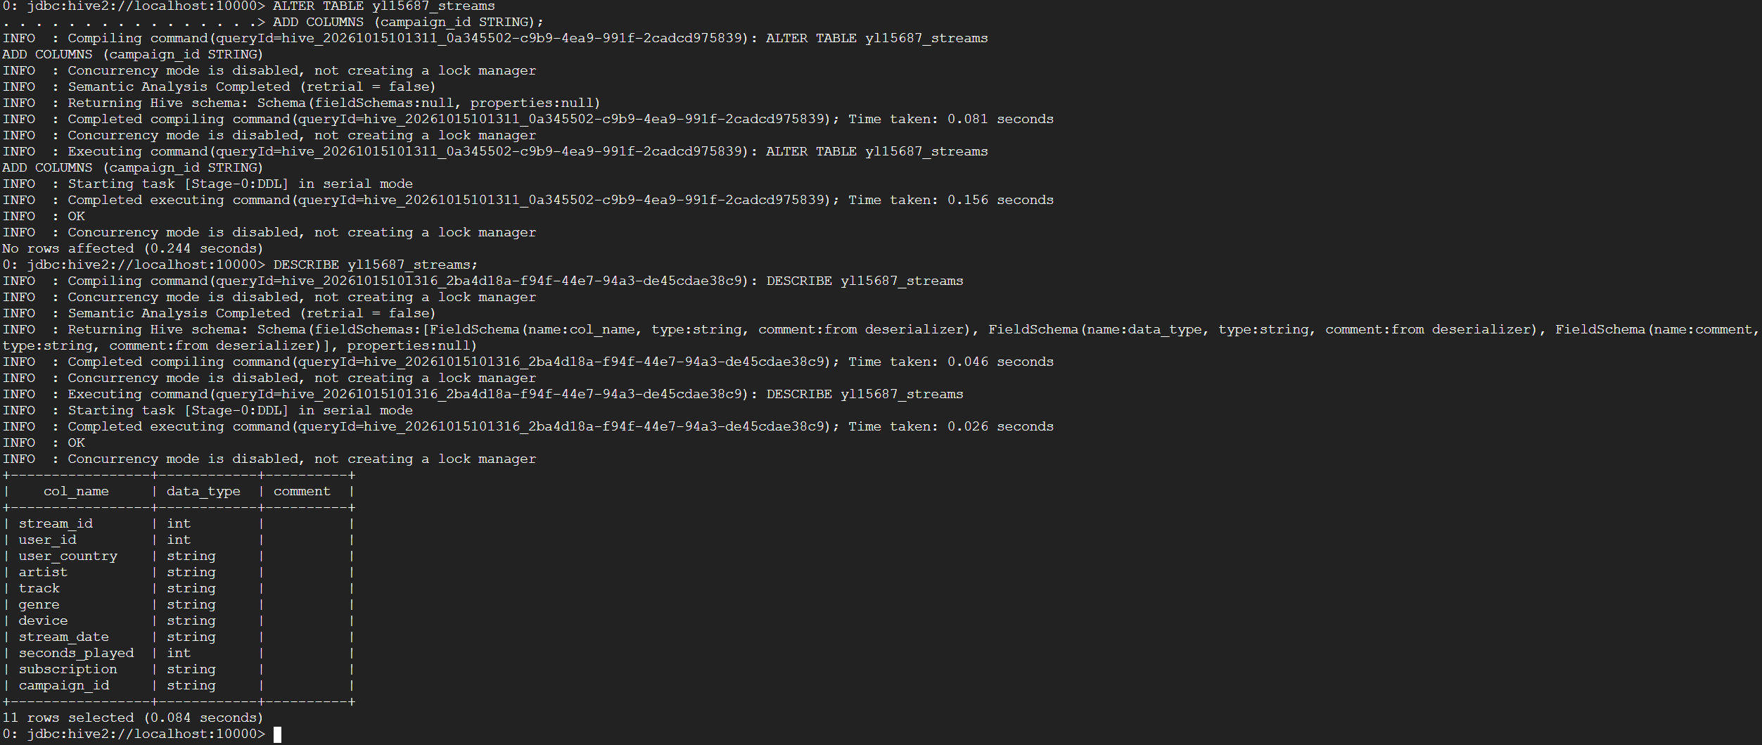

E.2
(3 points) Change seconds_played so it is renamed to play_seconds and its type becomes DOUBLE. Run DESCRIBE to confirm.
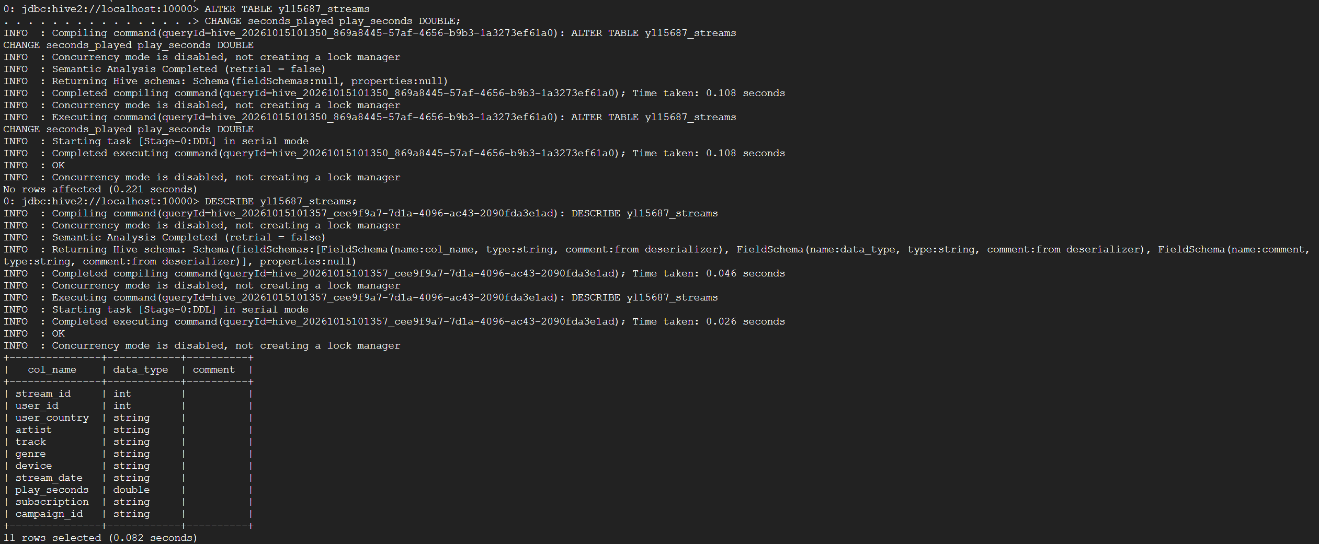

E.3
(3 points) Rename the table to yl15687_streams_v2.
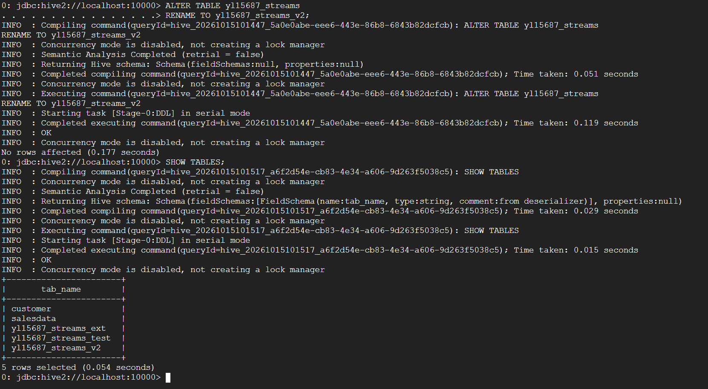

E.4
(3 points) Create a view yl15687_top_genres that returns each genre with its stream count, ordered by stream count descending. Query the view, then run SHOW VIEWS;
Submit: screenshots of every command and corresponding result
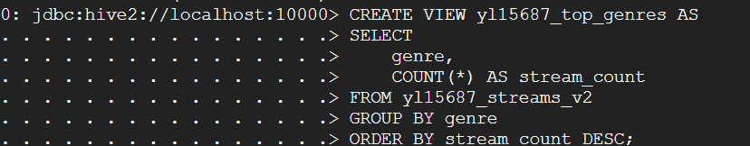
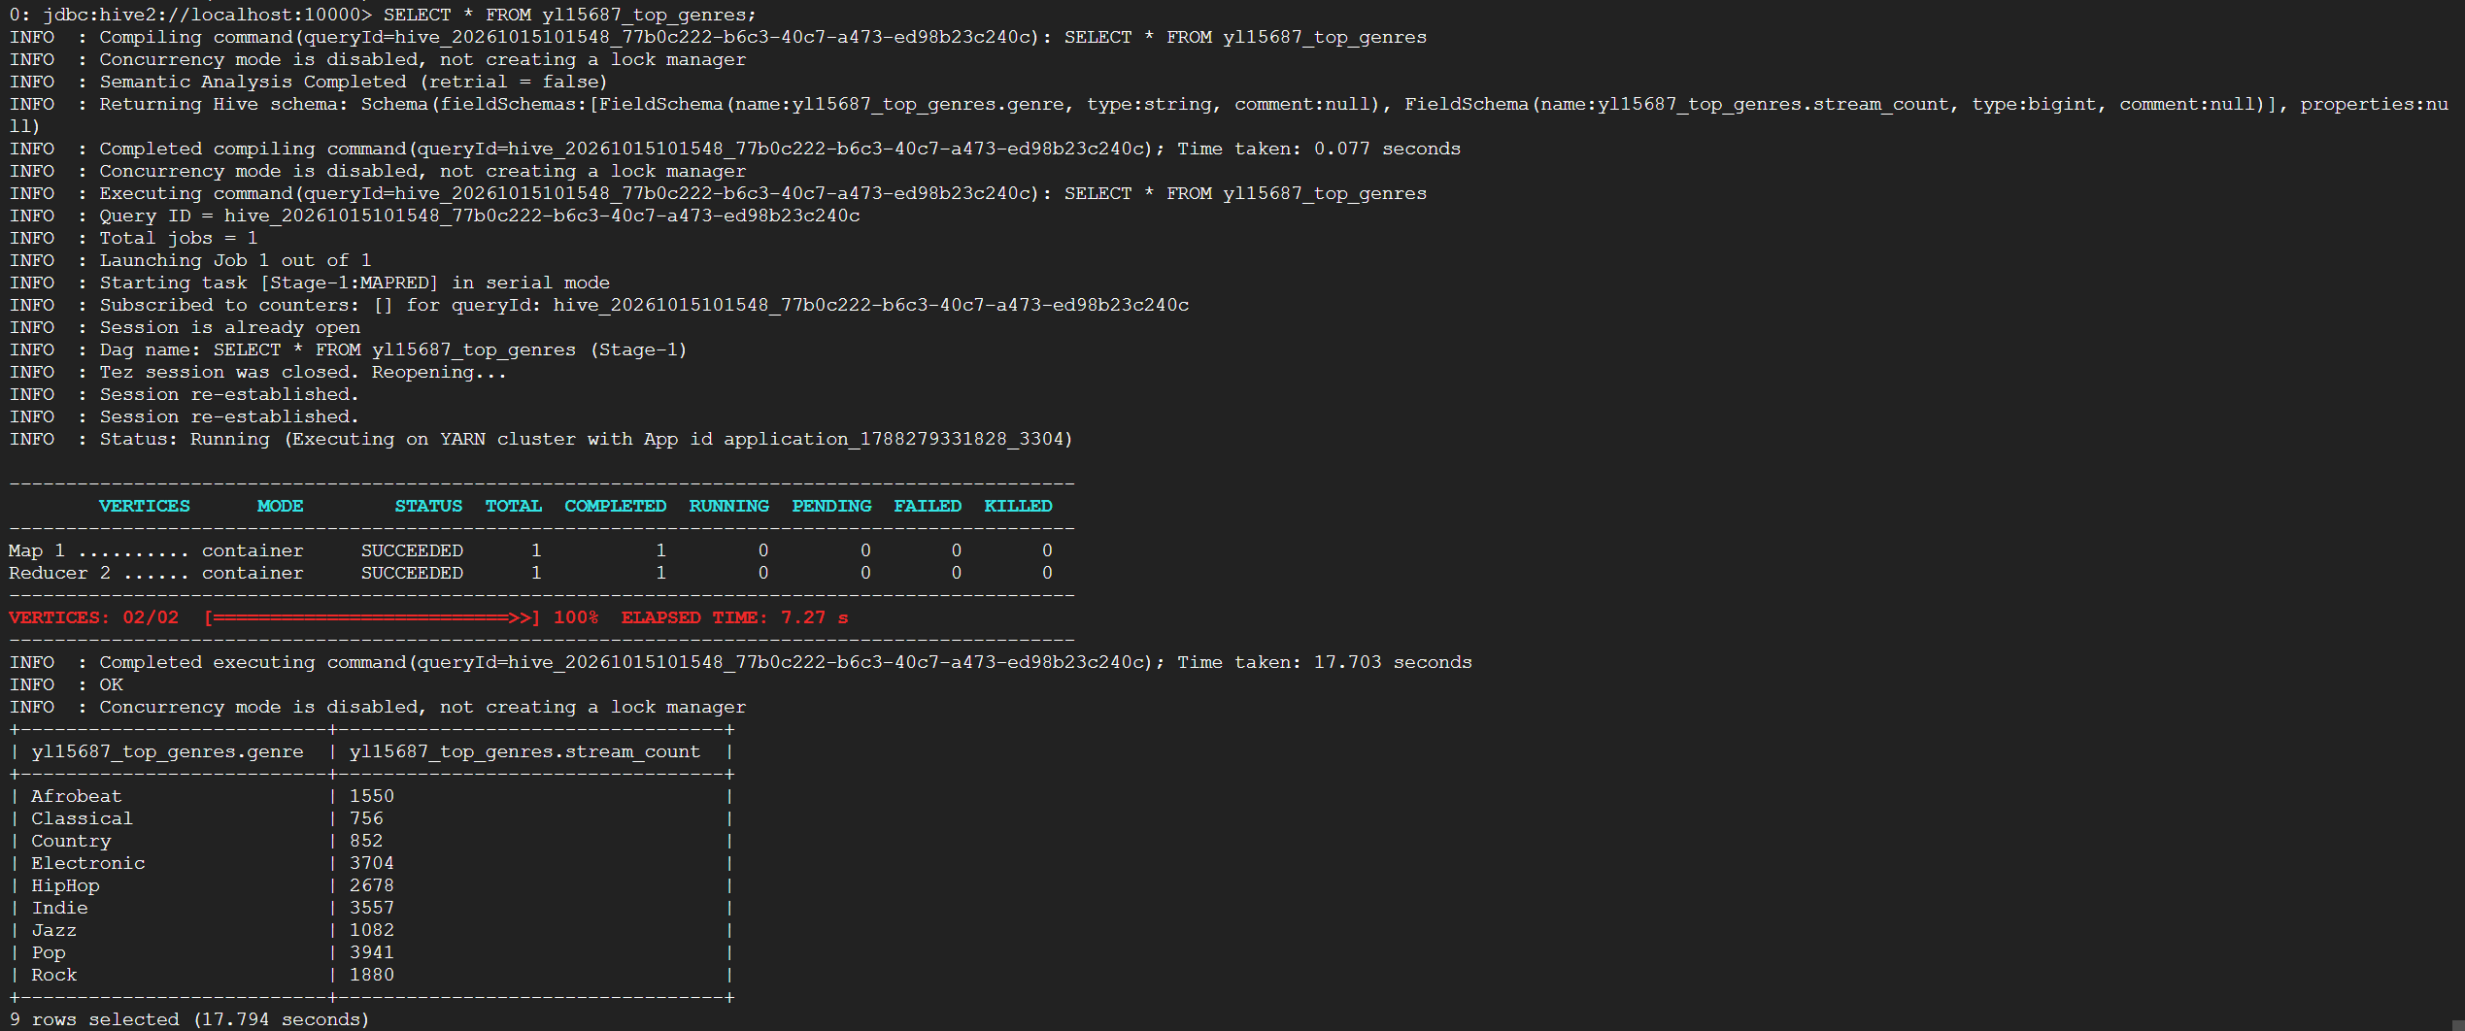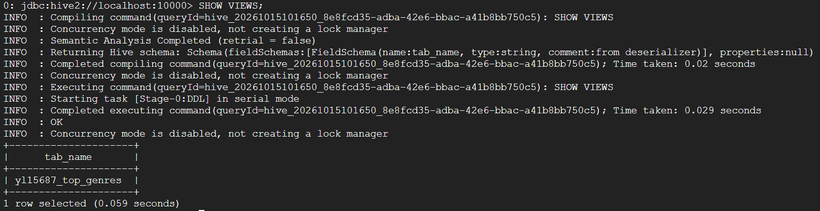

E.a
Answer in writing (E.a): Step 2 changed a column's name and its data type, yet it finished in well under a second on a 20,000-row table. Explain what Hive actually modified when it ran that ALTER TABLE ... CHANGE, and what it left untouched. (3 points)
Answer: The ALTER TABLE ... CHANGE command updated the table metadata in the Hive metastore, including the column name and data type. It did not rewrite or move the existing data files stored in HDFS.

Part F: Table types, conversion, and what DROP TABLE really does (20 points)
F.1
F.1 Convert the external table into a managed one and prove it changed: (3 points)
ALTER TABLE yl15687_streams_ext SET TBLPROPERTIES ('EXTERNAL'='FALSE');
DESCRIBE FORMATTED yl15687_streams_ext;
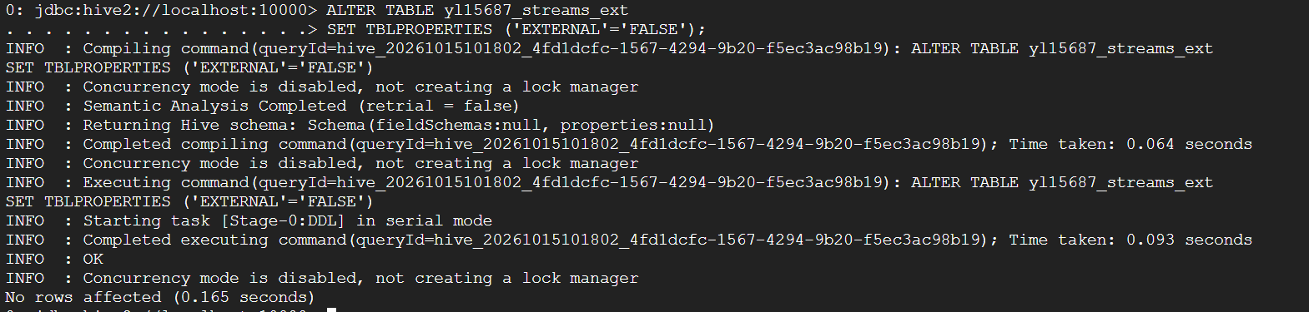
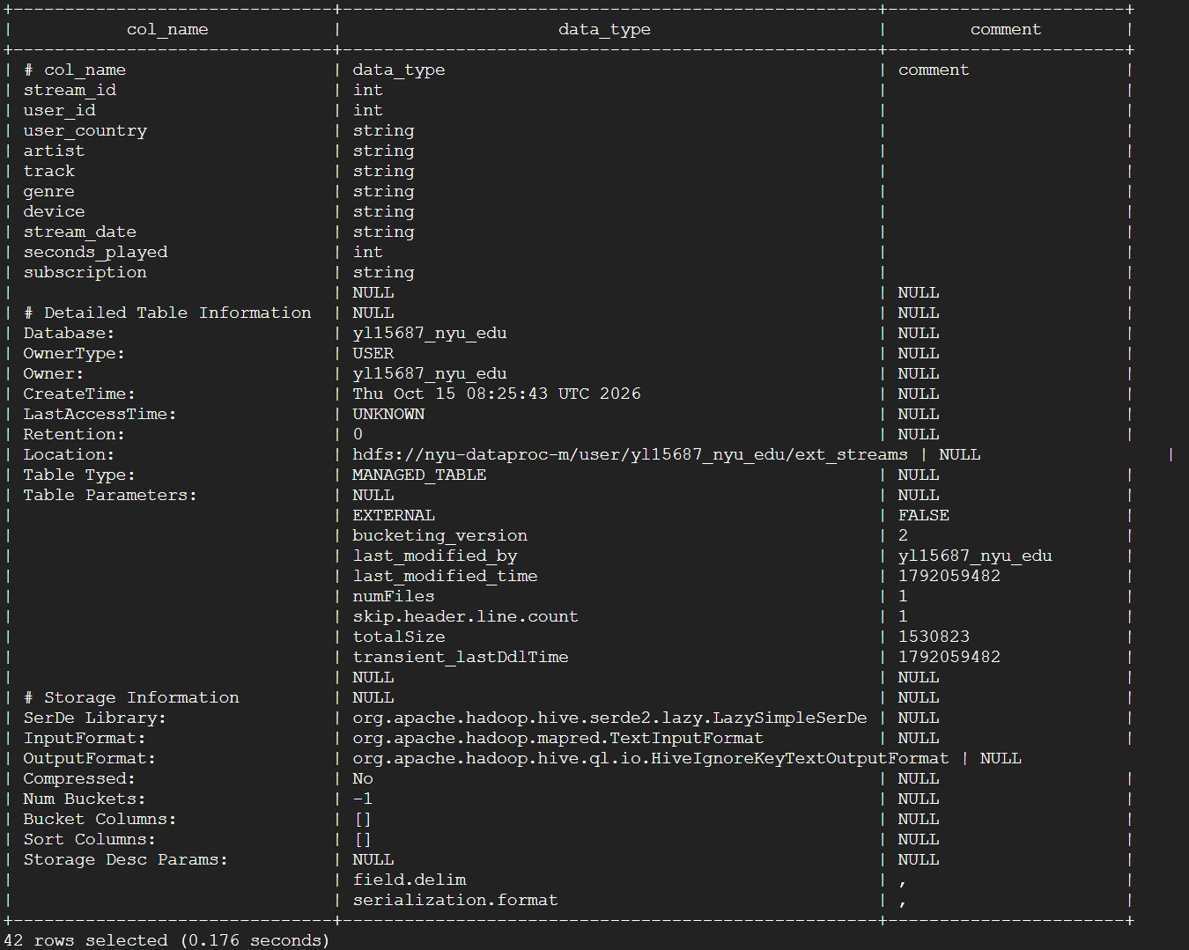

F.2
F.2 Convert it straight back to external and prove it again: (3 points)
ALTER TABLE yl15687_streams_ext SET TBLPROPERTIES ('EXTERNAL'='TRUE');
DESCRIBE FORMATTED yl15687_streams_ext;
Note: Do not skip F.2. If you drop the table while it is still marked managed, Hive deletes your ext_streams directory, and you will have to re-upload the CSV to finish Part F.
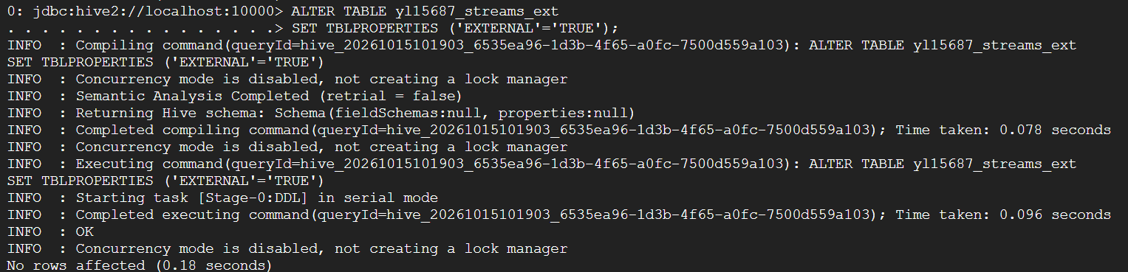
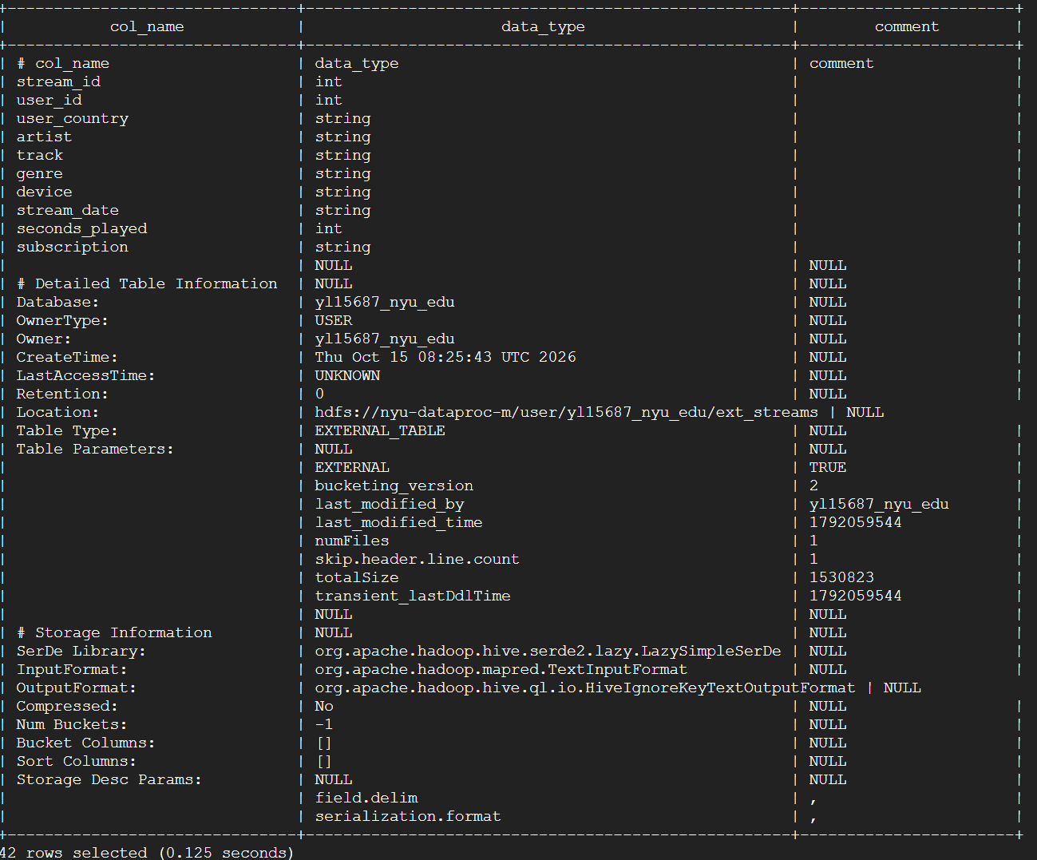
F.3
F.3 From the Linux shell, record the HDFS listing of both locations: (3 points)
hdfs dfs -ls /user/hive/warehouse/yl15687_nyu_edu.db/
hdfs dfs -ls /user/yl15687_nyu_edu/ext_streams
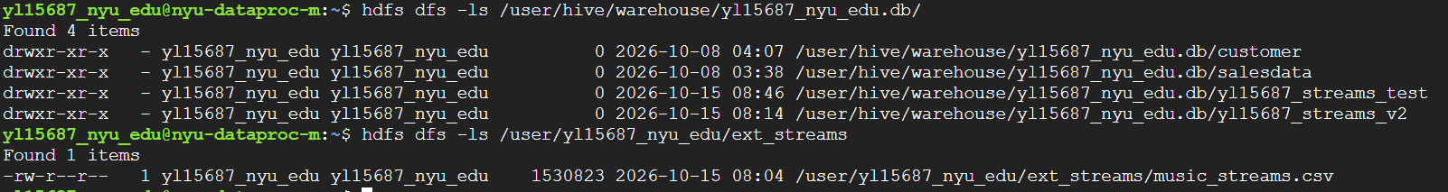

F.4
F.4 In Beeline, drop the view and then both tables: (3 points)
DROP VIEW yl15687_top_genres;
DROP TABLE yl15687_streams_ext;
DROP TABLE yl15687_streams_v2;
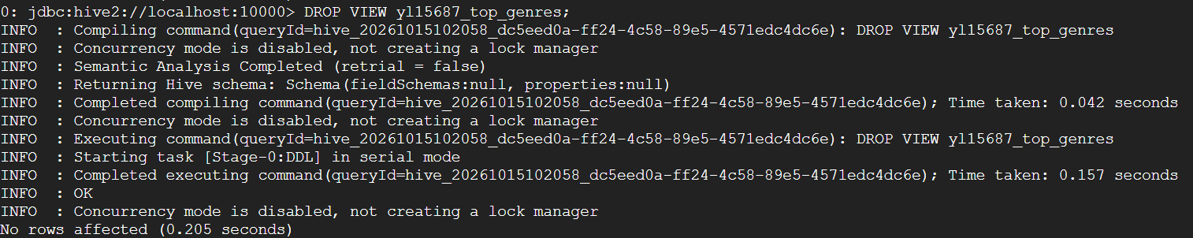
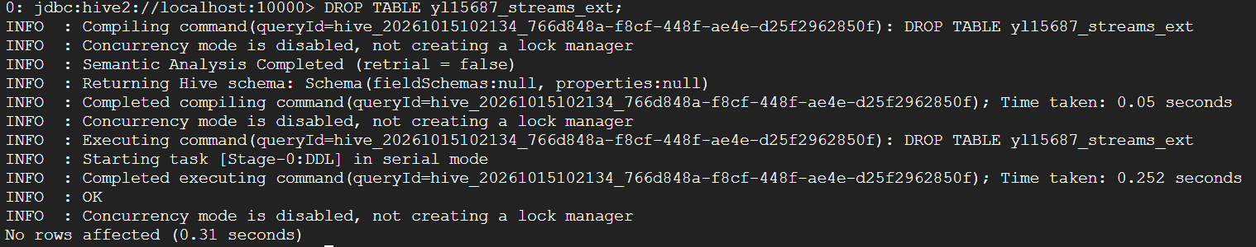
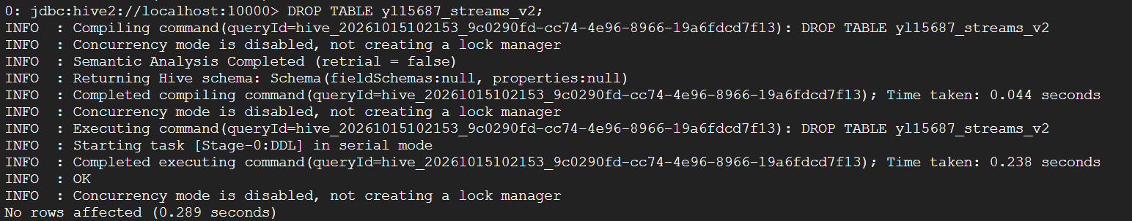

F.5
F.5 Re-run both hdfs dfs -ls commands from F.3. (3 points)
Submit: screenshots of every command and corresponding result
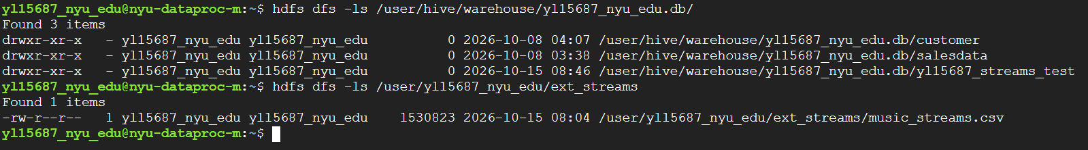

F.a
Answer in writing (F.a): one of the two data directories survived its DROP, and one did not. State which is which, and explain the rule Hive followed. (5 points)
Answer: The external table's data directory /user/yl15687_nyu_edu/ext_streams survived the DROP TABLE, while the managed table's warehouse directory was deleted. Hive deletes both the metadata and data for a managed table, but for an external table it removes only the table metadata and leaves the underlying HDFS data unchanged.

Part G — Cleanup and discussion (4 points)
G.1
G.1 Clean up: (2 points)
SHOW TABLES;
-- now drop every table you still have from this assignment, then
SHOW TABLES;
hdfs dfs -rm -r /user/yl15687_nyu_edu/ext_streams
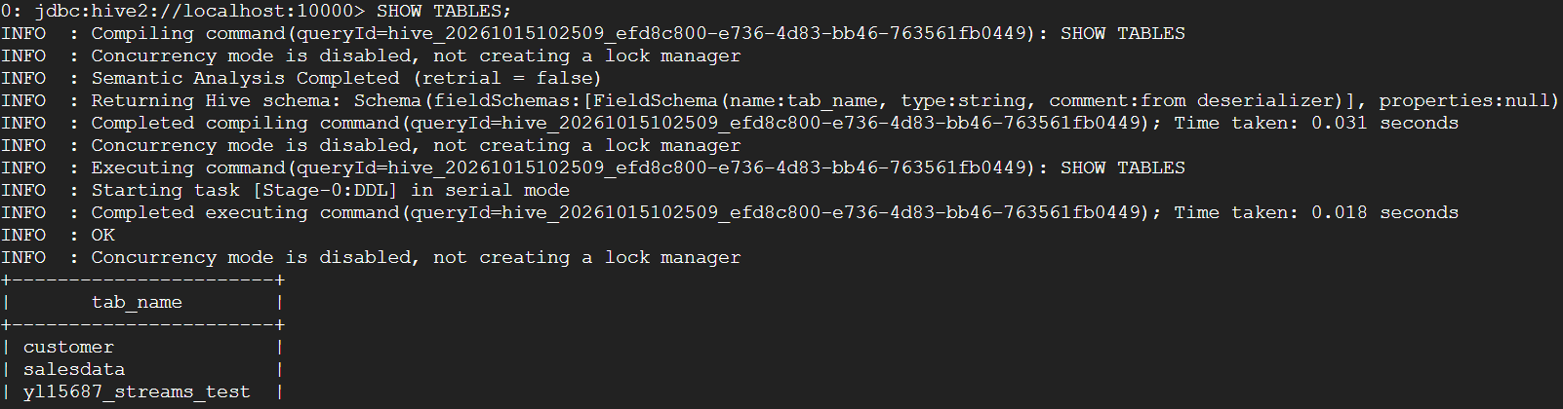
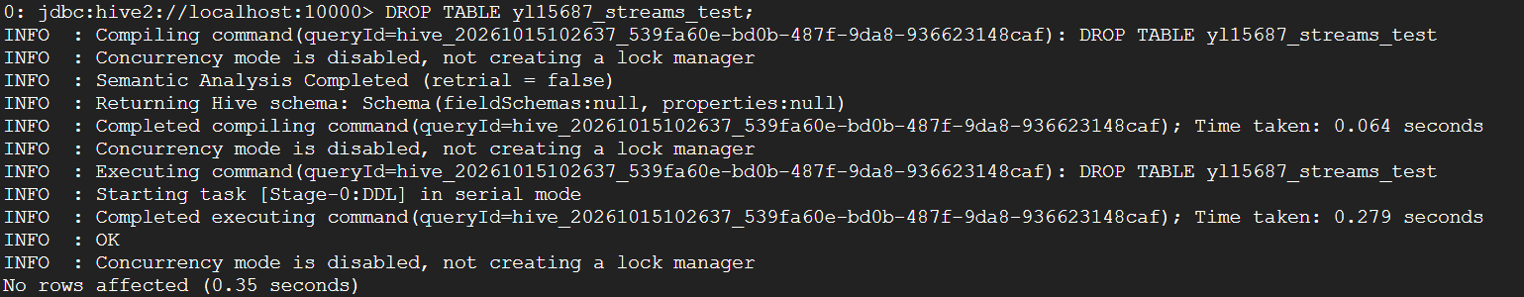
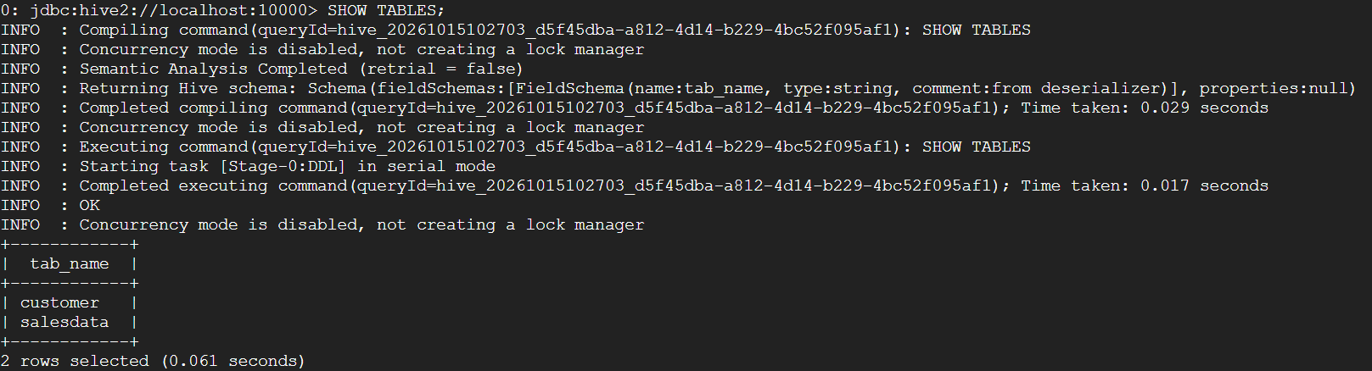
G.2
G.2 You are working in a shared database on NYU Dataproc where several people may query the same HDFS files. Give one concrete situation in which you would deliberately choose an external table over a managed one, and say what would go wrong if you used a managed table instead. (2 points)
Answer: I would use an external table when several users or applications need to access the same HDFS data files. An external table allows Hive to query the data without owning the files. If a managed table were used instead, dropping the table could delete the underlying data files, which could break other users' queries or applications that still depend on those files.

