Home-Dev software architecture

# Purpose

This document provides a high level overview and explains the architecture of the Home-Dev system.

The document defines goals of the architecture, architectural styles and components that have been selected.

# Model

The selected model is compose of the following layers:

* 1. **External layer**
* Remote devices;
* Clients and provisioners, that allow the users to manage, register and provision the devices.  
  1. **Access Layer**
     + Web Portal: allows the clients to interact with the platform using a web application;
     + Web APIs: allows to the clients, provisioners and WebPortal to interact with the business layer;
     + Data ingestion and devices management: represents the interaction between the remote devices and the back-end layer, that forwards the data between the remote devices and to the business layer.
  2. **Business and data layer**
     + Data transformation: it is in charge of adapting and transforming the data coming from the devices before storing them or before forwarding them to the server-less functions.
     + Faas: server-less functions that can be created ad hoc to perform custom task on stream data
     + Data analytics and predictive models: back-end services that analyze devices and platform data in order to provide features based on AI, predictive models and metrics related to the remote devices.
     + Persistence layer: it’s composed of a NoSQL database to store IoT information related to the streams coming the remote devices and a relational database to manage the registry of the devices, tenants and consumers.
     + Custom back-end services: represents a cluster of nodes of custom services that can be used for custom tasks such as exposing the APIs to interact with the databases, analytics and metrics.

**Deployment diagram** of the described architecture:

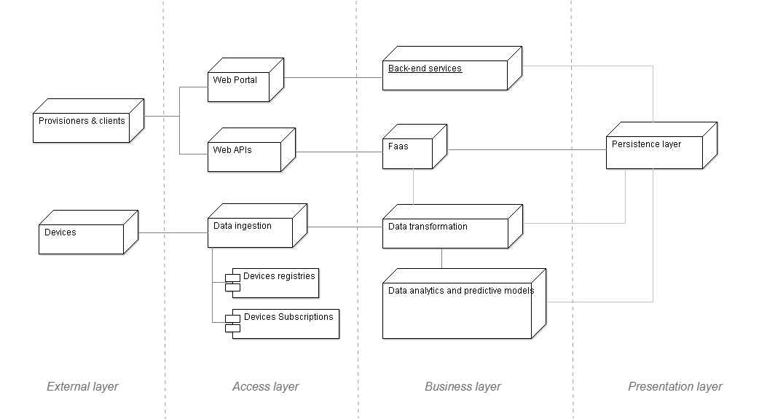

## Implementation on Google Cloud Platform

* 1. **Access layer**The access layer secures the external connections provides data ingestion and platform configuration:  
     + **HTTP(S) LB**: this is the load balancer, it’s important to balance the load while accessing to the web portal or web APIs.
     + **App Engine**: web portal hosting service
     + **API Gateway**: groups and exposes the available Web APIs
     + **IoT Core**: service that allows connect, manage, and ingest data from remote devices
     + **Pub/Sub**: service that is in charge of handling devices’ publishers and subscriptions
  2. **Business layer**

The business layer manages devices’ data transformation, server-less functions, services’ subscriptions and platform custom services:

* + - * **Cloud Dataflow**: devices’ stream data analytics and transformation;
      * **Cloud Functions**: custom server-less functions that execute context specific tasks collaborating with databases, device’s stream and custom services available in the Kubernetes cluster;
      * **Pub/Sub**: provides decoupling to execute asynchronous tasks with the data coming from server-less functions or Kubernetes services;
      * **Kubernetes**: represents a cluster of nodes that can be used for custom services scheduling, scaling and interaction.
  1. **Data layer**

The data layer is responsible for data storing and retrieving, and it’s composed by the following modules:

* + - * **BigQuery**: high throughput NoSQL database used to store devices’ data in order to make them available for offline data analytics or services based on deep learning;
      * **Cloud SQL**: relational database (PostgreSQL) used to store and retrieve consumers, devices or tenants data.

Diagram of the illustrated architecture on GCP:

