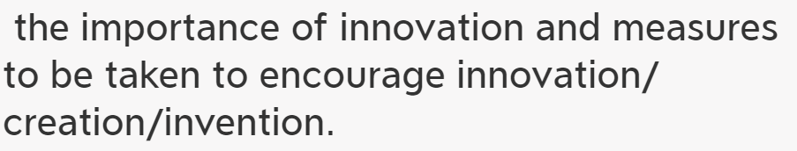

In the contemporary world, _______(主题词) have/has become increasingly important. It's of great necessity for___to______. Reasons and concrete evidence to support my view point are as follows.

In the first place,there is no doubt that_________________Based on big data, most of _______ admitted that________(they've spent 2/3 of their time in doing sth.) Moreover，no one can deny that___________________.where there is/are__________________, there is/are______.Last but not least, I firmly believe that_________. The more responsibilities you have, the more repay you will get.越......， 越........

In conclusion, ___________.If we spare no efforts to_______, the future of _______ will be both hopeful and rosy.