范文一

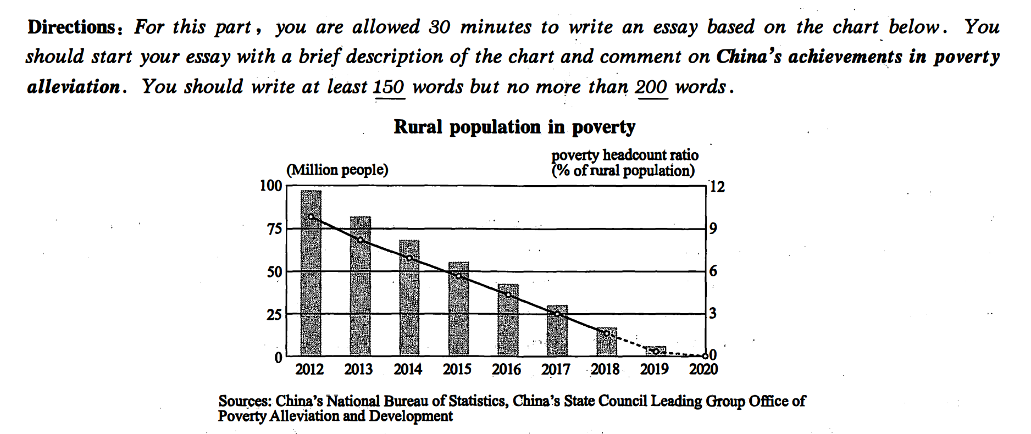

As is starkly mirrored in the chart（表格）that Chinese rural population has been lifted out of poverty. It is revealed that China’s achievements in poverty alleviation are extraordinary. （图片内涵）The following reasons can account for this issue.（过渡句）

In the first place, there is no doubt that officials in the governments have played an important role in this process . Based on big data, most of the governors involved have admitted that they've spent 2/3 of their time in the rural area. Moreover，no one can deny that the poverty alleviation policy is indeed beneficial.Where there are good policies, there are incentives. Last but not least, I firmly believe that the personal efforts of the rural residents can’t be ignored. The harder they work，the wealthier they are.

In conclusion, the accomplishment of poverty alleviation in China is outstanding.If we spare no efforts to implement the policy and maintain the work, the future of our country will be both hopeful and rosy.

范文二

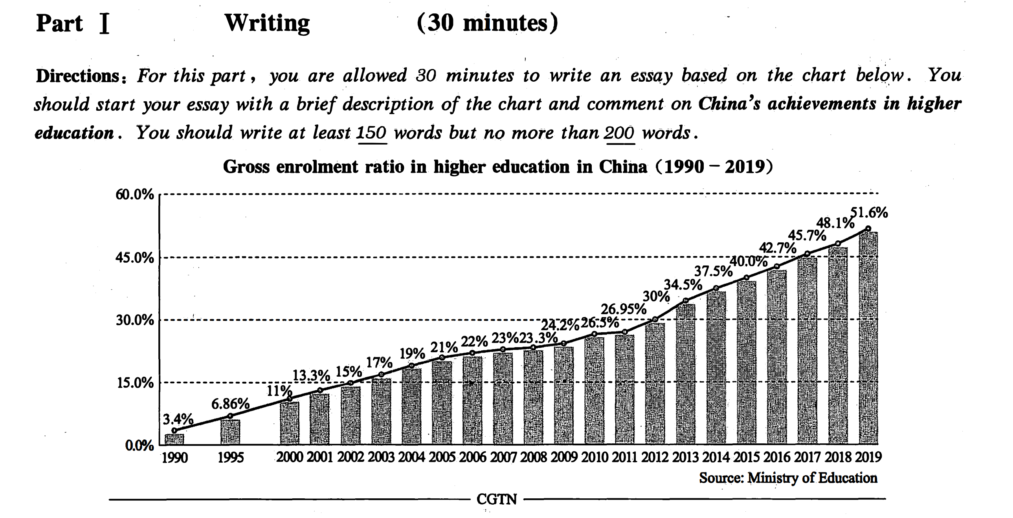

As is starkly mirrored in the chart（表格）that gross enrolment ratio in higher education in China has rocketed up from 1990 to 2019. In 2019, more than half of the high school graduates can seek for further education. It is revealed that China’s achievements in higher education are extraordinary. （图片内涵）The following reasons can account for this issue.（过渡句）

In the first place, there is no doubt that officials in the governments have played an important role in this process . Based on big data, most of the governors involved have admitted that they've spent 2/3 of their time in promoting education. Moreover，no one can deny that the advanced education policy is indeed beneficial. Where there are good policies, there are incentives. Last but not least, I firmly believe that the personal efforts of the students can’t be ignored. The harder they study，the better education they can get.

In conclusion, the accomplishment of education in China is outstanding.If we spare no efforts to implement the policy and maintain the work, the future of our country will be both hopeful and rosy.

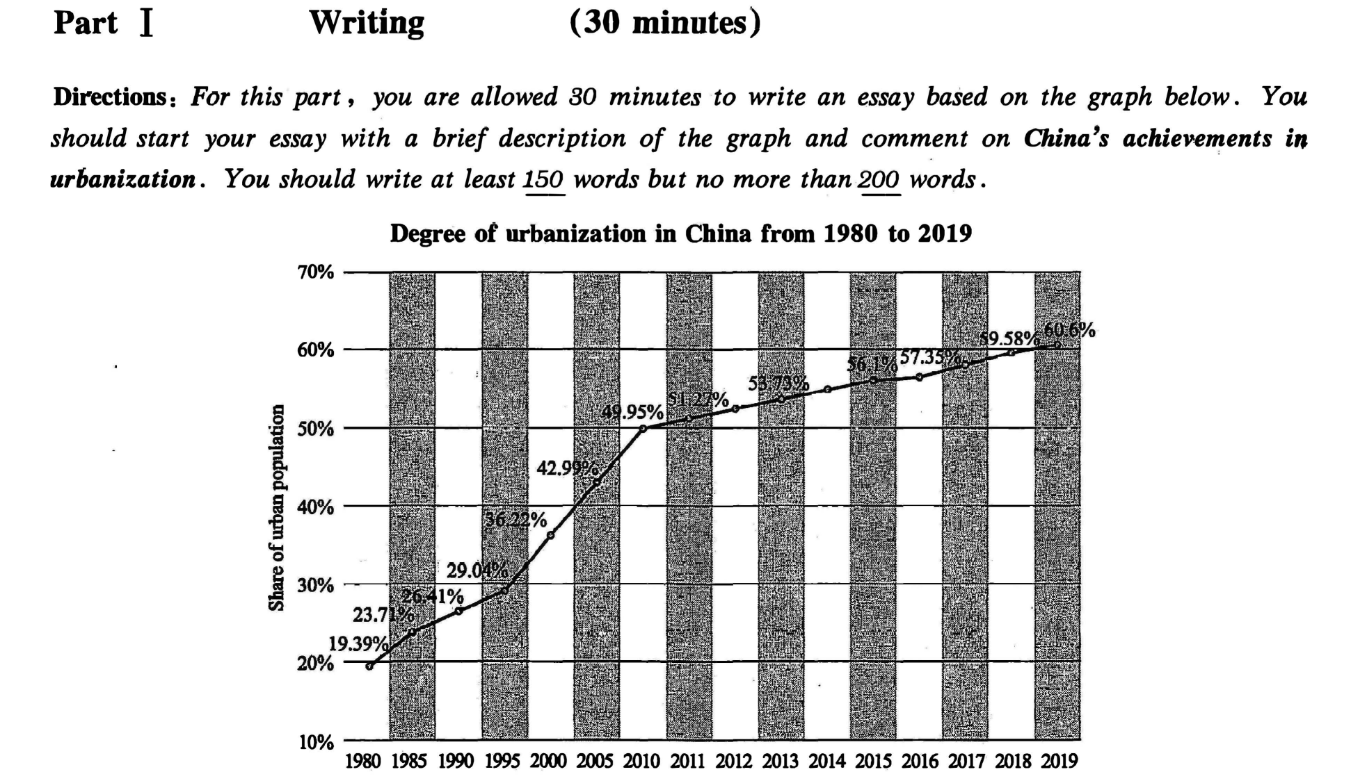

请先写再看解析

As is starkly mirrored in the chart（表格）that degree of urbanization in China has rocketed up from 1980 to 2019. In 2019, more than half of the citizens can live in the city. It is revealed that China’s achievements in urbanization are extraordinary. （图片内涵）The following reasons can account for this issue.（过渡句）

In the first place, there is no doubt that officials in the governments have played an important role in this process . Based on big data, most of the governors involved have admitted that they've spent 2/3 of their time in promoting urbanization. Moreover，no one can deny that the policy of urbanization is indeed beneficial. Where there are good policies, there are incentives. Last but not least, I firmly believe that the personal efforts of the residents can’t be ignored. The harder they work，the better life they can get.

In conclusion, the accomplishment of urbanization in China is outstanding.If we spare no efforts to implement the policy and maintain the work, the future of our country will be both hopeful and rosy.