第一套：

青藏铁路是世界上最高最长的高原铁路**，**全长1 956公里**，**其中有960公里在海拔4 000多 米之上**，**是连接西藏和中国其他地区的第一条铁路**。**由于铁路穿越世界上最脆弱的生态系统**，** 在建设期间和建成后都采取了生态保护措施**，**以确保其成为一条**“**绿色铁路**”。**青藏铁路大大 缩短了中国内地与西藏之间的旅行时间**。**更重要的是**，**它极大地促进了西藏的经济发展**，**改善 了当地居民的生活**。**铁路开通后**，**愈来愈多的人选择乘火车前往西藏**，**这样还有机会欣赏沿线 的美景**。**

听课笔记

参考翻译

The Qinghai-Tibet Railway is the highest and longest plateau railway in the world, with a total length of 1 956 kilometers, of which 960 kilometers are over 4 000 meters above sea level. It is the first railway connecting Tibet with other parts of China.As the railway crosses the world's most fragile ecosystems, ecological protection measures were taken during and after construction to ensure it becomes a "green railway".The Qinghai-Tibet Railway has greatly reduced travel time between mainland China and Tibet.What's more, it has greatly promoted the economic development of Tibet and improved the lives of local residents.After the opening of the railway, more and more people choose to travel to Tibet by train, which gives them a chance to enjoy the beautiful scenery along the route.

第二套：

港珠澳大桥(Hong Kong-Zhuhai-Macau Bridge)全长55公里，是我国一项不同寻常的工程 壮举。大桥将三个城市连接起来，是世界上最长的跨海桥梁和隧道系统。大桥将三个城市之间 的旅行时间从3小时缩短到30分钟。这座跨度巨大的钢筋混凝土大桥充分证明中国有能力建 造创纪录的巨型建筑。它将助推区域一体化，促进经济增长。大桥是中国发展自己的大湾区总 体规划的关键。中国希望将大湾区建成在技术创新和经济繁荣上能与旧金山、纽约和东京的湾 区相媲美的地区。

参考翻译

The 55-kilometer Hong Kong-Zhuhai-Macau Bridge is an unusual engineering feat for our country.The bridge connects the three cities and is the longest sea-crossing bridge and tunnel system in the world.The bridge cut travel time between the three cities from three hours to 30 minutes.The huge steel and concrete bridge is a testament to China's ability to build record-breaking megastructures.It will boost regional integration and economic growth.The bridge is key to China's master plan to develop its own Greater Bay Area.China hopes to build the Greater Bay Area into an area that rivals the Bay Areas of San Francisco, New York and Tokyo in terms of technological innovation and economic prosperity.

第三套

北京大兴国际机场位于天安门广场以南46公里处，于2019年9月30日投入使用。该巨型工程于2014年开工建设，高峰时工地上有4万多工人。航站楼设计紧凑，可以允许最大数量的飞机直接停靠在最靠近航站楼中心的位置，这给乘客提供了极大的方便。航站楼共有82个登机口，但乘客通过安检后，只需不到8分钟就能抵达任何一个登机口。机场的设计可确保每小时300架次起降。机场年客运量2040年将达到1亿人次，有望成为世界上最繁忙的机场。

参考翻译：

*TLocated 46 kilometers south of Tian 'anmen Square, Beijing Daxing International Airport was put into operation on September 30, 2019.Construction of the mega project began in 2014, with more than 40,000 workers on the site at its peak.The compact design of the terminal allows the maximum number of aircraft to park directly in the location closest to the center of the terminal, which provides great convenience to passengers.Passengers can get to any of the terminal's 82 gates in less than eight minutes after passing through security.The airport is designed to ensure 300 takeoffs and landings per hour.With an annual passenger capacity of 100 million by 2040, the airport is expected to be the busiest in the world.*

第四套：



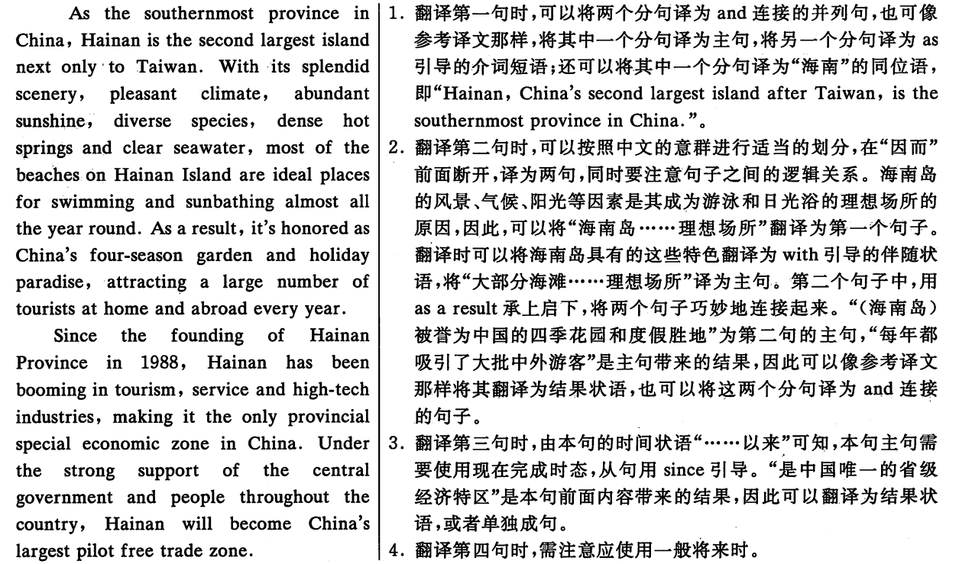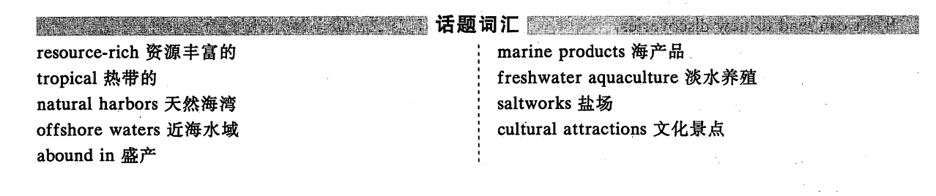

第五套

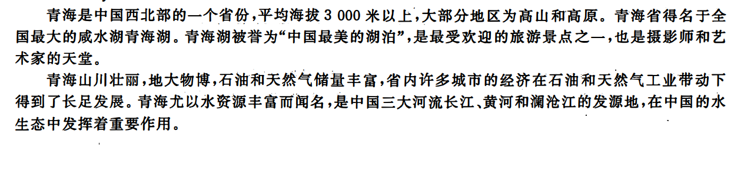

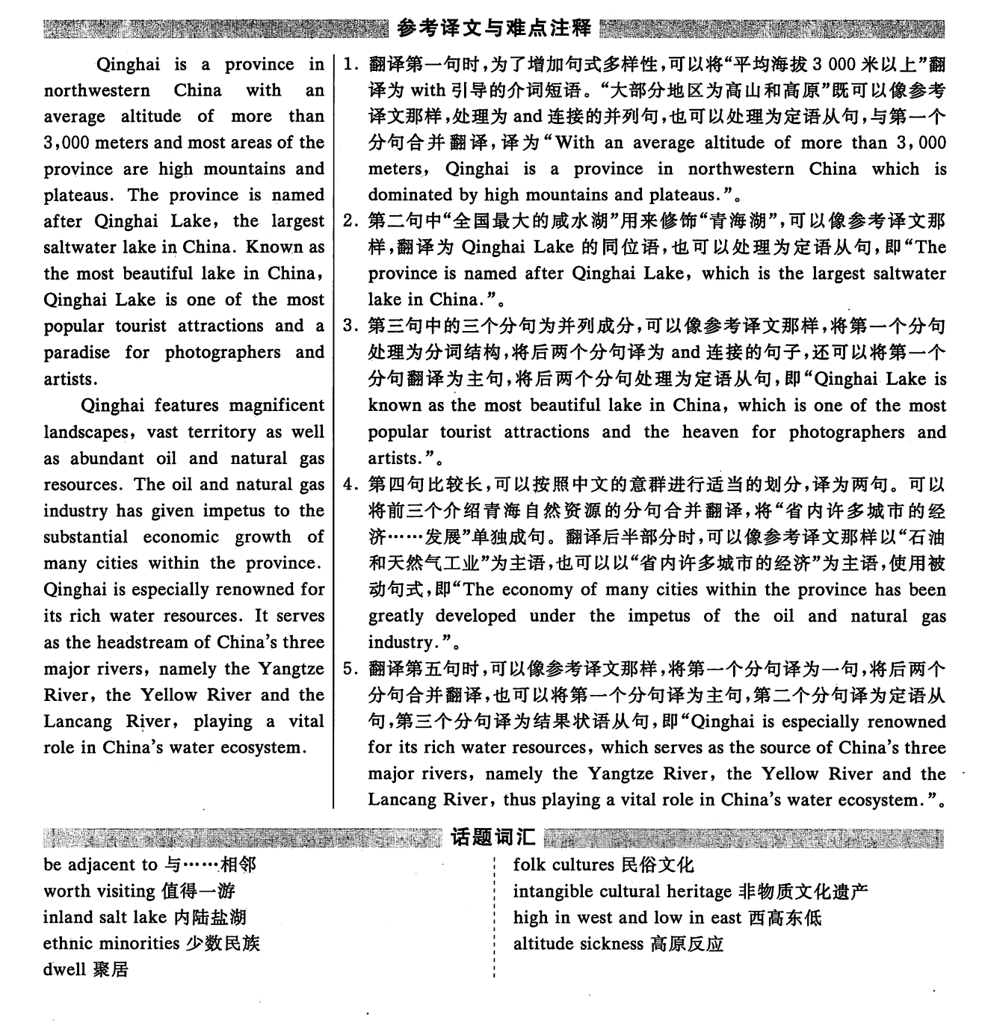

第六套：

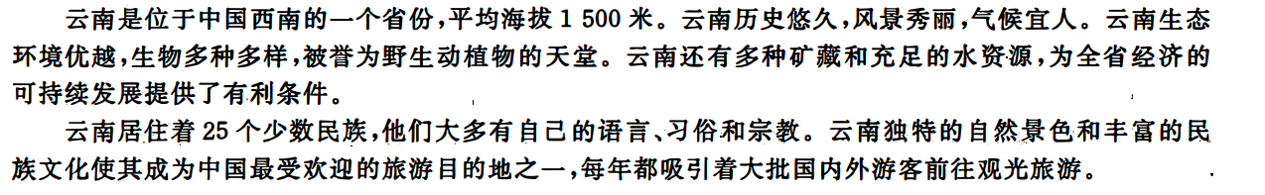

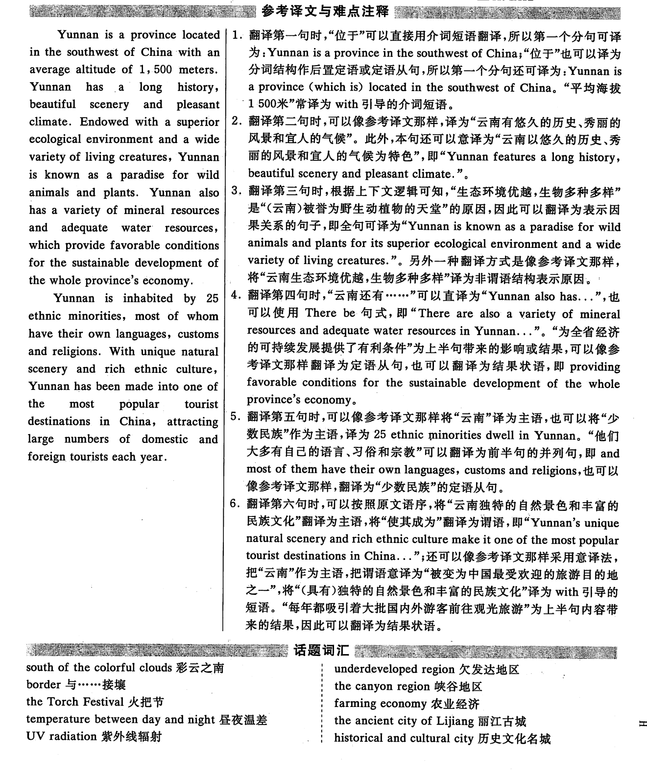

第七篇

《红楼梦》是中国古代文学史上思想性和艺术性结合得最好的作品之一，它集中国古代政治、经济和思想文化之大成。不仅如此，它全面展现了封建制度下错综复杂的阶级关系和形形色色的社会风貌，揭示了封建制度进入没落时期的各种历史特点，并进一步步趋向衰亡的过程。《红楼梦》无论是在思想内容上或是[艺术技巧](https://baike.baidu.com/item/%E8%89%BA%E6%9C%AF%E6%8A%80%E5%B7%A7" \t "https://baike.baidu.com/item/%E5%9B%9B%E5%A4%A7%E5%90%8D%E8%91%97/_blank)上都具有自己崭新的面貌，具有永久的[艺术魅力](https://baike.baidu.com/item/%E8%89%BA%E6%9C%AF%E9%AD%85%E5%8A%9B" \t "https://baike.baidu.com/item/%E5%9B%9B%E5%A4%A7%E5%90%8D%E8%91%97/_blank)，使它足以卓立于[世界文学](https://baike.baidu.com/item/%E4%B8%96%E7%95%8C%E6%96%87%E5%AD%A6" \t "https://baike.baidu.com/item/%E5%9B%9B%E5%A4%A7%E5%90%8D%E8%91%97/_blank)之林。

试译：

参考翻译：

*A Dream of Red Mansions* is one of the best works in the history of ancient Chinese literature combining thoughts and artistry. It is a collection of ancient Chinese political, economic and ideological and cultural achievements. Moreover, Not only that, it fully shows the complex class relations under the feudal system and all kinds of social features. It reveals various historical characteristics of the feudal system entering the declining period and a process of gradual decay. "A Dream of Red Mansions" has its own brand-new look both in ideological content and artistic skills. Therefore, it has a permanent artistic charm, which makes it stand out in the world of literature.

第八篇

《水浒传》是中国古代长篇小说的代表作之一。 其故事是以宋江起义故事为线索创作出来的。元代出现了不少水浒戏，一批梁山英雄作为舞台形象出现。[小说故事](https://baike.baidu.com/item/%E5%B0%8F%E8%AF%B4%E6%95%85%E4%BA%8B" \t "https://baike.baidu.com/item/%E5%9B%9B%E5%A4%A7%E5%90%8D%E8%91%97/_blank)情节曲折，语言生动，[人物性格](https://baike.baidu.com/item/%E4%BA%BA%E7%89%A9%E6%80%A7%E6%A0%BC" \t "https://baike.baidu.com/item/%E5%9B%9B%E5%A4%A7%E5%90%8D%E8%91%97/_blank)鲜明，具有高度的艺术成就。 全书以宋江领导的农民起义为主要题材，艺术地再现了中国古代人民反抗压迫的精神。

参考翻译：

Outlaws of the Marsh is one of the representative ancient Chinese novels.The story is based on the story of song Jiang’s rebellion. In the Yuan Dynasty, there were many plays with the theme of Outlaws of Marsh, in which a group of heroes of Liangshan appeared as stage images. In the novel, the plots are well-designed, language is vivid and the characters are distinctive, so it has reached a high degree of artistic achievement.With the peasant rebellions led by Song Jiang as the main theme, the book artistically recreates the anti-oppression spirit of the ancient Chinese people.